School attendance management system through sms

ABSTRACT
Child Safety is very important nowadays and everyone wants to get SMS alerts from the school about their child attendance in the school. Traditional ways of sending SMS is very time-consuming. It takes so many hours in collecting data and informing the parent about the child attends. We have a new solution for this in which we automate the attendance.

CHAPTER 2
2. SYSTEM ANALYSIS
  - EXISTING SYSTEM

- Most of the existing systems have tried to resolve the problem of taking attendance manually. But, almost all of them are unable to make the attendance system all around automatic.
- A major problem in the existing approaches is that no one has applied an RTC to fix the duration for taking attendance.
- In existing systems, if a student comes late, he/she is considered to be present, which should not happen. These are the main problems in the existing systems.
- In many cases, the attendances are marked using RFID technique and messages are sent to the parents of only those students, who are present.
2.1.1 DRAWBACKS OF EXISTING SYSTEM :
- When student place his/her finger on fingerprint sensor, if the fingerprint matches with the data which is stored in database, then attendance will be registered and at the same time the SMS will be send to parent’s mobile, indicating the presence of their child.
- In today’s world parents are worried whether their children are reaching safely to school or college, this problem will be solved with this system.
- Whenever an RFID tag is brought in front of the RFID reader, it starts matching the frequencies of both. For every card, a special ID number is issued.
- Radio Frequency Identification (RFID) based attendance system is one of the solutions to this problem.
2.2. PROPOSED SYSTEM
- In this paper, development and management of attendance reports using biometrics is proposed. The system makes use of fingerprints, which is a unique identification for every person.
- The method proposed here would eliminate the use of stationary materials as well as reduce human efforts in the process of attendance development.
- This paper will discuss the general overview of the proposed system; details of design and operation of system in both hardware and software domain.
- The records are stored in Microsoft SQL (Structured Query Language) Server database .This database is very fast and it can store large number of records.
2.2.1. ADVANTAGES OF PROPOSED SYSTEM
- Attendance is an important criteria for measuring the performance of any institute. For making this attendance management procedure simpler, fingerprints are one of the most common methods of biometric identification.
- As this system is less time consuming, the performance and efficiency of the system is much better than traditional way.
- An efficient and effective system is needed to mark attendance of students, which will deliver SMS via Global System for Mobile communication (GSM) to their respective parents.
- The system has used barcode scanner for recording attendance. The RFID technology has a number of advantages, which include simultaneous collection of large quantities of data with high accuracy and no contact.
Literature Survey:
TITLE | AUTHORS | DESCRIPTION
Development of Attendance Management System using Biometrics | O. Shoewu, Ph.D. and O.A. Idowu, B.Sc., | The ability to compute the attendance percentage becomes a major task as manual computation produces errors, and also wastes a lot of time.
Fingerprint Based Student Attendance System WithSmsAlert To Parents | K.Jaikumar, M.Santhosh Kumar, S.Rajkumar and A.Sakthivel, | This paper is a study of a fingerprint recognition system based on minutiae based fingerprint algorithms used in various techniques.
Automation of Attendance System using RFID,Biometrics, GSM Modem with .Net Framework | AamirNizam Ansari, ArundhatiNavada, SanchitAgarwal, SiddharthPatilandBalwant A. Sonkamble, | The purpose of this paper is to develop a wireless system to detect and maintain the attendance of a student and locate a student.
Biometric Attendance | M.A. Meor Said, M.H. Misran , M.A. Othman, M.M. Ismail, H.A. Sulaiman, A. Salleh and N. Yusop, | The system will facilitate institutions! organization to make attendance individual in time along with data information thumb impression will be taken as a signature for the system entry.

2.3 FEASIBILITY STUDY
The feasibility Analysis is an analytical program through project manager determines the project success ratio and through feasibility study project manager able to see either project. The key considerations involved in the feasibility analysis are:
- Economic Feasibility
- Technical Feasibility
- Operational Feasibility
- Environmental Feasibility
2.3.1 ECONOMICAL FEASIBILITY
Hence this project is economically feasible there is no need to involve any cost for this project.

2.3.2 TECHNICAL FEASIBILITY
Software Technologies used are PHP and MySql. In the educational institutions, it is possible to update the system in future. No special hardware is required for the purpose of using this system. Hence it is declared that this project is technically feasible.
2.3.3 OPERATIONAL FEASIBILITY
As the admin work mainly to maintain the Patient and Doctor .Doctor will predict patient cancer disease. Hence it is easy to operate with training. Therefore it is operationally feasible for implementation.
2.3.4 ENVIRONMENTAL FEASIBILITY
This project environment is correct as a admin has developed this system and no expenditure is involved under any head and this process is part of admin document management, this project environment is accessible.
2.4 SYSTEM REQUIREMENTS
- System : Pentium IV 2.4 GHz.
- Hard Disk : 40 GB.
- Monitor : 15 inch VGA Color.
- Mouse : Logitech Mouse.
- Ram : 512 MB
- Keyboard : Standard Keyboard

2.4.1 HARDWARE REQUIREMENTS
The Hardware of the computer consists of physical component such as Input Devices, Storage Devices, Processing & Control units and Output Devices. Computer includes external storage unit to store data in programs.
The Hardware Configuration involved in this project
- System : Pentium IV 2.4 GHz.
- Hard Disk : 40 GB.
- Monitor : 15 inch VGA Color.
- Mouse : Logitech Mouse.
- Ram : 512 MB
- Keyboard : Standard Keyboard

2.4.2 SOFTWARE REQUIREMENTS
Software is a group of programs that computers need to do a particular task. It is an essential requirement of Computer System. The Software used to develop the project is
- Operating System : Windows XP.
- Platform : DOT NET TECHNOLOGY
- Front End : ASP.Net 3.5
- Back End : SQL SERVER 2005

CHAPTER 3
SYSTEM DESIGN AND DEVELOPEMENT
SYSTEM ARCHICTURE

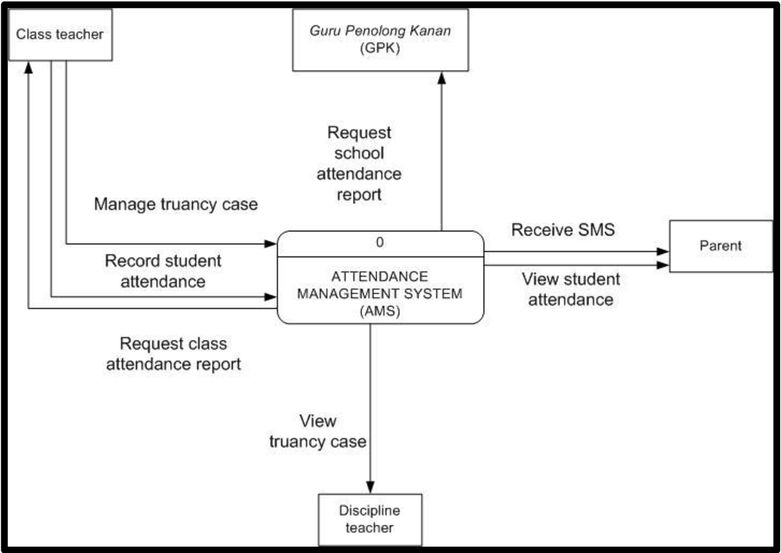

CHAPTER 4
TESTING AND IMPLEMENTATION

  - TESTING
Implementation is the stage of the project when the theoretical design is turned into a working system. This is the final and important phase in the system life cycle It is actually the process of converting the new system into a operational one.

4.1.1Unit Testing
Unit testing comprises the set of tests performed by an individual programmer prior to integration of the unit into a larger system. The module interface is tested to ensure that information properly flows into and out of the program unit. The local data structure is examined to ensure that data stored temporarily maintains its integrity during all steps in an algorithm’s execution. Boundary conditions are tested to ensure that the module operates properly at boundaries established to limit or restrict processing. All independent paths through the control structure are tested. All error-handling paths are tested.

4.1.2 Block Box Testing
Black-box testing is a method of software testing that examines the functionality of an application without peering into its internal structures or workings. This method of test can be applied virtually to every level of software testing: unit, integration, system and acceptance. It is sometimes referred to as specification-based testing.

4.2 SYSTEM IMPLEMENTATION
Implementation is the stage of the project when the theoretical design is turned into a working system. This is the final and important phase in the system life cycle It is actually the process of converting the new system into a operational one.

CHAPTER 5
CONCLUSION:
The system is able to take students attendance successfully. As this system is less time consuming, the performance and efficiency of the system is much better than traditional way. Attendance data is stored in database along with updated date and time.SMS notification about the attendance is successfully sent to parent’s mobile using GSM. Stored data of attendance is used for calculating defaulters list.

CHAPTER-6
REFERENCE
- [1] O. Shoewu, Ph.D. and O.A. Idowu, B.Sc., “Development of Attendance Management System using Biometrics,” in The Pacific Journal of Science and Technology,Volume 13. Number 1. May 2012 (Spring)
- [2] K.Jaikumar, M.Santhosh Kumar, S.Rajkumar and A.Sakthivel,“Fingerprint Based Student Attendance System WithSmsAlert To Parents,” in IJRET: International Journal of Research in Engineering and Technology,Volume: 04 Issue: 02 | Feb-2015.
- [3] AamirNizam Ansari, ArundhatiNavada, SanchitAgarwal, SiddharthPatilandBalwant A. Sonkamble, “Automation of Attendance System using RFID,Biometrics, GSM Modem with .Net Framework,” in 978-1-61284-774-0/11/$26.00 ©2011 IEEE.
- [4] M.A. Meor Said, M.H. Misran , M.A. Othman, M.M. Ismail, H.A. Sulaiman, A. Salleh and N. Yusop, “Biometric Attendance,” in 978-1-4799-3704- 2/14/$31.00 ©2014 IEEE.
- [5] Yash Mittal, AishwaryVarshney, PrachiAggarwa, KapilMatani and V. K. M ittal “Fingerprint Biometric based Access Control and Classroom Attendance Management System,” in [978-1-4673-6540-6/15/$31.00 ©2015 IEEE].
- [6] MadduKamaraju and Penta Anil Kumar , “Wireless Fingerprint Attendance Management System,” in 978-1-4799-6085-9/15/$31.00 ©2015 IEEE.
- [7] The IEEE website. [Online]. Available: http://www.ieee.org/
- [8] The fingerprint scanner website. [Online]. Available https://computer.howstuffworks.com/
- [9] The circuit digest website. [Online]. Available: https://circuitdigest.com/
- [10] Rishabh Mishra and PrashantTrivedi , “`Student Attendance System Based On Fingerprint Recognition and One-to-Many Matching, ”National Institute of Technology, Rourkela, Sep 2011.
- [11] MasoudNosrati , “Python: An appropriate language for real world Programming,” in World Applied Programming, Vol (1), No (2), June 2011.

