Hostel fees management

ABSTRACT
A hostel management system (HOMASY) was designed to provide a computerized process that is stress free, reliable and quick through the use of PHP computer programming language and MySQL database application to both the students and the staff in charge of the registration and hostel management processes. HTML would be at the front-end and provide the graphical user interface that relates with the user, while the MySQL database will be at the back-end to handle the data storage process. The porter and students’ affairs officers will also be able to access and create student records with ease and regular update of student profile is enhanced when adopted. The usual practice of filing and procedures involved in students’ registration and hostel accommodation in Lagos State University and other university was appraised for efficiency, economics and time management. The existing procedure was formed to be manually carried out. This is associated with inadequacies as more personnel are often required and a lot of times are wasted while the semester is on with lectures and other activities.

CHAPTER 2
2. SYSTEM ANALYSIS
  - EXISTING SYSTEM

- Hostel management is not a new thing it is came into existence when people have the idea of hostel.
- It’s very difficult perform the repetitive task by the authorized person to the existing data, we need to search and perform all the modification, upgradations and other activity.
- The data in hard copy is not so secure, because unauthorized persons will steal the data and can also perform some inconsistence modification to the existing data.
- It allows authorized person to access the data easily and modification to the existing data. Student can do their registration easily by student portal, and room allotment will be handled by hostel clerk and allotted the room according to availability.
2.1.1 DRAWBACKS OF EXISTING SYSTEM :
- System analysis is a method of problem-solving that deals with the breaking down of a system into components parts in order to study how well the individual parts work and interact to accomplish their purpose.
- It involves the process of enumerating the existing problems, analyzing the proposed system for costs and benefits, analyzing the system and user requirements, and considering possible alternative system.
- We can also maintain the room number and floor number, student overall reports easily without any problem.
- This problem can be solved by a system which can do the entire task related to information handling without any complexity and just a few clicks.
2.2. PROPOSED SYSTEM
- In proposed system the information about the hostel maintained in highly secured manner, no one can hack the information about the hostel.
- System also maintain student payment details, and generate unique room number for each student, System also maintain hostel clearance details, if student vacate the hostel he should complete this procedure, hostel clerk has a response with room physical checking and enter final charge if applicable.
- System also maintain and generate report of students staying in hostel, student report can access by the authorized person from anywhere at any time.
2.2.1. ADVANTAGES OF PROPOSED SYSTEM
- These processes are carried out manually with pen and papers; an unreliable procedure which is associated with inefficiencies.
- An increase in the number of student will obviously mean more paper work and less efficiency of the traditional registration system, hence, many Universities are finding the e-registration a better and more effective way of catering for the inconvenience and inefficiency of the traditional system of registration.
- An electronic system of registration focuses on saving cost, improving the efficiency of the processes involved in both registration and management of hostels and makes the overall procedure stress free.
- This system will help improve productivity and reliability of the hostel registration and management process in a more efficient manner.
2.3 FEASIBILITY STUDY
The feasibility Analysis is an analytical program through project manager determines the project success ratio and through feasibility study project manager able to see either project. The key considerations involved in the feasibility analysis are:
- Economic Feasibility
- Technical Feasibility
- Operational Feasibility
- Environmental Feasibility
2.3.1 ECONOMICAL FEASIBILITY
Hence this project is economically feasible there is no need to involve any cost for this project.

2.3.2 TECHNICAL FEASIBILITY
Software Technologies used are PHP and MySql. In the educational institutions, it is possible to update the system in future. No special hardware is required for the purpose of using this system. Hence it is declared that this project is technically feasible.
2.3.3 OPERATIONAL FEASIBILITY
As the admin work mainly to maintain the Patient and Doctor .Doctor will predict patient cancer disease. Hence it is easy to operate with training. Therefore it is operationally feasible for implementation.
2.3.4 ENVIRONMENTAL FEASIBILITY
This project environment is correct as a admin has developed this system and no expenditure is involved under any head and this process is part of admin document management, this project environment is accessible.
2.4 SYSTEM REQUIREMENTS
- System : Pentium IV 2.4 GHz.
- Hard Disk : 40 GB.
- Monitor : 15 inch VGA Color.
- Mouse : Logitech Mouse.
- Ram : 512 MB
- Keyboard : Standard Keyboard

2.4.1 HARDWARE REQUIREMENTS
The Hardware of the computer consists of physical component such as Input Devices, Storage Devices, Processing & Control units and Output Devices. Computer includes external storage unit to store data in programs.
The Hardware Configuration involved in this project
- System : Pentium IV 2.4 GHz.
- Hard Disk : 40 GB.
- Monitor : 15 inch VGA Color.
- Mouse : Logitech Mouse.
- Ram : 512 MB
- Keyboard : Standard Keyboard

2.4.2 SOFTWARE REQUIREMENTS
Software is a group of programs that computers need to do a particular task. It is an essential requirement of Computer System. The Software used to develop the project is
- Operating System : Windows XP.
- Platform : DOT NET TECHNOLOGY
- Front End : ASP.Net 3.5
- Back End : SQL SERVER 2005

CHAPTER 3
SYSTEM DESIGN AND DEVELOPEMENT
SYSTEM ARCHICTURE

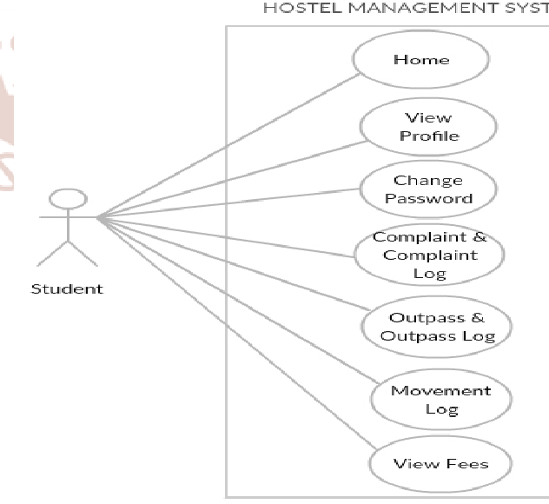

CHAPTER 4
TESTING AND IMPLEMENTATION

  - TESTING
Implementation is the stage of the project when the theoretical design is turned into a working system. This is the final and important phase in the system life cycle It is actually the process of converting the new system into a operational one.

4.1.1Unit Testing
Unit testing comprises the set of tests performed by an individual programmer prior to integration of the unit into a larger system. The module interface is tested to ensure that information properly flows into and out of the program unit. The local data structure is examined to ensure that data stored temporarily maintains its integrity during all steps in an algorithm’s execution. Boundary conditions are tested to ensure that the module operates properly at boundaries established to limit or restrict processing. All independent paths through the control structure are tested. All error-handling paths are tested.

4.1.2 Block Box Testing
Black-box testing is a method of software testing that examines the functionality of an application without peering into its internal structures or workings. This method of test can be applied virtually to every level of software testing: unit, integration, system and acceptance. It is sometimes referred to as specification-based testing.

4.2 SYSTEM IMPLEMENTATION
Implementation is the stage of the project when the theoretical design is turned into a working system. This is the final and important phase in the system life cycle It is actually the process of converting the new system into a operational one.

CHAPTER 5
CONCLUSION:
The introduction of an electronic system of registration focuses on saving cost, improving the efficiency of the processes involved in both registration and management of hostels and makes the overall procedure stress free. The hostel management system is aimed at streamlining the registration and management process of hostels for both students and the administrators in charge of the procedures involved. It is to eliminate unnecessary administrative tasks and reduce or even avoid paper work. This system will help improve productivity and reliability of the hostel registration and management process in a more efficient manner.

CHAPTER-6
REFERENCE
- 1. Whitten, Bentley, and Dittman. 2004. System Analysis and Design Methods (5th ed). McGrawHill: New York, NY.
- 2. PerlScriptsJavaScripts.com. 2006. “MySQL Tutorial, Database Commands, Beginners Guide”. http://www.perlscriptsjavascripts.com/tutorials/mys ql/index.html. Accessed 2/3/06.
- 3. HTML Elements. W3schools. Retrieved 3/16/15.
- 4. CSS Introduction. W3schools. Retrieved 3/16/15.
- 5. Xhtml.com. Retrieved on 5/16/12.
- 6. MySQL: Project Summary. Black Duck Software. Retrieved 9/17/12.
- 7. PHP Manual: www.php.net
- 8. PHP for Windows: php.net. Retrieved 10/29/13. https://wikipedia.org/wiki/PHP
- 9. https://wikipedia.org/wiki/HTML
- 10. https://wikipedia.org/wiki/CSS
- 11. https://wikipedia.org/wiki/MySQL
- 12. Segun O. Olatinwo and et al. 2014. “Development of an Automated Hostel Facility Management System”. Journal of Science and Engineering. 5 (1): 1-10.

