Department staff attendance mailing system

ABSTRACT
Attendance management is the act of managing attendance or presence in a work setting. Considering an academic institute, the conventional method of taking staff attendance is by signing on paper is very time consuming and insecure, hence inefficient. Maintaining these records for a long time adds to the difficulty of the task. In lieu of this, an efficient system is proposed to solve the problem of manual attendance. In this research work, staff attendance is taken electronically with the help of a fingerprint Biometric system, and all the records are saved for subsequent operations. Fingerprints are considered to be the best and fastest method for biometric identification because they are secure to use, unique for every person and do not change in one's lifetime. Staff attendance management system using fingerprint biometric identification technique employs an automated system to calculate staff attendance in lecture rooms in an institution and do further calculations of daily and monthly attendance summary in order to reduce human errors during calculations. In essence, this system can be employed in curbing the problems of tardiness or lateness of lecturers to lecture rooms, impersonation and missing lecture periods in any institution. The system will also improve the productivity of any institution if properly implemented.

CHAPTER 2
2. SYSTEM ANALYSIS
  - EXISTING SYSTEM

- The Organizations are required to register online (once) on the portal for using attendance.gov.in by giving number of employees and their existing website name.
- Such system should leverage on existing identity infrastructure created by Aadhaar which will result in cost, efficiency and scalability advantages.
- The Government agencies shall provide connectivity from various telecom service providers for connecting the bio-metric attendance terminals (GPRS/Wi-Fi using NICNET/Broadband/existing Internet) in a decentralized manner.
- Government organizations shall make suitable provision for getting Client ‘API’ installed on the software provided for wall mounted and desktop finger print devices.
2.1.1 DRAWBACKS OF EXISTING SYSTEM :
- A secure and effective identity management system plays an important role in the successful deployment of an attendance management system.
- Carrying different cards and remembering passwords for different services is a significant issue for individuals and organizations.
- The system provided faster processes, less inventory, fewer efforts, and better quality via providing direct cost savings while it caused some technical issues and slow system deployment.
- Employees can give their feedback about their attendance marking experience and the problems the encounter in the process.
2.2. PROPOSED SYSTEM
- The proposed system is achieving two aims, the first objective is to register, record, and manage a student attendance using RFID tag, and the second aim is to provide student information service such as timetable, lecture time and classroom number, and other student-related data that displayed in screen or LCD.
- The conducted system recorded students' attendance by using Bluetooth, but the limitation of the proposed system is that the phones must have Bluetooth technology within the operating system.
- The proposed circuit aims to investigate student’s services that provide presence and information services based on the internet of things applications and technologies by literature review that gives an overview of what has been done.
2.2.1. ADVANTAGES OF PROPOSED SYSTEM
- The system provides attendance managing records to evaluating their performance as well support an information services for students and faculty staff.
- It is an Object oriented programming language and has its core, many similarities to Java, C++ and VB. In fact C# combines the power and efficiency of C++ and it’s the simple and clean object oriented design of Java and the language simplification of VB.
- It can be concluded from the above discussion that a reliable, secure, fast and efficient system has been developed replacing a manual and unreliable system.
- While, and the proposed system is providing tracking students in their school, college or university to improve their student performance.
Literature Survey:
TITLE | AUTHORS | DESCRIPTION
Fingerprint-Based Authentication System for Time and Attendance Management | Ikuomola A (2014). | A fingerprint recognition system uses the distinctive and persistent characteristics from the ridges, also referred to as fingerprint features, to distinguish one person from another.
Attendance Management for Industrial Workers | Md. S and Rabindra N (2013) | Fingerprint recognition is a mature field to-day, but still identifying individual from a set of enrolled fingerprints is a time taking process.
2.3 FEASIBILITY STUDY
The feasibility Analysis is an analytical program through project manager determines the project success ratio and through feasibility study project manager able to see either project. The key considerations involved in the feasibility analysis are:
- Economic Feasibility
- Technical Feasibility
- Operational Feasibility
- Environmental Feasibility
2.3.1 ECONOMICAL FEASIBILITY
Hence this project is economically feasible there is no need to involve any cost for this project.
2.3.2 TECHNICAL FEASIBILITY
Software Technologies used are PHP and MySql. In the educational institutions, it is possible to update the system in future. No special hardware is required for the purpose of using this system. Hence it is declared that this project is technically feasible.
2.3.3 OPERATIONAL FEASIBILITY
As the admin work mainly to maintain the Patient and Doctor .Doctor will predict patient cancer disease. Hence it is easy to operate with training. Therefore it is operationally feasible for implementation.
2.3.4 ENVIRONMENTAL FEASIBILITY
This project environment is correct as a admin has developed this system and no expenditure is involved under any head and this process is part of admin document management, this project environment is accessible.

2.4 SYSTEM REQUIREMENTS
- System : Pentium IV 2.4 GHz.
- Hard Disk : 40 GB.
- Monitor : 15 inch VGA Color.
- Mouse : Logitech Mouse.
- Ram : 512 MB
- Keyboard : Standard Keyboard

2.4.1 HARDWARE REQUIREMENTS
The Hardware of the computer consists of physical component such as Input Devices, Storage Devices, Processing & Control units and Output Devices. Computer includes external storage unit to store data in programs.
The Hardware Configuration involved in this project
- System : Pentium IV 2.4 GHz.
- Hard Disk : 40 GB.
- Monitor : 15 inch VGA Color.
- Mouse : Logitech Mouse.
- Ram : 512 MB
- Keyboard : Standard Keyboard

2.4.2 SOFTWARE REQUIREMENTS
Software is a group of programs that computers need to do a particular task. It is an essential requirement of Computer System. The Software used to develop the project is
- Operating System : Windows XP.
- Platform : DOT NET TECHNOLOGY
- Front End : ASP.Net 3.5
- Back End : SQL SERVER 2005

CHAPTER 3
SYSTEM DESIGN AND DEVELOPEMENT
SYSTEM ARCHICTURE

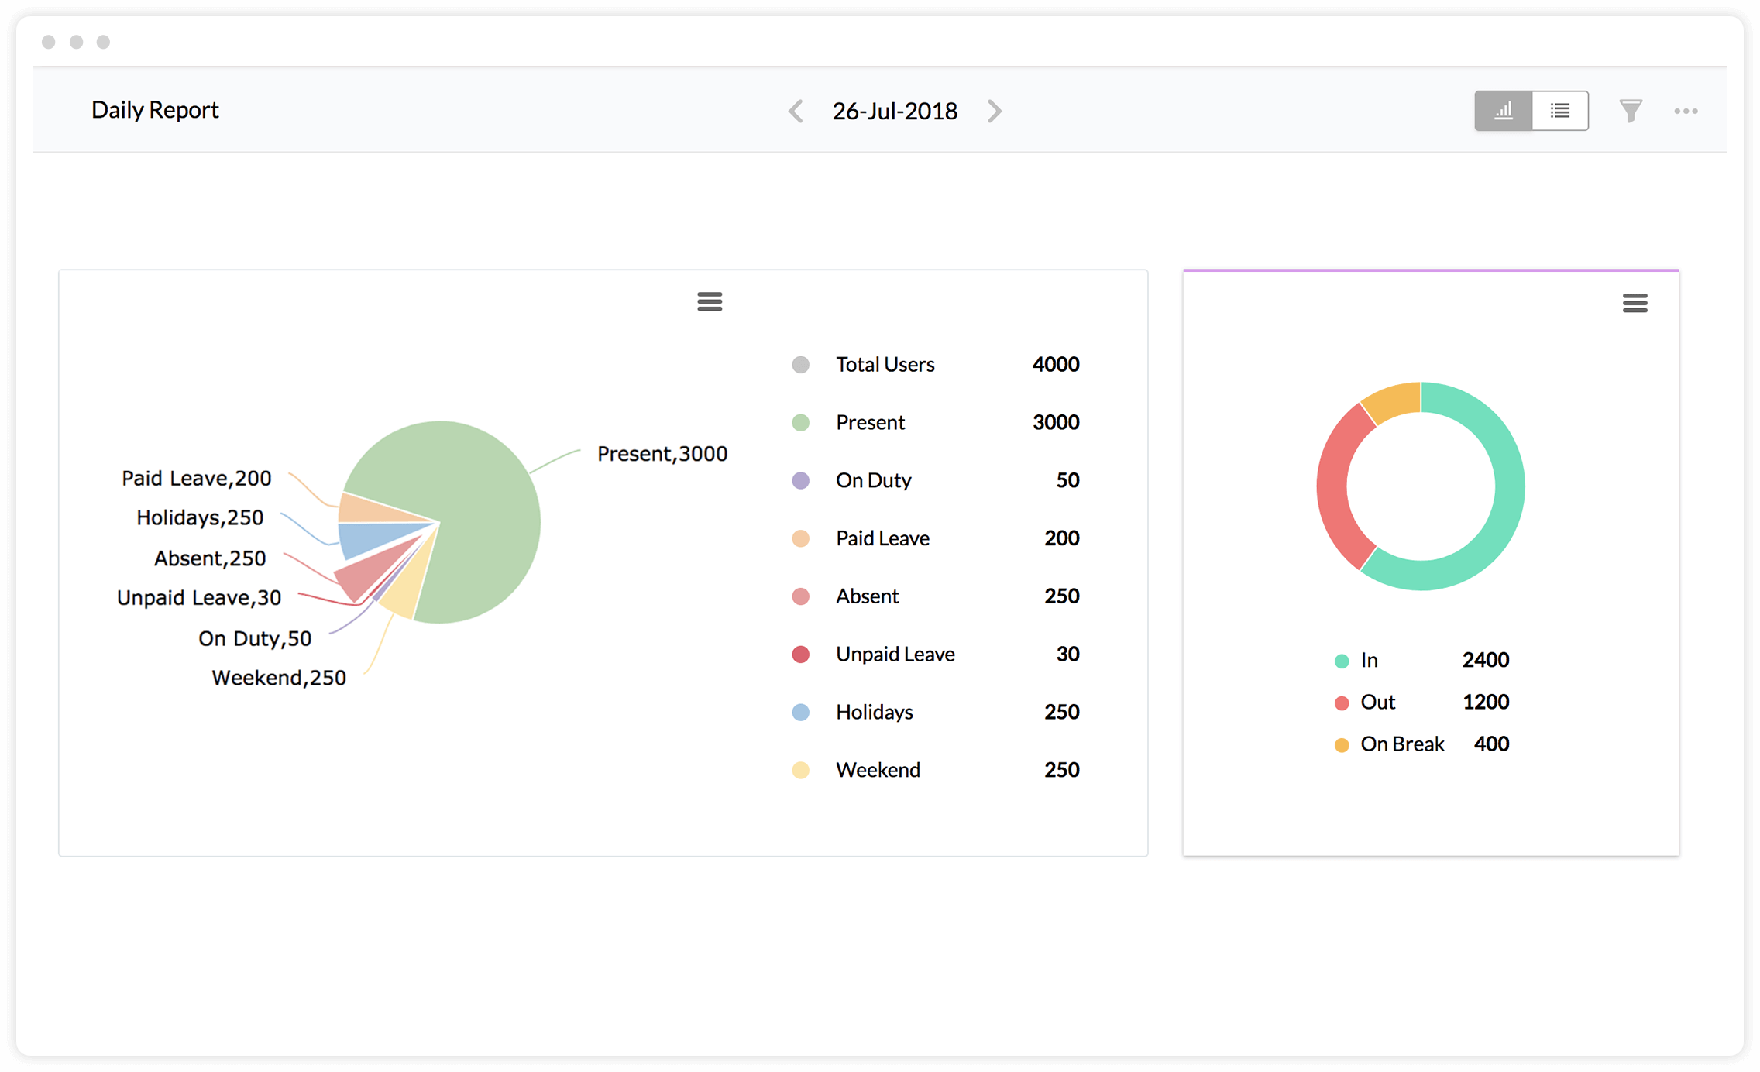

CHAPTER 4
TESTING AND IMPLEMENTATION

  - TESTING
Implementation is the stage of the project when the theoretical design is turned into a working system. This is the final and important phase in the system life cycle It is actually the process of converting the new system into a operational one.

4.1.1Unit Testing
Unit testing comprises the set of tests performed by an individual programmer prior to integration of the unit into a larger system. The module interface is tested to ensure that information properly flows into and out of the program unit. The local data structure is examined to ensure that data stored temporarily maintains its integrity during all steps in an algorithm’s execution. Boundary conditions are tested to ensure that the module operates properly at boundaries established to limit or restrict processing. All independent paths through the control structure are tested. All error-handling paths are tested.

4.1.2 Block Box Testing
Black-box testing is a method of software testing that examines the functionality of an application without peering into its internal structures or workings. This method of test can be applied virtually to every level of software testing: unit, integration, system and acceptance. It is sometimes referred to as specification-based testing.

4.2 SYSTEM IMPLEMENTATION
Implementation is the stage of the project when the theoretical design is turned into a working system. This is the final and important phase in the system life cycle It is actually the process of converting the new system into a operational one.

CHAPTER 5
CONCLUSION:
Traditionally, lecturer’s attendance is taken using the manual method which involves pen and paper registers. This research mainly comprises of development of staff attendance management system using fingerprint biometric technique. Attendance management system is very helpful in saving valuable time of students and lecturers, saving paper and generating report at required time. This research has presented a framework in which attendance management has been made automated. Furthermore, it can curb tardiness of lecturers in the institution and make them regular if implemented. It can be concluded from the above discussion that a reliable, secure, fast and efficient system has been developed replacing a manual and unreliable system. Results have shown that this system can be implemented in an institution for better results regarding the management of attendance. This system will save time, reduce the amount of work the administrator has to do and replace the stationery material with electronic devices. Hence, a system with expected results has been developed but there is still room for improvement.

CHAPTER-6
REFERENCE
- AFIS (1981). Automated Fingerprint Identification System. Textbook by Keneth R. Moses
- FBI (1969). Federal Bureau of Investigation, “The Ten most wanted fugitives “ from the Wikipedia, the free encyclopedia.
- Ikuomola A (2014). Fingerprint-Based Authentication System for Time and Attendance Management. BJMCS 5 (6) :735-747
- Maltoni D. and Cappelli R. (2008): Fingerprint Recognition, In Handbook of Biometrics,Springer Science and Business Media, U.S.A.
- Md. S and Rabindra N (2013) . Attendance Management for Industrial Workers. GJCST 13(6) :
- Ravi J.K, Raja B. and Venugopal K.R.(2009 a,b): Fingerprint Recognition Using Minutia Score Matching, IJEST (2): 35-42.
- SrideviBonthu. (2014). Security Enhancement of ATM System with Fingerprint and DNA Data: IJARCSSE 4 (8) : 477-479

