Electrical shop management

ABSTRACT
Electronic Shop Management software helps Electronic showrooms owners and management staff by producing different kind of financial and stock tracking reports, etc. This software is able to manage all electronic stocks. In this software shop owner can manage the data of customer and buyers. Also tax information and other government charges including recycle charges. Electrical shop management system is workable application for retail store inventory and account management. It keeps a list STOCKS and products at a store and can do operation on them. The most important operation on them. The most important operation is a PURCHASE, all the transactions and the billing details and stock purchasing details involved on it.

CHAPTER 2
2. SYSTEM ANALYSIS
  - EXISTING SYSTEM

- These software s has brought a revelation in the way we work, live and socialize.
- It has opened up entirely new business and technology, and revolutionized the current existing ones.
- Using the power of these software s all the information are acquired and finished at the particular schedule of time.
2.1.1 DRAWBACKS OF EXISTING SYSTEM :
- The organizations in which all the works are done manually the management approved the need of communication of office. During the study of existing system following Points are observed.
- As the current system is totally manual. Due to manually process is requires more time for completion of any work Existing system is manual. So it increases the chances of errors.
- To generate success reports, Each Report needed to generate next report. Lots of consumed for each report generation.
- More man Power is require and timely updating complicated. Immediate responses to the queries are difficult and time-consuming.
2.2. PROPOSED SYSTEM
- The system is easy to use as it is very simple.
- After the system implementation, the user will need no changes on the system is developed by keeping in view the user s requirements.
- The proposed system will cost no harm to the industry; instead it will enhance the result in a better respect.
- The new system will avoid confusion and resistance by catching the user s attention, as it is presentable.
2.2.1. ADVANTAGES OF PROPOSED SYSTEM
- The electricity generated should be utilised efficiently to meet the demand of countries. This improves the reliability of the power supply system.
- In the residential sector, rebates have been commonly offered for the purchase of efficient appliances and compact fluorescent bulbs.
- Improve voltage drop at the point of use, (voltages below equipment rating reduces efficiency, increases current, and reduces starting torque in motors).
- DSM options that are potential for efficiency improvement have to be identified, evaluated and implemented.
2.3 FEASIBILITY STUDY
The feasibility Analysis is an analytical program through project manager determines the project success ratio and through feasibility study project manager able to see either project. The key considerations involved in the feasibility analysis are:
- Economic Feasibility
- Technical Feasibility
- Operational Feasibility
- Environmental Feasibility
2.3.1 ECONOMICAL FEASIBILITY
Hence this project is economically feasible there is no need to involve any cost for this project.
2.3.2 TECHNICAL FEASIBILITY
Software Technologies used are PHP and MySql. In the educational institutions, it is possible to update the system in future. No special hardware is required for the purpose of using this system. Hence it is declared that this project is technically feasible.
2.3.3 OPERATIONAL FEASIBILITY
As the admin work mainly to maintain the Patient and Doctor .Doctor will predict patient cancer disease. Hence it is easy to operate with training. Therefore it is operationally feasible for implementation.
2.3.4 ENVIRONMENTAL FEASIBILITY
This project environment is correct as a admin has developed this system and no expenditure is involved under any head and this process is part of admin document management, this project environment is accessible.
2.4 SYSTEM REQUIREMENTS
- System : Pentium IV 2.4 GHz.
- Hard Disk : 40 GB.
- Monitor : 15 inch VGA Color.
- Mouse : Logitech Mouse.
- Ram : 512 MB
- Keyboard : Standard Keyboard

2.4.1 HARDWARE REQUIREMENTS
The Hardware of the computer consists of physical component such as Input Devices, Storage Devices, Processing & Control units and Output Devices. Computer includes external storage unit to store data in programs.
The Hardware Configuration involved in this project
- System : Pentium IV 2.4 GHz.
- Hard Disk : 40 GB.
- Monitor : 15 inch VGA Color.
- Mouse : Logitech Mouse.
- Ram : 512 MB
- Keyboard : Standard Keyboard

2.4.2 SOFTWARE REQUIREMENTS
Software is a group of programs that computers need to do a particular task. It is an essential requirement of Computer System. The Software used to develop the project is
- Operating System : Windows XP.
- Platform : DOT NET TECHNOLOGY
- Front End : ASP.Net 3.5
- Back End : SQL SERVER 2005

CHAPTER 3
SYSTEM DESIGN AND DEVELOPEMENT
SYSTEM ARCHICTURE

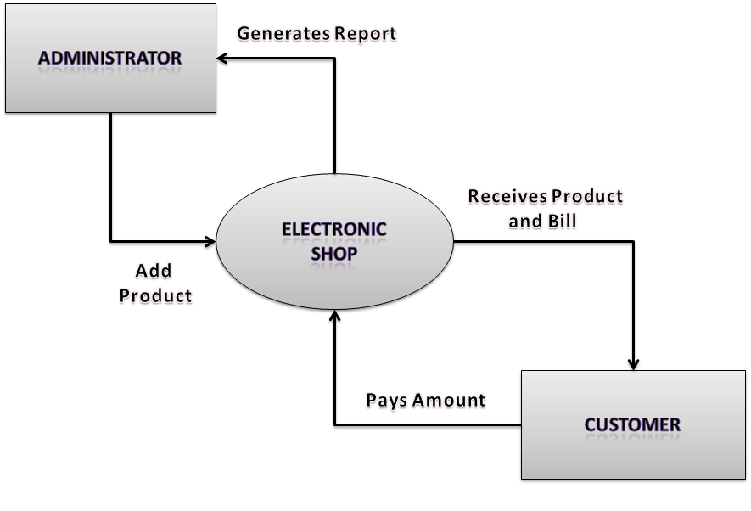

CHAPTER 4
TESTING AND IMPLEMENTATION

  - TESTING
Implementation is the stage of the project when the theoretical design is turned into a working system. This is the final and important phase in the system life cycle It is actually the process of converting the new system into a operational one.

4.1.1Unit Testing
Unit testing comprises the set of tests performed by an individual programmer prior to integration of the unit into a larger system. The module interface is tested to ensure that information properly flows into and out of the program unit. The local data structure is examined to ensure that data stored temporarily maintains its integrity during all steps in an algorithm’s execution. Boundary conditions are tested to ensure that the module operates properly at boundaries established to limit or restrict processing. All independent paths through the control structure are tested. All error-handling paths are tested.

4.1.2 Block Box Testing
Black-box testing is a method of software testing that examines the functionality of an application without peering into its internal structures or workings. This method of test can be applied virtually to every level of software testing: unit, integration, system and acceptance. It is sometimes referred to as specification-based testing.

4.2 SYSTEM IMPLEMENTATION
Implementation is the stage of the project when the theoretical design is turned into a working system. This is the final and important phase in the system life cycle It is actually the process of converting the new system into a operational one.

CHAPTER 5
CONCLUSION:
In this paper, electrical load management techniques on the supply side and demand side have been reviewed. On the supply side, this review found that there are three main methods used for load management i.e. direct load control, interruptible load control and time of use (TOU). These methods were developed on the supply side and implemented on the demand side, aiming at a reduction of system peak demand and improving the reliability of power supply.

