Dress rental purchasing system

ABSTRACT
As an emerging product-service system (PSS) and part of a growing sharing economy, rental services of casual clothing for women are becoming increasingly common in many countries around the world. Rental services of casual and formal wear have the potential to reduce the life cycle environmental impact compared to the conventional ownership model of consumption. However, the environmental impact of rental services highly depends on the structure of business models and the resulting consumption patterns, which therefore makes the environmental benefit uncertain. To clarify the environmental implication of casual wear PSS, we analyzed the business model of providing companies in Germany and Japan through media research and interviews with the business providers. We performed a simple life cycle assessment of representative business models in each country. Our results show that it is necessary to increase the number of times a garment is worn when rented to achieve environmental benefits. These benefits are more significant for formal garments, which are infrequently worn for specific occasions than for a T-Shirt.

CHAPTER 2
2. SYSTEM ANALYSIS
  - EXISTING SYSTEM

- The textile and clothing industry, in particular fast fashion, contributes to resource depletion, produces large amounts of wastewater and solid waste, contributes to chemical and pesticide residues, and is known for the exploitation of workers among many other negative impacts.
- Consumers may choose to rent clothes to increase their wardrobe choices, rather than replace their normal purchasing.
- The research is based on a comparative life-cycle assessment (LCA) of a rental business model (PSS) vs. a linear (ownership) model of dress consumption.
- The scope focuses on use-oriented PSS for clothing, meaning rental clothing business models. Shared or rental clothing in this research entails facilitation of use and provision of access.
2.1.1 DRAWBACKS OF EXISTING SYSTEM :
- Rental services of casual and formal wear have the potential to reduce the life cycle environmental impact compared to the conventional ownership model of consumption.
- However, the environmental impact of rental services highly depends on the structure of business models and the resulting consumption patterns, which therefore makes the environmental benefit uncertain.
- The environmental impact of clothing is heavily influenced by the behavior of the consumers, especially how they launder their garments.
- These impacts are divided by the assumed amount of times an item is worn during the renting period.
2.2. PROPOSED SYSTEM
- The purpose of the survey was to assess different behavioural consumption patterns of how users engage with the rental company.
- It was comprised of two main parts: the first focused on the consumer’s typical purchasing and use behaviour for formal dresses, and the second focused on the consumer’s relationships with the case company in their rental participation and its effect on their normal purchasing.
- The survey contributed data on garment use intensity, the number of dresses purchased yearly, transport modes and consumer transport distance, washing behaviour, and RR for rental dresses for purchased dresses.
2.2.1. ADVANTAGES OF PROPOSED SYSTEM
- Providing a product as a service can change consumption patterns and may provide incentives for the optimisation of supply chains and product design to maximise the value offering to the consumer and the company.
- This could result in extended life spans of products, higher use intensities, and other value chain optimisations leading to implications such as resource efficiency and dematerialisation.
- Although PSSs such as clothing libraries can reduce the speed of fashion if garments are used more times, they also have the potential to promote consumption if users update their closets more frequently.
- The production processes modelled for the linear and rental BMs were identical since the case company offers rental of pre-used dresses and does not produce any dresses.
Literature Survey:
TITLE | AUTHORS | DESCRIPTION
Benchmarking to trigger cleaner production in small businesses: drycleaning case study | W. Altham | This paper reports on research that investigated and implemented benchmarking as a trigger for cleaner production in the drycleaning industry in Western Australia and applies this knowledge to the small business sector.
Sustainable Fashion and Textiles: Design Journeys | K. Fletcher | Design Journeys brings together for the first time information about lifecycle sustainability impacts of fashion and textiles, practical alternatives, design concepts and social innovation
Environmental potential of reusing, renting, and sharing consumer products: Systematic analysis approach | E. Amasawa, T. Shibata, H. Sugiyama, M. Hirao | Consumer products are increasingly offered through renting and sharing, which are emerging as alternative business models to purchasing.
Electricity and water consumption for laundry washing by washing machine worldwide | C. Pakula, R. Stamminger | Washing laundry is one of the most widespread housework in the world. Today, washing machines do this work in many private households, using water, electricity, chemical substances, and process time.
2.3 FEASIBILITY STUDY
The feasibility Analysis is an analytical program through project manager determines the project success ratio and through feasibility study project manager able to see either project. The key considerations involved in the feasibility analysis are:
- Economic Feasibility
- Technical Feasibility
- Operational Feasibility
- Environmental Feasibility
2.3.1 ECONOMICAL FEASIBILITY
Hence this project is economically feasible there is no need to involve any cost for this project.
2.3.2 TECHNICAL FEASIBILITY
Software Technologies used are PHP and MySql. In the educational institutions, it is possible to update the system in future. No special hardware is required for the purpose of using this system. Hence it is declared that this project is technically feasible.
2.3.3 OPERATIONAL FEASIBILITY
As the admin work mainly to maintain the Patient and Doctor .Doctor will predict patient cancer disease. Hence it is easy to operate with training. Therefore it is operationally feasible for implementation.
2.3.4 ENVIRONMENTAL FEASIBILITY
This project environment is correct as a admin has developed this system and no expenditure is involved under any head and this process is part of admin document management, this project environment is accessible.
2.4 SYSTEM REQUIREMENTS
- System : Pentium IV 2.4 GHz.
- Hard Disk : 40 GB.
- Monitor : 15 inch VGA Color.
- Mouse : Logitech Mouse.
- Ram : 512 MB
- Keyboard : Standard Keyboard
2.4.1 HARDWARE REQUIREMENTS
The Hardware of the computer consists of physical component such as Input Devices, Storage Devices, Processing & Control units and Output Devices. Computer includes external storage unit to store data in programs.
The Hardware Configuration involved in this project
- System : Pentium IV 2.4 GHz.
- Hard Disk : 40 GB.
- Monitor : 15 inch VGA Color.
- Mouse : Logitech Mouse.
- Ram : 512 MB
- Keyboard : Standard Keyboard
2.4.2 SOFTWARE REQUIREMENTS
Software is a group of programs that computers need to do a particular task. It is an essential requirement of Computer System. The Software used to develop the project is
- Operating System : Windows XP.
- Platform : DOT NET TECHNOLOGY
- Front End : ASP.Net 3.5
- Back End : SQL SERVER 2005

CHAPTER 3
SYSTEM DESIGN AND DEVELOPEMENT
SYSTEM ARCHICTURE

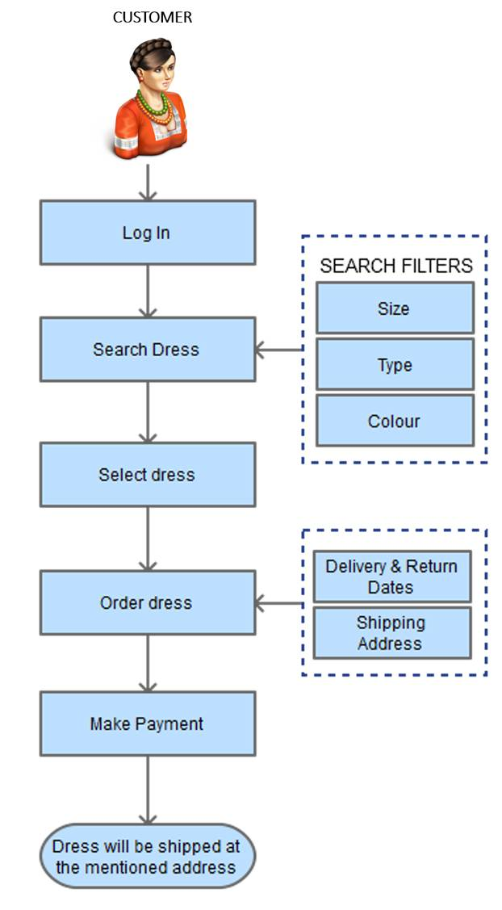

CHAPTER 4
TESTING AND IMPLEMENTATION

  - TESTING
Implementation is the stage of the project when the theoretical design is turned into a working system. This is the final and important phase in the system life cycle It is actually the process of converting the new system into a operational one.

4.1.1Unit Testing
Unit testing comprises the set of tests performed by an individual programmer prior to integration of the unit into a larger system. The module interface is tested to ensure that information properly flows into and out of the program unit. The local data structure is examined to ensure that data stored temporarily maintains its integrity during all steps in an algorithm’s execution. Boundary conditions are tested to ensure that the module operates properly at boundaries established to limit or restrict processing. All independent paths through the control structure are tested. All error-handling paths are tested.

4.1.2 Block Box Testing
Black-box testing is a method of software testing that examines the functionality of an application without peering into its internal structures or workings. This method of test can be applied virtually to every level of software testing: unit, integration, system and acceptance. It is sometimes referred to as specification-based testing.

4.2 SYSTEM IMPLEMENTATION
Implementation is the stage of the project when the theoretical design is turned into a working system. This is the final and important phase in the system life cycle It is actually the process of converting the new system into a operational one.

CHAPTER 5
CONCLUSION:
We only covered business models which rent out clothing for one month. As flat rate models are emerging, customers could wear a rented garment once and send it back to receive another parcel. Depending on the mode and distance of transport and the process to clean the garments, this could significantly enhance the impacts of the rental service and overcompensate the avoided impacts of production.

CHAPTER-6
REFERENCE
- W. Altham Benchmarking to trigger cleaner production in small businesses: drycleaning case study J Clean Prod, 15 (8–9) (2017), pp. 798-813
- E. Amasawa, T. Shibata, H. Sugiyama, M. HiraoEnvironmental potential of reusing, renting, and sharing consumer products: Systematic analysis approach J Clean Prod, 242 (2019), Article 118487
- E. Amasawa, Y. Suzuki, D. Moon, J. Nakatani, H. Sugiyama, M. HiraoDesigning interventions for behavioral shifts toward product sharing: The case of laundry activities in Japan Sustainability, 10 (8) (2018), p. 2687
- K. FletcherSustainable Fashion and Textiles: Design Journeys Routledge (2013)
- M.J. Goedkoop, C.J. VanHalen, H.R. TeRiele, P.J. Rommens Product service systems, ecological and economic basics Report Dutch Ministr. Environ. (VROM) Econ. Affairs (EZ), 36 (1) (1999), pp. 1-122
- L.L.Kjaer, D.C. Pigosso, T.C. McAloone, M. BirkvedGuidelines for evaluating the environmental performance of Product/Service-Systems through life cycle assessment J Clean Prod, 190 (2018), pp. 666-678
- A. Kozlowski, M. Bardecki, C. SearcyEnvironmental impacts in the fashion industry: A life-cycle and stakeholder framework J Corp Citizen, 45 (2012), pp. 17-36
- C. Pakula, R. StammingerElectricity and water consumption for laundry washing by washing machine worldwide Energ Effic, 3 (4) (2010), pp. 365-382
- F.M. Piontek, M. MüllerLiterature reviews: life cycle assessment in the context of product-service systems and the textile industry Procedia CIRP, 69 (1) (2018), pp. 758-763
- F.M. Piontek, M. Rapaport, M. Müller One year of clothing consumption of a german female consumer Procedia CIRP, 80 (2019), pp. 417-421

