Disease keyword search pattern in herbal products

ABSTRACT
Herbal medicines are an important part of healthcare throughout the world. In many countries including the U.S., herbal medicines are not regulated as extensively as conventional drug therapy. At present, there is a dearth of research evaluating the use of herbal medicines, especially in clinical trials. This, together with the ongoing development of new conventional drug therapies, compounds the number of unknown outcomes when using elements of these two treatment approaches together. Although many benefits can be derived from the use of herbs, potential areas of concern include possible product contamination and/or adulterations, potential toxicity, high potential of known and unknown drug/herb interactions, and substituting proven conventional medicine with herbal medicine. Mechanisms involved in herb-drug interactions are not fully understood, but both pharmacokinetic and pharmacodynamic processes may play a role. Because these can occur in 30-40% of older adults, health care providers and patients must be aware of potential interactions in order to monitor for alterations in therapeutic efficacy and/or potential toxicity.

CHAPTER 2
2. SYSTEM ANALYSIS
  - EXISTING SYSTEM

- The knowledge of traditional uses of medicinal plants by the indigenous communities is likely to be lost in near future, and for this it is essential to document existing available information and immediate need to conserve the nature’s wealth.
- This review provides existing evidence that might help to shape the design of future trials.
- Although double-blinded trials may be difficult due to the nature of the disease, study investigators should consider alternative strategies to minimize the risk of performance bias.
- The trials could have also at least blinded the individuals who assessed the trial outcomes.
2.1.1 DRAWBACKS OF EXISTING SYSTEM :
- One of the most basic problems with the use of herbs is that there is lack of consistent terminology when describing what category herbs fall under.
- We identified were due to the herbal product’s ability to alter glucose levels and blood pressure, which may result in clinically significant problems in patients already taking medications that affect glucose and blood pressure control.
- Herbs that induce metabolism of medications can lead to decreased medication levels, which may result in decreased efficacy of the medication or therapeutic failure.
- Herbs that cause p-glycoprotein alterations can have an impact on the absorption and bioavailability of the medication and either reduce or potentiate the effects of the medication.
2.2. PROPOSED SYSTEM
- The starting point in the design of a research protocol is a complete literature review, including the traditional use of the proposed practice and existing scientific research in the field.
- With respect to the study design, the statistical methods used should be appropriate to the proposed analysis of the study’s outcome.
- It is proposed to administer the herbal preparation to a human subject by the parenteral route, it may be sufficient to use this route alone for animal testing.
- The acceptability of the investigator for the proposed trial, on the basis of sufficient information made available to the committee, in terms of his or her qualifications, experience, availability for the duration of the trial, supporting staff and available facilities.
2.2.1. ADVANTAGES OF PROPOSED SYSTEM
- There is a great need for coordinated efforts to conduct the necessary clinical trials to study the efficacy and safety of herbal medicines, both alone and in conjunction with conventional drug therapies.
- These findings suggest that patients may have clinically relevant alterations in the efficacy of their medication (if medication levels are decreased) or potential toxicity (if medication levels are increased).
- It is important for health care providers and patients to be aware of the potential for herb/drug interactions in order to monitor for alterations in therapeutic efficacy or potential toxicity.
- Herbal products that inhibit the metabolism of medications will result in higher medication levels, which can increase efficacy or risk for toxicity.
2.3 FEASIBILITY STUDY
The feasibility Analysis is an analytical program through project manager determines the project success ratio and through feasibility study project manager able to see either project. The key considerations involved in the feasibility analysis are:
- Economic Feasibility
- Technical Feasibility
- Operational Feasibility
- Environmental Feasibility
2.3.1 ECONOMICAL FEASIBILITY
Hence this project is economically feasible there is no need to involve any cost for this project.

2.3.2 TECHNICAL FEASIBILITY
Software Technologies used are PHP and MySql. In the educational institutions, it is possible to update the system in future. No special hardware is required for the purpose of using this system. Hence it is declared that this project is technically feasible.
2.3.3 OPERATIONAL FEASIBILITY
As the admin work mainly to maintain the Patient and Doctor .Doctor will predict patient cancer disease. Hence it is easy to operate with training. Therefore it is operationally feasible for implementation.
2.3.4 ENVIRONMENTAL FEASIBILITY
This project environment is correct as a admin has developed this system and no expenditure is involved under any head and this process is part of admin document management, this project environment is accessible.
2.4 SYSTEM REQUIREMENTS
- System : Pentium IV 2.4 GHz.
- Hard Disk : 40 GB.
- Monitor : 15 inch VGA Color.
- Mouse : Logitech Mouse.
- Ram : 512 MB
- Keyboard : Standard Keyboard

2.4.1 HARDWARE REQUIREMENTS
The Hardware of the computer consists of physical component such as Input Devices, Storage Devices, Processing & Control units and Output Devices. Computer includes external storage unit to store data in programs.
The Hardware Configuration involved in this project
- System : Pentium IV 2.4 GHz.
- Hard Disk : 40 GB.
- Monitor : 15 inch VGA Color.
- Mouse : Logitech Mouse.
- Ram : 512 MB
- Keyboard : Standard Keyboard

2.4.2 SOFTWARE REQUIREMENTS
Software is a group of programs that computers need to do a particular task. It is an essential requirement of Computer System. The Software used to develop the project is
- Operating System : Windows XP.
- Platform : DOT NET TECHNOLOGY
- Front End : ASP.Net 3.5
- Back End : SQL SERVER 2005

CHAPTER 3
SYSTEM DESIGN AND DEVELOPEMENT
SYSTEM ARCHICTURE

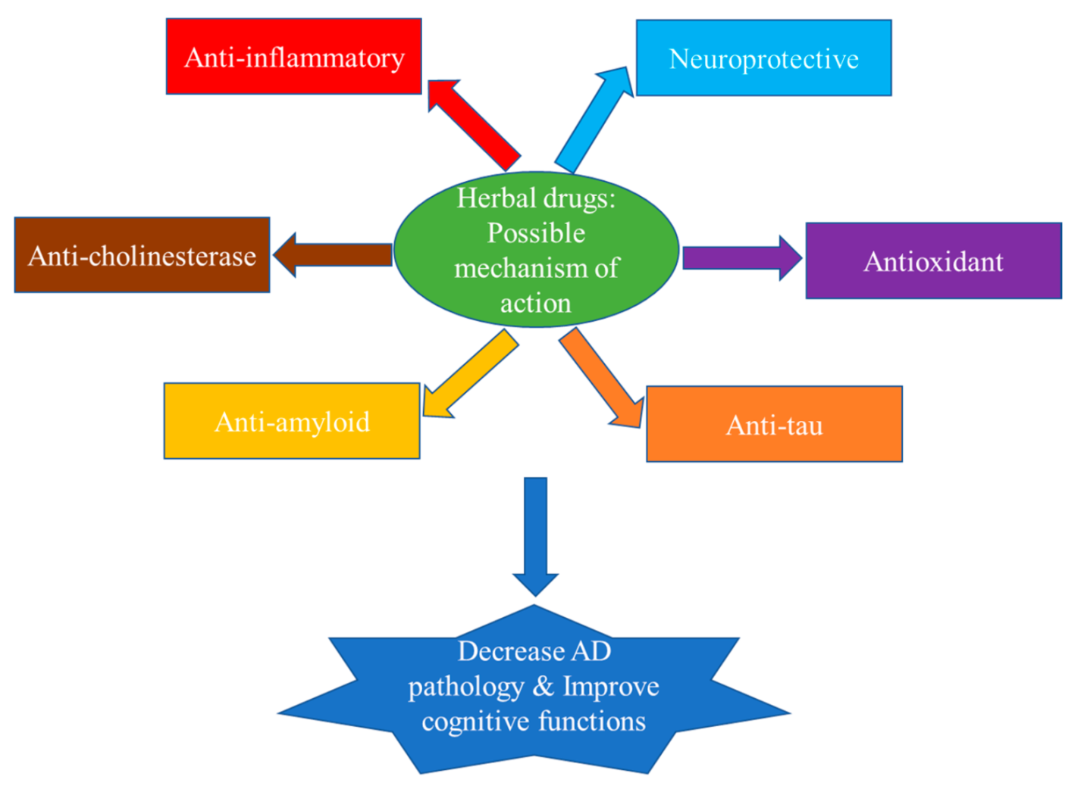

CHAPTER 4
TESTING AND IMPLEMENTATION

  - TESTING
Implementation is the stage of the project when the theoretical design is turned into a working system. This is the final and important phase in the system life cycle It is actually the process of converting the new system into a operational one.

4.1.1Unit Testing
Unit testing comprises the set of tests performed by an individual programmer prior to integration of the unit into a larger system. The module interface is tested to ensure that information properly flows into and out of the program unit. The local data structure is examined to ensure that data stored temporarily maintains its integrity during all steps in an algorithm’s execution. Boundary conditions are tested to ensure that the module operates properly at boundaries established to limit or restrict processing. All independent paths through the control structure are tested. All error-handling paths are tested.

4.1.2 Block Box Testing
Black-box testing is a method of software testing that examines the functionality of an application without peering into its internal structures or workings. This method of test can be applied virtually to every level of software testing: unit, integration, system and acceptance. It is sometimes referred to as specification-based testing.

4.2 SYSTEM IMPLEMENTATION
Implementation is the stage of the project when the theoretical design is turned into a working system. This is the final and important phase in the system life cycle It is actually the process of converting the new system into a operational one.

CHAPTER 5
CONCLUSION:
Older adults are more likely to encounter potential problems with the use of herbs in conjunction to conventional drug therapies. Worldwide standardization of herbal medicines and adequate clinical trials are necessary to understand the potential benefits and risks of these products. Supporters of western medicine and traditional medicine should work together to incorporate best practices verified by sound scientific methods.

