Pharmacy Management System in PHP + MySQL

ABSTRACT
Pharmacy management system is one of the most essential tools that are mostly used in medical store in Tanzania; it is mostly used to manage pharmacy related activities such as medical inventory, record keeping, sales management as well as managing the drug stock and information of the expired medicines. Many pharmacies in Tanzania are still operating manually; they don’t have adequate software to manage their daily activities. It needs the pharmacist assistant to check the expired date of the medicine twice a week, and it can take a lot of time to find out whether certain medicine are out of stock. In this project we tried to develop a computerised and web based Pharmacy management system. Our main intention is to allow this application to be used in most retailing pharmacies in Tanzania, where a small point of customization will be required to each pharmacy in the implementation period. This system is designed to overcome all challenges related to the management of medicine that were used to be handled locally and manually. Pharmacy management system has its own significance to the retail pharmacy shops in Tanzania. Using this system, it will help us to records all transaction made at the daily sales, recognise all debtors, customers, employees, balance stock, etc. It will manage all activities around the shop that increases productivity and maximize profit, it will also minimizing the risk of getting loss because all transactions are recorded to the system.
CHAPTER 2
2. SYSTEM ANALYSIS
  - EXISTING SYSTEM

- The person who has access to this part of the system can insert new medicine, update existed one and check the medicines quantities.
- We insert new medicine, update an existed one and check the medicines quantities.
- The database built using SQL Server contains the pharmacy information related to the medicines, patient information….etc. the GUI frames ease the use of the proposed system by unskilled users.
- A Pharmacology is the branch of biology deals with the properties of chemicals and interests with the study of use, action, side effect of drug.
2.1.1 DRAWBACKS OF EXISTING SYSTEM :
- It is the process of identifying problems, opportunities, and objectives.
- This phase required the analysts to look honestly at what is occurring in a business. Then, together with other organizational members, the analyst pinpoints problems.
- The analyst was able able to see whether some aspect of information systems applications can help the business reach its objectives by addressing specific problems or opportunities.
- The output of this phase is a feasibility report containing a problem definition and summarizing the objectives.
- It is a process of collecting factual data, understand the processes involved, identifying problems and recommending feasible suggestions for improving the system functioning.
2.2. PROPOSED SYSTEM
- In this paper, a hospital e-pharmacy system is proposed in order to facilitate the job, outdo the mentioned problems.
- The proposed system is equipped with alarm that alerts the admin about all medicines which are reached the minimum quantity and medicines that expired.
- The proposed system managing as most as possible the whole job of hospital pharmacy.
- The GUI frames are used for controlling the work of the proposed system, while the database is for saving the related information.
- The proposed system was tested in terms of registration function by entering new records for inpatient and outpatient, release and update function.

2.2.1. ADVANTAGES OF PROPOSED SYSTEM
- Improving performance and efficiency in pharmacy shops is a major goal of Pharmacy Management System.
- The overall objective of this project is to establish a System for pharmacy shops so as to improve the performance and efficiency of pharmacy shops management.
- If a major change to a system has been needed, a new project was being sated to carry out the change.
- Pharmacy management system is designed to improve the accuracy, enhance safety and efficiency in the pharmaceutical store.
- Pharmacy management System is a very effective tool for an organization to be efficient in business management.
2.3 FEASIBILITY STUDY
The feasibility Analysis is an analytical program through project manager determines the project success ratio and through feasibility study project manager able to see either project. The key considerations involved in the feasibility analysis are:
- Economic Feasibility
- Technical Feasibility
- Operational Feasibility
- Environmental Feasibility
2.3.1 ECONOMICAL FEASIBILITY
Hence this project is economically feasible there is no need to involve any cost for this project.
2.3.2 TECHNICAL FEASIBILITY
Software Technologies used are PHP and MySql. In the educational institutions, it is possible to update the system in future. No special hardware is required for the purpose of using this system. Hence it is declared that this project is technically feasible.
2.3.3 OPERATIONAL FEASIBILITY
As the admin work mainly to maintain the Patient and Doctor .Doctor will predict patient cancer disease. Hence it is easy to operate with training. Therefore it is operationally feasible for implementation.
2.3.4 ENVIRONMENTAL FEASIBILITY
This project environment is correct as a admin has developed this system and no expenditure is involved under any head and this process is part of admin document management, this project environment is accessible.
2.4 SYSTEM REQUIREMENTS
- System : Pentium IV 2.4 GHz.
- Hard Disk : 40 GB.
- Monitor : 15 inch VGA Color.
- Mouse : Logitech Mouse.
- Ram : 512 MB
- Keyboard : Standard Keyboard

2.4.1 HARDWARE REQUIREMENTS
The Hardware of the computer consists of physical component such as Input Devices, Storage Devices, Processing & Control units and Output Devices. Computer includes external storage unit to store data in programs.
The Hardware Configuration involved in this project
- System : Pentium IV 2.4 GHz.
- Hard Disk : 40 GB.
- Monitor : 15 inch VGA Color.
- Mouse : Logitech Mouse.
- Ram : 512 MB
- Keyboard : Standard Keyboard

2.4.2 SOFTWARE REQUIREMENTS
Software is a group of programs that computers need to do a particular task. It is an essential requirement of Computer System. The Software used to develop the project is
- Operating System : Windows XP.
- Platform : DOT NET TECHNOLOGY
- Front End : ASP.Net 3.5
- Back End : SQL SERVER 2005

CHAPTER 3
SYSTEM DESIGN AND DEVELOPEMENT
SYSTEM ARCHICTURE

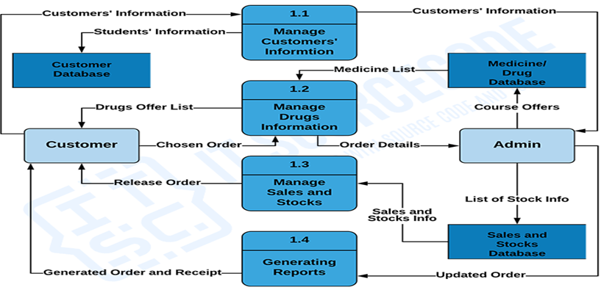

CHAPTER 4
TESTING AND IMPLEMENTATION

  - TESTING
Implementation is the stage of the project when the theoretical design is turned into a working system. This is the final and important phase in the system life cycle It is actually the process of converting the new system into a operational one.

4.1.1Unit Testing
Unit testing comprises the set of tests performed by an individual programmer prior to integration of the unit into a larger system. The module interface is tested to ensure that information properly flows into and out of the program unit. The local data structure is examined to ensure that data stored temporarily maintains its integrity during all steps in an algorithm’s execution. Boundary conditions are tested to ensure that the module operates properly at boundaries established to limit or restrict processing. All independent paths through the control structure are tested. All error-handling paths are tested.

4.1.2 Block Box Testing
Black-box testing is a method of software testing that examines the functionality of an application without peering into its internal structures or workings. This method of test can be applied virtually to every level of software testing: unit, integration, system and acceptance. It is sometimes referred to as specification-based testing.

4.2 SYSTEM IMPLEMENTATION
Implementation is the stage of the project when the theoretical design is turned into a working system. This is the final and important phase in the system life cycle It is actually the process of converting the new system into a operational one.

CHAPTER 5
CONCLUSION:
Today management is one of the most essential features of all form. Management provides sophistication to perform any kind of task in a particular form. This is pharmacy management system; it is used to manage most pharmacy related activities in the pharmacy. The primary aim of is to improve accuracy and enhance safety and efficiency in the pharmaceutical store. In this project we can also include BAR CODE facility using the bar code reader, which will detect the expiry date and the other information about the related medicines. We may also concluded that by using pharmacy software, processing both new prescriptions and refills can be done quickly and simply with just a few keystrokes or mouse clicks with new, easy to learn and use Graphical User Interface (GUI) pharmacy management solution. That due to automation where the pharmacist does his or her work much faster, a switch from product oriented to patient oriented which is one of the most important keys in pharmaceutical care. In other words that the pharmacist will have more time in counseling his/her customers, where the goal of patient counseling is one of the important solution to avoid medication error.

CHAPTER-6
REFERENCE
- [1]Library Learning http://www.usg.edu/galileo/skills/unit04/primer04_01 .phtml
- [2] Search sql server http://searchsqlserver.techtarget.com/definition/datab ase-management-system
- [3] Library Learning http://www.usg.edu/galileo/skills/unit04/primer04_01 .phtml
- [4] merriam-webster http://www.merriamwebster.com/dictionary/database
- [5] Everything http://everything.explained.today/Entity%E2%80%93 relationship_ model

