Jewellery Shopping PHP Project

ABSTRACT
Jewellery shops sells various types of Jewellery items and it is very difficult to categorize these items on the basis of their manufacturing dates, type of gold used to manufacture it such as either using 24K or 22K. Which items comes under the category of ISI Gold Mark and which items are of local brand. It is also very difficult to analyze the overall transaction for a particular period of time and which ornaments are not available in the shop. To solve these problems this system has been developed. This system will follow the steps and rules to meet user requirements on demand and on time. Apart from this it will remove the difficulties faced by the admin to manage their shop and can be easily handled by the admin without any technical knowledge of the platform used and about the system. Through this system employees working under a particular shop can be easily managed and overall transactions of particular date and time can easily be viewed. The current system does not provide the method to back up the database which is very important for any business transactions. Current system provides the details of overall business transactions but they do not provide information on sells/purchase in and sells/purchase out.

CHAPTER 2
2. SYSTEM ANALYSIS
  - EXISTING SYSTEM

- At present all the activities in transaction are handled manually. Manual data processing system, whole providing economy, flexibility and adaptability at low data volumes become more complex when the volume of data becomes large.
- As an organization expands in size and function, a stage is reached when manual procedures become inadequate and inefficient.
- No matter how many clerks are employed a stage is reached then it becomes impossible to systemize such a large amount of information. What is required then is an upgrading in the class of information processing technology.
- The present system is not sufficient to hold all the information that is necessary for the processing. So the library is in need of new computerized system, which is very flexible, user-friendly and capable of holding the system in a robust manner.
2.1.1 DRAWBACKS OF EXISTING SYSTEM :
- Physical volume of the data is very large.
- The delay in information search and retrieval.
- Problems in updating and backup.
- Damage of papers containing the information.
- Considerable time taken for report generation.
- Accuracy of data is very lower in manual system.
2.2. PROPOSED SYSTEM
- The system study phase studies the problem, identifies alternate solution, evaluates these solutions and finally recommends best solution.
- The system gives the structure and function of the system.
- A detailed system study is essential for developing an efficient system.
- The proposed system provides a better user interface. The system is a menu driven program.
2.2.1. ADVANTAGES OF PROPOSED SYSTEM
- It may be used as mini project in subsystem.
- Give a original view on all activities performed in the shop.
- Maintains the historical records on all transactions.
- Flexible project you can edit its code very easily.
- Ready to download.
- No need of deeply coding,only some basic php and html coding is needed to understand the project,even a beginner can understand it very soon.
- Error free project.
- No any doubt of misleading information of business.
- No any cost to pay in downloading the project,just you have to click on download button and it will be start in few seconds.
2.3 FEASIBILITY STUDY
The feasibility Analysis is an analytical program through project manager determines the project success ratio and through feasibility study project manager able to see either project. The key considerations involved in the feasibility analysis are:
- Economic Feasibility
- Technical Feasibility
- Operational Feasibility
- Environmental Feasibility
2.3.1 ECONOMICAL FEASIBILITY
Hence this project is economically feasible there is no need to involve any cost for this project.
2.3.2 TECHNICAL FEASIBILITY
Software Technologies used are PHP and MySql. In the educational institutions, it is possible to update the system in future. No special hardware is required for the purpose of using this system. Hence it is declared that this project is technically feasible.
2.3.3 OPERATIONAL FEASIBILITY
As the admin work mainly to maintain the Patient and Doctor .Doctor will predict patient cancer disease. Hence it is easy to operate with training. Therefore it is operationally feasible for implementation.

2.3.4 ENVIRONMENTAL FEASIBILITY
This project environment is correct as a admin has developed this system and no expenditure is involved under any head and this process is part of admin document management, this project environment is accessible.
2.4 SYSTEM REQUIREMENTS
- System : Pentium IV 2.4 GHz.
- Hard Disk : 40 GB.
- Monitor : 15 inch VGA Color.
- Mouse : Logitech Mouse.
- Ram : 512 MB
- Keyboard : Standard Keyboard

2.4.1 HARDWARE REQUIREMENTS
The Hardware of the computer consists of physical component such as Input Devices, Storage Devices, Processing & Control units and Output Devices. Computer includes external storage unit to store data in programs.
The Hardware Configuration involved in this project
- System : Pentium IV 2.4 GHz.
- Hard Disk : 40 GB.
- Monitor : 15 inch VGA Color.
- Mouse : Logitech Mouse.
- Ram : 512 MB
- Keyboard : Standard Keyboard

2.4.2 SOFTWARE REQUIREMENTS
Software is a group of programs that computers need to do a particular task. It is an essential requirement of Computer System. The Software used to develop the project is
- Operating System : Windows XP.
- Platform : DOT NET TECHNOLOGY
- Front End : ASP.Net 3.5
- Back End : SQL SERVER 2005

CHAPTER 3
SYSTEM DESIGN AND DEVELOPEMENT
SYSTEM ARCHICTURE

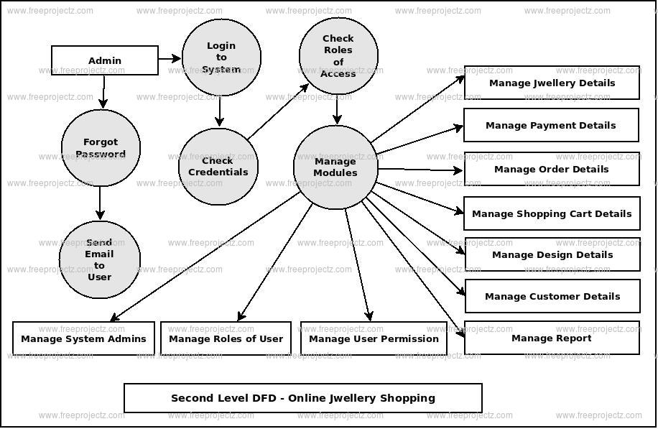

CHAPTER 4
TESTING AND IMPLEMENTATION

  - TESTING
Implementation is the stage of the project when the theoretical design is turned into a working system. This is the final and important phase in the system life cycle It is actually the process of converting the new system into a operational one.

4.1.1Unit Testing
Unit testing comprises the set of tests performed by an individual programmer prior to integration of the unit into a larger system. The module interface is tested to ensure that information properly flows into and out of the program unit. The local data structure is examined to ensure that data stored temporarily maintains its integrity during all steps in an algorithm’s execution. Boundary conditions are tested to ensure that the module operates properly at boundaries established to limit or restrict processing. All independent paths through the control structure are tested. All error-handling paths are tested.

4.1.2 Block Box Testing
Black-box testing is a method of software testing that examines the functionality of an application without peering into its internal structures or workings. This method of test can be applied virtually to every level of software testing: unit, integration, system and acceptance. It is sometimes referred to as specification-based testing.

4.2 SYSTEM IMPLEMENTATION
Implementation is the stage of the project when the theoretical design is turned into a working system. This is the final and important phase in the system life cycle It is actually the process of converting the new system into a operational one.

CHAPTER 5
CONCLUSION:
This system has been developed to satisfy all the proposed requirements. The process of recording details about supplier, item, Billing and customers is more simple and easy. The system reduces the possibility of errors to a great extent and maintains the data in an efficient manner. User friendliness is the unique feature of this system. The system generates the reports as and when required. The system is highly interactive and flexible for further enhancement.The coding is done in a simplified and easy to understandable manner so that other team trying to enhance the project can do so without facing much difficulty. The documentation will also assist in the process as it has also been carried out in a simplified and concise way.

