Online Election System A Proposed System for Pakistan

ABSTRACT
The Election Schedule for the conduct of General Elections as well as for the by-elections, as the case may be, is decided by the Chief Election Commissioner in Pakistan. The current system is being operated manually. Votes are polled manually. All the record of voters, candidates, polling stations, regions detail and parties’ information are stored manually. Results are calculated manually. All records are stored in registers and files. There is a big problem for election commission to manage the records. Our proposed cost effective Online Voting system will replace the manual record keeping system of voters, candidates; duty staff by polling the votes by a computerize system, which will reduce the chances of error occurrence, while counting, minimize time being consumed during counting, increase security of votes being polled. No chances of vote’s rejection and easy management of records.

CHAPTER 2
2. SYSTEM ANALYSIS
  - EXISTING SYSTEM

- A huge number of ballot papers are printed and distributed on polling stations and this cost billions; not acceptable for a developing state like Pakistan.
- Many of the votes are not counted due to slight mistake by the voter, e.g. Voter left Thumb impression in between two check boxes etc.
- Presiding Officers count the ballot papers, but human counting is usually sluggish and has chances of error as well; which means an ultimate disaster ahead in the process of Democracy.
- Increasing number of polling booths raises the number of staff required. Polling staff is appointed away from the area where they belong to, thus many of the people could not cast their vote.
2.1.1 DRAWBACKS OF EXISTING SYSTEM :
- Digging deep into the problem the root cause is the ill mannered activities people do in the elections.
- Breaking down the problems more deeply into the security concerns we found that the present day system being followed by the Government of Pakistan is not secure and hence people can misuse the facilities.
- We limit our research to social and technical aspects of the problems in the problem discussion.
- Along with these issues one the main emergence of e – government is e – democracy specifically eVoting.
2.2. PROPOSED SYSTEM
- System will replace the manual record keeping system by computerize system. System will reduce the chances of error occurrence, while calculation.
- System will minimize time being consumed. System will increase security of votes.
- System will not allow chance of rejection of vote. System will do easy management of records.
- System wills easy searching of desire record.
- System will do online polling.
- To know easily whether the voter is registered or not. High and reliable security can be achieved.
2.2.1. ADVANTAGES OF PROPOSED SYSTEM
- E-voting combines technology with the democratic process, in order to make voting more efficient and convenient for voters.
- Time is very important factor for measuring the efficiency of the system.
- This form of design would be very helpful to the system developers and would help in engineering the system in a consistent and efficient manner.
- How to secure eVoting; may it be electronics machines being used at polling stations, or getting citizen cast their votes through specifically driven websites for the sake of election.
- With respect to industry standards, structured as well as object oriented approach was used to capture the system requirements and design.
Literature Survey:
TITLE | AUTHORS | DESCRIPTION
E-government Around the World | Swartz N. 2004. | The article delves into six best practice cases for e-governance and analyzes world-wide growth trends.
what is e-Government | R. Silcock, | Government is an institution that meets some of society’s most critical needs and any/every member,of the society sometime or other has to interact with the government.

2.3 FEASIBILITY STUDY
The feasibility Analysis is an analytical program through project manager determines the project success ratio and through feasibility study project manager able to see either project. The key considerations involved in the feasibility analysis are:
- Economic Feasibility
- Technical Feasibility
- Operational Feasibility
- Environmental Feasibility
2.3.1 ECONOMICAL FEASIBILITY
Hence this project is economically feasible there is no need to involve any cost for this project.
2.3.2 TECHNICAL FEASIBILITY
Software Technologies used are PHP and MySql. In the educational institutions, it is possible to update the system in future. No special hardware is required for the purpose of using this system. Hence it is declared that this project is technically feasible.
2.3.3 OPERATIONAL FEASIBILITY
As the admin work mainly to maintain the Patient and Doctor .Doctor will predict patient cancer disease. Hence it is easy to operate with training. Therefore it is operationally feasible for implementation.
2.3.4 ENVIRONMENTAL FEASIBILITY
This project environment is correct as a admin has developed this system and no expenditure is involved under any head and this process is part of admin document management, this project environment is accessible.

2.4 SYSTEM REQUIREMENTS
- System : Pentium IV 2.4 GHz.
- Hard Disk : 40 GB.
- Monitor : 15 inch VGA Color.
- Mouse : Logitech Mouse.
- Ram : 512 MB
- Keyboard : Standard Keyboard

2.4.1 HARDWARE REQUIREMENTS
The Hardware of the computer consists of physical component such as Input Devices, Storage Devices, Processing & Control units and Output Devices. Computer includes external storage unit to store data in programs.
The Hardware Configuration involved in this project
- System : Pentium IV 2.4 GHz.
- Hard Disk : 40 GB.
- Monitor : 15 inch VGA Color.
- Mouse : Logitech Mouse.
- Ram : 512 MB
- Keyboard : Standard Keyboard

2.4.2 SOFTWARE REQUIREMENTS
Software is a group of programs that computers need to do a particular task. It is an essential requirement of Computer System. The Software used to develop the project is
- Operating System : Windows XP.
- Platform : DOT NET TECHNOLOGY
- Front End : ASP.Net 3.5
- Back End : SQL SERVER 2005

CHAPTER 3
SYSTEM DESIGN AND DEVELOPEMENT
SYSTEM ARCHICTURE

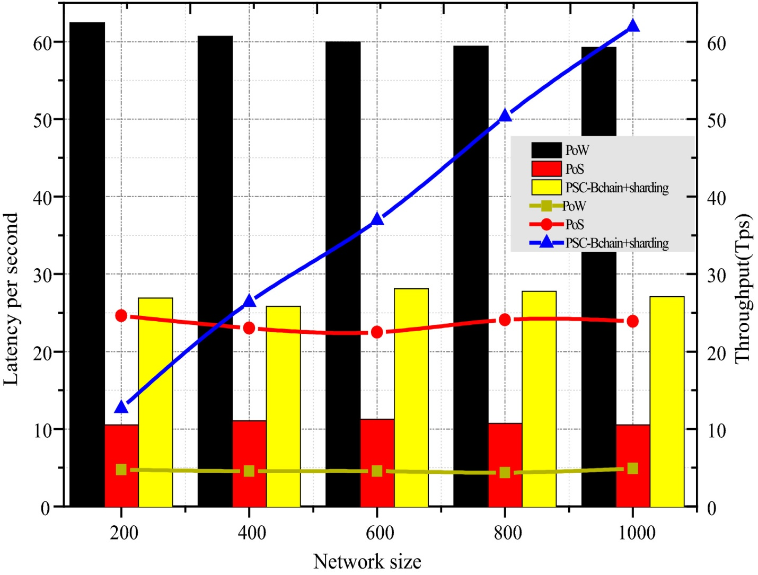

CHAPTER 4
TESTING AND IMPLEMENTATION

  - TESTING
Implementation is the stage of the project when the theoretical design is turned into a working system. This is the final and important phase in the system life cycle It is actually the process of converting the new system into a operational one.

4.1.1Unit Testing
Unit testing comprises the set of tests performed by an individual programmer prior to integration of the unit into a larger system. The module interface is tested to ensure that information properly flows into and out of the program unit. The local data structure is examined to ensure that data stored temporarily maintains its integrity during all steps in an algorithm’s execution. Boundary conditions are tested to ensure that the module operates properly at boundaries established to limit or restrict processing. All independent paths through the control structure are tested. All error-handling paths are tested.

4.1.2 Block Box Testing
Black-box testing is a method of software testing that examines the functionality of an application without peering into its internal structures or workings. This method of test can be applied virtually to every level of software testing: unit, integration, system and acceptance. It is sometimes referred to as specification-based testing.

4.2 SYSTEM IMPLEMENTATION
Implementation is the stage of the project when the theoretical design is turned into a working system. This is the final and important phase in the system life cycle It is actually the process of converting the new system into a operational one.

CHAPTER 5
CONCLUSION:
When we see today’s world, e – government has played an enormous role in the advancement of the services provided by the government worldwide. Today each and every country is giving e – governance a go. There are different levels of implementation of the e – governance worldwide but it is more of interest to find out this in developing countries. Pakistan is one of the emerging countries in the world which is trying to make a difference in the developed world and is implementing e – government at an enormous rate. This system of voting will certainly increase the turn out, security and result compilation much easy for the polling staff and the election commission.

CHAPTER-6
REFERENCE
- 1. Swartz N. 2004.”E-government Around the World”. Information Management Journal, 38(1):12.
- 2. Electronic Government Directorate, News and Projects undergoing http://e-governmnet.gov.pk
- 3. BBC Controversy mars Pakistan poll http://news.bbc.co.uk/1/hi/world/south_asia/1962942. stm
- 4. R. Silcock, what is e-Government http://pa.oxfordjournals.org/cgi/reprint/54/1/88?ijkey =ef28bcf065b9aeb96a17dc33edb7bdb2b2bc129d
- 5. Definition of e-democracy http://en.wikipedia.org/wiki/EDemocracy
- 6. Dr. Subhash Kapila Consultant, strategic Affairs with South Asia Analysis Group http://www.saag.org/papers22/papers3132.html
- 7. Int.Crisis Group Pakistan’s Local Polls: Shoring Up Military Rule http://crisisgroup.org/home/index.cfm?id=3799&1=1
- 8. Int. Crisis Group Authoritarianism and Political Party Reform in Pakistan http://crisisgroup.org/home/index.cfm?id=3704
- 9. Freedom House Country Report- Pakistan http://freedomhouse.org
- 10. Daily Times, MMA leadership was “involved in horse-trading” http://www.dailytimes.com.pk/default.asp?page=200 6%5C03%5C31%5Cstory_31-3-2006_pg3_5

