Sales management system

ABSTRACT
Sales management is a key function which helps small and medium size enterprises (SMEs) in monitoring and tracking stock and co-ordinating transaction processing. The efficiency of sales management dependends on effective tools and facilities, especially mordern information and communication technologies. Despite this, majority of businesses in developing countries, especially those in remote areas do not take full advantage of these technologies due to challenges related to the design of these technologies. This paper presents the design and development of a tailor-made computerized sales management system for SMEs in Northern Ghana.The object-oriented methodology is employed with UML, VB.NET and Microsoft Access Database for the design and development of the system which is flexible and tailor-made for SMEs in the region.

CHAPTER 2
2. SYSTEM ANALYSIS
  - EXISTING SYSTEM

- Existing inventory management also does not provide any means in detecting expired date for food based products such as milk, bread, flour and etc.
- Basic information about existing Sales and Inventory System and how to develop inventory tracking system in general.
- When first dealing with industrial projects, it was decided to use the existing guidelines for discounts because other activities, such as planning, were relying on it.
- The research showed that it is difficult to change all dimensions at once and therefore only Sales Force Management and Sales Planning & Steering are optimised.
2.1.1 DRAWBACKS OF EXISTING SYSTEM :
- It is important that the wide spread of information and communication technologies (ICT) should enable every willing business to find an appropriate solution to its particular problems among the various solutions provided.
- While a few of the SMEs find the existing sales management systems (SMS) to be problem-free and a key to their continuous growth, most of them quit using these systems after a while for various reasons.
- While some businesses have had their problems solved by using computerized systems, others have to bear high cost if they wish to meet their sales target with the systems they wish to or are currently implementing.
2.2. PROPOSED SYSTEM
- The design of the appropriate Sales Planning & Steering system is one of the core elements of the proposed Sales Management System.
- The proposed methodology for data collection resulted in a large amount of data, as with most qualitative approaches.
- The optimal price setting approach is aligned with the proposed incentive system and thus uses the contribution margin in project and the discount on the list price in standard business as steering parameters.
- It is unreasonable to suspect no problems with the Sales Management System after implementing the proposed measures, because not all areas are optimised.
2.2.1. ADVANTAGES OF PROPOSED SYSTEM
- Based on these requirements and the generalised prerequisites of the case company, a Sales Management framework was created, including an incentive system suggestion, a price setting approach and eleven key performance indicators (KPIs).
- However, the bigger the price decisions become, the more important it is to focus on the overall company performance, an area where top management has more knowledge.
- This leads to a wrong or at least inconsistent picture of reality because performance in sales is measured based on the discount ratio.
- The findings from the study are not yet implemented in a practical situation, and it would be interesting to evaluate their acceptance and effect on sales performance, for example, using action research.
Literature Survey:
TITLE | AUTHORS | DESCRIPTION
The Policy Environment for Promoting Small and Medium-Sized Enterprises in Ghana and Malawi | D. Kayanula and P. Quartey, | The dynamic role of small and medium scale enterprises(SMEs) in developing countries have been highly emphasised.
Sales and Sales Management | R. D. Hisrich and R. W. Jackson, | The incontrovertibly interlinked relationship between selling and sales management is then explained and the notion of more sophisticated marketing thought is described as having its roots in sales.
A student Guide To Object-Oriented Development | J. Carol & Doake Britton, | A Student Guide to Object-Oriented Development is an introductory text that follows the software development process, from requirements capture to implementation, using an object-oriented approach.
Sales Management | R. K. Srivastava, E. C. DeRun, and K. S. Fam, | In field sales management, the structure consists of the unit manager, district manager, regional manager, general manager and vice president of sales.

2.3 FEASIBILITY STUDY
The feasibility Analysis is an analytical program through project manager determines the project success ratio and through feasibility study project manager able to see either project. The key considerations involved in the feasibility analysis are:
- Economic Feasibility
- Technical Feasibility
- Operational Feasibility
- Environmental Feasibility
2.3.1 ECONOMICAL FEASIBILITY
Hence this project is economically feasible there is no need to involve any cost for this project.
2.3.2 TECHNICAL FEASIBILITY
Software Technologies used are PHP and MySql. In the educational institutions, it is possible to update the system in future. No special hardware is required for the purpose of using this system. Hence it is declared that this project is technically feasible.
2.3.3 OPERATIONAL FEASIBILITY
As the admin work mainly to maintain the Patient and Doctor .Doctor will predict patient cancer disease. Hence it is easy to operate with training. Therefore it is operationally feasible for implementation.
2.3.4 ENVIRONMENTAL FEASIBILITY
This project environment is correct as a admin has developed this system and no expenditure is involved under any head and this process is part of admin document management, this project environment is accessible.

2.4 SYSTEM REQUIREMENTS
- System : Pentium IV 2.4 GHz.
- Hard Disk : 40 GB.
- Monitor : 15 inch VGA Color.
- Mouse : Logitech Mouse.
- Ram : 512 MB
- Keyboard : Standard Keyboard

2.4.1 HARDWARE REQUIREMENTS
The Hardware of the computer consists of physical component such as Input Devices, Storage Devices, Processing & Control units and Output Devices. Computer includes external storage unit to store data in programs.
The Hardware Configuration involved in this project
- System : Pentium IV 2.4 GHz.
- Hard Disk : 40 GB.
- Monitor : 15 inch VGA Color.
- Mouse : Logitech Mouse.
- Ram : 512 MB
- Keyboard : Standard Keyboard

2.4.2 SOFTWARE REQUIREMENTS
Software is a group of programs that computers need to do a particular task. It is an essential requirement of Computer System. The Software used to develop the project is
- Operating System : Windows XP.
- Platform : DOT NET TECHNOLOGY
- Front End : ASP.Net 3.5
- Back End : SQL SERVER 2005

CHAPTER 3
SYSTEM DESIGN AND DEVELOPEMENT
SYSTEM ARCHICTURE

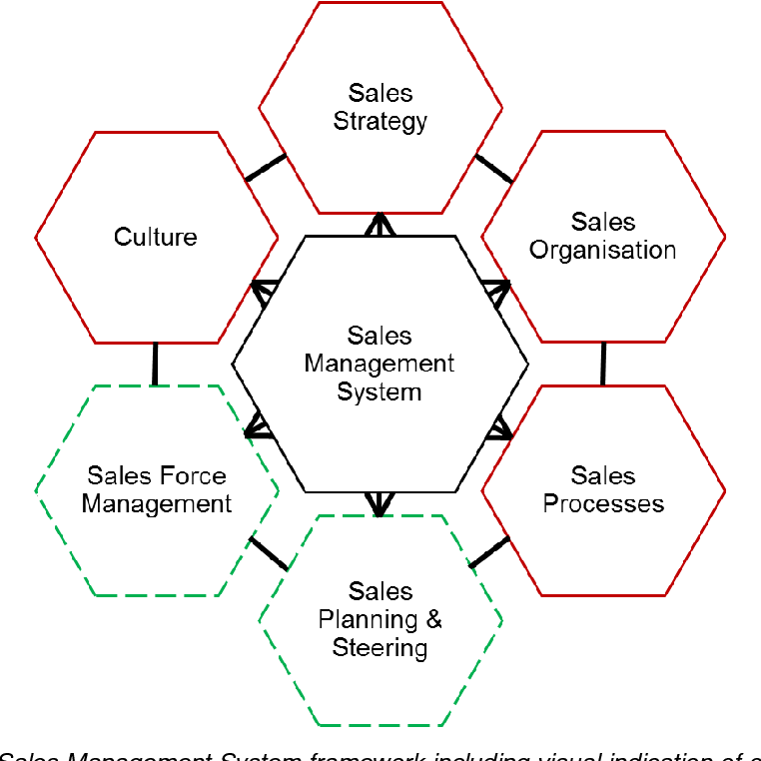

CHAPTER 4
TESTING AND IMPLEMENTATION

  - TESTING
Implementation is the stage of the project when the theoretical design is turned into a working system. This is the final and important phase in the system life cycle It is actually the process of converting the new system into a operational one.

4.1.1Unit Testing
Unit testing comprises the set of tests performed by an individual programmer prior to integration of the unit into a larger system. The module interface is tested to ensure that information properly flows into and out of the program unit. The local data structure is examined to ensure that data stored temporarily maintains its integrity during all steps in an algorithm’s execution. Boundary conditions are tested to ensure that the module operates properly at boundaries established to limit or restrict processing. All independent paths through the control structure are tested. All error-handling paths are tested.

4.1.2 Block Box Testing
Black-box testing is a method of software testing that examines the functionality of an application without peering into its internal structures or workings. This method of test can be applied virtually to every level of software testing: unit, integration, system and acceptance. It is sometimes referred to as specification-based testing.

4.2 SYSTEM IMPLEMENTATION
Implementation is the stage of the project when the theoretical design is turned into a working system. This is the final and important phase in the system life cycle It is actually the process of converting the new system into a operational one.

CHAPTER 5
CONCLUSION:
The success of any system is dependent on its usage. It is therefore hoped that the system will be used under conditions that satisfy its requirements. Given the required maintenance, the system will help facilitate sales management by tracking and storing relevant data needed for effective sales management.

CHAPTER-6
REFERENCE
- [1] D. Kayanula and P. Quartey, “The Policy Environment for Promoting Small and Medium-Sized Enterprises in Ghana and Malawi,” Manchester, UK: Institute for Development Policy and Management, University of Manchester., 2000.
- [2] NBSSI, Supporting Micro & Small Scale Enterprises, A Handbook on Enterprise Development Part 1. NBSSI, Print Solutions, Accra, 1990.
- [3] R. K. Srivastava, E. C. DeRun, and K. S. Fam, Sales Management. Anurag jain for excel books, New Delhi 110028, 2008.
- [4] “American Marketing Association Dictionary Available: https://www.ama.org/resources/Pages/Dictionary.aspx?dLetter=S.” .
- [5] R. D. Hisrich and R. W. Jackson, Sales and Sales Management. Barons Education Series, inc., New York 117782, 1993., 1993.
- [6] “Sales Management, IILM Institute of higher Education, available:www.iilm.edu/iim-onlinesales%20management%20Selflearning%20manual.pdf.” .
- [7] J. Carol & Doake Britton, A student Guide To Object-Oriented Development. Oxford: Elsevier, 2005.

