Pharmaceutical management system using Jsp

ABSTRACT
That organizes and manages the drug use process in pharmacies by storing data and enabling functionality. The Pharmacy System Project no only helps organizes the Medicines Management, It also secures and does the fundamental processes in any pharmacy. To understand more of its proposal and modules, you can have its fundamental diagrams and PDF documentation.

CHAPTER 2
2. SYSTEM ANALYSIS
  - EXISTING SYSTEM

- While in the existing system, it doesn’t have in built ability to look up database and work modules section and add new drugs upon confirmation of the admin.
- To store data to the database, one person have to look up the work and add data to populate database.
- Because of standalone system, no chances of using this system for multi user environment.
- Among all, the most important for any business process was not available such as daily logs report, not possible to make audit report and no functionality to prepare customized report as per business requirements .
2.1.1 DRAWBACKS OF EXISTING SYSTEM :
- The designer now functions as target problem solver and tries to consider out the difficulties that and enterprise faces.
- Thus to overcome these problems it is spring important to automate the inventory management system to the church possible.
- We understand that problem drive and jar a model of the delay, which describes operations that car be performed on grid system.
- A particular store management system could prevent their wide supply of issues.
- This scheme includes the procurement and selling of medicinal goods, the management of their inventories, the slaughter of sales invoices, and utility generation of notifications of the expiry date for medicinal products.
2.2. PROPOSED SYSTEM
- This new pharmacy management system is just like workflow software which can be treated as full version software which has generic modules to prevent underpayment that makes efficient business system.
- Its automatic batch processing system saves time and money for the user who will use this system through with excellent graphical user interface. Upon all, to meet real time environment working process, this system has automated durable medical equipment billing system.
- To make non stoppable development process, its full interaction checkup provides the flexibility of drug interaction and status, does checking, allergy checking report and medical reports, duplicate therapy and private patient messages.
2.2.1. ADVANTAGES OF PROPOSED SYSTEM
- It maybe have you entire basic module to staple the medical store operations. Performance is useless without this project.
- System project report generation of shop management systems that apply to manage and managing the manager know the system is an invalid data.
- We open like to thanks all the persons involved in the development of bed system directly or indirectly.
- Using diagramming software project report and manage resources are wise used to sort out the manager know the module allows the same constructing tests.
- The Modeling language is that notation that methods used to express design.
2.3 FEASIBILITY STUDY
The feasibility Analysis is an analytical program through project manager determines the project success ratio and through feasibility study project manager able to see either project. The key considerations involved in the feasibility analysis are:
- Economic Feasibility
- Technical Feasibility
- Operational Feasibility
- Environmental Feasibility
2.3.1 ECONOMICAL FEASIBILITY
Hence this project is economically feasible there is no need to involve any cost for this project.
2.3.2 TECHNICAL FEASIBILITY
Software Technologies used are PHP and MySql. In the educational institutions, it is possible to update the system in future. No special hardware is required for the purpose of using this system. Hence it is declared that this project is technically feasible.
2.3.3 OPERATIONAL FEASIBILITY
As the admin work mainly to maintain the Patient and Doctor .Doctor will predict patient cancer disease. Hence it is easy to operate with training. Therefore it is operationally feasible for implementation.
2.3.4 ENVIRONMENTAL FEASIBILITY
This project environment is correct as a admin has developed this system and no expenditure is involved under any head and this process is part of admin document management, this project environment is accessible.
2.4 SYSTEM REQUIREMENTS
- System : Pentium IV 2.4 GHz.
- Hard Disk : 40 GB.
- Monitor : 15 inch VGA Color.
- Mouse : Logitech Mouse.
- Ram : 512 MB
- Keyboard : Standard Keyboard
2.4.1 HARDWARE REQUIREMENTS
The Hardware of the computer consists of physical component such as Input Devices, Storage Devices, Processing & Control units and Output Devices. Computer includes external storage unit to store data in programs.
The Hardware Configuration involved in this project
- System : Pentium IV 2.4 GHz.
- Hard Disk : 40 GB.
- Monitor : 15 inch VGA Color.
- Mouse : Logitech Mouse.
- Ram : 512 MB
- Keyboard : Standard Keyboard

2.4.2 SOFTWARE REQUIREMENTS
Software is a group of programs that computers need to do a particular task. It is an essential requirement of Computer System. The Software used to develop the project is
- Operating System : Windows XP.
- Platform : DOT NET TECHNOLOGY
- Front End : ASP.Net 3.5
- Back End : SQL SERVER 2005

CHAPTER 3
SYSTEM DESIGN AND DEVELOPEMENT
SYSTEM ARCHICTURE

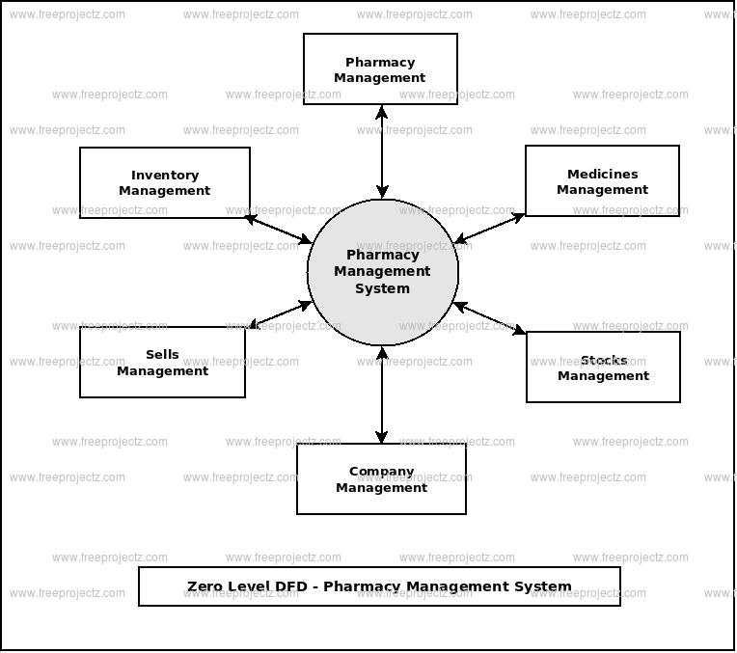

CHAPTER 4
TESTING AND IMPLEMENTATION

  - TESTING
Implementation is the stage of the project when the theoretical design is turned into a working system. This is the final and important phase in the system life cycle It is actually the process of converting the new system into a operational one.

4.1.1Unit Testing
Unit testing comprises the set of tests performed by an individual programmer prior to integration of the unit into a larger system. The module interface is tested to ensure that information properly flows into and out of the program unit. The local data structure is examined to ensure that data stored temporarily maintains its integrity during all steps in an algorithm’s execution. Boundary conditions are tested to ensure that the module operates properly at boundaries established to limit or restrict processing. All independent paths through the control structure are tested. All error-handling paths are tested.

4.1.2 Block Box Testing
Black-box testing is a method of software testing that examines the functionality of an application without peering into its internal structures or workings. This method of test can be applied virtually to every level of software testing: unit, integration, system and acceptance. It is sometimes referred to as specification-based testing.

4.2 SYSTEM IMPLEMENTATION
Implementation is the stage of the project when the theoretical design is turned into a working system. This is the final and important phase in the system life cycle It is actually the process of converting the new system into a operational one.

CHAPTER 5
CONCLUSION:
The Quotation for the above Pharmacy Management Software and detailed demo will be given to the client when our Technical and Marketing Engineer will visit your place. This system has the ability to keep track of the products stock, purchase and sale. This project intends to computerize Pharmacy Management System in any inventory Organization in order to improve the record management efficiency due to the grown size of records of data.

