Online library management system

ABSTRACT
The paper titled Library Management System is Library management software for monitoring and controlling the transactions in a library .The paper "Library Management System" is developed in java which mainly focuses on basic operations in a library like adding new member, new books, and updating new information, searching books and members and facility to borrow and return books. "Library Management System" is a windows application written for 32-bit Windows operating systems, designed to help users maintain and organize library. This software is easy to use for both beginners and advanced users.

CHAPTER 2
2. SYSTEM ANALYSIS
  - EXISTING SYSTEM

- System Analysis is a detailed study of the various operations performed by a system and their relationships within and outside of the system.
- Here the key question is- what all problems exist in the present system what must be done to solve the problem Analysis begins when a user or manager begins a study of the program using existing system.
2.1.1 DRAWBACKS OF EXISTING SYSTEM :
- In our existing system all the transaction of books are done manually, So taking more time for a transaction like borrowing a book or returning a book and also for searching of members and books.
- Another major disadvantage is that to preparing the list of books borrowed and the available books in the library will take more time, currently it is doing as a one day process for verifying all records.
- So after conducting the feasibility study we decided to make the manual Library management system to be computerized.
2.2. PROPOSED SYSTEM
- Proposed system is an automated Library Management System.
- Through our software user can add members, add books, search members, search books, update information, edit information, borrow and return books in quick time.
2.2.1. ADVANTAGES OF PROPOSED SYSTEM
- User friendly interface
- Fast access to database
- Less error
- More Storage Capacity
- Search facility
- Look and Feel Environment
2.3 FEASIBILITY STUDY
The feasibility Analysis is an analytical program through project manager determines the project success ratio and through feasibility study project manager able to see either project. The key considerations involved in the feasibility analysis are:
- Economic Feasibility
- Technical Feasibility
- Operational Feasibility
- Environmental Feasibility
2.3.1 ECONOMICAL FEASIBILITY
Hence this project is economically feasible there is no need to involve any cost for this project.

2.3.2 TECHNICAL FEASIBILITY
Software Technologies used are PHP and MySql. In the educational institutions, it is possible to update the system in future. No special hardware is required for the purpose of using this system. Hence it is declared that this project is technically feasible.
2.3.3 OPERATIONAL FEASIBILITY
As the admin work mainly to maintain the Patient and Doctor .Doctor will predict patient cancer disease. Hence it is easy to operate with training. Therefore it is operationally feasible for implementation.
2.3.4 ENVIRONMENTAL FEASIBILITY
This project environment is correct as a admin has developed this system and no expenditure is involved under any head and this process is part of admin document management, this project environment is accessible.
2.4 SYSTEM REQUIREMENTS
- System : Pentium IV 2.4 GHz.
- Hard Disk : 40 GB.
- Monitor : 15 inch VGA Color.
- Mouse : Logitech Mouse.
- Ram : 512 MB
- Keyboard : Standard Keyboard

2.4.1 HARDWARE REQUIREMENTS
The Hardware of the computer consists of physical component such as Input Devices, Storage Devices, Processing & Control units and Output Devices. Computer includes external storage unit to store data in programs.
The Hardware Configuration involved in this project
- System : Pentium IV 2.4 GHz.
- Hard Disk : 40 GB.
- Monitor : 15 inch VGA Color.
- Mouse : Logitech Mouse.
- Ram : 512 MB
- Keyboard : Standard Keyboard

2.4.2 SOFTWARE REQUIREMENTS
Software is a group of programs that computers need to do a particular task. It is an essential requirement of Computer System. The Software used to develop the project is
- Operating System : Windows XP.
- Platform : DOT NET TECHNOLOGY
- Front End : ASP.Net 3.5
- Back End : SQL SERVER 2005

CHAPTER 3
SYSTEM DESIGN AND DEVELOPEMENT
SYSTEM ARCHICTURE

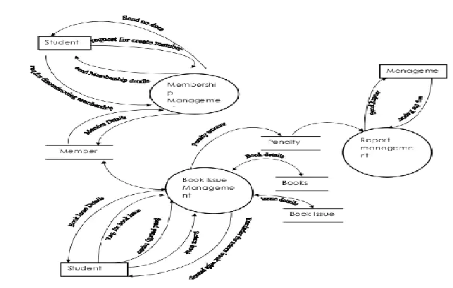

CHAPTER 4
TESTING AND IMPLEMENTATION

  - TESTING
Implementation is the stage of the project when the theoretical design is turned into a working system. This is the final and important phase in the system life cycle It is actually the process of converting the new system into a operational one.

4.1.1Unit Testing
Unit testing comprises the set of tests performed by an individual programmer prior to integration of the unit into a larger system. The module interface is tested to ensure that information properly flows into and out of the program unit. The local data structure is examined to ensure that data stored temporarily maintains its integrity during all steps in an algorithm’s execution. Boundary conditions are tested to ensure that the module operates properly at boundaries established to limit or restrict processing. All independent paths through the control structure are tested. All error-handling paths are tested.

4.1.2 Block Box Testing
Black-box testing is a method of software testing that examines the functionality of an application without peering into its internal structures or workings. This method of test can be applied virtually to every level of software testing: unit, integration, system and acceptance. It is sometimes referred to as specification-based testing.

4.2 SYSTEM IMPLEMENTATION
Implementation is the stage of the project when the theoretical design is turned into a working system. This is the final and important phase in the system life cycle It is actually the process of converting the new system into a operational one.

CHAPTER 5
CONCLUSION:
This paper is only a humble venture to satisfy the needs in a made within a limited time frame at the beginning of the software paper and should be updated regularly as the paper progresses requirements of the organization.

