SOLAR POWER HEAT REDUCTION EXHAUST SYSTEM FROM CAR

ABSTRACT
It takes times for an air-conditioner to effectively start cooling the passenger compartment in the car. So the passenger of the car will feel the heat in the car extremely before the air-conditioner fully cooling the interior of the car. Excessive heat can also damage an automobile's interior as well as personal property kept in the passenger compartment. So, a system to reduce this excessive heat by pumping out hot air and allowing cooler ambient air to enter the car by means of two micro fans was made. Also a cooling chamber was set up around the inlet fan to cool it a little further.

DRAWBACKS OF EXISTING SYSTEM :
- This led to the increase in harmful gases emission and increase in global warming and environmental problems.
ADVANTAGES OF PROPOSED SYSTEM
- A TEG is easy and very beneficial as it has some advantages like small in size, it has no vibrations, makes less or no noise while operating, it generally requires less or no maintenance.
- And major advantage is that it is using free thermal energy and converting into useful electrical energy.

BLOCK DIAGRAM:

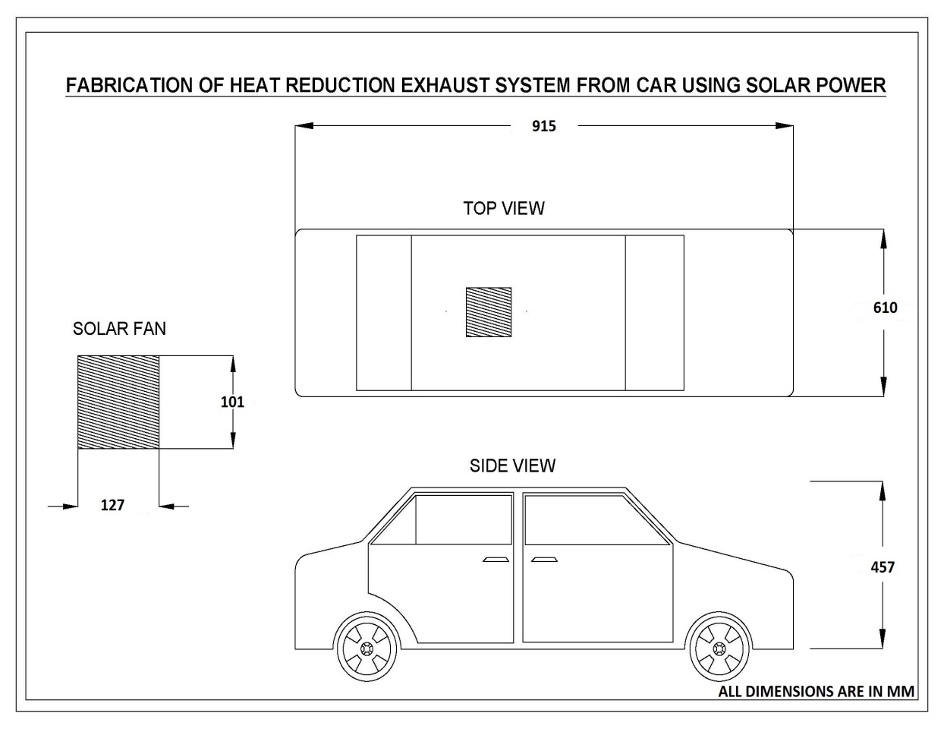

CONCLUSION:
A dynamic model of TEG is presented in this paper. Research has found an appropriate way of exhaust heat to convert into electricity and efficiency of the fuel in a vehicle can be improved. TEG is a promising technology for recovering waste heat of the vehicle exhaust as it is small in size, possess very less vibration and noise, requires very low maintenance and have a long life. Automobile industries are introducing TEG as next step for the contribution towards green earth. Performance of a TEG can be varied according to the change in vehicle speed, engine rpm and installation position. The average efficiency of a TEG IS 3 -4% and the maximum efficiency achieved is 5% in automobile field.

