FABRICATION OF THREE AXIS TRAILER

ABSTRACT
This project work titled “THREE AXIS TRAILER” has been conceived having studied the difficulty in unloading the materials. Our survey in the regard in several automobile garages, revealed the facts that mostly some difficult methods were adopted in unloading the materials from the trailer. The trailer will unload the material in only one single direction. It is difficult to unload the materials in small compact streets and small roads. In our project these are rectified to unload the trailer in all three sides very easily. Now the project has mainly concentrated on this difficulty, and hence a suitable arrangement has been designed. Such that the vehicles can be unloaded from the trailer in three axes without application of any impact force.

DRAWBACKS OF EXISTING SYSTEM :
- Hydraulic cylinder needs to be change periodically because it get wear as hydraulic have some disadvantages such as the seal.
ADVANTAGES OF PROPOSED SYSTEM
- Lifting cost will be less.
- Free from wear adjustment.
- Less power consumption
- Less skill technicians is sufficient to operate.
- Installation is simplified very much.

BLOCK DIAGRAM:

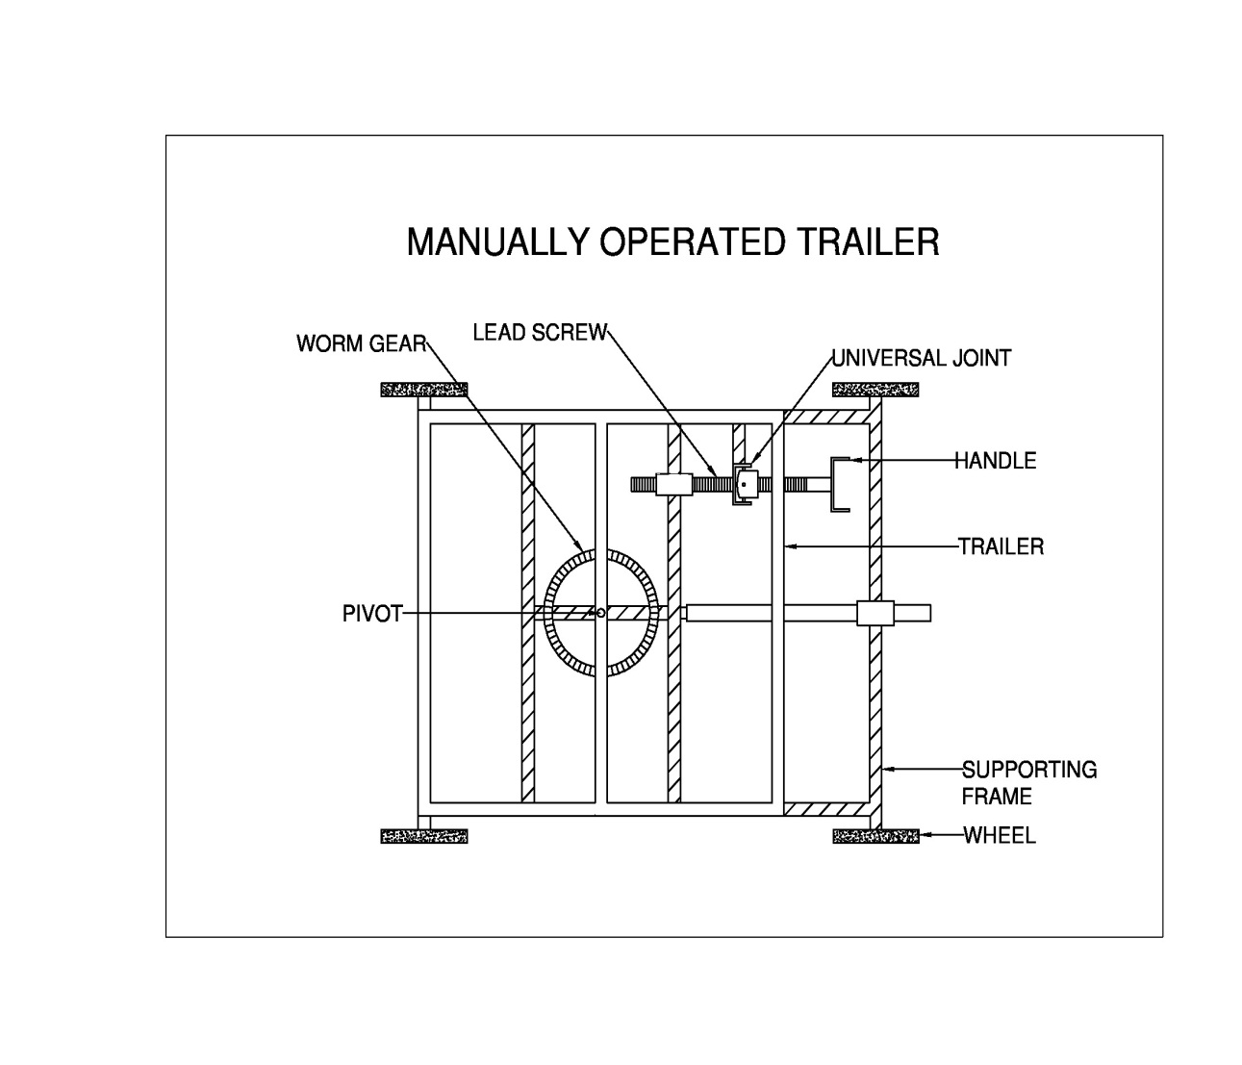

CONCLUSION:
This paper will review the need of the modern three axis pneumatic trailer for the ship to perform the operation of lifting heavy weight materials. This paper also studies the importance of pneumatic circuit system and its application in shipping industry. Various parts of the modern three axis pneumatic trailer was studied and their performance was analyzed in terms of the work. Further review is made on the cost wise analysis with the other lifting systems and with the help of pneumatic system lifting operations can be easily carried out without much effort and without.

