FABRICATION OF SOLAR SEED SPRAYER ROBOT

ABSTRACT
The real power required for machine equipment depends on the resistance to the movement of it. Even now, in our country 98% of the contemporary machines use the power by burning of fossil fuels to run IC engines or external combustion engines. This evident has led to widespread air, water and noise pollution and most importantly has led to a realistic energy crisis in the near future. Now the approach of this project is to develop the machine to minimize the working cost and also to reduce the time for digging and seed sprayer operation by utilizing solar energy to run the robotic machine. In this machine solar panel is used to capture solar energy and then it is converted into electrical energy which in turn is used to charge 12V battery, which then gives the necessary power to a shunt wound DC motor. This power is then transmitted to the DC motor to drive the wheels. Seed sowing and digging robot will move on different ground contours and performs digging, sow the seed and water the ground after closing. This project is very useful in agriculture field to reduce the time of work and easy way to implement this process. This project is designed by following blocks Solar panel, Battery, sprayer and hopper.

DRAWBACKS OF EXISTING SYSTEM :
- In the field of agriculture various problems are faced by the farmers in the operations like seed sowing, plowing, and waste planet cutting, weeding.
- The system will have some automation work for guidance and other obstacle detection and the power source that is battery and a solar panel will be attached on the top of the robot because of this reduces the power problem.
ADVANTAGES OF PROPOSED SYSTEM
- The automated solar tracking system is design in order to optimize the efficiency of overall solar energy output.
- Farmers today spend a lot of money on machines that help them decrease labor and increase yield of crops but the profit and efficiency are very less.
- Developed agriculture needs to find new ways to improve efficiency.

BLOCK DIAGRAM:

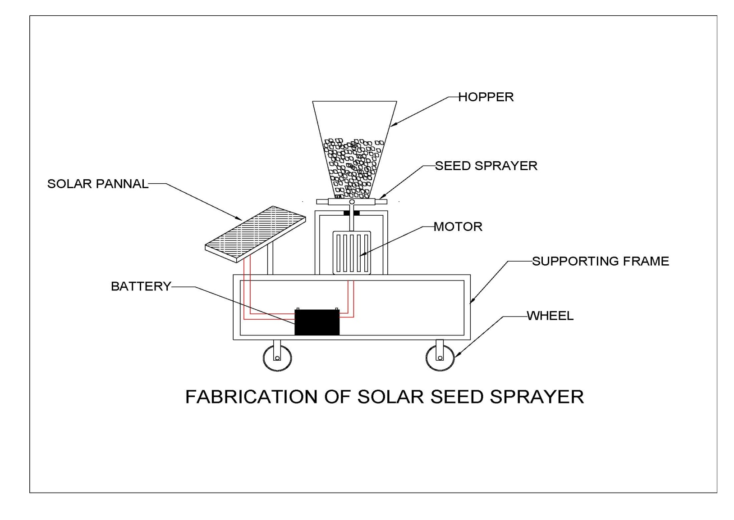

CONCLUSION:
The project is designed using structured modelling and is able to provide the desired results. It can be successfully implemented as a Real Time system with certain modifications. Science is discovering or creating major breakthrough in various fields, and hence technology keeps changing from time to time. Going further, most of the units can be fabricated on a single along with microcontroller thus making the system compact thereby making the existing system more effective. To make the system applicable for real time purposes components with greater range needs to be implemented.

