FABRICATION OF ELECTRO HYDRAULIC JACK FOR FOUR WHEELER

ABSTRACT
The project work titled “Electro Hydraulic Jack” has been conceived having studied the difficulty in lifting any type of vehicles. Our survey regarding several automobile garages, revealed the facts that mostly some difficult methods were adopted in lifting the vehicles for reconditioning. The project has mainly concentrated on this difficulty. In this project we are converting the conventional hydraulic jack in to automated hydraulic jack by using linkage mechanism with a help of a motor. Such that the vehicles can be lifted from the floor land without the application of impact force. It works on the principle of Pascal law the invention relates to hydraulic jack and more specifically to an automobile hydraulic jack system. The fabrication part of it has been considered with almost case for simplicity and economy, such that this can be accommodated as one of the essential tools on automobile garages.

DRAWBACKS OF EXISTING SYSTEM :
- Wear of pads and rotors
- Complexity and fuel consumption of power assistance
- Slow response time due to power assistance, especially in trucks, buses and trains
- Complexity of controlling each wheel’s braking independently
- Necessity of complex and costly anti-lock controls
ADVANTAGES OF PROPOSED SYSTEM
- No need of external battery.
- Power consumption is comparably less.
- Does not depend on the petrol level.
- Operating principle is very easy
- Installation is simplified very much
- The safety of driver is ensured
- The cost is low

BLOCK DIAGRAM:

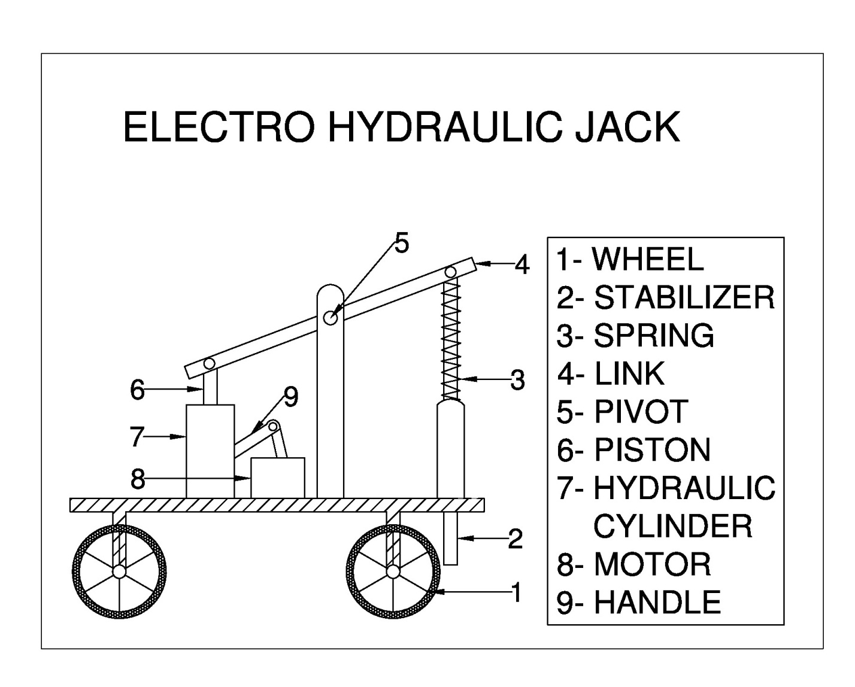

CONCLUSION:
With some design consideration an inbuilt car lifting mechanism can easily be fitted in all light weight automobiles. The project works on hydraulic power provided by battery. Maintenance and service of the vehicle can be easily done by this project. With this project the usage of automobile can be made easy for women and old people. Some extra automation like solenoid control valve can add great value to the project. The inbuilt jack is operated by battery so it can also be used when the vehicle engine is not started.

