FABRICATION OF CAM OPERATED SOLAR POWER HAMMER

ABSTRACT
The project “Solar operated cam hammer”is compact and portable, handy equipment, which is skillful and is having something different from the ancient conventional, hammering process. Olden days hammering process using for man power its use for more energy to spend the working process. This project used for reduce the man power and easy to hammering process. The solar panel is producing electric current to store in battery. Motor is connecting to cam and rotating motion is converting to vertical motion. This project is using for automatic hammering process it’s used for mass production. It is a working project and having guarantee of success. This project is the equipment useful to improve the quality and small scale industriesof the forging process. This cam operated hammer using manufacturing made in less time, hence we have selected this project.

DRAWBACKS OF EXISTING SYSTEM :
- This mechanism is only suitable for few operations.
- As torque force required is more there is difficult to find the motor to achieve the required torque.
- Having little wear.
ADVANTAGES OF PROPOSED SYSTEM
- Available in wide variety of sizes.
- Maintain good control and required force.
- Low cost.
- Save man power.
- Saves time.
- Time delay can be achieved easily.
- Mass production.

BLOCK DIAGRAM:

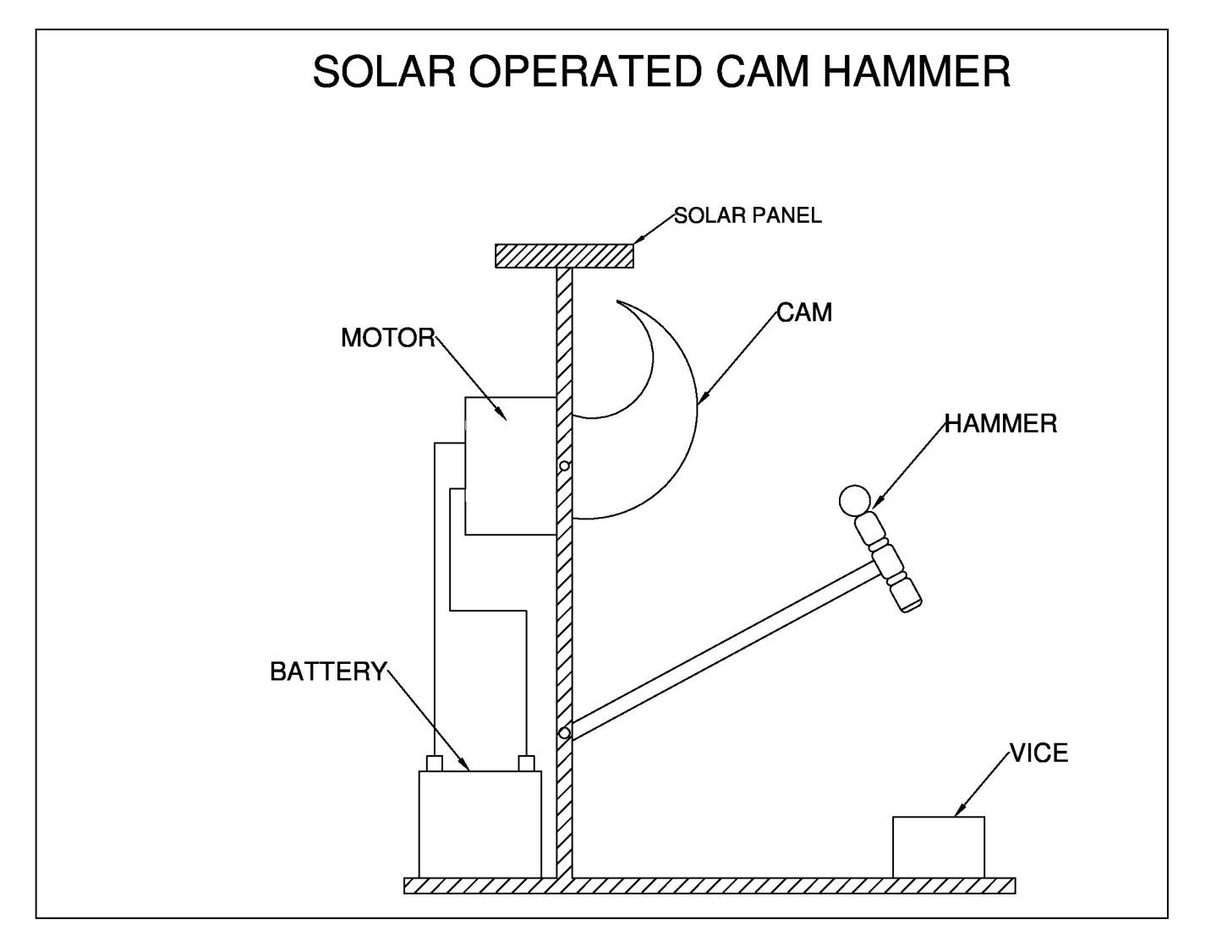

CONCLUSION:
We have successfully calculated the torque force of the motor. For the design the impact velocity and torque force for riveting of 2 mm rivet is calculated accurately. The entire modelling of the project is done with the help of CATIA V5R20. In this addition to this. The project work has provided us an excellent opportunity and experience, to use our limited knowledge. We gained a lot of practical knowledge regarding. Planning, Perching, assembling and machining while doing this feel that the project work is good solution to bridge the gates project work. We between institutions and industries. We are proud that we have completed the work with limited time successfully Automatic hammering machine is working with satisfactory condition. We have done to our ability and skill making ma work.

