OVER SPEED INDICATOR AND FUEL CUTOFF SYSTEM

ABSTRACT
The Objective of this project is to detect the speed of the vehicle and cutoff the fuel if it exceeds the set speed. This project is very useful to the traffic police department in order to measure the speed of the vehicles. This project is also used to avoid the accident. This project is designed with control unit, speed sensor as speed sensor and driver circuit with Relay and keypad. In this project we are using speed sensor as a speed detector. A speed sensor can detect objects without any physical contact. The object being sensed is often referred to as the speed sensor's target. Here is an inductive speed sensor, requires a metal target. The speed sensor is fixed near the wheel of the vehicle for easy detection of sensor we fix a plate on the wheel. When vehicle is traveling on the road speed sensor crosses the plates and it gives the signal to control unit. The control unit is already programmed. Here we update the speed each second and compare with the fixed speed. The fixed speed can be changed through the given keypad. If the current speed exceeds the fixed speed first time then it intimates in LCD as OVER SPEED. Even after the warning if it exceeds the limit again, then it cuts the fuel to engine through relay connected with solenoid. When the speed limit is exceeded an alarm is kept to indicate the over speed.

DRAWBACKS OF EXISTING SYSTEM :
- Controlling is tough.
ADVANTAGES OF PROPOSED SYSTEM
- Low cost
- Easy implementation
- Low power consumption
- More efficient

BLOCK DIAGRAM:
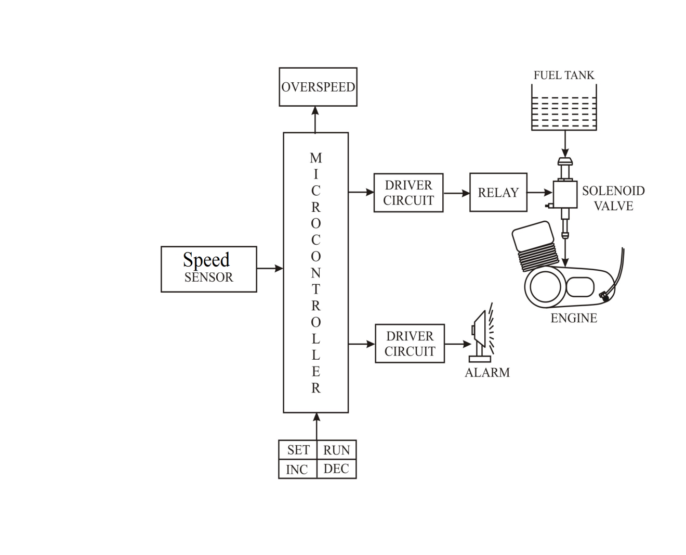

CONCLUSION:
This project work given us experience and excellent opportunities to use our limited knowledge .we also feel that project work is the good solution to fill gap between industry and institute. Thus, we studied the “over speed indication and accident prevention system “indicate the over speed and prevent the accident automatically. This system is implemented in to vehicle. Now a day’s accident is one of the danger, while traveling in vehicle, our moral is to avoid accident, save the passenger and prevent damage to vehicle We would also like to add few words, while working on this project we gain lot of practical knowledge regarding, purchasing designing and fabricating the model. We are also proud to complete this project successfully within a given limit.

