FABRICATION OF HAND OPERATED GARDEN CULTIVATOR

ABSTRACT
This project deals with the design and fabrication of hand operated garden cultivator. Our aim is to manufacture the simplest form of cultivator which can be used for all kind of domestic purpose. This project uses the human effort for operation. This hand operated garden cultivator consists of a wheel, three ploughs and support frames are used for rigid construction. The total view of hand operated garden cultivator is shown in the figure for reference. When the cultivator’s handle is pushed , the wheel starts to rotate. The ploughs are attached with the wheel through support frames. When the operator drives the cultivator, the cultivator blade is made to hit ground surface. If the operation continues, the cultivating process is successfully carried on.

DRAWBACKS OF EXISTING SYSTEM :
- On the-row mechanical cultivation however is still problematic mainly because of the risks of damaging the crop that is associated with this cultural practice.
- Creative design seems more to be a matter of developing and refining together both the formulation of a problem and ideas for a solution, with constant iteration of analysis, synthesis and evaluation processes between the two notional design 'spaces'— problem space and solution space.
ADVANTAGES OF PROPOSED SYSTEM
- The effect of treatments on machine parameters like fuel consumption and field efficiency was evaluated.
- Environmental sustainability and energy efficiency factors are key factors for the better utilization of the resources.
- After manufacturing the performance of a multifunctional agricultural machine was evaluated to find maximum field efficiency along with other parameters.

BLOCK DIAGRAM:
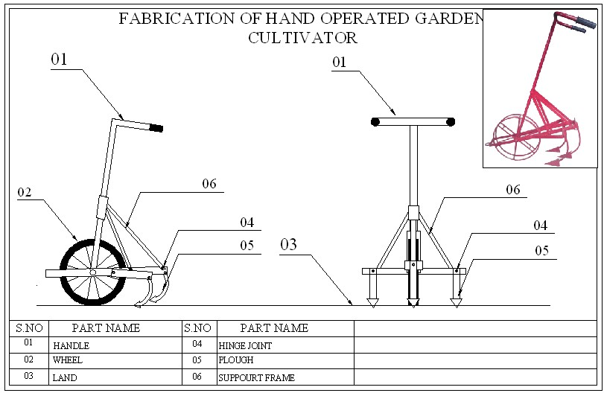

CONCLUSION:
The objectives specified are satisfied at the end of this project. Cultivator creates a perfectly formed bed of soil ready to embrace the roots of flowers and vegetables require tools and techniques suited to the task. The agricultural machine was designed and developed with an aim to Working on machines at a different speed and soil conditions, the machine can sustain and faces frequently changing conditions.

