FABRICATION OF EDDY CURRENT BRAKING SYSTEM

ABSTRACT
The eddy-current is created by the relative motion between a magnet and a metal (or alloy) conductor. The current induces the reverse magnetic field and results in the deceleration of motion. The proposed mechanism implements this phenomenon in developing a braking system. The potential applications of the braking system can be a decelerating system to increase the safety of an elevator or any guided rail transportation system. To provide scientific investigation for industrial application of magnetic braking, this study presents four systematic engineering design scenarios to design a braking system. The constant magnetic field is the simplest and easiest design to implement. The optimal magnetic field distribution is obtained by minimizing the deceleration effort. The piecewise constant magnetic field distribution offers a compromise between performance and magnetic field requirements. The advantages of the section-wise guide rail are tolerable deceleration; and simple design requirement and manufacturing processes. In the study, an experimental braking system using constant magnetic field is built to demonstrate the design procedure.

DRAWBACKS OF EXISTING SYSTEM :
- A disadvantage is that since the braking force is proportional to velocity the brake has no holding force when the moving object is stationary, as is provided by static friction in a friction brake, so in vehicles, it must be supplemented by a friction brake.
- Development of test rig
- It must be easy to use
- The test rig should give the accurate and precise results
- It must be robust and insensitive
ADVANTAGES OF PROPOSED SYSTEM
- The hybrid excitation linear eddy current brake has the advantages of high force density and low excitation loss compared to the electric excitation linear eddy current brakes.
- Parametric analysis was performed to explore the influence of the design parameters on the eddy current brake performance.

BLOCK DIAGRAM:

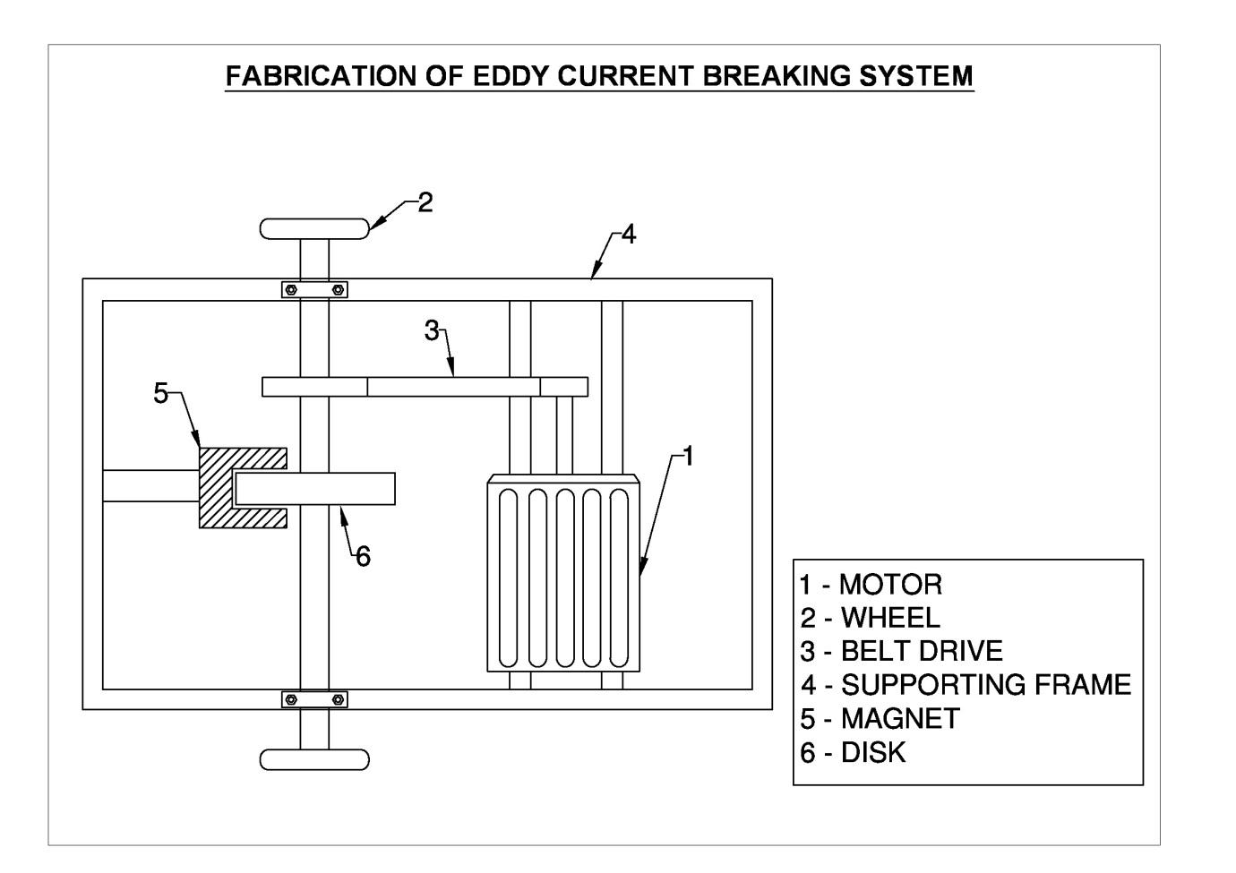

CONCLUSION:
The purpose of the study was to perform a comparative study of theoretical and practical braking time and establish a practical air gap limit beyond which the electromagnetic brakes loses their effectiveness. From theoretical calculations and experimented braking time values, a maximum reduction in braking time 23.97% is found and max air gap limit of 3 mm is obtained beyond with electromagnetic brakes are found to be ineffective.

