EXHAUST GAS HEAT RECOVERY (TEG) POWER GENERATION SYSTEM

ABSTRACT
Here we are fabricating an automobile for producing power using turbines. Nowadays in automobile field many new innovating concepts are being developed. We are using the power from vehicle exhaust to generate the electric power which can be stored in battery for the later consumption. In this project, we are demonstrating a concept of generating power in a moving vehicle by the thermo electric generator. Here we are placing a TEG (thermoelectric generator) on the silencer. An engine is also placed in the chassis of the vehicle. Depending upon the temperature of the silencer, the electric power is generated. The generated power is stored to the battery. It can be stored in the battery after rectification. The rectified voltage can be inverted and can be used in various forms of utilities. The battery power can be consumed for the users comfort.

DRAWBACKS OF EXISTING SYSTEM :
- This led to the increase in harmful gases emission and increase in global warming and environmental problems.
ADVANTAGES OF PROPOSED SYSTEM
- Such thermoelectric generators (TEGs) were unsuitable for use in the automobile due to their low level of efficiency. But since significant progress has been made in materials research in recent times, the performance and output of such modules has increased significantly.
- Although the above mentioned materials still remain the cornerstone for commercial and practical applications in thermoelectric power generation, significant advances have been made in synthesizing new materials and fabricating material structures with improved thermoelectric performance.

BLOCK DIAGRAM:

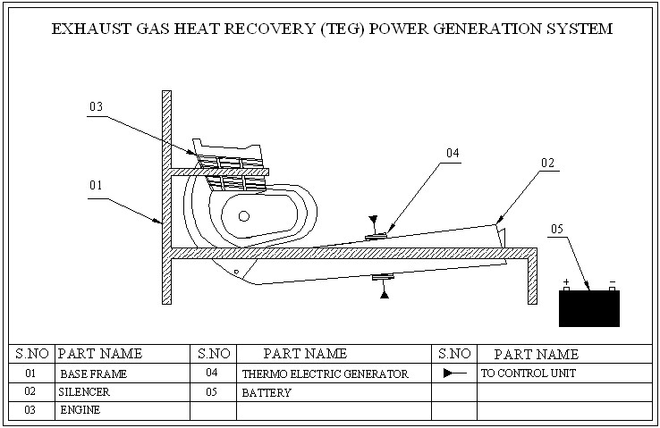

CONCLUSION:
In this project we understand a exhaust gas gas heat recovery power generatior. Thus the eco-friendly power generation method can be implemented for domestic and commercial use at an affordable cost. Since this system requires less power input, it can also be used as a portable refrigerator. The thermoelectric generator can be used in remote areas where powersource is not possible to get.

