DESIGN AND FABRICATION OF SEED SOWING MACHINE

ABSTRACT

The seed sowing machine is used to sowing the seeds into land for making lots of plant production in agricultural field. It is a mechanical device here no electrical or other power source is not required. The cost of this machine is very low and easy to operate simple in construction. This project is designed by following parts, wheels, lead screw, sowing wheel, handle and unplug plate. It is simple in construction made up of two wheel used to move the machine manually. It consists of wheel shaft in the middle of the vehicle. The sowing wheel is connected with the wheel shaft. The lead screw is plugging the land and it can be adjusted by the handle. And deploughing plate is fixed at the back of the vehicle.

DRAWBACKS OF EXISTING SYSTEM :
- Difficult to operate in moist condition.
- Machine requires more effort in hard soil.
- Operating force varies from person to person.
ADVANTAGES OF PROPOSED SYSTEM
- Improved efficiency in planting.
- Increased yielding and reliability in crop. Increased cropping frequency.
- Increased speed of seed planting.
- Seed planting accuracy.
- Durable and cheap as low cost materials are used.
- Less maintenance cost.
- Since seed can be poured at any required depth, the plant germination is improved.
- Dependency on labor also decreased. Also it saves time of sowing.
- Uniform placement of seeds in row with required distance.
- Proper compaction over the seeds is provided.

BLOCK DIAGRAM:
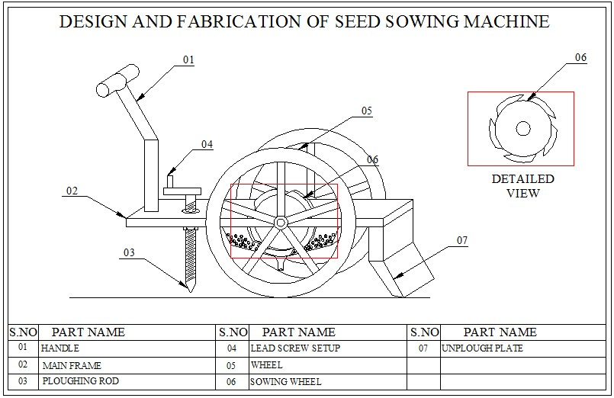

CONCLUSION:
This seed plantation machine has great potential for increasing the productivity of the planting. Till now tractor was the main traction unit for nourishment in farming. With the adaptation of this seed planting machine its purpose will be done. Hence there is need to promote this technology and made available to even small scale farmers with affordable prices. This machine can be made by raw materials also which saves the cost of whole project and is easily manufactured in available workshops. The only cost is of metering device and sensors. Hence by using this machine we can achieve flexibility of distance and control depth variation for different seeds. hence usable to all seeds.

