DESIGN AND FABRICATION OF PEDAL POWERED GROUNDNUT THRUSTER

ABSTRACT

Groundnut product demand is on the increase and the application is largely dependent on the cleanness of the nuts. The separation process from plant is usually an energy sapping task that requires a lot of time. In order to separate the nuts from its plant effectively a machine was developed. The machine basically comprises of chain drive, pedal, fixed frame, rotating frame with blade and collecting tray. This groundnut thruster machine is the manually operated machine. This machine is constructed by the following components such as chain and sprocket, pedal, bearing, fixed frame , rotating frame with blade, seat and collecting tray. Here we have fabricated the groundnut thruster machine which is operated by the pedal power. This machine consists of two cover frames which is placed with a small gap for feeding the groundnut plant. The rotating frame is placed below these cover frames and connected to the chain drive. The pedal is connected to the chain drive for rotating the blade setup. The seat arrangement is placed just above the pedal. At first the pedal is operated manually which will rotate the blade. Then the plant with seed is feeded towards the blade through the cover frames. At that time, the groundnut seed is separated from the plant and it is collected in a collecting tray. This technique can be used in agricultural fields in future.

DRAWBACKS OF EXISTING SYSTEM :
- Too much time is required in traditional method
- Labour requirement is very high
- Efficiency is low
- Harvesting cost is high
ADVANTAGES OF PROPOSED SYSTEM
- Labour required is very low
- Efficiency is very high
- Thresting time is very low when compared with the manual methods.
- Shelling cost is low

BLOCK DIAGRAM:

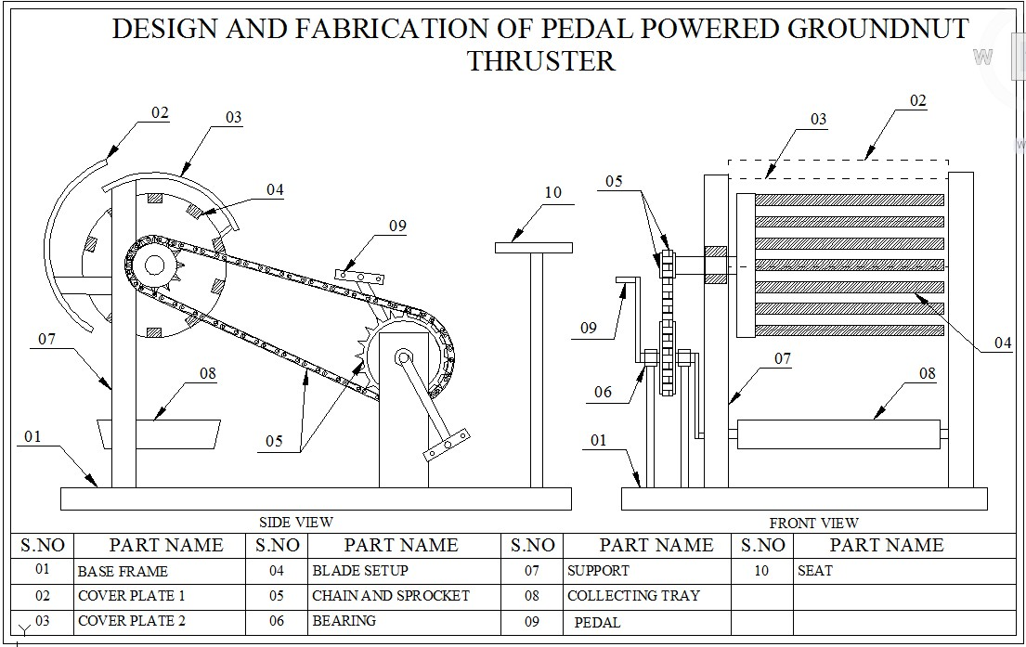

CONCLUSION:
Hence the cost of this groundnut thruster is very low. this invested money can be taken away by the farmers, this machine can reduce the labour crisis, the labour cost is very much reduced, only one workers is used for operation, the time consumption is low when compared with the manual thresting method.

