DESIGN AND FABRICATION OF COCONUT SHELL BREAKER

ABSTRACT

This concept is mainly designed to cut the shell of the coconut to making the oil etc.., nowadays lot of technology have been developed to reduce the human fatigue and to save the time. This is the new innovative concept we have been designed for agricultural peoples. The coconut oil refining is very crucial in manufacturing for coconut oil refining we are spend more time to remove the coconut meat. But we are using the simple arrangement to remove the coconut shell. In our project were using the wooden roller to feed the coconut to the cutter. The roller is operated by the motor through the belt and pulley arrangement to reducing the speed. The coconuts are loading manually on the slots in the roller. The saw cutter is placed on opposite of the roller to cut the coconuts. Here the cutter is rotated by using the motor. Here the saw cutter speed is increased by the belt and pulley arrangements. The coconuts are stored in the collecting tray after the process is completed.

DRAWBACKS OF EXISTING SYSTEM :
- High labour cost
- Dangerous in work
ADVANTAGES OF PROPOSED SYSTEM
- Skilled labor is not required.
- Easy operation
- It can be transported easily from one place to another place
- Maintenance is easy.
- Investment is low
- Dismantling and assembling is simple

BLOCK DIAGRAM:

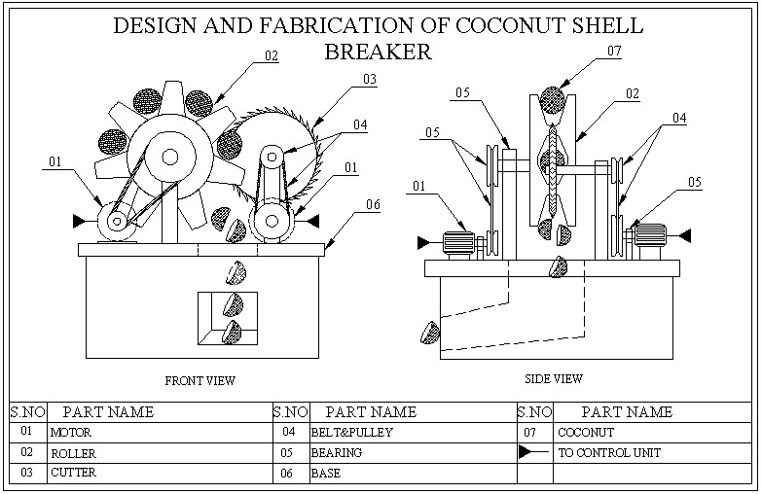

CONCLUSION:
The project carried out by us made an impressing task in the field of agricultural. It is very useful to the farmers for motorized husk remover. Easy to assemble.Easy Maintenance. About the market, this model is compact with good range of productivity with low cost and safety This project will reduce the cost involved in the concern. Project has been designed to perform the entire requirement task at the shortest time available. Power operated dehusking tool can help any unskilled operator to get his work done with ease. The dehusker is completely safe to operate. For example 32 coconut husk/hour removed in manual operated machines, In our projects 110 coconut husk /hour are removed. Operator cost of manual is Rs.250/hour,In our projects consumed overall cost is 175/hour. The saving amount is an 75/hour.

