MAGNETIC POWER GENRATION FROM SHOCK ABSORBER

ABSTRACT

The objective of this project is to generate the electric power through the fabrication of shock absorber arrangement. Now day’s power demand is increased, so this project is used to generate the electrical power in order to compensate the electric power demand. Here we have fabricated the electric power generation by using modified spring shock absorber is electric two wheeler this project can be utilized in every two wheeler. The spring shock absorber makes use of the magnetic EMF produce between dipoles to achieve shock absorption action. The spring shock absorber gives smooth action and power generation to the vehicle while moving on a bumpy road. This project is based on simple electromagnetism. A current-carrying conductor generates a magnetic field; when this is placed in an external magnetic field, it will experience a force proportional to the current flow in the conductor, and to the strength of the external magnetic field. The rotor consists of windings and the windings produce EMF when it is passed in between two permanent magnet. When the permanent magnets with different poles are kept beside the coil power is produced from the coil for an indication an LED is made to glow.

DRAWBACKS OF EXISTING SYSTEM :
- Problem occurred in collecting materials.
- Time consuming.
- Found some drawbacks of suspension system like rubbing in (LWV) light weight vehicles.
- In case of Induction Brakes, whole system can undergo failure because of electric motor.
- As whole system consist electric wiring so this may occur short circuit of system.
- This system consist a speed limit up to 35 km/h.
ADVANTAGES OF PROPOSED SYSTEM
- Shock absorbers have a great for performance, handling and stability.
- They are best choice for work and severe use vehicles.
- High pressure gas mono tube design- 360psi to prevent aeration and shock fade. These have a lighter valving than the heavy duty units.
- Low pressure gas twin tube design- These units are good for average, everyday driving and a very good replacement for OE units.
- The “electricity generating suspension system” has a much higher energy yield than other known invention.

BLOCK DIAGRAM:

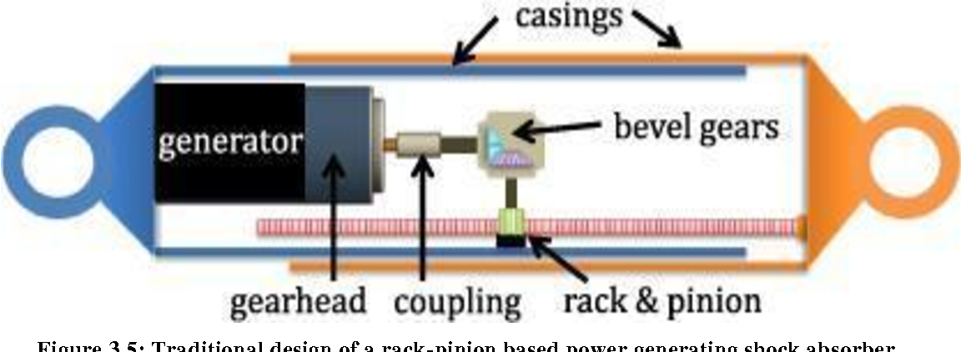

CONCLUSION:
Conventionally, the vibration energy of vehicle suspension is dissipated as heat by shock absorber, which wastes a considerable number of resources. Power Generating Shock Absorber brings hope for recycling the wasted energy. All types of Power Generating Shock Absorber, especially electromagnetic suspension, and their properties are reviewed in this seminar. From the perspective of comprehensive performance including vibration control ability, regenerative efficiency and application reliability, the configuration of hydraulic transmission and self-powered MR damper shows the best attraction. With improvement of technology, Power Generating Shock Absorber may become one of promising trends of vehicle industry.

