FABRICATION OF SEE SAW POWER GENERATION

ABSTRACT
This project is a proof of concept work, where playground equipment is implemented for power generation. In using a seesaw design, this project was able to show how a simple mechanical motion could be transformed in electrical power. A seesaw power generator was designed and constructed to demonstrate its feasibility. Results show that with some modification and improvement to the current design, the seesaw me indeed provide a viable method to produce electricity.

DRAWBACKS OF EXISTING SYSTEM :
- Excessive use of clutch will lead to the damage of clutch plate also.
- They are rarely used for power generation now because of the dominance of alternating current, the disadvantages of the commutator, and the ease of converting alternating to direct current using solid state methods.
ADVANTAGES OF PROPOSED SYSTEM
- This project will help in increasing the life of brake shoes as the see- saw mechanism also produces braking effect. Also this will increase the efficiency of engine by removing the alternator which is used for starting of the vehicle.
- It will work efficiently only in those areas where we have to operate clutch more i.e. in crowded areas.

BLOCK DIAGRAM:
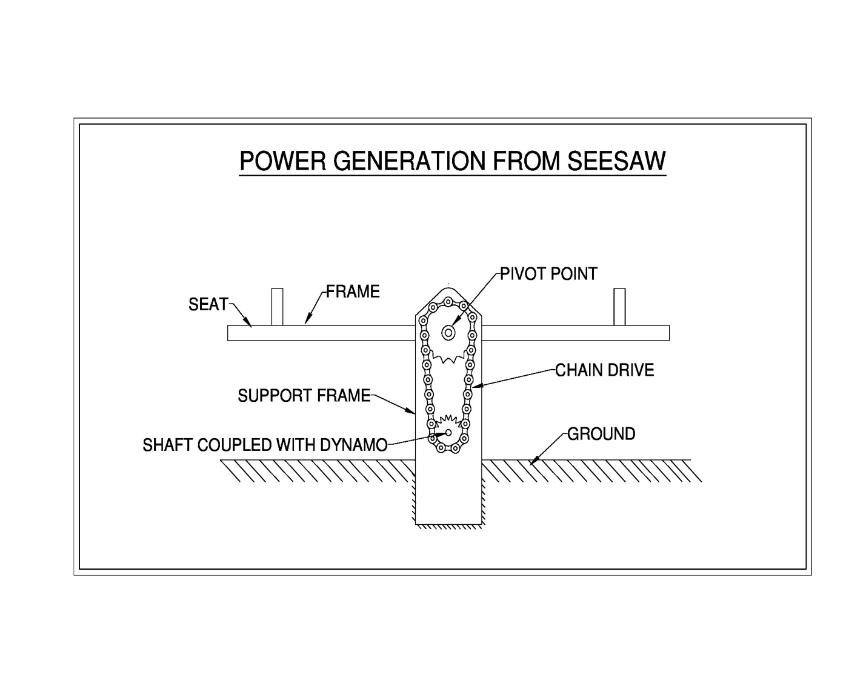

CONCLUSION:
On providing power input of 0.551 KW, 22.2 volt electric potential is produced by using power of 15.4 watt which would have been wasted during clutch operation. This project will help in increasing the life of brake shoes as the see- saw mechanism also produces braking effect. Also this will increase the efficiency of engine by removing the alternator which is used for starting of the vehicle.

