FABRICATION OF PEDAL OPERATED DRILLING MACHINE

ABSTRACT
In this Pedal operated drilling machine which can be used for industrial applications and Household needs in which no specific input energy or power is needed. This project consists of a crank and slider mechanism. In the mechanism pedal is directly connected to the hacksaw through crank and slider mechanism for the processing of drilling the wooden blocks, metal bars, and PVC materials. The objective of the modal is using the conventional mechanical process which plays a vital role. The main aim is to reduce the human effort for machining various materials such as wooden blocks, steel, PVC etc. The power drilling machine, which runs on human power, works on the principle of the conversion of rotational motion. Importance of this project lies in the very fact that it is green project and helps us to reduce our electricity need. Secondly, this drill can be used and transferred to our working place easily. Moreover, if we want we can generate electricity with our project by connecting it to dynamo, diode and battery.

DRAWBACKS OF EXISTING SYSTEM :
- The technical problem addressed by the utility model: the prior art, the process is relatively simple, small parts of the object is small grinder, using electric drive is not conducive to energy saving.
ADVANTAGES OF PROPOSED SYSTEM
- The multipurpose machine that is ‘exercise bicycle’ which was basically used for exercising purpose has been modified for grinding, water lifting, washing machine and generation of electricity.
- The consideration for designing was to grind and used as blender, lift water to the height of 10 meter and to generate 14 volts, 4 ampere of electricity in most efficient way. Source of power utilized for above purpose is pedal power.

BLOCK DIAGRAM:
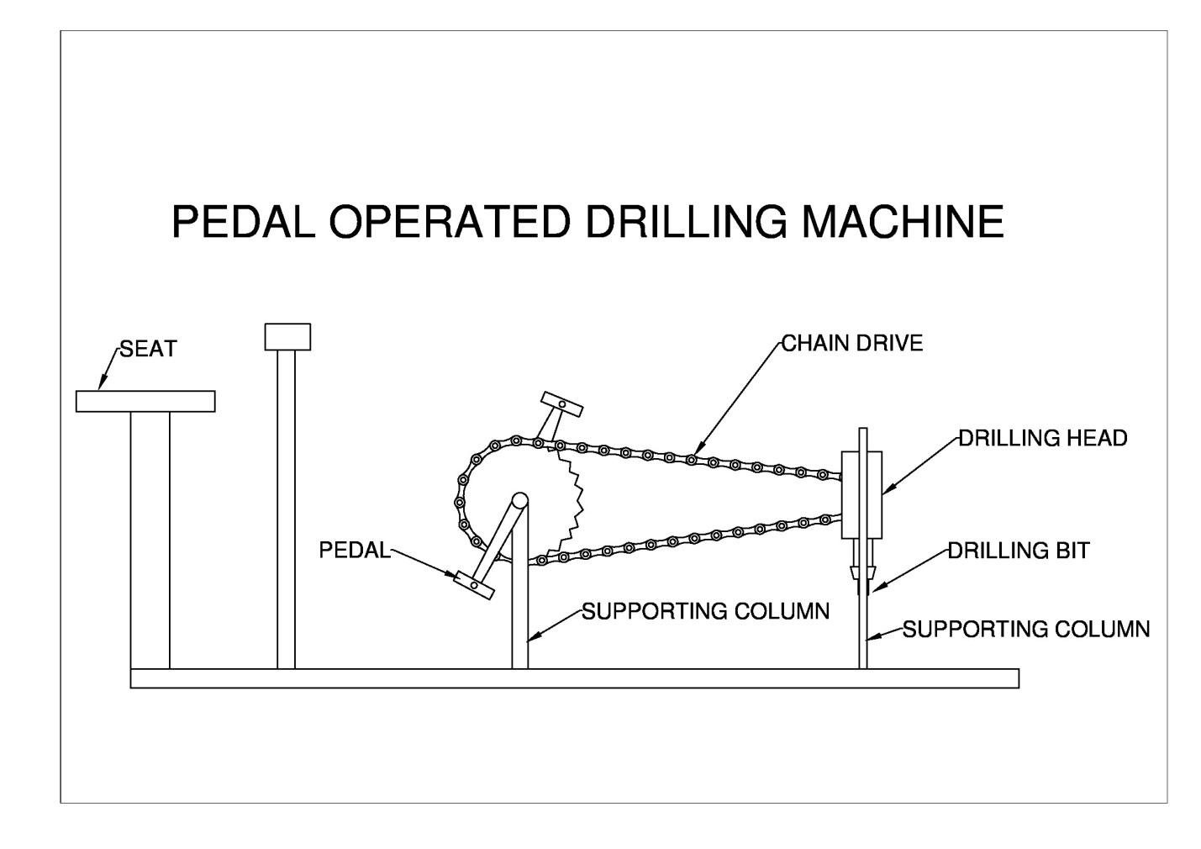

CONCLUSION:
Time saving is much more in machine operated by motor as compared to our pedal operated machine but there is no need of electricity. Cost of labour is nil. Only human power is needed. Useful for village people where villagers are facing power cut off daily for several hours. Cost of our equipment is 50% less compared to cost of traditional machine in use.

