DESIGN AND FABRICATION OF PNEUMATIC MULTI PURPOSE VEGETABLES CUTTER

ABSTRACT
Our project is designed to fabricate the multipurpose air cutter. The main aim of this project is to cut the vegetable by using pneumatic cylinder with the help of compressed air. Tray will be provided near that arrangement to collect the vegetable pieces. Pneumatic cylinder, solenoid valve, collecting tray and vegetable holder are the components of multi-purpose air cutter. it are very simple and efficient way to fabricate this model. It is one of the innovate project in the line of food manufacturing industry. Initially compressor supplies the air at certain pressure to the solenoid valve. This solenoid valve is used to control the direction of flow of air to the pneumatic cylinder. This pneumatic cylinder actuates the piston due to high pressure of air. At the end of the piston rod vegetable cutting knife is fitted. So the reciprocating motion of piston gives cutting action on the vegetable like potato (or) carrot which is placed inside the vegetable holder having grill type cover. Then the flow direction is reversed by the solenoid valve. So this will actuate the piston rod to retard position. Now the solenoid valve changes the direction of flow of air to the pneumatic cylinder. This process is carried continuously.

DRAWBACKS OF EXISTING SYSTEM :
- The fabrication of this automated multipurpose vegetable slicing machine is to improves the time constraint problem to cut a large amount of vegetables into smaller size and to design and fabricate a simple automated machine that easy to control with multipurpose function for industrial usage.
- This project is aimed at solving above stated problems by introducing a special product named Automatic Vegetable Chopper.
- As the time goes by, the slicing technology has been developed to overcome these problems.
ADVANTAGES OF PROPOSED SYSTEM
Low investment cost
- No contamination
- No additional manpower
- Less time consumption
- Reliable
- Simple construction
- Can be cut the vegetables into various shape according to our requirements.
- Automation

BLOCK DIAGRAM:

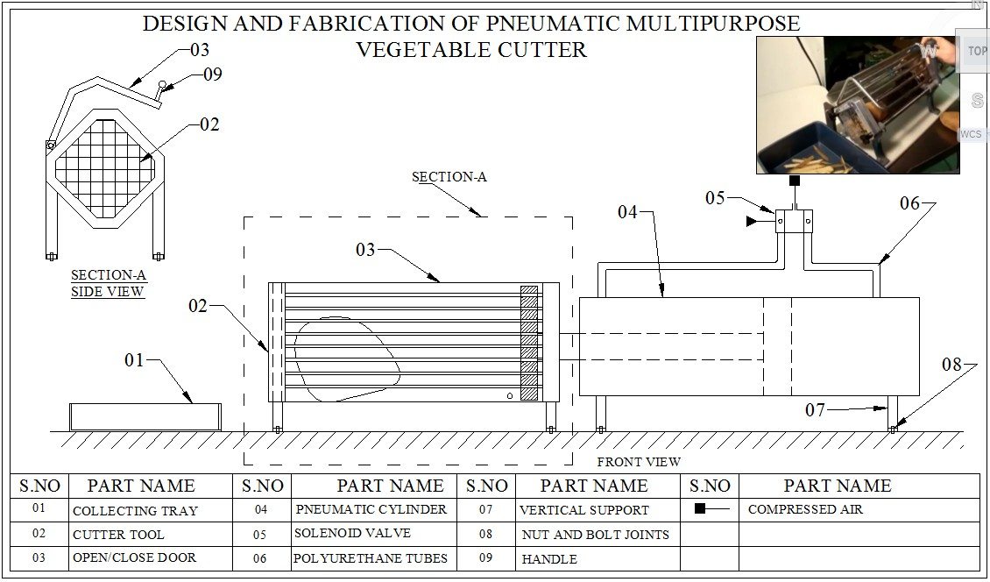

CONCLUSION:
Over the years, the traditional process of slicing vegetable has always been slow, tedious, boring, time consuming and in some cases unhygienic. The fabricating a machine capable of slicing vegetable which will mechanize the slicing process for both domestic and commercial consumption becomes a necessity. Simple design equations involving Cutting force, Torque, Bending moment and shear forces, etc were related in the course of going through the design process. Almost Every home in Nigeria eats vegetables. Hence, the vegetable slicing machine would serve perfectly in slicing of these vegetables into edible sizes.

