FABRICATION OF PEDAL OPERATED MIXI

ABSTRACT
The main aim of the project is to save the electrical power in house, hotels and fast food stalls. Pedal operated maxi is operated by chain and sprocket. The manual power is utilized to run the maxi. This project consists of a pedal, bevel gear arrangement, cutting blades, bearing blocks, arrangement for jar removing.The following working principle is about pedal operated maxi. In this project the chain and sprocket plays a vital role. A pedal is attached with the chain and sprocket arrangement. Normally the gears are used to transmit power. Driven sprocket is attached with bevel gear arrangement. Here we have used 4 sprockets in two different sizes and 2 chains. When the pedal which is attached with the larger sprocket is rotated, then the smaller sprocket which is connected with another larger one. hence the smaller sprocket attached to the gear shaft will rotated in high speed . This leads to speed up the rotation of the maxi jar. In the above project to transmit the power in 90° we use a bevel gear arrangement. The shaft from the bevel gear is attached to the maxi jar. Here the jar is of removable type. Since the jar is attached with the bevel gear shaft the blades in the jar also rotates in a very high speed.

SYSTEM ANALYSIS
EXISTING SYSTEM
- A low cost technology of a mixer machine was constructed to homogenously mix the premix (Super cereal Plus) together with maize flour of ratio 0.00525:15 kg respectively.
- The design steps were systematically analyzed to generate the correct data for the final construction of the Hand operated mixer machine.
- This research is to design and construct a hand operated mixer machine that will homogenously mix maize flour together with a high concentrated micro-nutrient substance (premix) of a required quantity.
- This technology should also be cost effective to a low income person.
DRAWBACKS OF EXISTING SYSTEM :
- The system described above is being developed with these problems in mind. it is being designed with specific goals to make the greatest impact possible with multi tasks. low cost, portability, reliability, and ease of use are all essential to the success of the system.
- In this way we have concluded that the power is generated and which can be used to operate small power devices such as mobile, laptops, LED lights, charging units.
PROPOSED SYSTEM
- The main objective behind development of pedal operated flour mill was on producing cheap, easy to operate system which can be easily fabricated by readily available material and thus we proposed a simplistic design that can deliver efficient, productive and reliable flour mill which can be used in rural as well as urban areas. this equipment can be easily operated by semi rather low skilled operator.
- Keeping these limitations of human capabilities in mind the proposed machine consists of three sub systems: (1) The energy unit, (2) Transmission mechanism (3) The process unit.
ADVANTAGES OF PROPOSED SYSTEM
- It is economically efficient. This machine can be used in remote places where electricity is irregular or insufficient.
- The machine is operated without any external energy like fuel or electric supply.
- We had seen designs for devices that take power from the rear tire by means of a friction roller pressed against it, but we had doubts about the efficiency of this arrangement.
- In order to improve efficiency we used hard bearing surfaces such as roller chains, sprockets and ball bearings.
- Unskilled labour can also handle it, efficientl because of this we can reduce the cost of production which is the most important factor in production industry.

BLOCK DIAGRAM
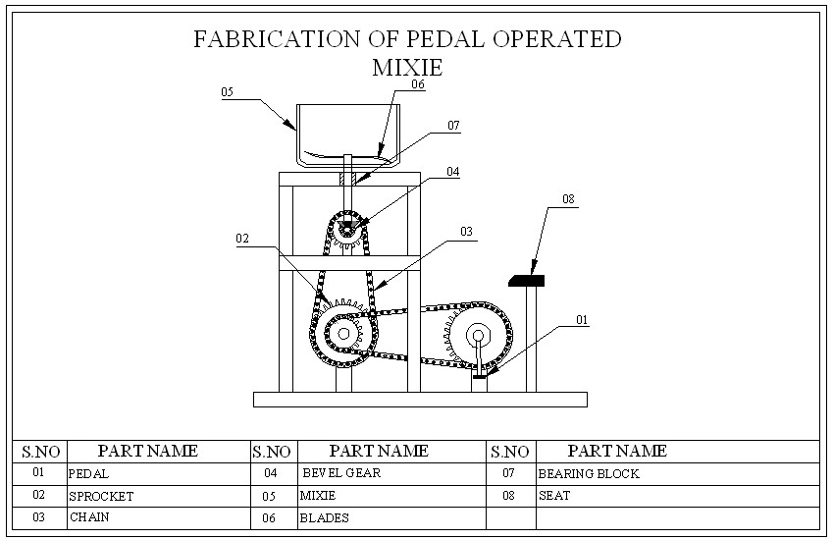

CONCLUSION:
A pedal operated flour mill was developed for the households in rural areas, where there is shortage of electricity. The developed flour mill consisted of a hopper along with a feeding tube at the top, a pair of grinding stones and the hemi spherical collector at the bottom, a seat for the operator and power transmission system. The performance of the mill was optimum at pedaling rate of 50-60 rpm with desired fineness.

