Mega Satellite Constellation System Optimization From Network Control Structure Perspective

ABSTRACT
The network control plays a vital role in the mega satellite constellation (MSC) to coordinate massive network nodes to ensure the effectiveness and reliability of operations and services for future space wireless communications networks. One of the critical issues in satellite network control is how to design an optimal network control structure (ONCS) by configuring the least number of controllers to achieve efficient control interaction within a limited number of hops. Considering the wide coverage, rising capacity, and no geographical constraints of space platforms, this paper contributes to designing the ONCS by constructing an optimal space control network (SCN) to improve the temporal effectiveness of network control. Specifically, we formulate the optimal SCN construction problem from the perspective of satellite coverage factors, and apply geometric topology analysis to derive both the conditions for constructing the optimal SCN and the formulaic conclusions for SCN and MSC configurations (i.e., scale and structure). From numerical results, we investigate the tradeoff between network scale, the number of controllers, and control delays in several satellite network control scenarios, to provide guidelines for the MSC control. We also design the optimal SCN for an existing MSC system to demonstrate the effectiveness of the proposed ONCS.

CHAPTER 2
2. SYSTEM ANALYSIS
  - EXISTING SYSTEM

- There are several limitations exist in the introduced framework. The Constellation Coverage Computation Module only considers perturbation and ignores others such as radiation, third body, and atmospheric drag perturbations.
- Two comparisons are performed for the optimization results: a comparison with a global coverage constellation and a comparison with an all-in-single-stage constellation.
- The computational scalability of this model depends on two major factors the number of areas of interest and the number of stages. The number of scenarios grows as the factorial of the number of regions.
- The current assumption of three uncertain areas of interest, there exist total six scenarios possible as depicted.
2.1.1 DRAWBACKS OF EXISTING SYSTEM :
- This problem is addressed in, where the need for an increased accuracy in orbit determination is pushed forward as a means to reduce false alarms and implement automatic orbital corrections.
- Alternative solutions to the debris problem include active removal and space-based surveillance networks.
- It highlights also the tools most often proposed in the analyzed works to overcome constellation management issues, such as applications of machine learning/artificial intelligence and resource/infrastructure sharing.
- Among the issues to be faced in the “constellation race” the space traffic management is probably the most critical, yet not directly faced.
2.2. PROPOSED SYSTEM
- The proposed multi-stage satellite constellation enables the constellation designer to react flexibly and efficiently to the uncertain future expansion of the areas of interest.
- Another relevant concept was proposed by Paek regarding the reconfigurable satellite constellation between the global and local modes to consider different areas of interest for Earth observation.
- The framework proposed in this paper is applied to the particular case of a two-stage problem with uncertainties lying in the second stage area of interest.
- The purpose of the constellation is telecommunications; therefore, a maximum latency is set according to the International Telecommunication Union (ITU) recommendation for the mouth-to-ear delay for high-quality speech.

2.2.1. ADVANTAGES OF PROPOSED SYSTEM
- At the same time, constellation management shall be enhanced to make an efficient use the new infrastructure.
- Other efficient deployment strategies are compared in such as J2 driven deployment and carrier-vehicle deployment.
- A survey of mobile satellite systems endorsing IP-based communication, discouraging however communication satellites other than GEO, mainly for cost efficiency.
- Using this approach, the temporarily unused spectrum could be reallocated for a more efficient use.
- The level of maturity reached by these three areas is, however, not homogeneous: communication is probably the most matured, where relevant work is being done concerning infrastructure integration and protocol efficiency.
Literature Survey:
TITLE | AUTHORS | DESCRIPTION
Small satellites for global coverage: Potential and limits | Sandaua, R.; Brieß, K.; D’Errico, M. | There is an increasing need for Earth Observation (EO) missions to meet the information requirements in connection with Global Change Studies.
Boom of the CubeSat: A Statistic Survey of CubeSats Launch in 2003–2015 | Panga, W.J.; Bo, B.; Meng, X.; Yu, X.Z.; Guo, J.; Zhou, J. | The CubeSats can, in general, be distinguished from other nanosatellites by their standardized modular design.
Space traffic management in the new space era | Muelhaupt, T.J.; Sorge, M.E.; Morin, J.; Wilson, R.S. | Major changes are expected in the space environment due to the imminent launch of NewSpace (sometimes Space 2.0) systems, particularly large low Earth orbit (LEO) constellations that will change the space operations environment.
LEO and MEO Broadband Constellations Mega Source of Consternation | Henry, C. | Demand for ever-faster broadband internet connections is maxing out today’s satellites, setting off an industry-wide stampede toward increasingly powerful high-throughput satellites (HTS).

2.3 FEASIBILITY STUDY
The feasibility Analysis is an analytical program through project manager determines the project success ratio and through feasibility study project manager able to see either project. The key considerations involved in the feasibility analysis are:
- Economic Feasibility
- Technical Feasibility
- Operational Feasibility
- Environmental Feasibility
2.3.1 ECONOMICAL FEASIBILITY
Hence this project is economically feasible there is no need to involve any cost for this project.
2.3.2 TECHNICAL FEASIBILITY
Software Technologies used are PHP and MySql. In the educational institutions, it is possible to update the system in future. No special hardware is required for the purpose of using this system. Hence it is declared that this project is technically feasible.
2.3.3 OPERATIONAL FEASIBILITY
As the admin work mainly to maintain the Patient and Doctor .Doctor will predict patient cancer disease. Hence it is easy to operate with training. Therefore it is operationally feasible for implementation.
2.3.4 ENVIRONMENTAL FEASIBILITY
This project environment is correct as a admin has developed this system and no expenditure is involved under any head and this process is part of admin document management, this project environment is accessible.

2.4 SYSTEM REQUIREMENTS
- System : Pentium IV 2.4 GHz.
- Hard Disk : 40 GB.
- Monitor : 15 inch VGA Color.
- Mouse : Logitech Mouse.
- Ram : 512 MB
- Keyboard : Standard Keyboard

2.4.1 HARDWARE REQUIREMENTS
The Hardware of the computer consists of physical component such as Input Devices, Storage Devices, Processing & Control units and Output Devices. Computer includes external storage unit to store data in programs.
The Hardware Configuration involved in this project
- System : Pentium IV 2.4 GHz.
- Hard Disk : 40 GB.
- Monitor : 15 inch VGA Color.
- Mouse : Logitech Mouse.
- Ram : 512 MB
- Keyboard : Standard Keyboard

2.4.2 SOFTWARE REQUIREMENTS
Software is a group of programs that computers need to do a particular task. It is an essential requirement of Computer System. The Software used to develop the project is
- Operating System : Windows XP.
- Platform : DOT NET TECHNOLOGY
- Front End : ASP.Net 3.5
- Back End : SQL SERVER 2005

CHAPTER 3
SYSTEM DESIGN AND DEVELOPEMENT
SYSTEM ARCHICTURE

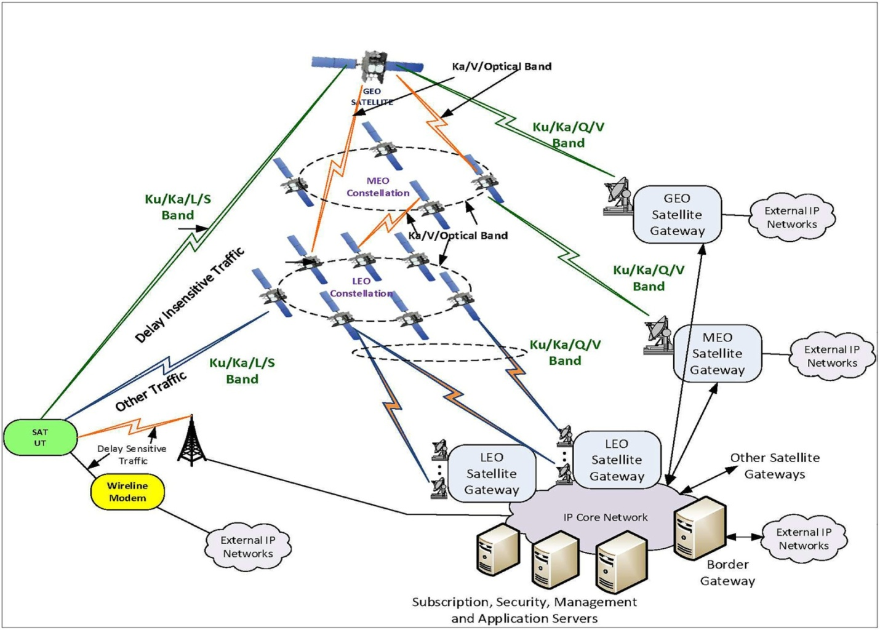

CHAPTER 4
TESTING AND IMPLEMENTATION

  - TESTING
Implementation is the stage of the project when the theoretical design is turned into a working system. This is the final and important phase in the system life cycle It is actually the process of converting the new system into a operational one.

4.1.1Unit Testing
Unit testing comprises the set of tests performed by an individual programmer prior to integration of the unit into a larger system. The module interface is tested to ensure that information properly flows into and out of the program unit. The local data structure is examined to ensure that data stored temporarily maintains its integrity during all steps in an algorithm’s execution. Boundary conditions are tested to ensure that the module operates properly at boundaries established to limit or restrict processing. All independent paths through the control structure are tested. All error-handling paths are tested.

4.1.2 Block Box Testing
Black-box testing is a method of software testing that examines the functionality of an application without peering into its internal structures or workings. This method of test can be applied virtually to every level of software testing: unit, integration, system and acceptance. It is sometimes referred to as specification-based testing.

4.2 SYSTEM IMPLEMENTATION
Implementation is the stage of the project when the theoretical design is turned into a working system. This is the final and important phase in the system life cycle It is actually the process of converting the new system into a operational one.

CHAPTER 5
CONCLUSION:
The increasing trend of launching very small satellites into space has been clear and well established for the last two decades. Smaller satellites are in turn paving the way to constellations, which are gaining widespread interest. Spacecraft constellations are appealing, especially in three fields, namely, (i) communications, for global coverage, (ii) Earth observation, for near real time measurements and (iii) space observation for continuous monitoring/surveillance. During this survey, about one hundred companies have been found proposing constellations with varying numbers of satellites. Satellite sizes range mainly from nano to micro-sizes, i.e., from 1 kg up to 100 kg. Most of them are expected to be active in orbit before 2025. The most common number of elements for the constellations is below 150 units.

CHAPTER-6
REFERENCE
- 1. McIntyre, D.A. The 10 Biggest Tech Failures of the Last Decade—Failure to Launch Iridium. 14 May 2009. Available online: http://content.time.com/time/specials/packages/article/0,28804,1898610_1898625_1898640, 00.html (accessed on 28 June 2019).
- 2. Glasner, J. Globalstar: Broke But Not Out. 14 November 2001. Available online: https://www.wired.com/ 2001/11/globalstar-broke-but-not-out/ (accessed on 20 July 2019).
- 3. Williams, C.; Doncaster, B.; Shulman, J. 2018 Nano/Microsatellite Market Forecast, 8th ed.; SpaceWorks Enterprises Inc.: Atlanta, GA, USA, 2018.
- 4. Lal, B.; de la Rosa, E.B.; Behrens, J.; Corbin, B.; Green, E.K.; Picard, A.A.J.; Balakrishnan, A. Global Trends in Small Satellites; IDA Science and Technology Policy Institute: Alexandria, VA, USA, 2017.
- 5. Sandaua, R.; Brieß, K.; D’Errico, M. Small satellites for global coverage: Potential and limits. ISPRS J. Photogramm. Remote Sens. 2010, 65, 492–504.
- 6. Panga, W.J.; Bo, B.; Meng, X.; Yu, X.Z.; Guo, J.; Zhou, J. Boom of the CubeSat: A Statistic Survey of CubeSats Launch in 2003–2015. In Proceedings of the 67th International Astronautical Congress (IAC), Guadalajara, Mexico, 26–30 September 2016.
- 7. Muelhaupt, T.J.; Sorge, M.E.; Morin, J.; Wilson, R.S. Space traffic management in the new space era. J. Space Saf. Eng. 2019, 85, 51–60.
- 8. Selva, D.; Golkar, A.; Korobova, O.; Cruz, I.L.; Collopy, P.; de Weck, O.L. Distributed Earth Satellite Systems: What Is Needed to Move Forward? J. Aerosp. Inf. Syst. 2017, 14, 412–438. [CrossRef]
- 9. Henry, C. LEO and MEO Broadband Constellations Mega Source of Consternation. 13 March 2018. Available online: https://spacenews.com/divining-what-the-stars-hold-in-store-for-broadband-megaconstellations/ (accessed on 20 July 2019).
- 10. Globalstar Completes 48-Satellite Constellation. 23 November 1999. Available online: https://www. wirelessnetworksonline.com/doc/globalstar-completes-48-satellite-constellati-0001 (accessed on 28 June 2019).

