Dynamic Age Minimization with Real-Time Information Preprocessing for Edge-Assisted IoT Devices with Energy Harvesting

ABSTRACT
Age of information (AoI) is a newly proposed metric to quantify the freshness of system status. However, in many cases, the original raw data collected by IoT devices needs to be preprocessed in real-time to extract the hidden effective information, which is usually time consuming. To this end, we promote an edge computing assisted approach and aim to reduce the AoI by flexibly offloading the raw IoT data to the edge server for information preprocessing. We consider that the IoT devices can opportunistically collect extra energy through energy harvesting for sustainable operations, and propose a novel timely system status update model that consists of multiple IoT devices with energy harvesting and edge-assisted information preprocessing. The objective is to minimize the system-wide average AoI under a fixed energy cost budget. To tackle the key challenges due to the unpredictability of the stochastic energy harvesting process and the long-term energy constraints, we propose a Lyapunov-based average AoI Minimization (LAoIM) algorithm to derive an approximate optimal solution, and further quantify the performance gap from the optimal solution. Extensive numerical evaluations demonstrate that LAoIM can take full advantages of local and edge computation resources and achieve superior performance gain over existing schemes.

CHAPTER 2
2. SYSTEM ANALYSIS
  - EXISTING SYSTEM

- The most natural mode of DL computation offloading is similar to the existed “end-cloud” computing, i.e., the end device sends its computation requests to the cloud for DL inference.
- All these challenges put forward the need for a novel training scheme against existing cloud training.
- In this case, DL is used to learn input-solution relations, and DNN-based methods are only available when optimization algorithms for the original caching problem exist.
- Most existed works focus only on vision applications. However, the heterogeneous data structures and characteristics of a wide variety of DL-based services are not addressed well yet.
- Existing FL methods focus on synchronous training, and can only process hundreds of devices in parallel.
2.1.1 DRAWBACKS OF EXISTING SYSTEM :
- We propose a novel alternate group iteration optimization (AGIO) algorithm, which decomposes the original problem into three subproblems, and alternately optimizes each subproblem using the group interior point iterative algorithm.
- An achievable rate maximization problem was discussed in for multiuser satellite IoT system with SWIPT and MEC to overcome the limitation in battery capacity and computing capability of IoT terminals.
- With the development of artificial intelligence technology, reinforcement learning (RL) methods are used to solve various communication problems in 5G and IoT systems.
- We formulate a more practical WSN energy minimization problem by jointly optimizing the key decision variables in the system.
2.2. PROPOSED SYSTEM
- Adaptive Locality Sensitive Hashing (A-LSH), a variant of LSH commonly used for indexing high-dimensional data, is proposed to index these vectors for fast and accurate lookup.
- In, the proposed distributed infrastructure Deep Decision ties together powerful edge nodes with less powerful end devices.
- Based on these prediction models, wireless conditions and server load levels, the proposed Neurosurgeon evaluates each candidate point in terms of end-to-end latency or mobile energy consumption and partition the DNN at the best one.
- In, a Fused Tile Partitioning (FTP) method, able to divide each CNN layer into independently distributable tasks, is proposed.

2.2.1. ADVANTAGES OF PROPOSED SYSTEM
- It can attribute the success to more reasonable expressions of several parameters, which affects the system performance.
- Although the current terminal devices are equipped with high-performance hardware, it is still difficult to meet the needs of computing intensive tasks, especially in the case of ensuring low power consumption and low latency.
- In such new framework, the communication and computation resource allocation as well as wireless energy harvesting scheme are crucial for maximizing the system performance.
- We analyze the transmission process of the system, we can formulate an problem which can optimize the system performance.
- It also indicates the distinguished feature of our algorithm both in energy consumption performance and latency performance.
Literature Survey:
TITLE | AUTHORS | DESCRIPTION
A comprehensive survey on internet of things (IoT) toward 5G sireless systems | Chettri, L.; Bera, R. | This paper provides a comprehensive review on emerging and enabling technologies related to 5G system that enables internet of things.
From IoT to 5G HoT: The next generation IoT-based intelligent algorithms and 5G technologies | Wang, D.; Chen, D.; Song, B.; Guizani, N.; Yu, X.; Du, X. | The Internet of Things is a novel paradigm with access to wireless communication systems and artificial intelligence technologies, which is considered to be applicable to a variety of promising fields and applications.
Three tier fog networks: Enabling IoT/5G for latency sensitive applications | Shahzadi, R.; Niaz, A.; Ali, M.; Naeem, M.; Rodrigues, J.J.; Qamar, F.; Anwar, S.M. | Fog computing provides mobile computing, network control and storage to the network edges to assist latency critical and computation-intensive applications.
Security in 5G-Enabled internet of things communication: Issues, challenges, and future research roadmap | Wazid, M.; Das, A.K.; Shetty, S.; Gope, P.; Rodrigues, J.J. | Some of the future research challenges and directions in the security of 5G-enabled IoT environment are displayed.

2.3 FEASIBILITY STUDY
The feasibility Analysis is an analytical program through project manager determines the project success ratio and through feasibility study project manager able to see either project. The key considerations involved in the feasibility analysis are:
- Economic Feasibility
- Technical Feasibility
- Operational Feasibility
- Environmental Feasibility
2.3.1 ECONOMICAL FEASIBILITY
Hence this project is economically feasible there is no need to involve any cost for this project.
2.3.2 TECHNICAL FEASIBILITY
Software Technologies used are PHP and MySql. In the educational institutions, it is possible to update the system in future. No special hardware is required for the purpose of using this system. Hence it is declared that this project is technically feasible.
2.3.3 OPERATIONAL FEASIBILITY
As the admin work mainly to maintain the Patient and Doctor .Doctor will predict patient cancer disease. Hence it is easy to operate with training. Therefore it is operationally feasible for implementation.
2.3.4 ENVIRONMENTAL FEASIBILITY
This project environment is correct as a admin has developed this system and no expenditure is involved under any head and this process is part of admin document management, this project environment is accessible.

2.4 SYSTEM REQUIREMENTS
- System : Pentium IV 2.4 GHz.
- Hard Disk : 40 GB.
- Monitor : 15 inch VGA Color.
- Mouse : Logitech Mouse.
- Ram : 512 MB
- Keyboard : Standard Keyboard

2.4.1 HARDWARE REQUIREMENTS
The Hardware of the computer consists of physical component such as Input Devices, Storage Devices, Processing & Control units and Output Devices. Computer includes external storage unit to store data in programs.
The Hardware Configuration involved in this project
- System : Pentium IV 2.4 GHz.
- Hard Disk : 40 GB.
- Monitor : 15 inch VGA Color.
- Mouse : Logitech Mouse.
- Ram : 512 MB
- Keyboard : Standard Keyboard

2.4.2 SOFTWARE REQUIREMENTS
Software is a group of programs that computers need to do a particular task. It is an essential requirement of Computer System. The Software used to develop the project is
- Operating System : Windows XP.
- Platform : DOT NET TECHNOLOGY
- Front End : ASP.Net 3.5
- Back End : SQL SERVER 2005

CHAPTER 3
SYSTEM DESIGN AND DEVELOPEMENT
SYSTEM ARCHICTURE

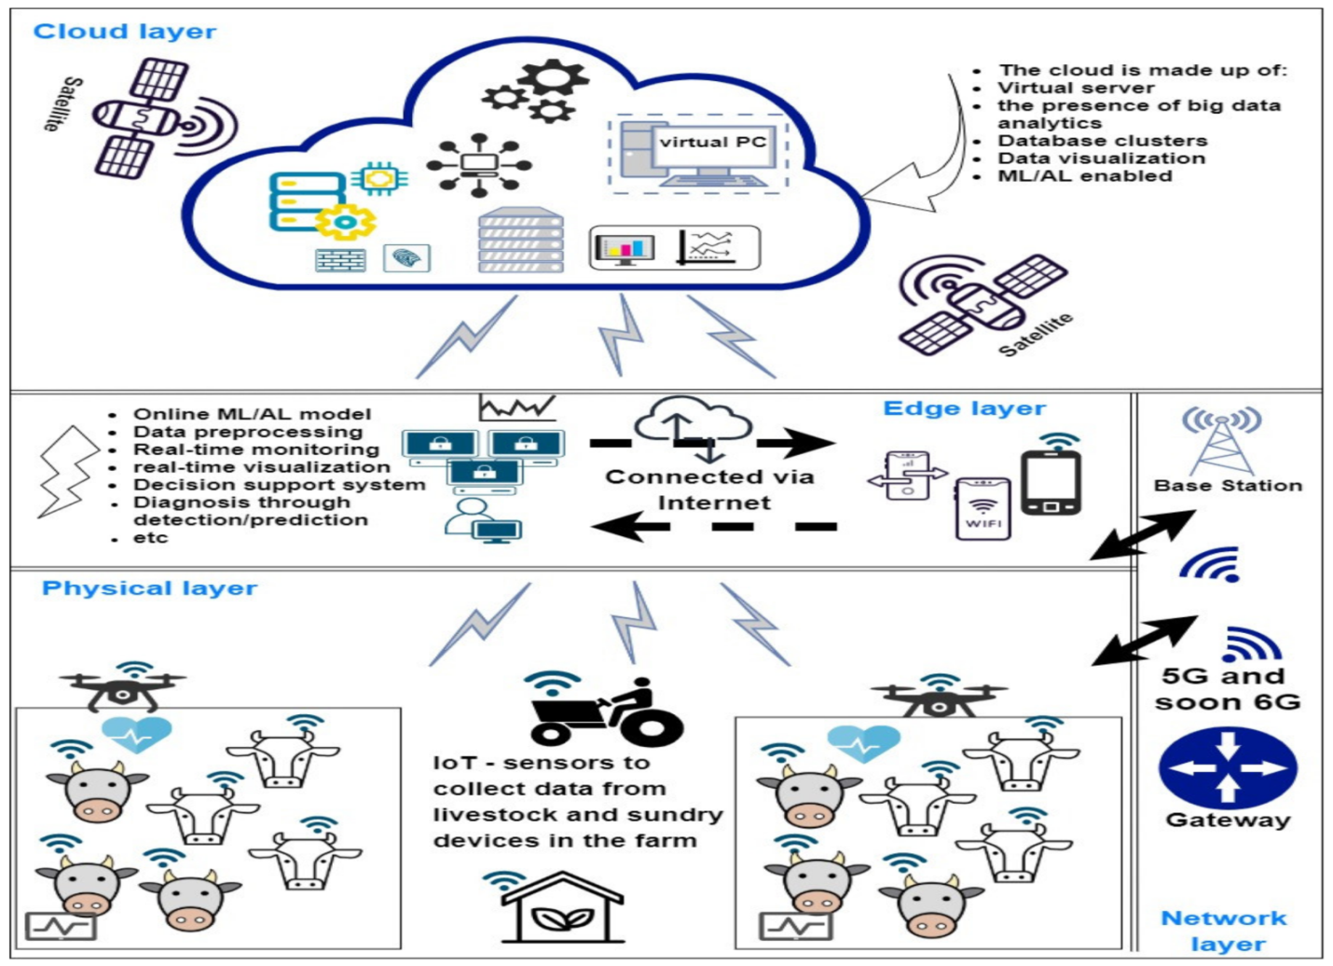

CHAPTER 4
TESTING AND IMPLEMENTATION

  - TESTING
Implementation is the stage of the project when the theoretical design is turned into a working system. This is the final and important phase in the system life cycle It is actually the process of converting the new system into a operational one.

4.1.1Unit Testing
Unit testing comprises the set of tests performed by an individual programmer prior to integration of the unit into a larger system. The module interface is tested to ensure that information properly flows into and out of the program unit. The local data structure is examined to ensure that data stored temporarily maintains its integrity during all steps in an algorithm’s execution. Boundary conditions are tested to ensure that the module operates properly at boundaries established to limit or restrict processing. All independent paths through the control structure are tested. All error-handling paths are tested.

4.1.2 Block Box Testing
Black-box testing is a method of software testing that examines the functionality of an application without peering into its internal structures or workings. This method of test can be applied virtually to every level of software testing: unit, integration, system and acceptance. It is sometimes referred to as specification-based testing.

4.2 SYSTEM IMPLEMENTATION
Implementation is the stage of the project when the theoretical design is turned into a working system. This is the final and important phase in the system life cycle It is actually the process of converting the new system into a operational one.

CHAPTER 5
CONCLUSION:
In this paper, we investigate the wireless information transmission and energy transfer of a novel SWIPT-MEC enabled WSN-assisted IoT System. We fomulate an optimization problem by jointly optimizing the CPU frequency, transmitted power, offloading weight factor and harvest weight factor to achieve the minimum system energy consumption. In order to render the problem solvable, we propose a novel alternate group iteration optimization (AGIO) algorithm, which decomposes the original problem into three subproblems and alternately optimizes each subproblem using the group interior point iterative optimization algorithm. Finally, numerical simulation of the proposed strategy is carried on to compare with the two other benchmark schemes. The results demonstrate that the proposed design presents the performance advantages both in energy consumption and latency.

CHAPTER-6
REFERENCE
- 1. Chettri, L.; Bera, R. A comprehensive survey on internet of things (IoT) toward 5G sireless systems. IEEE Internet Things J. 2020, 7, 16–32. [CrossRef]
- 2. Shafique, K.; Khawaja, B.A.; Sabir, F.; Qazi, S.; Mustaqim, M. Internet of things (IoT) for next-generation smart systems: A review of current challenges, future trends and prospects for emerging 5G-IoT scenarios. IEEE Access 2020, 7, 23022–23040. [CrossRef]
- 3. Wang, D.; Chen, D.; Song, B.; Guizani, N.; Yu, X.; Du, X. From IoT to 5G HoT: The next generation IoT-based intelligent algorithms and 5G technologies. IEEE Commun. Mag. 2018, 56, 114–120. [CrossRef]
- 4. Shahzadi, R.; Niaz, A.; Ali, M.; Naeem, M.; Rodrigues, J.J.; Qamar, F.; Anwar, S.M. Three tier fog networks: Enabling IoT/5G for latency sensitive applications. China Commun. 2019, 16, 1–11.
- 5. Wazid, M.; Das, A.K.; Shetty, S.; Gope, P.; Rodrigues, J.J. Security in 5G-Enabled internet of things communication: Issues, challenges, and future research roadmap. IEEE Access 2020, 9, 4466–4489. [CrossRef]
- 6. Ma, X.E.Z.; Yu, K. Energy-efficient computation offloading and resource allocation in SWIPT-based MEC Networks. IEEE Access 2020. [CrossRef]
- 7. Dua, A.; Dutta, A.; Zaman, N.; Kumar, N. Blockchain-based E-waste Management in 5G Smart Communities. In Proceedings of the IEEE INFOCOM 2020—IEEE Conference on Computer Communications Workshops (INFOCOM WKSHPS), Toronto, ON, Canada, 6–9 July 2020; pp. 195–200.
- 8. Lu, W.; Xu, X.; Huang, G.; Li, B.; Wu, Y.; Zhao, N.; Yu, F.R. Energy efficiency optimization in SWIPT enabled WSNs for smart agriculture. IEEE Trans. Ind. Inform. 2020, 17, 4335–4344. [CrossRef]
- 9. Cui, J.; Zhang, Y.; Cao, M.; Wang, S.; Xu, Y. Thyroid tumor care risk based on medical IoT system. Micropress. Microsyst. 2021, 82, 103845. [CrossRef]
- 10. Zhang, Q.; Sun, H.; Wei, Z.; Feng, Z. Sensing and Communication Integrated System for Autonomous Driving Vehicles. In Proceedings of the IEEE INFOCOM 2020—IEEE Conference on Computer Communications Workshops (INFOCOM WKSHPS), Toronto, ON, Canada, 6–9 July 2020; pp. 1278–1279.

