Energy Efficient Data Gathering in IoT Networks with Heterogeneous Traffic for Remote Area Surveillance Applications A Cross layer Approach

ABSTRACT
In this paper, the problem of energy-efficient data gathering in an Internet of Things (IoT) based remote area surveillance application is addressed by designing a suitable MAC layer uplink solution. We follow the 3GPP specified scheduled access scheme for narrowband IoT (NB-IoT) and consider presence of both delay sensitive and delay tolerant traffic in the network. First, we present a mixed integer non-linear programming (MINLP) based optimization framework to minimize the IoT devices’ cumulative transmission energy per uplink frame under the constraints of finite resource blocks, mean queue stability and residual energy levels of IoT nodes. A cross layer approach has been adopted. Precisely, using Lyapunov optimization, we propose a dynamic, distributed transmit power allocation for IoT nodes and a centralized node scheduling scheme. Further, assuming Poisson model for traffic generation at delay tolerant traffic generating nodes, we suggest a distributed probabilistic sleep scheduling scheme to improve the average delay experience of delay sensitive traffic while improving the overall energy conservation. Simulation results suggest impressive performance of our proposed solution over the existing uplink solution for NB-IoT, in terms of delay experience of delay sensitive traffic, buffer length requirement and nodes’ total energy consumption at high traffic load.

CHAPTER 2
2. SYSTEM ANALYSIS
  - EXISTING SYSTEM

- It also provides the opportunity to transform the traditional functioning of several existing industrial systems such as healthcare and manufacturing.
- The routing performance can be significantly improved for IoT based applications, and it is preferable than the existing OFs.
- Many existing studies have presented a different version of RPL energy optimization, but the duty cycling aspect has ignored mostly.
- In order to enlarge network lifetime, efficient resource utilization of nodes is an important concern particularly for resource-constrained networks.
- Each node in a graph connects in a way where there exist no cycles. The DAG is destined to one or more root and generally known as destination oriented DAG (DODAG).
2.1.1 DRAWBACKS OF EXISTING SYSTEM :
- The cluster heads that are one hop away from BS exhaust their energy resource much quickly and lead to the energy hole issue, which degrades network throughput and increases the latency ratio.
- However, sensors have limited resources concerning processing, energy, transmitting, and memory capabilities that can negatively impact agriculture production.
- The drastic changes in climate negatively impact the agriculture eco-system causing heaving rains, droughts, floods, and abrupt weather conditions.
- These low powered sensor nodes have significant impact on the performance of the network in terms of delivery ratio and energy consumption.
2.2. PROPOSED SYSTEM
- The extensive simulation results show that the proposed RAROF can effectively extend the lifetime of the network, enhance the energy efficiency, and achieve higher reliability than that of other OFs.
- A new routing metric named node vulnerability index (NVI) is proposed, which includes the duty cycle information, link quality, energy profile of a node during the path selection process for network life improvement.
- The proposed work points out that default single-metric-based OFs are vulnerable in situations where congestion occurs due to a sudden increase in traffic volume, resulting in packet loss and delay.
- The proposed composite metric considers both energy and reliability parameters to select the optimum path.

2.2.1. ADVANTAGES OF PROPOSED SYSTEM
- In various domains, the technology of wireless sensor network (WSN) has been used in an efficient way to improve network performances.
- Although, the field of WSN has been exploited by many researchers in the domain of agriculture to improve its performance and reduce the farmer’s burden.
- The main aim of the proposed solution is to improve the network performance in terms of cluster formation and cluster head selection based on distance, density, mobility, and energy factors.
- However, in most of the other existing works, the proposed solution also does not consider the performance of links in data transmission and leads to packets drop and latency ratio.
- The performance of the proposed framework with other solutions is measured based on network throughput, packets drop ratio, network latency, energy consumption, and routing overheads.
Literature Survey:
TITLE | AUTHORS | DESCRIPTION
STWSN: A novel secure distributed transport protocol for wireless sensor networks | Dvir A., Ta V.T., Erlich S., Buttyan L. | Several transport protocols for wireless sensor networks (WSNs) have been designed to fulfill efficiency requirements such as energy and reliability.
Fuzzy based enhanced cluster head selection (FBECS) for WSN | Mehra P.S., Doja M.N., Alam B. | Clustering not only organizes a deployed network into connected hierarchy but also balances the network load thereby dragging out the lifetime of the system.
Coverage and connectivity in WSNs: A survey, research issues and challenges | Tripathi A., Gupta H.P., Dutta T., Mishra R., Shukla K.K., Jit S. | The sensing coverage of the Field of Interest (FoI) is an important function of the sensor nodes in connected WSNs.
An energy-aware routing and filtering node (ERF) selection in CCEF to extend network lifetime in WSN | Shahzad M.K., Cho T.H. | In security protocols, the general approach for energy efficiency is to reduce the number of attacks while underlying routing protocols are often ignored.

2.3 FEASIBILITY STUDY
The feasibility Analysis is an analytical program through project manager determines the project success ratio and through feasibility study project manager able to see either project. The key considerations involved in the feasibility analysis are:
- Economic Feasibility
- Technical Feasibility
- Operational Feasibility
- Environmental Feasibility
2.3.1 ECONOMICAL FEASIBILITY
Hence this project is economically feasible there is no need to involve any cost for this project.
2.3.2 TECHNICAL FEASIBILITY
Software Technologies used are PHP and MySql. In the educational institutions, it is possible to update the system in future. No special hardware is required for the purpose of using this system. Hence it is declared that this project is technically feasible.
2.3.3 OPERATIONAL FEASIBILITY
As the admin work mainly to maintain the Patient and Doctor .Doctor will predict patient cancer disease. Hence it is easy to operate with training. Therefore it is operationally feasible for implementation.
2.3.4 ENVIRONMENTAL FEASIBILITY
This project environment is correct as a admin has developed this system and no expenditure is involved under any head and this process is part of admin document management, this project environment is accessible.
2.4 SYSTEM REQUIREMENTS
- System : Pentium IV 2.4 GHz.
- Hard Disk : 40 GB.
- Monitor : 15 inch VGA Color.
- Mouse : Logitech Mouse.
- Ram : 512 MB
- Keyboard : Standard Keyboard
2.4.1 HARDWARE REQUIREMENTS
The Hardware of the computer consists of physical component such as Input Devices, Storage Devices, Processing & Control units and Output Devices. Computer includes external storage unit to store data in programs.
The Hardware Configuration involved in this project
- System : Pentium IV 2.4 GHz.
- Hard Disk : 40 GB.
- Monitor : 15 inch VGA Color.
- Mouse : Logitech Mouse.
- Ram : 512 MB
- Keyboard : Standard Keyboard
2.4.2 SOFTWARE REQUIREMENTS
Software is a group of programs that computers need to do a particular task. It is an essential requirement of Computer System. The Software used to develop the project is
- Operating System : Windows XP.
- Platform : DOT NET TECHNOLOGY
- Front End : ASP.Net 3.5
- Back End : SQL SERVER 2005

CHAPTER 3
SYSTEM DESIGN AND DEVELOPEMENT
SYSTEM ARCHICTURE

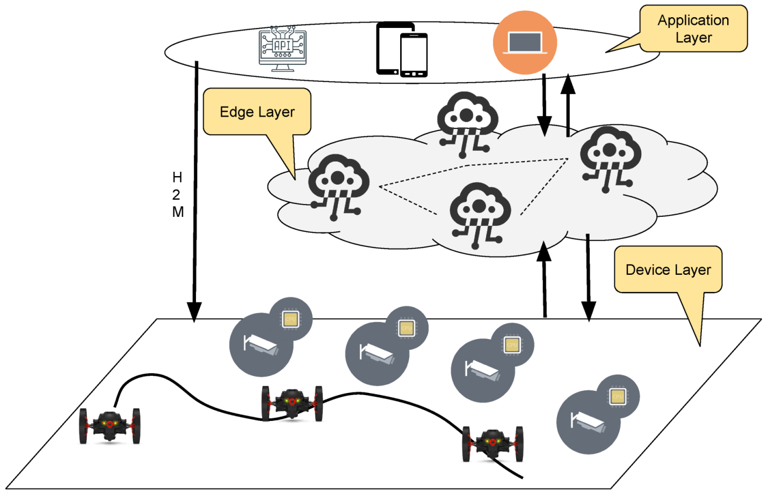

CHAPTER 4
TESTING AND IMPLEMENTATION

  - TESTING
Implementation is the stage of the project when the theoretical design is turned into a working system. This is the final and important phase in the system life cycle It is actually the process of converting the new system into a operational one.

4.1.1Unit Testing
Unit testing comprises the set of tests performed by an individual programmer prior to integration of the unit into a larger system. The module interface is tested to ensure that information properly flows into and out of the program unit. The local data structure is examined to ensure that data stored temporarily maintains its integrity during all steps in an algorithm’s execution. Boundary conditions are tested to ensure that the module operates properly at boundaries established to limit or restrict processing. All independent paths through the control structure are tested. All error-handling paths are tested.

4.1.2 Block Box Testing
Black-box testing is a method of software testing that examines the functionality of an application without peering into its internal structures or workings. This method of test can be applied virtually to every level of software testing: unit, integration, system and acceptance. It is sometimes referred to as specification-based testing.

4.2 SYSTEM IMPLEMENTATION
Implementation is the stage of the project when the theoretical design is turned into a working system. This is the final and important phase in the system life cycle It is actually the process of converting the new system into a operational one.

CHAPTER 5
CONCLUSION:
The technology of wireless sensor networks performs a vital role in the development of the agriculture domain. This paper presents an energy-efficient and secure IoT based WSN framework for smart agriculture application. The main aim of the proposed framework is to appoint the more suitable cluster heads based on multi-criteria decision function. The decision is based on residual energy, distance to BS, and SNR factors. Additionally, the proposed framework is to adopt a single-hop paradigm for data transmission and decreases the chances of bottlenecks among agriculture sensors and BS. Our proposed framework presents an intelligent decision for data routing and decreases the ratio of energy consumption with improved data delivery performance in the agriculture field. Unlike most of the existing solutions, the proposed framework exploits a mechanism that is based on the SNR factor to determine the strength of signals and it achieves more stable network performance between agriculture sensors and BS. Moreover, the proposed framework offers secure data transmission from agriculture sensors towards BS based on secret keys while using the recurrence of the linear congruential generator. In future work, we aim to analyze the performance of the proposed framework in a mobile-based IoT network and Intelligent Transportation System (ITS).

CHAPTER-6
REFERENCE
- 1. Dvir A., Ta V.T., Erlich S., Buttyan L. STWSN: A novel secure distributed transport protocol for wireless sensor networks. Int. J. Commun. Syst. 2018;31:e3827. doi: 10.1002/dac.3827.
- 2. Mehra P.S., Doja M.N., Alam B. Fuzzy based enhanced cluster head selection (FBECS) for WSN. J. King Saud Univ.-Sci. 2018;32:390–401. doi: 10.1016/j.jksus.2018.04.031.
- 3. Tripathi A., Gupta H.P., Dutta T., Mishra R., Shukla K.K., Jit S. Coverage and connectivity in WSNs: A survey, research issues and challenges. IEEE Access. 2018;6:26971–26992. doi: 10.1109/ACCESS.2018.2833632.
- 4. Shahzad M.K., Cho T.H. An energy-aware routing and filtering node (ERF) selection in CCEF to extend network lifetime in WSN. IETE J. Res. 2017;63:368–380. doi: 10.1080/03772063.2016.1241721.
- 5. Zhang D.G., Zheng K., Zhang T., Wang X. A novel multicast routing method with minimum transmission for WSN of cloud computing service. Soft Comput. 2015;19:1817–1827. doi: 10.1007/s00500-014-1366-x.
- 6. Awan K.A., Din I.U., Almogren A., Guizani M., Khan S. StabTrust—A Stable and Centralized Trust-Based Clustering Mechanism for IoT Enabled Vehicular Ad-Hoc Networks. IEEE Access. 2020;8:21159–21177. doi: 10.1109/ACCESS.2020.2968948.
- 7. Din I.U., Guizani M., Kim B.S., Hassan S., Khan M.K. Trust management techniques for the Internet of Things: A survey. IEEE Access. 2018;7:29763–29787. doi: 10.1109/ACCESS.2018.2880838.
- 8. Hamzah A., Shurman M., Al-Jarrah O., Taqieddin E. Energy-Efficient Fuzzy-Logic-Based Clustering Technique for Hierarchical Routing Protocols in Wireless Sensor Networks. Sensors. 2019;19:561. doi: 10.3390/s19030561.
- 9. Kang S.H. Energy Optimization in Cluster-Based Routing Protocols for Large-Area Wireless Sensor Networks. Symmetry. 2019;11:37. doi: 10.3390/sym11010037.
- 10. Elshrkawey M., Elsherif S.M., Wahed M.E. An enhancement approach for reducing the energy consumption in wireless sensor networks. J. King Saud Univ.-Comput. Inf. Sci. 2018;30:259–267. doi: 10.1016/j.jksuci.2017.04.002.

