An Opportunistic Approach for Cloud Service based IoT Routing Framework Administering Data, Transaction, and Identity Security

ABSTRACT
There has been an asymmetric shift towards harnessing cloud-based technologies as the world focuses on shifting operations remotely. Data security for remote operations is crucial for the protection and preservation of critical infrastructure. Furthermore, there has been an emerging trend to integrate IoT based devices with the expanding cloud infrastructure. In this work, mobile cloudbased infrastructure is considered where contact opportunities are developed in an opportunistic manner so as to facilitate efficient data forwarding and secure process handling. A probabilistic framework is proposed that facilitates data routing between the nodes and local cloud in an IoT network coupled with a multi-tier trust and encryption scheme for secure data delivery in the cloudbased IoT network. The proposed scheme is evaluated with simulations over two datasets against attack resilience and routing efficiency-based performance metrics, comparing to standard protocols like PRoPHET, MaxProp, ProWait and TCAFE, which displays the enhancement in operations of Sec-CIoT.

CHAPTER 2
2. SYSTEM ANALYSIS
  - EXISTING SYSTEM

- The existing cellular network doesn’t allow to connect all smart devices without centralized infrastructure even if they are very near to each other.
- The MANET model of smart devices in a local communication can work very well using the cloud, it is failed when it connects in exist wired networking framework.
- This mobile app should be installed on every smart device of MANET infrastructure. The experiment was conducted using the smart device with proposed research implementation and other existing algorithms were installed on same configuration devices.
- We notice the performance of the proposed research was better than all existing algorithms.
2.1.1 DRAWBACKS OF EXISTING SYSTEM :
- These problems have been investigated in along with a solution based on reinforcement learning for eNB selection.
- In, an evaluation of RPL for low-power and lossy networks has been conducted in which several problems are identified including: under specification, incompatibility of modes of operation in storing and nonstoring modes, and loops.
- Some other problems have been reported for a 6LoWPAN gateway such as high rate of packet loss, and ease of interference.
- IETF‘s Smart Object Lifecycle Architecture for Constrained Environments (SOLACE) started some work to overcome this problem.
- The IoT increases productivity by analyzing production data, timing and causes of production issues.
2.2. PROPOSED SYSTEM
- The proposed research work in this study is an enhancement and implementation of existing mobile ad hoc network communication using the cloud in the framework of the IoT.
- The proposed research uses the correct and efficient simulation of the desired study and can be implemented in a framework of the Internet of Things.
- The proposed technique will be very useful in machine to machine (M2M) networks because, in the M2M network, there are several devices nearby to each other.
- In this article, we proposed a new framework to enhance the capability of MANET and cloud computing on the internet of smart devices that can be useful in the 5G heterogeneous network.

2.2.1. ADVANTAGES OF PROPOSED SYSTEM
- The performance comparison between CoAP and HTTP is investigated for energy consumption and response time in.
- Due to its condensed header and small packet size, CoAP is more efficient than HTPP in transmission time and energy usage.
- To carry out their study, the authors used the average number of exchange messages between the client and the server in a specific interval to measure the performance.
- In, the authors also analyzed the performance of MTC communications with a queuing model as well as eNB selection.
- Evaluating the performance of IoT services is a big challenge since it depends on the performance of many components as well as the performance of the underlying technologies.
Literature Survey:
TITLE | AUTHORS | DESCRIPTION
The internet of things: A survey | L. Atzori, A. Iera and G. Morabito, | Main enabling factor of this promising paradigm is the integration of several technologies and communications solutions.
Future internet: The internet of things architecture, possible applications and key challenges | R. Khan, S. U. Khan, R. Zaheer and S. Khan, | The Internet of Things (IoT) can be considered as the future evaluation of the Internet that realizes machine-to-machine (M2M) learning.
Internet of Things (IoT): A vision, architectural elements, and future directions | J. Gubbi, R. Buyya, S. Marusic and M. Palaniswami, | This offers the ability to measure, infer and understand environmental indicators, from delicate ecologies and natural resources to urban environments.
Survey of internet of things technologies for clinical environments | P. Lopez, D. Fernandez, A. J. Jara and A. F. Skarmeta, | This work carries out a technical survey about the technologies available for wireless communication of personal clinical devices.

2.3 FEASIBILITY STUDY
The feasibility Analysis is an analytical program through project manager determines the project success ratio and through feasibility study project manager able to see either project. The key considerations involved in the feasibility analysis are:
- Economic Feasibility
- Technical Feasibility
- Operational Feasibility
- Environmental Feasibility
2.3.1 ECONOMICAL FEASIBILITY
Hence this project is economically feasible there is no need to involve any cost for this project.
2.3.2 TECHNICAL FEASIBILITY
Software Technologies used are PHP and MySql. In the educational institutions, it is possible to update the system in future. No special hardware is required for the purpose of using this system. Hence it is declared that this project is technically feasible.
2.3.3 OPERATIONAL FEASIBILITY
As the admin work mainly to maintain the Patient and Doctor .Doctor will predict patient cancer disease. Hence it is easy to operate with training. Therefore it is operationally feasible for implementation.
2.3.4 ENVIRONMENTAL FEASIBILITY
This project environment is correct as a admin has developed this system and no expenditure is involved under any head and this process is part of admin document management, this project environment is accessible.
2.4 SYSTEM REQUIREMENTS
- System : Pentium IV 2.4 GHz.
- Hard Disk : 40 GB.
- Monitor : 15 inch VGA Color.
- Mouse : Logitech Mouse.
- Ram : 512 MB
- Keyboard : Standard Keyboard
2.4.1 HARDWARE REQUIREMENTS
The Hardware of the computer consists of physical component such as Input Devices, Storage Devices, Processing & Control units and Output Devices. Computer includes external storage unit to store data in programs.
The Hardware Configuration involved in this project
- System : Pentium IV 2.4 GHz.
- Hard Disk : 40 GB.
- Monitor : 15 inch VGA Color.
- Mouse : Logitech Mouse.
- Ram : 512 MB
- Keyboard : Standard Keyboard

2.4.2 SOFTWARE REQUIREMENTS
Software is a group of programs that computers need to do a particular task. It is an essential requirement of Computer System. The Software used to develop the project is
- Operating System : Windows XP.
- Platform : DOT NET TECHNOLOGY
- Front End : ASP.Net 3.5
- Back End : SQL SERVER 2005

CHAPTER 3
SYSTEM DESIGN AND DEVELOPEMENT
SYSTEM ARCHICTURE

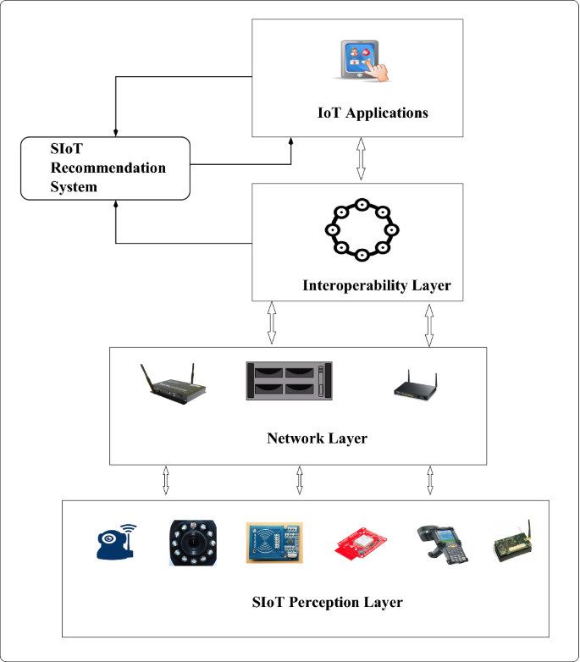

CHAPTER 4
TESTING AND IMPLEMENTATION

  - TESTING
Implementation is the stage of the project when the theoretical design is turned into a working system. This is the final and important phase in the system life cycle It is actually the process of converting the new system into a operational one.

4.1.1Unit Testing
Unit testing comprises the set of tests performed by an individual programmer prior to integration of the unit into a larger system. The module interface is tested to ensure that information properly flows into and out of the program unit. The local data structure is examined to ensure that data stored temporarily maintains its integrity during all steps in an algorithm’s execution. Boundary conditions are tested to ensure that the module operates properly at boundaries established to limit or restrict processing. All independent paths through the control structure are tested. All error-handling paths are tested.

4.1.2 Block Box Testing
Black-box testing is a method of software testing that examines the functionality of an application without peering into its internal structures or workings. This method of test can be applied virtually to every level of software testing: unit, integration, system and acceptance. It is sometimes referred to as specification-based testing.

4.2 SYSTEM IMPLEMENTATION
Implementation is the stage of the project when the theoretical design is turned into a working system. This is the final and important phase in the system life cycle It is actually the process of converting the new system into a operational one.

CHAPTER 5
CONCLUSION:
The emerging idea of the Internet of Things (IoT) is rapidly finding its path throughout our modern life, aiming to improve the quality of life by connecting many smart devices, technologies, and applications. Overall, the IoT would allow for the automation of everything around us. This paper presented an overview of the premise of this concept, its enabling technologies, protocols, applications, and the recent research addressing different aspects of the IoT. This, in turn, should provide a good foundation for researchers and practitioners who are interested to gain an insight into the IoT technologies and protocols to understand the overall architecture and role of the different components and protocols that constitute the IoT. Further, some of the challenges and issues that pertain to the design and deployment of IoT implementations have been presented. Moreover, the interplay between the IoT, big data analytics, cloud and fog computing has been discussed. We finally presented the need for new ―smart‖ autonomic management, data aggregation, and protocol adaptation services to achieve better horizontal integration among IoT service. Finally, detailed application-use cases were presented to illustrate typical protocol integration scenarios to deliver desired IoT services.

CHAPTER-6
REFERENCE
- [1] D. Evans, "The internet of things: How the next evolution of the internet is changing everything," CISCO White Paper, 2011.
- [2] L. Atzori, A. Iera and G. Morabito, "The internet of things: A survey," Computer Networks, vol. 54, pp. 2787-2805, 2010.
- [3] R. Khan, S. U. Khan, R. Zaheer and S. Khan, "Future internet: The internet of things architecture, possible applications and key challenges," in Frontiers of Information Technology (FIT), 2012 10th International Conference On, 2012, pp. 257-260.
- [4] J. Gubbi, R. Buyya, S. Marusic and M. Palaniswami, "Internet of Things (IoT): A vision, architectural elements, and future directions," Future Generation Comput. Syst., vol. 29, pp. 1645- 1660, 2013.
- [5] P. Lopez, D. Fernandez, A. J. Jara and A. F. Skarmeta, "Survey of internet of things technologies for clinical environments," in Advanced Information Networking and Applications Workshops (WAINA), 2013 27th International Conference On, 2013, pp. 1349-1354.
- [6] D. Yang, F. Liu and Y. Liang, "A survey of the internet of things," in Proceedings of the 1st International Conference on EBusiness Intelligence (ICEBI2010), 2010, pp. 358-366.
- [7] A. Gluhak, S. Krco, M. Nati, D. Pfisterer, N. Mitton and T. Razafindralambo, "A survey on facilities for experimental internet of things research," Communications Magazine, IEEE, vol. 49, pp. 58-67, 2011.
- [8] Z. Sheng, S. Yang, Y. Yu, A. V. Vasilakos, J. A. McCann and K. K. Leung, "A survey on the ietf protocol suite for the internet of things: standards, challenges, and opportunities," Wireless Communications, IEEE, vol. 20, pp. 91-98, 2013.
- [9] J. Gantz and D. Reinsel, "The digital universe in 2020: Big data, bigger digital shadows, and biggest growth in the far east," IDC iView: IDC Analyze the Future, vol. 2007, pp. 1-16, 2012.
- [10] S. Taylor, "The Next Generation of the Internet Revolutionizing the Way We Work, Live, Play, and Learn," CISCO Point of View, 2013.

