A Two-Stage Feature Transformation-Based Fingerprint Authentication System for Privacy Protection in IoT

ABSTRACT
Bio-features are fast becoming a key tool to authenticate the IoT devices; in this sense, the purpose of this investigation is to summaries the factors that hinder biometrics models’ development and deployment on a large scale, including human physiological (e.g., face, eyes, fingerprints-palm, or electrocardiogram) and behavioral features (e.g., signature, voice, gait, or keystroke). The different machine learning and data mining methods used by authentication and authorization schemes for mobile IoT devices are provided. Threat models and countermeasures used by biometrics-based authentication schemes for mobile IoT devices are also presented. More specifically, We analyze the state of the art of the existing biometric-based authentication schemes for IoT devices. Based on the current taxonomy, We conclude our paper with different types of challenges for future research efforts in biometrics-based authentication schemes for IoT devices.

CHAPTER 2
2. SYSTEM ANALYSIS
  - EXISTING SYSTEM

- Our system has a conspicuously smaller hardware footprint in comparison to the existing exclusively hardware-based works, and its algorithm is computationally much simpler in comparison to the existing lightweight biometric recognition systems.
- The existing works related to the security vulnerabilities of the AES cryptographic hardware. These Trojans target the hardware functionality in order to harm the biometric data.
- Fingerprint has been used in criminal investigation for a long period of time and is known to provide good accuracy, good execution time and good security.
- A fingerprint is the pattern of friction ridges and valleys on the surface of a fingertip, the formation of which is determined during the first seven months of fetal development.
2.1.1 DRAWBACKS OF EXISTING SYSTEM :
- We emphasize the challenges and open issues of authentication and authorization schemes for mobile IoT devices.
- This amount is calculated without taking into account the economic problems and psychological oppression that victims of this fraud suffer.
- Vocal resonance can be used as a passive biometric, and it achieves high accuracy in terms of identification and verification problems.
- Except from data use issues, general terms such as computer f ear and technophobia also provide established accounts of individuals resistance to use new and unfamiliar information technologies, especially for elder people.
2.2. PROPOSED SYSTEM
- In this work, we propose a cross-layer biometric recognition system that has small computational complexity and is suitable for mobile Internet of Things (IoT) devices.
- Due to the involvement of both hardware and software in realizing this system in a decussate and chaining structure, it is easier to locate and provide alternative paths for the system flow in the case of an attack.
- In order to compare the proposed system with its counterparts, two benchmark recognition systems are adopted.
- The purpose of these Trojans is to sabotage the biometric data that are under process by the biometric recognition system.
- All of the software and the hardware modules of this system are implemented using MATLAB and Verilog HDL, respectively.

2.2.1. ADVANTAGES OF PROPOSED SYSTEM
- Biometric identification is applied nowadays in sectors where security is a top priority, like airports and could be used as a means to control border crossing at sea, land and air frontier.
- The paper also states the benefits of the deep learning technique such as efficient segmentation on large data sets.
- This method can be a basis for future biometric systems that can be fast, efficient and recognize unique characteristics of the human body.
- The authentication of mobile IoT devices will be achieved when the bio-features models becomes sufficiently mature, efficient and resistant to IoT attacks.
- Mobile devices are nowadays an essential part of our everyday life, as they are used for a variety of mobile applications.
Literature Survey:
TITLE | AUTHORS | DESCRIPTION
Automated border control e-gates and facial recognition systems | J. S. del Rio, D. Moctezuma, C. Conde, I. M. de Diego, and E. Cabello, | Automated border control (ABC) systems handle the problems caused by this growth, such as congestion at electronic gates (e-gates) or delays in the planned arrival schedules.
Security analysis of the estonian internet voting system | D. Springall, T. Finkenauer, Z. Durumeric, J. Kitcat, H. Hursti, M. MacAlpine, and J. A. Halderman, | In this paper, we analyze the security of the Estonian I-voting system based on a combination of in-person election observation, code review, and adversarial testing.
A survey of biometric gait recognition: Approaches, security and challenges | D. Gafurov, | Biometric gait recognition (i.e. recognizing people from the way they walk) is one of the recent attractive topics in biometric research.
A survey of user authentication based on mouse dynamics | K. Revett, H. Jahankhani, S. T. de Magalhães, and H. M. Santos, | Most system relies on a continuous monitoring process, or require the user to interact with a program (such as a game) in order to derive sufficient statistical information regarding their mouse dynamics.

2.3 FEASIBILITY STUDY
The feasibility Analysis is an analytical program through project manager determines the project success ratio and through feasibility study project manager able to see either project. The key considerations involved in the feasibility analysis are:
- Economic Feasibility
- Technical Feasibility
- Operational Feasibility
- Environmental Feasibility
2.3.1 ECONOMICAL FEASIBILITY
Hence this project is economically feasible there is no need to involve any cost for this project.
2.3.2 TECHNICAL FEASIBILITY
Software Technologies used are PHP and MySql. In the educational institutions, it is possible to update the system in future. No special hardware is required for the purpose of using this system. Hence it is declared that this project is technically feasible.
2.3.3 OPERATIONAL FEASIBILITY
As the admin work mainly to maintain the Patient and Doctor .Doctor will predict patient cancer disease. Hence it is easy to operate with training. Therefore it is operationally feasible for implementation.
2.3.4 ENVIRONMENTAL FEASIBILITY
This project environment is correct as a admin has developed this system and no expenditure is involved under any head and this process is part of admin document management, this project environment is accessible.

2.4 SYSTEM REQUIREMENTS
- System : Pentium IV 2.4 GHz.
- Hard Disk : 40 GB.
- Monitor : 15 inch VGA Color.
- Mouse : Logitech Mouse.
- Ram : 512 MB
- Keyboard : Standard Keyboard

2.4.1 HARDWARE REQUIREMENTS
The Hardware of the computer consists of physical component such as Input Devices, Storage Devices, Processing & Control units and Output Devices. Computer includes external storage unit to store data in programs.
The Hardware Configuration involved in this project
- System : Pentium IV 2.4 GHz.
- Hard Disk : 40 GB.
- Monitor : 15 inch VGA Color.
- Mouse : Logitech Mouse.
- Ram : 512 MB
- Keyboard : Standard Keyboard

2.4.2 SOFTWARE REQUIREMENTS
Software is a group of programs that computers need to do a particular task. It is an essential requirement of Computer System. The Software used to develop the project is
- Operating System : Windows XP.
- Platform : DOT NET TECHNOLOGY
- Front End : ASP.Net 3.5
- Back End : SQL SERVER 2005

CHAPTER 3
SYSTEM DESIGN AND DEVELOPEMENT
SYSTEM ARCHICTURE

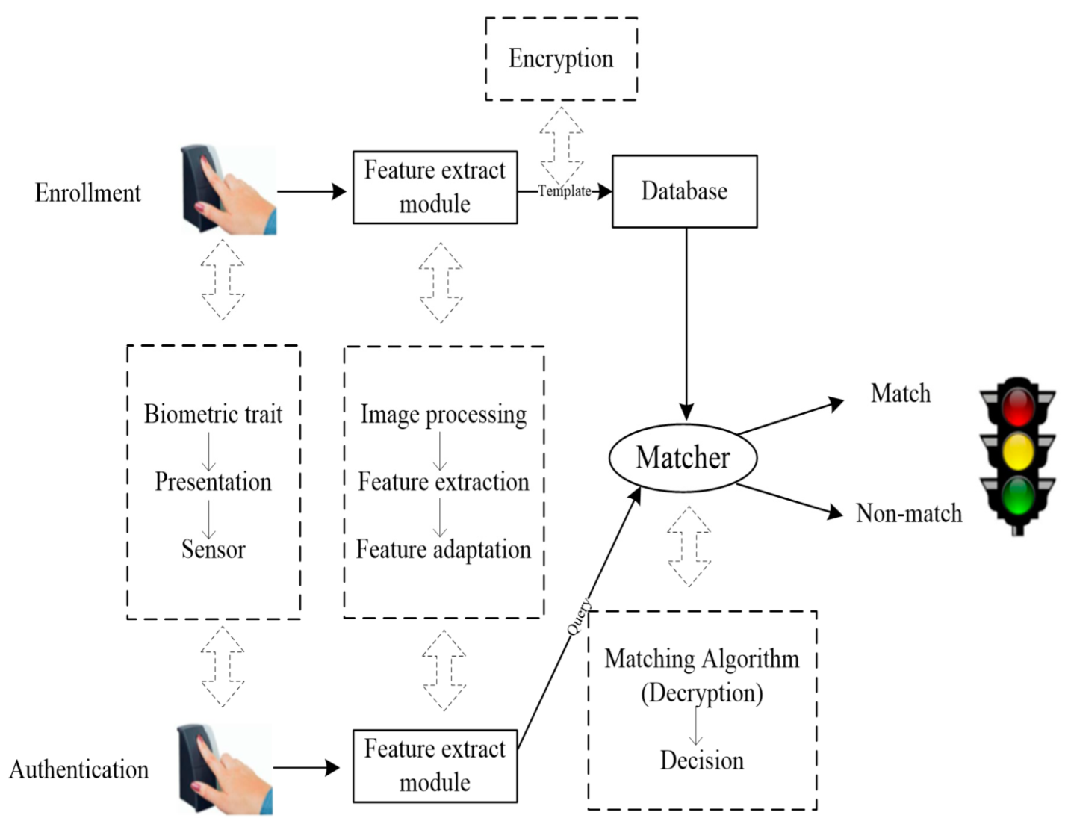

CHAPTER 4
TESTING AND IMPLEMENTATION

  - TESTING
Implementation is the stage of the project when the theoretical design is turned into a working system. This is the final and important phase in the system life cycle It is actually the process of converting the new system into a operational one.

4.1.1Unit Testing
Unit testing comprises the set of tests performed by an individual programmer prior to integration of the unit into a larger system. The module interface is tested to ensure that information properly flows into and out of the program unit. The local data structure is examined to ensure that data stored temporarily maintains its integrity during all steps in an algorithm’s execution. Boundary conditions are tested to ensure that the module operates properly at boundaries established to limit or restrict processing. All independent paths through the control structure are tested. All error-handling paths are tested.

4.1.2 Block Box Testing
Black-box testing is a method of software testing that examines the functionality of an application without peering into its internal structures or workings. This method of test can be applied virtually to every level of software testing: unit, integration, system and acceptance. It is sometimes referred to as specification-based testing.

4.2 SYSTEM IMPLEMENTATION
Implementation is the stage of the project when the theoretical design is turned into a working system. This is the final and important phase in the system life cycle It is actually the process of converting the new system into a operational one.

CHAPTER 5
CONCLUSION:
In this article, we have presented a comprehensive literature review, focusing on authentication and authorization for mobile IoT devices using bio-features, which were published between 2007 and 2018. We presented the machine learning and data mining algorithms used by authentication and authorization schemes for mobile IoT devices, including, unsupervised, semi-supervised, and supervised approaches. We reviewed all the Bio-features used by authentication and authorization schemes for mobile IoT devices. We presented the pitfalls and limitations of the existing authentication and authorization schemes for mobile IoT devices. Several challenging research areas (e.g., doppler radar, vocal resonance, mobile malware threats, adversarial machine learning, machine learning and blockchain-based authentication) will open doors for possible future research directions for mobile IoT devices.

CHAPTER-6
REFERENCE
- [1] J. S. del Rio, D. Moctezuma, C. Conde, I. M. de Diego, and E. Cabello, “Automated border control e-gates and facial recognition systems,” computers & security, vol. 62, pp. 49–72, 2016.
- [2] P. Vinkel and R. Krimmer, “The how and why to internet voting an attempt to explain e-stonia,” in International Joint Conference on Electronic Voting. Springer, 2016, pp. 178–191.
- [3] D. Springall, T. Finkenauer, Z. Durumeric, J. Kitcat, H. Hursti, M. MacAlpine, and J. A. Halderman, “Security analysis of the estonian internet voting system,” in Proceedings of the 2014 ACM SIGSAC Conference on Computer and Communications Security. ACM, 2014, pp. 703–715.
- [4] D. Gafurov, “A survey of biometric gait recognition: Approaches, security and challenges,” in Annual Norwegian computer science conference, 2007, pp. 19–21.
- [5] K. Revett, H. Jahankhani, S. T. de Magalhães, and H. M. Santos, “A survey of user authentication based on mouse dynamics,” in Global E-Security. Springer, 2008, pp. 210–219.
- [6] R. V. Yampolskiy and V. Govindaraju, “Behavioural biometrics: a survey and classification,” International Journal of Biometrics, vol. 1, no. 1, pp. 81–113, 2008.
- [7] D. Shanmugapriya and G. Padmavathi, “A survey of biometric keystroke dynamics: Approaches, security and challenges,” arXiv preprint arXiv:0910.0817, 2009.
- [8] M. Karnan, M. Akila, and N. Krishnaraj, “Biometric personal authentication using keystroke dynamics: A review,” Applied soft computing, vol. 11, no. 2, pp. 1565–1573, 2011.
- [9] S. P. Banerjee and D. L. Woodard, “Biometric authentication and identification using keystroke dynamics: A survey,” Journal of Pattern Recognition Research, vol. 7, no. 1, pp. 116–139, 2012.
- [10] P. S. Teh, A. B. J. Teoh, and S. Yue, “A survey of keystroke dynamics biometrics,” The Scientific World Journal, vol. 2013, 2013.

