Nonnegative Matrix Factorization based Heterogeneous Graph Embedding Method for Trigger-Action Programming in IoT

ABSTRACT
Nowadays, users can personalize IoT devices/Web services via Trigger-Action Programming (TAP). As the number of connected entities grows, the relations of triggers and actions become progressively complex (i.e., the heterogeneity of TAP), which becomes a challenge for existing models to completely preserve the heterogeneous data and semantic information in trigger and action. To address this issue, we propose IoT-NMF, a Nonnegative-Matrix-Factorization-based heterogeneous graph embedding method for TAP. Prior to using IoT-NMF, we map triggers and actions to an IoT Heterogeneous Information Network (IoT-HIN), from which we can extract three structures that preserve heterogeneous relations in triggers and actions. IoT-NMF can factorize the structures simultaneously for getting low-dimensional representation vectors of the triggers and actions, which can be further utilized in Artificial Intelligence of Things (AIoT) applications (e.g., TAP rule recommendation). Lastly, we demonstrate the proposed approach using an IFTTT dataset. The result shows that IoT-NMF outperforms the state-of-the-art approaches.

CHAPTER 2
2. SYSTEM ANALYSIS
  - EXISTING SYSTEM

- Network analysis has attracted considerable attention as networks exist in various complex systems, such as biological and social systems.
- Network analysis heavily relies on the network representation, which is traditionally represented as discrete adjacency matrix.
- However, this straightforward representation usually cannot well reflect the underlying distinct structural characteristics of networks and suffers from the data sparsity issue.
- The representations of nodes within a community should be more similar than those belonging to different communities.
- Therefore, whether the learned embedding space can well reflect the community structures in the original network is a critical requirement for network embedding methods.
2.1.1 DRAWBACKS OF EXISTING SYSTEM :
- These algorithms usually result in an eigenvalue decomposition problem and the communities can be identified from the resultant eigenvectors.
- However, it is generally hard to tell the exact physical meanings of those eigenvectors, which is important for explaining the final results when associated with real world applications.
- In this paper, we propose how to apply nonnegative matrix factorization based methods to solve the community discovery problem.
- In this paper, we will investigate another important issue, community discovery, in network analysis.
2.2. PROPOSED SYSTEM
- In this paper, we propose a novel Modularized Nonnegative Matrix Factorization (M-NMF) model to incorporate the community structure into network embedding.
- We proposed a novel Modularized Nonnegative Matrix Factorization (M-NMF) model for network embedding, which preserves both the microscopic structure (firstand second-order proximities) and mesoscopic community structure.
- A number of community detection methods have been proposed from different perspectives.
- M-NMF0 is our proposed M-NMF model which only preserves the first- and second-order proximities.

2.2.1. ADVANTAGES OF PROPOSED SYSTEM
- We further compare the performance of the proposed Symmetric Nonnegative Matrix Factorization (SNMF) method with other competitive algorithms.
- The data set we used here is the WebKB data set4, which consists of about 6000 web pages from computer science departments of four schools.
- Efficiently identifying those communities can help us to know the nature of those networks better and facilitate the analysis on those large networks.
- The users that are familiar with many users (via user network) while they do not watch similar movies or give similar ratings as their friends can be thought as boundary spanners.
Literature Survey:
TITLE | AUTHORS | DESCRIPTION
The diameter of the world wide web | Albert R, Jeong H, Barabasi A-L (1999) | we use local connectivity measurements to construct a topological model of the world wide web, allowing us to explore and characterize its large scale properties.
Classes of small-world networks | Amaral LAN, Scala A, Bartheélémy M, Stanley HE (2000) | we note for the classes of broad-scale and single-scale networks that there are constraints limiting the addition of new links.
Small-world networks: evidence for a crossover picture | Barthelemy M, Amaral LAN (1999) | We propose that the average distance $\ell$ between any two vertices of the network is a scaling function of $n / n^*$.
Metagenes and molecular pattern discovery using matrix factorization | Brunet JP, Tamayo P, Golub TR, Mesirov JP (2004) | We describe here the use of nonnegative matrix factorization (NMF), an algorithm based on decomposition by parts that can reduce the dimension of expression data from thousands of genes to a handful of metagenes.
2.3 FEASIBILITY STUDY
The feasibility Analysis is an analytical program through project manager determines the project success ratio and through feasibility study project manager able to see either project. The key considerations involved in the feasibility analysis are:
- Economic Feasibility
- Technical Feasibility
- Operational Feasibility
- Environmental Feasibility
2.3.1 ECONOMICAL FEASIBILITY
Hence this project is economically feasible there is no need to involve any cost for this project.
2.3.2 TECHNICAL FEASIBILITY
Software Technologies used are PHP and MySql. In the educational institutions, it is possible to update the system in future. No special hardware is required for the purpose of using this system. Hence it is declared that this project is technically feasible.
2.3.3 OPERATIONAL FEASIBILITY
As the admin work mainly to maintain the Patient and Doctor .Doctor will predict patient cancer disease. Hence it is easy to operate with training. Therefore it is operationally feasible for implementation.
2.3.4 ENVIRONMENTAL FEASIBILITY
This project environment is correct as a admin has developed this system and no expenditure is involved under any head and this process is part of admin document management, this project environment is accessible.
2.4 SYSTEM REQUIREMENTS
- System : Pentium IV 2.4 GHz.
- Hard Disk : 40 GB.
- Monitor : 15 inch VGA Color.
- Mouse : Logitech Mouse.
- Ram : 512 MB
- Keyboard : Standard Keyboard
2.4.1 HARDWARE REQUIREMENTS
The Hardware of the computer consists of physical component such as Input Devices, Storage Devices, Processing & Control units and Output Devices. Computer includes external storage unit to store data in programs.
The Hardware Configuration involved in this project
- System : Pentium IV 2.4 GHz.
- Hard Disk : 40 GB.
- Monitor : 15 inch VGA Color.
- Mouse : Logitech Mouse.
- Ram : 512 MB
- Keyboard : Standard Keyboard
2.4.2 SOFTWARE REQUIREMENTS
Software is a group of programs that computers need to do a particular task. It is an essential requirement of Computer System. The Software used to develop the project is
- Operating System : Windows XP.
- Platform : DOT NET TECHNOLOGY
- Front End : ASP.Net 3.5
- Back End : SQL SERVER 2005

CHAPTER 3
SYSTEM DESIGN AND DEVELOPEMENT
SYSTEM ARCHICTURE

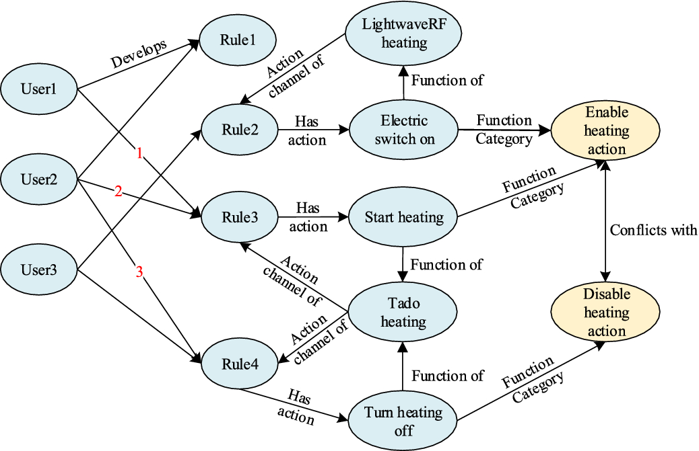

CHAPTER 4
TESTING AND IMPLEMENTATION

  - TESTING
Implementation is the stage of the project when the theoretical design is turned into a working system. This is the final and important phase in the system life cycle It is actually the process of converting the new system into a operational one.

4.1.1Unit Testing
Unit testing comprises the set of tests performed by an individual programmer prior to integration of the unit into a larger system. The module interface is tested to ensure that information properly flows into and out of the program unit. The local data structure is examined to ensure that data stored temporarily maintains its integrity during all steps in an algorithm’s execution. Boundary conditions are tested to ensure that the module operates properly at boundaries established to limit or restrict processing. All independent paths through the control structure are tested. All error-handling paths are tested.

4.1.2 Block Box Testing
Black-box testing is a method of software testing that examines the functionality of an application without peering into its internal structures or workings. This method of test can be applied virtually to every level of software testing: unit, integration, system and acceptance. It is sometimes referred to as specification-based testing.

4.2 SYSTEM IMPLEMENTATION
Implementation is the stage of the project when the theoretical design is turned into a working system. This is the final and important phase in the system life cycle It is actually the process of converting the new system into a operational one.

CHAPTER 5
CONCLUSION:
In this paper, we propose how to apply nonnegative matrix factorization based methods to solve the community discovery problem. We have proposed three concrete algorithms, Symmetric NMF, Asymmetric NMF and Joint NMF to work on undirected networks, directed networks and compound networks, and we also proved the correctness and convergence of those algorithms. Finally the experiments on real world network data sets are presented to show the effectiveness of those methods.

CHAPTER-6
REFERENCE
- Albert R, Jeong H, Barabasi A-L (1999) The diameter of the world wide web. Nature 401:130
- Amaral LAN, Scala A, Bartheélémy M, Stanley HE (2000) Classes of small-world networks. Proc Natl Acad Sci USA 97:11149–11152
- Barthelemy M, Amaral LAN (1999) Small-world networks: evidence for a crossover picture. Phys Rev Lett 82:3180
- Brunet JP, Tamayo P, Golub TR, Mesirov JP (2004) Metagenes and molecular pattern discovery using matrix factorization. Proc Natl Acad Sci USA 102(12):4164–4169
- Chen G, Wang F, Zhang C (2007) Collaborative filtering using orthogonal nonnegative matrix tri-factorization. In: ICDM workshops on high performance computing, pp 303–308
- Ding C, He X, Simon HD (2005) On the equivalence of nonnegative matrix factorization and spectral clustering. In: Proceedings of SIAM international conference on data mining, pp 606–610
- Ding C, Li T, Jordan MI (2006a) Convex and semi-nonnegative matrix factorizations. LBNL Tech Report 60428
- Ding C, Li T, Peng W, Park H (2006b) Orthogonal nonnegative matrix tri-factorizations for clustering. In: SIGKDD, pp 126–135
- Ding C, Li T, Peng W (2008) On the equivalence between nonnegative matrix factorization and probabilistic latent semantic indexing. Comput Stat Data Anal 52(1):155–173
- Faloutsos M, Faloutsos P, Faloutsos C (1999) On power-law relationships of the internet topology. In: SIGCOMM, pp 251–262

