A Transfer Learning Approach for Securing Resource-Constrained IoT Devices

ABSTRACT
In recent years, Internet of Things (IoT) security has attracted significant interest by researchers due to new characteristics of IoT such as heterogeneity of devices, resource constraints, and new types of attacks targeting IoT. Intrusion detection, which is an indispensable part of a security system, is also included in these studies. In order to explore the complex characteristics of IoT, machine learning methods, which rely on long training time to generate intrusion detection models, are proposed in the literature. Furthermore, these systems need to learn a new/fresh model from scratch when the environment changes. This study explores the use of transfer learning in order to generate intrusion detection algorithms for such dynamically changing IoT. Transfer learning is an approach that stores knowledge learned from a problem domain/task and applies that knowledge to another problem domain/task. Here, it is employed in the following two settings: transferring knowledge for generating suitable intrusion algorithms for new devices, transferring knowledge for detecting new types of attacks. In this study, Routing Protocol for Low-Power and Lossy Network (RPL), a routing protocol for resource-constrained wireless networks, is used as an exemplar protocol and specific attacks against RPL are targeted. The experimental results show that the transfer learning approach gives better performance than the traditional approach. Moreover, the proposed approach significantly reduces learning time, which is an important factor for putting devices/networks in operation in a timely manner. Even though transfer learning has been considered a potential candidate for improving IoT security, to the best of our knowledge, this is the first application of transfer learning under these two settings in RPL-based IoT networks.

CHAPTER 2
2. SYSTEM ANALYSIS
  - EXISTING SYSTEM

- It is possible that most of the proficient clients go out of the network, and existing clients do not fulfill system requirements.
- Existing methods in the literature that are proposed to reduce communication overhead can be categorized into decentralized training, compression, and local updating.
- Most existing studies and implementations consider synchronous FL, where the progress of the iteration round’s training period depends on the slowest device within the network.
- Due to mobility of clients, new clients may join a network that is more competent than the existing clients, and any client may leave the network during communication that can hamper the model training.
2.1.1 DRAWBACKS OF EXISTING SYSTEM :
- It is a population-based search algorithm in order to evolve better individuals that correspond to candidate solutions for a targeted problem at each generation.
- The individuals, which represent candidate solutions for the problem at hand, are usually generated randomly in the first population.
- Transfer learning is a way to handle this problem by transferring the information from a source domain to a target domain that has limited data.
- Therefore, the problem at hand becomes a multi-objective problem with the goals of higher accuracy and lower energy consumption.
- This problem is not desired in many GP applications, hence the tree depth parameter is often decreased.
2.2. PROPOSED SYSTEM
- In this work, they eliminate the straggler clients using an optimization technique named ‘soft-training’ that dynamically masks different neurons based on model updates, and their proposed aggregation scheme speeds up the collaborative convergence.
- To ensure convergence in a non-IID scenario, particularly for asynchronous learning, loss functions of the non-convex problem need to be considered, and supportive algorithms should be proposed.
- We need to select clients for training purposes based on system requirements.
- However, due to strict cost and energy requirements, only a few clients might end up meeting the required criterion.

2.2.1. ADVANTAGES OF PROPOSED SYSTEM
- It is unsurprising to observe that the comparative convergence capability of the proposed approach is proportional to its initial performance by showing early convergence behavior.
- Moreover, it is expected to produce higher initial and final performances for the learned model in the new task/domain compared to learning without transfer.
- Attacker node contrarily prefers the worst parent to send or forward packets, which degrades the performance of the network (e.g., end-to-end delay, delivery ratio).
- It is statistically proven that the proposed approach shows much better performance than the traditional approach.
- DR is observed to generally degrade the performance of the proposed approach.
Literature Survey:
TITLE | AUTHORS | DESCRIPTION
Rpl: Ipv6 routing protocol for low-power and lossy networks | T. Winter, P. Thubert, A. Brandt, J. W. Hui, R. Kelsey, P. Levis, K. Pister, R. Struik, J.-P. Vasseur, and R. K. Alexander, | Low-Power and Lossy Networks (LLNs) are a class of network in which both the routers and their interconnect are constrained.
A survey of machine and deep learning methods for internet of things (iot) security | M. A. Al-Garadi, A. Mohamed, A. Al-Ali, X. Du, and M. Guizani, | Machine learning and deep learning (ML/DL) have advanced considerably over the last few years, and machine intelligence has transitioned from laboratory curiosity to practical machinery in several important applications.
A taxonomy of attacks in rpl-based internet of things | A. Mayzaud, R. Badonnel, and I. Chrisment, | These networks support communications amongst objects from the real world, such as home automation devices and embedded sensors, and their interconnection to the Internet.
Genetic programming as a means for programming computers by natural selection | J. R. Koza, | Many seemingly different problems in machine learning, artificial intelligence, and symbolic processing can be viewed as requiring the discovery of a computer program that produces some desired output for particular inputs.

2.3 FEASIBILITY STUDY
The feasibility Analysis is an analytical program through project manager determines the project success ratio and through feasibility study project manager able to see either project. The key considerations involved in the feasibility analysis are:
- Economic Feasibility
- Technical Feasibility
- Operational Feasibility
- Environmental Feasibility
2.3.1 ECONOMICAL FEASIBILITY
Hence this project is economically feasible there is no need to involve any cost for this project.
2.3.2 TECHNICAL FEASIBILITY
Software Technologies used are PHP and MySql. In the educational institutions, it is possible to update the system in future. No special hardware is required for the purpose of using this system. Hence it is declared that this project is technically feasible.
2.3.3 OPERATIONAL FEASIBILITY
As the admin work mainly to maintain the Patient and Doctor .Doctor will predict patient cancer disease. Hence it is easy to operate with training. Therefore it is operationally feasible for implementation.

2.3.4 ENVIRONMENTAL FEASIBILITY
This project environment is correct as a admin has developed this system and no expenditure is involved under any head and this process is part of admin document management, this project environment is accessible.
2.4 SYSTEM REQUIREMENTS
- System : Pentium IV 2.4 GHz.
- Hard Disk : 40 GB.
- Monitor : 15 inch VGA Color.
- Mouse : Logitech Mouse.
- Ram : 512 MB
- Keyboard : Standard Keyboard
2.4.1 HARDWARE REQUIREMENTS
The Hardware of the computer consists of physical component such as Input Devices, Storage Devices, Processing & Control units and Output Devices. Computer includes external storage unit to store data in programs.
The Hardware Configuration involved in this project
- System : Pentium IV 2.4 GHz.
- Hard Disk : 40 GB.
- Monitor : 15 inch VGA Color.
- Mouse : Logitech Mouse.
- Ram : 512 MB
- Keyboard : Standard Keyboard

2.4.2 SOFTWARE REQUIREMENTS
Software is a group of programs that computers need to do a particular task. It is an essential requirement of Computer System. The Software used to develop the project is
- Operating System : Windows XP.
- Platform : DOT NET TECHNOLOGY
- Front End : ASP.Net 3.5
- Back End : SQL SERVER 2005

CHAPTER 3
SYSTEM DESIGN AND DEVELOPEMENT
SYSTEM ARCHICTURE

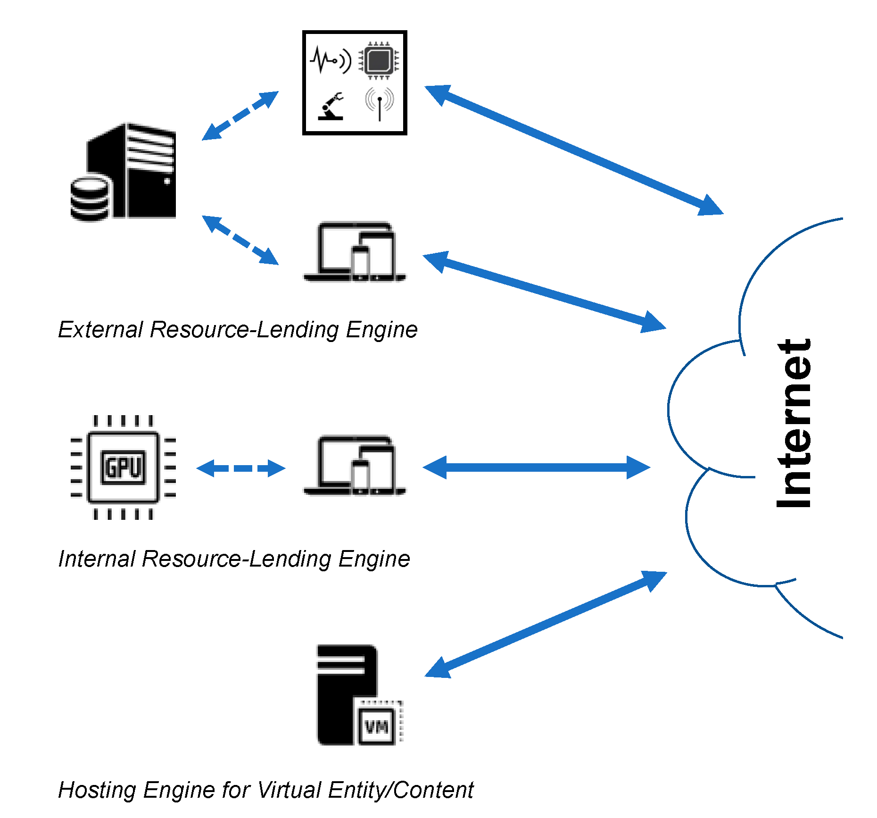

CHAPTER 4
TESTING AND IMPLEMENTATION

  - TESTING
Implementation is the stage of the project when the theoretical design is turned into a working system. This is the final and important phase in the system life cycle It is actually the process of converting the new system into a operational one.

4.1.1Unit Testing
Unit testing comprises the set of tests performed by an individual programmer prior to integration of the unit into a larger system. The module interface is tested to ensure that information properly flows into and out of the program unit. The local data structure is examined to ensure that data stored temporarily maintains its integrity during all steps in an algorithm’s execution. Boundary conditions are tested to ensure that the module operates properly at boundaries established to limit or restrict processing. All independent paths through the control structure are tested. All error-handling paths are tested.

4.1.2 Block Box Testing
Black-box testing is a method of software testing that examines the functionality of an application without peering into its internal structures or workings. This method of test can be applied virtually to every level of software testing: unit, integration, system and acceptance. It is sometimes referred to as specification-based testing.

4.2 SYSTEM IMPLEMENTATION
Implementation is the stage of the project when the theoretical design is turned into a working system. This is the final and important phase in the system life cycle It is actually the process of converting the new system into a operational one.

CHAPTER 5
CONCLUSION:
In this study, the use of the transfer learning approach is explored in order to detect RPL-specific attacks. To the best of the authors’ knowledge, this is the first application of transfer learning in IoT security in the following two settings: transferring knowledge for new types of attacks and transferring knowledge for new devices. In transferring knowledge for new types of attacks, the efficacy of transfer learning is analyzed for detecting different attacks, where three attack scenarios are included: singleto-single, single-to-multi, and multi-to-multi. In transferring knowledge for new devices, the use of transfer learning is explored for generating suitable intrusion detection algorithms for new types of devices with varying energy constraints. While only the accuracy of the generated intrusion detection algorithms is considered for the first setting, the energy consumption of these algorithms is also included in the second setting. The experimental results in both settings prove that the proposed transfer learning-based approach yields better performance than the traditional learning approach in most cases. In addition, it performs higher convergence speed and hence a shorter training time for the evolution of new detection algorithms in a new task/domain. This is especially important for IoT, where new attacks emerge every day and new types of devices can be added to the network. Although the proposed approach targets attacks against RPL, it could be easily adapted to other protocols and/or general attacks in IoT.

CHAPTER-6
REFERENCE
- [1] “Internet of things (iot) connected devices installed base worldwide from 2015 to 2025 (in billions),” https://www.statista.com/statistics/471264/ iot-number-of-connected-devices-worldwide/, accessed: 2020-04-01.
- [2] Cisco, “Cisco visual networking index: Forecast and trends, 2017–2022 white paper,” https://www.cisco.com/c/en/us/solutions/collateral/ service-provider/visual-networking-index-vni/white-paper-c11-741490. html, accessed: 2020-04-01.
- [3] T. Winter, P. Thubert, A. Brandt, J. W. Hui, R. Kelsey, P. Levis, K. Pister, R. Struik, J.-P. Vasseur, and R. K. Alexander, “Rpl: Ipv6 routing protocol for low-power and lossy networks.” rfc, vol. 6550, pp. 1–157, 2012.
- [4] M. A. Al-Garadi, A. Mohamed, A. Al-Ali, X. Du, and M. Guizani, “A survey of machine and deep learning methods for internet of things (iot) security,” arXiv preprint arXiv:1807.11023, 2018.
- [5] A. Mayzaud, R. Badonnel, and I. Chrisment, “A taxonomy of attacks in rpl-based internet of things,” I. J. Network Security, vol. 18, pp. 459– 473, 2016.
- [6] J. R. Koza, “Genetic programming as a means for programming computers by natural selection,” Statistics and Computing, vol. 4, no. 2, pp. 87–112, 1994. [Online]. Available: https://doi.org/10.1007/ BF00175355
- [7] A. E. Eiben, J. E. Smith et al., Introduction to evolutionary computing. Springer, 2003, vol. 53.
- [8] R. Poli, W. B. Langdon, N. F. McPhee, and J. R. Koza, “Genetic programming: An introductory tutorial and a survey of techniques and applications,” University of Essex, UK, Tech. Rep. CES-475, 2007.
- [9] F. Zhuang, Z. Qi, K. Duan, D. Xi, Y. Zhu, H. Zhu, H. Xiong, and Q. He, “A comprehensive survey on transfer learning,” 2019.
- [10] K. Weiss, T. M. Khoshgoftaar, and D. Wang, “A survey of transfer learning,” Journal of Big Data, vol. 3, no. 1, p. 9, 2016. [Online]. Available: https://doi.org/10.1186/s40537-016-0043-6

