Towards Blockchain for Suitable Efficiency and Data Integrity of IoT Ecosystem Transactions

ABSTRACT
This article analyzes the effectiveness of deploying the Blockchain technology in the implementation of the IoT ecosystem database. To this end, we assess the processing efficiency of transactions originated by smart devices and the storeddata integrity. The processing-efficiency evaluation is carried out through queue-theory-based analytical modeling, in which the average time for transaction confirmation is estimated. By its turn, the data-integrity is measured through simulations, where the probability of fraudsters altering already-stored data is estimated. Moreover, the experiments consider a set of scenarios related to different application domains. Final results show that the Blockchain technology may meet IoT efficiency requirements, besides providing adequate data integrity. Lastly, general conclusions and avenues for further research close this article.

CHAPTER 2
2. SYSTEM ANALYSIS
  - EXISTING SYSTEM

- Existing security solutions are not well suited because current IoT devices may consume significant amounts of energy and may have significant processing overhead.
- The propositions that we derive in this paper extend existing academic literature by providing a structured foundation for systematic research that investigates the combined impact of IoT and Blockchain technology on modern supply chains.
- In this paper, we conducted a narrative literature review with the goals of summarizing the existing body of literature, identifying essential research gaps and developing novel research propositions.
- In order to foster incremental research, we especially encourage researchers to carefully investigate the applicability of existing theories to better understand emerging phenomena at the confluence of Blockchain, the IoT, and supply chain management.
2.1.1 DRAWBACKS OF EXISTING SYSTEM :
- Several issues regarding IoT security need to be addressed, including IoT device trust, access control, data integrity, physical tampering, and user privacy.
- Moreover, problems such as counterfeiting, physical tampering, hacking, and data theft might raise trust concerns among supply chain exchange partners.
- When combined‚ these enabling technologies will help firms to overcome problems related to data acquisition and integrity, address security challenges‚ mitigate traceability concerns, and reduce information asymmetry.
- RFID tags help to overcome the (occasional) problematic readability of barcodes in specific industrial environments and result in a higher read accuracy.
2.2. PROPOSED SYSTEM
- A decentralized computation offloading platform was proposed to coordinate tasks among devices and edge servers.
- To assist MEC based offloading for inter-domain traffic, they proposed a blockchain-enabled market to motivate both D2D and MEC nodes.
- They proposed an energy-efficient IoT task offloading algorithm for blockchain-enabled edge computing.
- The participating nodes were authenticated by the smart contract in the proposed FL framework.
- An incentive mechanism was proposed for discharging electrical vehicles to boost the electric power grid.

2.2.1. ADVANTAGES OF PROPOSED SYSTEM
- They pointed out that machine learning (ML) algorithms, such as Q-learning, can improve the performance of the network, in terms of block time minimization and transaction throughput enhancement.
- The transparency, auditability, and distributed properties of blockchains were considered to address issues, such as security, resources management, and energy efficiency.
- Efficient control and incentive of cooperation among edge devices and servers are securely enabled by blockchain.
- MEC improves the scalability of blockchain in a distributed and efficient manner by delivering computing and cache resources to the blockchain enabled IoT systems.
- In the Bitcoin system, which is the most well-known application of public blockchain, proof-of-work (PoW) is used to reach this consensus.
Literature Survey:
TITLE | AUTHORS | DESCRIPTION
A Survey on Consensus Mechanisms and Mining Strategy Management in Blockchain Networks | W. Wang, D. T. Hoang, P. Hu, Z. Xiong, D. Niyato, P. Wang, Y. Wen, andD. I. Kim, | The blockchain network was originated from the Internet financial sector as a decentralized, immutable ledger system for transactional data ordering.
On the Convergence of Blockchain and Internet of Things (IoT) Technologies | M. Maroufi, R. Abdolee, and B. Tazekand, | The Blockchain decentralized nature and its multi-faceted procedures offer a useful mechanism to tackle several of these IoT challenges.
Blockchain for Internet of Things: ASurvey | H. Dai, Z. Zheng, and Y. Zhang, | Internet of Things (IoT) is reshaping the incumbent industry to smart industry featured with data-driven decision-making.
Blockchain mechanisms forIoT security | D. Minoli and B. Occhiogrosso, | There is a need for comprehensive support of security in the IoT, especially for mission-critical applications, but also for the down-stream business applications.

2.3 FEASIBILITY STUDY
The feasibility Analysis is an analytical program through project manager determines the project success ratio and through feasibility study project manager able to see either project. The key considerations involved in the feasibility analysis are:
- Economic Feasibility
- Technical Feasibility
- Operational Feasibility
- Environmental Feasibility
2.3.1 ECONOMICAL FEASIBILITY
Hence this project is economically feasible there is no need to involve any cost for this project.
2.3.2 TECHNICAL FEASIBILITY
Software Technologies used are PHP and MySql. In the educational institutions, it is possible to update the system in future. No special hardware is required for the purpose of using this system. Hence it is declared that this project is technically feasible.
2.3.3 OPERATIONAL FEASIBILITY
As the admin work mainly to maintain the Patient and Doctor .Doctor will predict patient cancer disease. Hence it is easy to operate with training. Therefore it is operationally feasible for implementation.
2.3.4 ENVIRONMENTAL FEASIBILITY
This project environment is correct as a admin has developed this system and no expenditure is involved under any head and this process is part of admin document management, this project environment is accessible.
2.4 SYSTEM REQUIREMENTS
- System : Pentium IV 2.4 GHz.
- Hard Disk : 40 GB.
- Monitor : 15 inch VGA Color.
- Mouse : Logitech Mouse.
- Ram : 512 MB
- Keyboard : Standard Keyboard
2.4.1 HARDWARE REQUIREMENTS
The Hardware of the computer consists of physical component such as Input Devices, Storage Devices, Processing & Control units and Output Devices. Computer includes external storage unit to store data in programs.
The Hardware Configuration involved in this project
- System : Pentium IV 2.4 GHz.
- Hard Disk : 40 GB.
- Monitor : 15 inch VGA Color.
- Mouse : Logitech Mouse.
- Ram : 512 MB
- Keyboard : Standard Keyboard

2.4.2 SOFTWARE REQUIREMENTS
Software is a group of programs that computers need to do a particular task. It is an essential requirement of Computer System. The Software used to develop the project is
- Operating System : Windows XP.
- Platform : DOT NET TECHNOLOGY
- Front End : ASP.Net 3.5
- Back End : SQL SERVER 2005

CHAPTER 3
SYSTEM DESIGN AND DEVELOPEMENT
SYSTEM ARCHICTURE

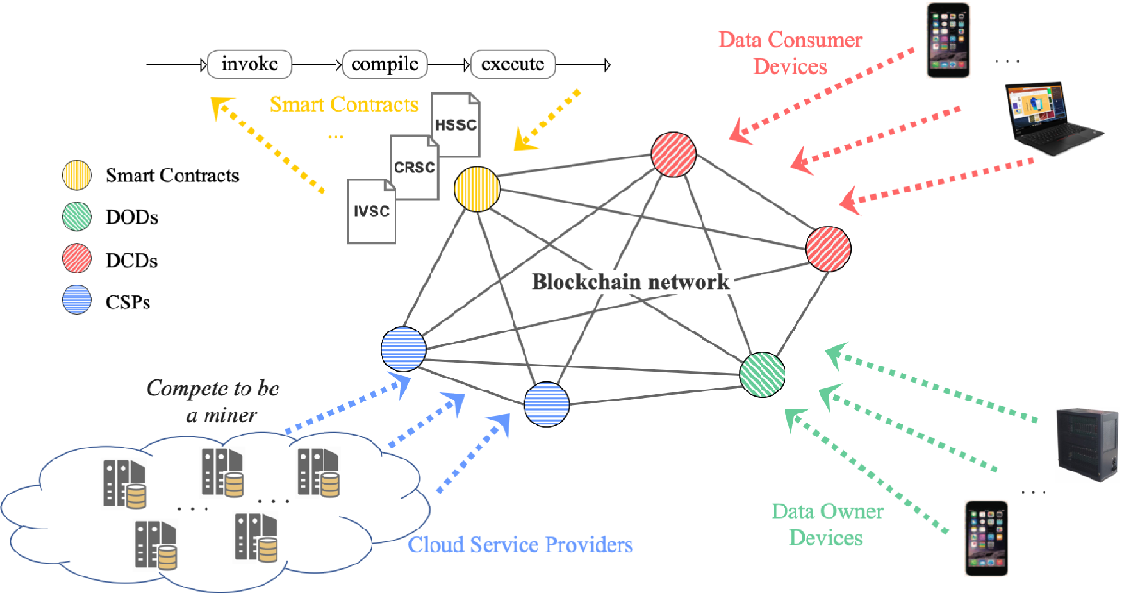

CHAPTER 4
TESTING AND IMPLEMENTATION

  - TESTING
Implementation is the stage of the project when the theoretical design is turned into a working system. This is the final and important phase in the system life cycle It is actually the process of converting the new system into a operational one.

4.1.1Unit Testing
Unit testing comprises the set of tests performed by an individual programmer prior to integration of the unit into a larger system. The module interface is tested to ensure that information properly flows into and out of the program unit. The local data structure is examined to ensure that data stored temporarily maintains its integrity during all steps in an algorithm’s execution. Boundary conditions are tested to ensure that the module operates properly at boundaries established to limit or restrict processing. All independent paths through the control structure are tested. All error-handling paths are tested.

4.1.2 Block Box Testing
Black-box testing is a method of software testing that examines the functionality of an application without peering into its internal structures or workings. This method of test can be applied virtually to every level of software testing: unit, integration, system and acceptance. It is sometimes referred to as specification-based testing.

4.2 SYSTEM IMPLEMENTATION
Implementation is the stage of the project when the theoretical design is turned into a working system. This is the final and important phase in the system life cycle It is actually the process of converting the new system into a operational one.

CHAPTER 5
CONCLUSION:
Este artigo analisou aBlockchainpara implementac ̧ ̃ao dabase de dados do ecossistema IoT. Por meio de modelos defilas e simulac ̧ ̃oes, os experimentos especialmente mostraramqueBlockchainpode ser configurada para atender aos requi-sitos de tempo de confirmac ̧ ̃ao de transac ̧ ̃oes em diferentesaplicac ̧ ̃oes sem impactar a integridade dos dados (i.e., proba-bilidade de fraude≤0,1), desde que o processamento honestodo sistema seja ao menos 70% do total. Essa configurac ̧ ̃aoconsiste na alterac ̧ ̃ao do tamanho do bloco de transac ̧ ̃oes ena reduc ̧ ̃ao da complexidade de seu processamento. Comopesquisas futuras e contemplando limitac ̧ ̃oes deste trabalho,apontam-se: an ́alise de algoritmos de consenso diferentesdo PoW; comparac ̧ ̃ao de implementac ̧ ̃oes de base de dadosdiferentes do tipop ́ublica; estudo de tecnologias de registrosdistribu ́ıdos diferentes daBlockchain; e realizac ̧ ̃ao detestbeds.

CHAPTER-6
REFERENCE
- [1] W. Wang, D. T. Hoang, P. Hu, Z. Xiong, D. Niyato, P. Wang, Y. Wen, andD. I. Kim, “A Survey on Consensus Mechanisms and Mining StrategyManagement in Blockchain Networks,”IEEE Access, vol. 7, pp. 22 328–22 370, 2019, doi: 10.1109/ACCESS.2019.2896108.
- [2] M. Maroufi, R. Abdolee, and B. Tazekand, “On the Convergence ofBlockchain and Internet of Things (IoT) Technologies,”Journal ofStrategic Innovation and Sustainability, vol. 14, no. 1, Mar. 2019,doi:10.33423/jsis.v14i1.990.
- [3] H. Dai, Z. Zheng, and Y. Zhang, “Blockchain for Internet of Things: ASurvey,”IEEE Internet of Things Journal, vol. 6, no. 5, pp. 8076–8094,2019, doi: 10.1109/JIOT.2019.2920987.
- [4] D. Minoli and B. Occhiogrosso, “Blockchain mechanisms forIoT security,”Internet of Things, vol. 1-2, pp. 1 – 13, 2018,doi:10.1016/j.iot.2018.05.002.
- [5] K. Zhang and H. Jacobsen, “Towards Dependable, Scalable, and Per-vasive Distributed Ledgers with Blockchains,” in2018 IEEE 38thInternational Conference on Distributed Computing Systems (ICDCS),July 2018, pp. 1337–1346, doi: 10.1109/ICDCS.2018.00134.
- [6] S. Nakamoto, “Bitcoin: A peer-to-peer electronic cash system,” 2008,Available at: https://bitcoin.org/bitcoin.pdf. Accessed on: June 28th,2020.
- [7] J. J. Hunhevicz and D. M. Hall, “Do you need a blockchain inconstruction? Use case categories and decision framework for DLTdesign options,”Advanced Engineering Informatics, vol. 45, p. 101094,2020, doi:10.1016/j.aei.2020.101094.
- [8] Q. Wang, X. Zhu, Y. Ni, L. Gu, and H. Zhu, “Blockchain for the IoTand industrial IoT: A review,”Internet of Things, p. 100081, 2019,doi:10.1016/j.iot.2019.100081.
- [9] H. Gilbert and H. Handschuh, “Security Analysis of SHA-256 andSisters,” inSelected Areas in Cryptography, M. Matsui and R. J.Zuccherato, Eds. Berlin, Heidelberg: Springer Berlin Heidelberg, 2004,pp. 175–193, doi:10.1007/978-3-540-24654-113.
- [10] M. Jakobsson and A. Juels,Proofs of Work and Bread Pudding Protocols(Extended Abstract).Boston, MA: Springer US, 1999, pp. 258–272,doi: 10.1007/978-0-387-35568-918.

