A Deep Reinforcement Learning Approach for Composing Moving IoT Services

ABSTRACT
We develop a novel framework for efficiently and effectively discovering crowdsourced services that move in close proximity to a user over a period of time. We introduce a moving crowdsourced service model which is modelled as a moving region. We propose a deep reinforcement learning-based composition approach to select and compose moving IoT services considering quality parameters. Additionally, we develop a parallel flock-based service discovery algorithm as a ground-truth to measure the accuracy of the proposed approach. The experiments on two real-world datasets verify the effectiveness and efficiency of the deep reinforcement learning-based approach.

CHAPTER 2
2. SYSTEM ANALYSIS
  - EXISTING SYSTEM

- In this work, we propose the evolution of an existing Edge-IoT architecture to a new improved version in which SDN/NFV are used over the Edge-IoT capabilities.
- We will make an analysis of the related work existing in the field of the Internet of Things and Industrial Internet of Things.
- This sublayer inherits the existing components of the previous GECA 1.0 Edge Layer. That is, it is formed by the Edge nodes or Edge Gateways. Thus, these nodes act as a gateway between the IoT devices and the applications in the Cloud (Business Solution Layer).
- This sublayer includes all the functionalities that previously existed in the Business Solution Layer in GECA 1.0.
2.1.1 DRAWBACKS OF EXISTING SYSTEM :
- In this paper, a task scheduling problem is studied in the EC scenario, and multiple tasks are scheduled to virtual machines (VMs) configured at the edge server by maximizing the longterm task satisfaction degree (LTSD).
- The problem is formulated as a Markov decision process (MDP) for which the state, action, state transition, and reward are designed.
- Two special problems must be addressed for task scheduling in edge computing: time scheduling and resource allocation.
- In, the joint optimization problem of task allocation and the time scheduling problem were formulated as mixed-integer programming (MIP), and the logicbased Benders decomposition (LBBD) approach was proposed to maximize the number of admitted tasks.
2.2. PROPOSED SYSTEM
- The proposed new architecture contemplates the use of Deep Reinforcement Learning techniques for the implementation of the SDN controller.
- In this sense, it is proposed the application of a Deep Q-Learning model for the management of virtual data flows in SDN/NFV in an Edge-IoT architecture according to the required quality of service.
- The Global Edge Computing Architecture and the new mechanism proposed to manage data flows in Software Defined Networks based on GECA.
- The GECA architecture on which this work is based also followed the hierarchical model before the update proposed in this paper.
- Deep Q-Networks is proposed to manage the Network Function Virtualization in Edge-IoT scenarios.
2.2.1. ADVANTAGES OF PROPOSED SYSTEM
- To better evaluate the performance of the proposed DRL-based task scheduling algorithm, the FCFS algorithm and the SJF algorithm were selected as the two benchmark methods.
- The performance comparison of the proposed DRL-based task scheduling algorithm and the baselines toward the task popularity.
- It demonstrates that our proposed algorithm has good convergence performance.
- A heuristic algorithm was proposed in to address the energy-efficient and delay-sensitive task scheduling in IoT edge computing.
- The outcome of the cross-entropy multiplied by the expected discounted cumulative reward is used as the loss function to optimize the policy network parameter θ.
Literature Survey:
TITLE | AUTHORS | DESCRIPTION
A Survey on Internet of Things: Architecture, Enabling Technologies, Security and Privacy, and Applications | Lin, J.; Yu, W.; Zhang, N.; Yang, X.; Zhang, H.; Zhao, W. | To investigate the fog/edge computing-based IoT, this paper also investigate the relationship between IoT and fog/edge computing, and discuss issues in fog/edge computing-based IoT.
Reference Architectures for the Internet of Things | Weyrich, M.; Ebert, C. | The Internet of Things (IoT) is about innovative functionality and better productivity by seamlessly connecting devices.
Computation Offloading for Service Workflow in Mobile Cloud Computing | Deng, S.; Huang, L.; Taheri, J.; Zomaya, A.Y. | A mobile device should judiciously determine whether to offload computation as well as what portion of an application should be offloaded to the cloud.
Mobile Edge Computing: A Survey | Abbas, N.; Zhang, Y.; Taherkordi, A.; Skeie, T. | Traditional telecom network operators perform traffic control flow (forwarding and filtering of packets), but in Mobile Edge Computing, cloud servers are also deployed in each base station.
2.3 FEASIBILITY STUDY
The feasibility Analysis is an analytical program through project manager determines the project success ratio and through feasibility study project manager able to see either project. The key considerations involved in the feasibility analysis are:
- Economic Feasibility
- Technical Feasibility
- Operational Feasibility
- Environmental Feasibility
2.3.1 ECONOMICAL FEASIBILITY
Hence this project is economically feasible there is no need to involve any cost for this project.
2.3.2 TECHNICAL FEASIBILITY
Software Technologies used are PHP and MySql. In the educational institutions, it is possible to update the system in future. No special hardware is required for the purpose of using this system. Hence it is declared that this project is technically feasible.
2.3.3 OPERATIONAL FEASIBILITY
As the admin work mainly to maintain the Patient and Doctor .Doctor will predict patient cancer disease. Hence it is easy to operate with training. Therefore it is operationally feasible for implementation.

2.3.4 ENVIRONMENTAL FEASIBILITY
This project environment is correct as a admin has developed this system and no expenditure is involved under any head and this process is part of admin document management, this project environment is accessible.
2.4 SYSTEM REQUIREMENTS
- System : Pentium IV 2.4 GHz.
- Hard Disk : 40 GB.
- Monitor : 15 inch VGA Color.
- Mouse : Logitech Mouse.
- Ram : 512 MB
- Keyboard : Standard Keyboard

2.4.1 HARDWARE REQUIREMENTS
The Hardware of the computer consists of physical component such as Input Devices, Storage Devices, Processing & Control units and Output Devices. Computer includes external storage unit to store data in programs.
The Hardware Configuration involved in this project
- System : Pentium IV 2.4 GHz.
- Hard Disk : 40 GB.
- Monitor : 15 inch VGA Color.
- Mouse : Logitech Mouse.
- Ram : 512 MB
- Keyboard : Standard Keyboard

2.4.2 SOFTWARE REQUIREMENTS
Software is a group of programs that computers need to do a particular task. It is an essential requirement of Computer System. The Software used to develop the project is
- Operating System : Windows XP.
- Platform : DOT NET TECHNOLOGY
- Front End : ASP.Net 3.5
- Back End : SQL SERVER 2005

CHAPTER 3
SYSTEM DESIGN AND DEVELOPEMENT
SYSTEM ARCHICTURE

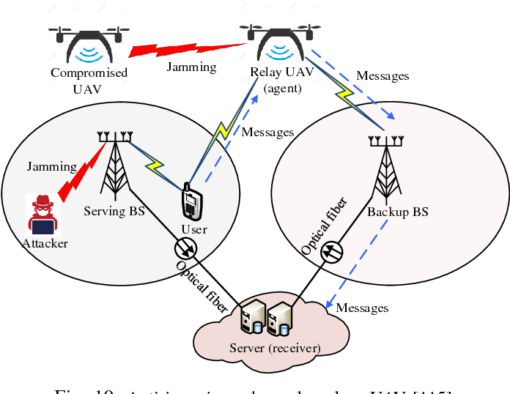

CHAPTER 4
TESTING AND IMPLEMENTATION

  - TESTING
Implementation is the stage of the project when the theoretical design is turned into a working system. This is the final and important phase in the system life cycle It is actually the process of converting the new system into a operational one.

4.1.1Unit Testing
Unit testing comprises the set of tests performed by an individual programmer prior to integration of the unit into a larger system. The module interface is tested to ensure that information properly flows into and out of the program unit. The local data structure is examined to ensure that data stored temporarily maintains its integrity during all steps in an algorithm’s execution. Boundary conditions are tested to ensure that the module operates properly at boundaries established to limit or restrict processing. All independent paths through the control structure are tested. All error-handling paths are tested.

4.1.2 Block Box Testing
Black-box testing is a method of software testing that examines the functionality of an application without peering into its internal structures or workings. This method of test can be applied virtually to every level of software testing: unit, integration, system and acceptance. It is sometimes referred to as specification-based testing.

4.2 SYSTEM IMPLEMENTATION
Implementation is the stage of the project when the theoretical design is turned into a working system. This is the final and important phase in the system life cycle It is actually the process of converting the new system into a operational one.

CHAPTER 5
CONCLUSION:
This paper proposes the computationally-intensive task scheduling problem in the IoT edge system, where the task execution order and task allocation are jointly optimized. We formulate the optimization problems as an MDP model, where the state, action, reward, and state transition are carefully designed. To reduce the dimension of the action space, the scheduling time step is decoupled from the real time step. A policy-based deep reinforcement learning algorithm is applied to solve the MDP. It demonstrates that our proposed algorithm has good convergence performance. Moreover, extensive simulations are conducted to evaluate the cumulative task satisfaction degree and success ratio. The results show that the proposed algorithm outperforms other benchmark methods. Future work will focus on collaborative cloud computing and edge computing, where the communication delay will be taken into account.

CHAPTER-6
REFERENCE
- 1. Lin, J.; Yu, W.; Zhang, N.; Yang, X.; Zhang, H.; Zhao, W. A Survey on Internet of Things: Architecture, Enabling Technologies, Security and Privacy, and Applications. IEEE Internet Things J. 2017, 4, 1125–1142. [CrossRef]
- 2. Weyrich, M.; Ebert, C. Reference Architectures for the Internet of Things. IEEE Softw. 2016, 33, 112–116. [CrossRef]
- 3. Deng, S.; Huang, L.; Taheri, J.; Zomaya, A.Y. Computation Offloading for Service Workflow in Mobile Cloud Computing. IEEE Trans. Parallel Distrib. Syst. 2015, 26, 3317–3329. [CrossRef]
- 4. Abbas, N.; Zhang, Y.; Taherkordi, A.; Skeie, T. Mobile Edge Computing: A Survey. IEEE Internet Things J. 2018, 5, 450–465. [CrossRef]
- 5. Shi, W.; Cao, J.; Zhang, Q.; Li, Y.; Xu, L. Edge Computing: Vision and Challenges. IEEE Internet Things J. 2016, 3, 637–646. [CrossRef]
- 6. Yan, J.; Bi, S.; Zhang, Y.J.A. Offloading and Resource Allocation With General Task Graph in Mobile Edge Computing: A Deep Reinforcement Learning Approach. IEEE Trans. Wirel. Commun. 2020, 19, 5404–5419. [CrossRef]
- 7. Ren, J.; Yu, G.; He, Y.; Li, G.Y. Collaborative Cloud and Edge Computing for Latency Minimization. IEEE Trans. Veh. Technol. 2019, 68, 5031–5044. [CrossRef]
- 8. Fan, Q.; Ansari, N. Application Aware Workload Allocation for Edge Computing-Based IoT. IEEE Internet Things J. 2018, 5, 2146–2153. [CrossRef]
- 9. Samie, F.; Bauer, L.; Henkel, J. From Cloud Down to Things: An Overview of Machine Learning in Internet of Things. IEEE Internet Things J. 2019, 6, 4921–4934. [CrossRef]
- 10. Lin, L.; Liao, X.; Jin, H.; Li, P. Computation Offloading Toward Edge Computing. Proc. IEEE 2019, 107, 1584–1607. [CrossRef]

