Constrained App Data Caching over Edge Server Graphs in Edge Computing Environment

ABSTRACT
In recent years, edge computing, as an extension of cloud computing, has emerged as a promising paradigm for powering a variety of applications demanding low latency, e.g., virtual or augmented reality, interactive gaming, real-time navigation, etc. In the edge computing environment, edge servers are deployed at base stations to offer highly-accessible computing capacities to nearby end-users, e.g., CPU, RAM, storage, etc. From a service provider's perspective, caching app data on edge servers can ensure low latency in its users' data retrieval. Given constrained cache spaces on edge servers due to their physical sizes, the optimal data caching strategy must minimize overall user latency. In this paper, we formulate this Constrained Edge Data Caching (CEDC) problem as a constrained optimization problem from the service provider's perspective and prove its NP-hardness. We propose an optimal approach named CEDC-IP to solve this CEDC problem exactly with the Integer Programming technique. We also provide an approximation algorithm named CEDC-A for finding approximate solutions to large-scale CEDC problems efficiently and prove its approximation ratio. CEDC-IP and CEDC-A are evaluated on a real-world data set and a synthesized data set. The results demonstrate that they significantly outperform four representative approaches.

CHAPTER 2
2. SYSTEM ANALYSIS
  - EXISTING SYSTEM

- Existing PID controllers used in grid resource information system support monitoring, managing, deploying resources and services dynamically.
- The existing algorithm that reflects the rate of change in PID output has an advantage in environment with low rate of change.
- However, existing cloud computing has inevitable latency caused by its geographical location and the huge traffic concentrated in the central cloud.
- Existing caching techniques predominantly predict user patterns or data flows and deploy data in advance to provide data when needed by users.
- The possibility of this framework and the proposed algorithm was confirmed by comparing with the PID basic algorithm and the existing algorithm.
2.1.1 DRAWBACKS OF EXISTING SYSTEM :
- In this paper, we investigate the collaborative caching problem in the EC environment with the aim to minimize the system cost including data caching cost, data migration cost and quality-of-service (QoS) penalty.
- In the long-term, how to keep an app vendor’s edge caching system stable over time across multiple time slots is the key problem to be solved in this paper.
- We refer to this data caching problem in the EC environment collaborative edge data caching (CEDC) problem.
- To quantify the optimization objective and constraints in the CEDC problem in a generic manner, we measure the data sizes and cache spaces by the number of data units, and the data retrieval latency with the number of hops.
2.2. PROPOSED SYSTEM
- We hope the proposed algorithm not only supports high-quality cloud service by reducing network latency and congestion, but also contributes real-time services, such as AR and VR, autonomous vehicles, and ITS.
- The proposed algorithm considers the rate-of-change of the output of the PID controller.
- Within that environment, we used four experimental scenarios to evaluate the proposed rate-control algorithm for in- and outflows and caching of streaming data on resource-limited edge nodes.
- The proposed algorithm also reflects the rate of change in the PID output and increases sensitivity.
- Lightweight, agile caching with a PID controller is proposed as an efficient rate-control algorithm for streaming high-quality data.
2.2.1. ADVANTAGES OF PROPOSED SYSTEM
- To analyze the performance of our CEDC-O comprehensively, we conducted seven sets of simulations to observe its performance in different CEDC scenarios.
- This way, we can compare the performance of the four approaches and observe how the changes in the setting parameters impact the performance of CEDC-O.
- They addressed this issue with a holistic model for provisioning the storage capability based on the network performance and the provisioning cost.
- By innovatively and realistically modeling the CEDC problem as a long-term optimization problem, CEDC-O can help app vendors ensure the longterm performance of their edge data caching performance.
Literature Survey:
TITLE | AUTHORS | DESCRIPTION
The foundation of the mobile and wireless communications system for 2020 and beyond: Challenges, enablers and technology solutions | A. Osseiran, V. Braun, T. Hidekazu, P. Marsch, H. Schotten, H. Tullberg, M. A. Uusitalo, and M. Schellman, | The variety of applications and data traffic types will be significantly larger than today, and will result in more diverse requirements on services, devices and networks.
Optimal edge user allocation in edge computing with variable sized vector bin packing | P. Lai, Q. He, M. Abdelrazek, F. Chen, J. Hosking, J. Grundy, and Y. Yang, | In mobile edge computing, edge servers are geographically distributed around base stations placed near end-users to provide highly accessible and efficient computing capacities and services
Computation peer offloading for energy-constrained mobile edge computing in small-cell networks | L. Chen, S. Zhou, and J. Xu, | OPEN works online without requiring information about future system dynamics, yet provides provably near-optimal performance compared with the oracle solution that has the complete future information.
Computation offloading and resource allocation in wireless cellular networks with mobile edge computing | C. Wang, C. Liang, F. R. Yu, Q. Chen, and L. Tang, | Mobile edge computing has risen as a promising technology for augmenting the computational capabilities of mobile devices.

2.3 FEASIBILITY STUDY
The feasibility Analysis is an analytical program through project manager determines the project success ratio and through feasibility study project manager able to see either project. The key considerations involved in the feasibility analysis are:
- Economic Feasibility
- Technical Feasibility
- Operational Feasibility
- Environmental Feasibility
2.3.1 ECONOMICAL FEASIBILITY
Hence this project is economically feasible there is no need to involve any cost for this project.
2.3.2 TECHNICAL FEASIBILITY
Software Technologies used are PHP and MySql. In the educational institutions, it is possible to update the system in future. No special hardware is required for the purpose of using this system. Hence it is declared that this project is technically feasible.
2.3.3 OPERATIONAL FEASIBILITY
As the admin work mainly to maintain the Patient and Doctor .Doctor will predict patient cancer disease. Hence it is easy to operate with training. Therefore it is operationally feasible for implementation.
2.3.4 ENVIRONMENTAL FEASIBILITY
This project environment is correct as a admin has developed this system and no expenditure is involved under any head and this process is part of admin document management, this project environment is accessible.

2.4 SYSTEM REQUIREMENTS
- System : Pentium IV 2.4 GHz.
- Hard Disk : 40 GB.
- Monitor : 15 inch VGA Color.
- Mouse : Logitech Mouse.
- Ram : 512 MB
- Keyboard : Standard Keyboard

2.4.1 HARDWARE REQUIREMENTS
The Hardware of the computer consists of physical component such as Input Devices, Storage Devices, Processing & Control units and Output Devices. Computer includes external storage unit to store data in programs.
The Hardware Configuration involved in this project
- System : Pentium IV 2.4 GHz.
- Hard Disk : 40 GB.
- Monitor : 15 inch VGA Color.
- Mouse : Logitech Mouse.
- Ram : 512 MB
- Keyboard : Standard Keyboard

2.4.2 SOFTWARE REQUIREMENTS
Software is a group of programs that computers need to do a particular task. It is an essential requirement of Computer System. The Software used to develop the project is
- Operating System : Windows XP.
- Platform : DOT NET TECHNOLOGY
- Front End : ASP.Net 3.5
- Back End : SQL SERVER 2005

CHAPTER 3
SYSTEM DESIGN AND DEVELOPEMENT
SYSTEM ARCHICTURE

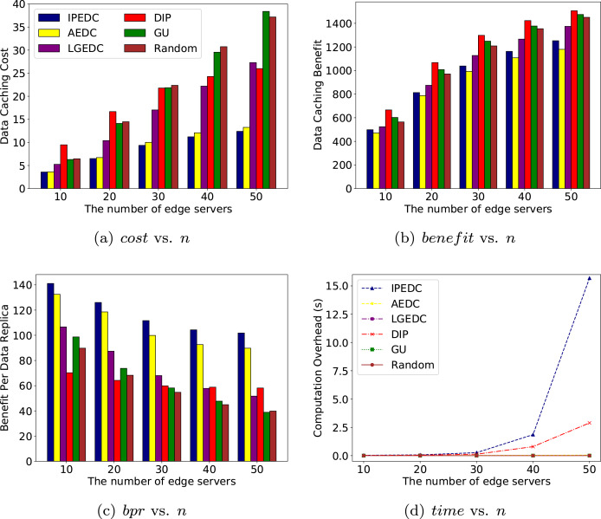

CHAPTER 4
TESTING AND IMPLEMENTATION

  - TESTING
Implementation is the stage of the project when the theoretical design is turned into a working system. This is the final and important phase in the system life cycle It is actually the process of converting the new system into a operational one.

4.1.1Unit Testing
Unit testing comprises the set of tests performed by an individual programmer prior to integration of the unit into a larger system. The module interface is tested to ensure that information properly flows into and out of the program unit. The local data structure is examined to ensure that data stored temporarily maintains its integrity during all steps in an algorithm’s execution. Boundary conditions are tested to ensure that the module operates properly at boundaries established to limit or restrict processing. All independent paths through the control structure are tested. All error-handling paths are tested.

4.1.2 Block Box Testing
Black-box testing is a method of software testing that examines the functionality of an application without peering into its internal structures or workings. This method of test can be applied virtually to every level of software testing: unit, integration, system and acceptance. It is sometimes referred to as specification-based testing.

4.2 SYSTEM IMPLEMENTATION
Implementation is the stage of the project when the theoretical design is turned into a working system. This is the final and important phase in the system life cycle It is actually the process of converting the new system into a operational one.

CHAPTER 5
CONCLUSION:
In this paper, we studied the collaborative edge data caching (CEDC) problem. We first identified the major challenges and proposed a comprehensive cost model for this problem, where system cost is composed of data caching cost, data migration cost and QoS penalty. We also proved the N Pcompleteness of the CEDC problem. We proposed CEDC-O, an online algorithm with provable performance guarantee, and evaluated its performance with extensive simulations. This research has established the foundation for the CEDC problem and opened up a number of future research directions. In our future work, we will consider dynamics on available edge server caches, user mobility and security policies.

CHAPTER-6
REFERENCE
- [1] A. Osseiran, V. Braun, T. Hidekazu, P. Marsch, H. Schotten, H. Tullberg, M. A. Uusitalo, and M. Schellman, “The foundation of the mobile and wireless communications system for 2020 and beyond: Challenges, enablers and technology solutions,” in IEEE 77th Vehicular Technology Conference (VTC2013-Spring), 2013, pp. 1– 5.
- [2] P. Lai, Q. He, M. Abdelrazek, F. Chen, J. Hosking, J. Grundy, and Y. Yang, “Optimal edge user allocation in edge computing with variable sized vector bin packing,” in International Conference on Service-Oriented Computing, 2018, pp. 230–245.
- [3] T. X. Tran, M.-P. Hosseini, and D. Pompili, “Mobile edge computing: Recent efforts and five key research directions,” IEEE COMSOC MMTC Commun.-Frontiers, vol. 12, no. 4, pp. 29–33, 2017.
- [4] L. Chen, S. Zhou, and J. Xu, “Computation peer offloading for energy-constrained mobile edge computing in small-cell networks,” IEEE/ACM Transactions on Networking, vol. 26, no. 4, pp. 1619–1632, 2018.
- [5] C. Wang, C. Liang, F. R. Yu, Q. Chen, and L. Tang, “Computation offloading and resource allocation in wireless cellular networks with mobile edge computing,” IEEE Transactions on Wireless Communications, vol. 16, no. 8, pp. 4924–4938, 2017.
- [6] C. You, K. Huang, H. Chae, and B.-H. Kim, “Energy-efficient resource allocation for mobile-edge computation offloading,” IEEE Transactions on Wireless Communications, vol. 16, no. 3, pp. 1397– 1411, 2017.
- [7] X. Chen, L. Jiao, W. Li, and X. Fu, “Efficient multi-user computation offloading for mobile-edge cloud computing,” IEEE/ACM Transactions on Networking, vol. 24, no. 5, pp. 2795–2808, 2016.
- [8] Q. He, G. Cui, X. Zhang, F. Chen, S. Deng, H. Jin, Y. Li, and Y. Yang, “A game-theoretical approach for user allocation in edge computing environment,” IEEE Transactions on Parallel and Distributed Systems, 2019.
- [9] P. Stenstrom, “A survey of cache coherence schemes for multiprocessors,” Computer, vol. 23, no. 6, pp. 12–24, 1990.
- [10] J. D. Owens, D. Luebke, N. Govindaraju, M. Harris, J. Kruger, ¨ A. E. Lefohn, and T. J. Purcell, “A survey of general-purpose computation on graphics hardware,” in Computer graphics forum, vol. 26, no. 1. Wiley Online Library, 2007, pp. 80–113.

