Accurate and Efficient Monitoring for Virtualized SDN in Clouds

ABSTRACT
This paper presents V-Sight, a network monitoring framework for programmable virtual networks in clouds. Network virtualization based on software-defined networking (SDN-NV) in clouds makes it possible to realize programmable virtual networks; consequently, this technology offers many benefits to cloud services for tenants. However, to the best of our knowledge, network monitoring, which is a prerequisite for managing and optimizing virtual networks, has not been investigated in the context of SDN-NV systems. As the first framework for network monitoring in SDN-NV, we identify three challenges: non-isolated and inaccurate statistics, high monitoring delay, and excessive control channel consumption for gathering statistics. To address these challenges, V-Sight introduces three key mechanisms: 1) statistics virtualization for isolated statistics, 2) transmission disaggregation for reduced transmission delay, and 3) pCollector aggregation for efficient control channel consumption. The evaluation results reveal that V-Sight successfully provides accurate and isolated statistics while reducing the monitoring delay and control channel consumption in orders of magnitude. We also show that V-Sight can achieve a data plane throughput close to that of non-virtualized SDN.

CHAPTER 2
2. SYSTEM ANALYSIS
  - EXISTING SYSTEM

- The special features of cloud-fog, other existing orchestrations, such as the one from cloud, cannot be applied.
- It can reduce the overall energy consumption by an average of 20%, compared to existing IoT networks.
- There exist already research studies for each layer. In this paper, we introduce some works used SDN in hybrid cloud-fog systems, mostly for connecting the cloud layer to the fog layer, or connecting fog nodes together for different use cases.
- We should consider that fog is tightly linked to the existence of a cloud, and it cannot work in a standalone mode.
- ScalCon outperforms existing schemes in terms of path computation time, path setup latency, end-to-end delay and communication overhead.
2.1.1 DRAWBACKS OF EXISTING SYSTEM :
- One way to solve this problem is for the “hypervisor” software that provides processor virtualization also implements as many virtual NICs (vNICs) as there are VMs.
- However, the problem of routing using ASPs’ policies in a very dynamic multi-cloud environment is not possible since Internet service providers (ISPs) offer no service to dynamically route messages to a different server using an ASP’s policies.
- This is the time when researchers, startups, and all vendors need to pay attention since this is the opportunity to make an impact.
- SDN is expected to make the networks programmable and easily partitionable and virtualizable. These features are required for cloud computing where the network infrastructure is shared by a number of competing entities.
2.2. PROPOSED SYSTEM
- In the research paper, the authors proposed a dynamic offloading mechanism among the fog nodes to address the challenge of static offloading and oblivious link selection in vehicular networks.
- In the proposed method, the SDN controller collects the statistics, computational capabilities status, and supported services of a fog node, using the fog agent.
- To analyze the performance of proposed solutions, the authors considered three environments, where the links and nodes reliability could be good, poor and mixed.
- They also proposed an algorithm (which is dependent on partitioning the SDN virtually) to select the optimal access point and optimal place to process the data.

2.2.1. ADVANTAGES OF PROPOSED SYSTEM
- The service may be partitioned for improved performance, with each partition hosted on a different group of servers.
- Proxies can be located anywhere on the global Internet. Of course, they should be located in proximity to users and servers for optimal performance.
- This is quite inefficient, but is how current Internet control protocols work. Centralization of control makes sensing the state and adjusting the control dynamically based on state changes much faster than with distributed protocols.
- Each processor can run multiple virtual machines (VMs), and each machine can be used by a different user.
- This is the case with storage, where a large number of inexpensive unreliable disks can be used to make up large reliable storage.
Literature Survey:
TITLE | AUTHORS | DESCRIPTION
Routing Bridges (RBridges): Base Protocol Specification | R. Perlman et al., | The design supports VLANs and the optimization of the distribution of multi-destination frames based on VLAN ID and based on IP-derived multicast groups.
NVGRE: Network Virtualization Using Generic Routing Encapsulation | M. Sridharan et al., | Network Virtualization decouples virtual networks and addresses from physical network infrastructure, providing isolation and concurrency between multiple virtual networks on the same physical network infrastructure.
VXLAN: A Framework for Overlaying Virtualized Layer 2 Networks over Layer 3 Networks | M. Mahalingam et al., | The scheme and the related protocols can be used in networks for cloud service providers and enterprise data centers.
A Stateless Transport Tunneling Protocol for Network Virtualization (STT) | B. Davie, Ed., J. Gross, | STT is particularly useful when some tunnel endpoints are in end-systems, as it utilizes the capabilities of the network interface card to improve performance.

2.3 FEASIBILITY STUDY
The feasibility Analysis is an analytical program through project manager determines the project success ratio and through feasibility study project manager able to see either project. The key considerations involved in the feasibility analysis are:
- Economic Feasibility
- Technical Feasibility
- Operational Feasibility
- Environmental Feasibility
2.3.1 ECONOMICAL FEASIBILITY
Hence this project is economically feasible there is no need to involve any cost for this project.
2.3.2 TECHNICAL FEASIBILITY
Software Technologies used are PHP and MySql. In the educational institutions, it is possible to update the system in future. No special hardware is required for the purpose of using this system. Hence it is declared that this project is technically feasible.
2.3.3 OPERATIONAL FEASIBILITY
As the admin work mainly to maintain the Patient and Doctor .Doctor will predict patient cancer disease. Hence it is easy to operate with training. Therefore it is operationally feasible for implementation.
2.3.4 ENVIRONMENTAL FEASIBILITY
This project environment is correct as a admin has developed this system and no expenditure is involved under any head and this process is part of admin document management, this project environment is accessible.

2.4 SYSTEM REQUIREMENTS
- System : Pentium IV 2.4 GHz.
- Hard Disk : 40 GB.
- Monitor : 15 inch VGA Color.
- Mouse : Logitech Mouse.
- Ram : 512 MB
- Keyboard : Standard Keyboard

2.4.1 HARDWARE REQUIREMENTS
The Hardware of the computer consists of physical component such as Input Devices, Storage Devices, Processing & Control units and Output Devices. Computer includes external storage unit to store data in programs.
The Hardware Configuration involved in this project
- System : Pentium IV 2.4 GHz.
- Hard Disk : 40 GB.
- Monitor : 15 inch VGA Color.
- Mouse : Logitech Mouse.
- Ram : 512 MB
- Keyboard : Standard Keyboard

2.4.2 SOFTWARE REQUIREMENTS
Software is a group of programs that computers need to do a particular task. It is an essential requirement of Computer System. The Software used to develop the project is
- Operating System : Windows XP.
- Platform : DOT NET TECHNOLOGY
- Front End : ASP.Net 3.5
- Back End : SQL SERVER 2005

CHAPTER 3
SYSTEM DESIGN AND DEVELOPEMENT
SYSTEM ARCHICTURE

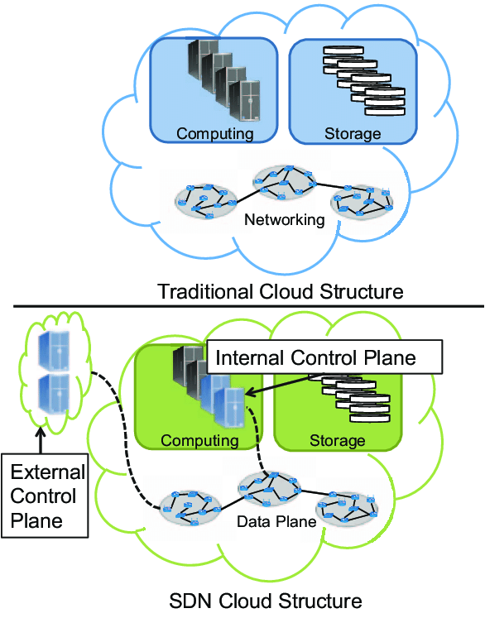

CHAPTER 4
TESTING AND IMPLEMENTATION

  - TESTING
Implementation is the stage of the project when the theoretical design is turned into a working system. This is the final and important phase in the system life cycle It is actually the process of converting the new system into a operational one.

4.1.1Unit Testing
Unit testing comprises the set of tests performed by an individual programmer prior to integration of the unit into a larger system. The module interface is tested to ensure that information properly flows into and out of the program unit. The local data structure is examined to ensure that data stored temporarily maintains its integrity during all steps in an algorithm’s execution. Boundary conditions are tested to ensure that the module operates properly at boundaries established to limit or restrict processing. All independent paths through the control structure are tested. All error-handling paths are tested.

4.1.2 Block Box Testing
Black-box testing is a method of software testing that examines the functionality of an application without peering into its internal structures or workings. This method of test can be applied virtually to every level of software testing: unit, integration, system and acceptance. It is sometimes referred to as specification-based testing.

4.2 SYSTEM IMPLEMENTATION
Implementation is the stage of the project when the theoretical design is turned into a working system. This is the final and important phase in the system life cycle It is actually the process of converting the new system into a operational one.

CHAPTER 5
CONCLUSION:
Cloud computing is a result of advances in virtualization in computing, storage, and networking. Networking virtualization is still in its infancy. Numerous standards related to network virtualization have recently been developed in the IEEE and Internet Engineering Task Force (IETF), and several are still being developed. One of the key recent developments in this direction is software defined networking. The key innovations of SDN are separation of the control and data planes, centralization of control, programmability, and standard southbound, northbound, and east-west APIs. This will allow a large number of devices to easily be orchestrated (programmed). OpenFlow is the standard southbound API being defined by Open Networking Forum. We are working on OpenADN, which is a network application based on SDN that enables application partitioning and delivery in a multi-cloud environment.

CHAPTER-6
REFERENCE
- [1] PCI-SIG, “Single Root I/O Virtualization and Sharing 1.1 Specification,” http://www.pcisig.com/members/downloads/specifications/iov/sr-iov1_1_20Jan10.pdf, available only to members.
- [2] IEEE Std. 802.1Qbg-2012, “IEEE Standard for Local and Metropolitan Area Networks — Media Access Control (MAC) Bridges and Virtual Bridged Local Area Networks — Amendment 21: Edge Virtual Bridging,” July 5, 2012, http://standards.ieee.org/getieee802/download/802.1Qbg-2012.pdf, p. 191.
- [3] R. Perlman et al., “Routing Bridges (RBridges): Base Protocol Specification,” IEEE RFC 6325, July 2011, 99 pages, http://tools.ietf.org/html/rfc6325.
- [4] M. Sridharan et al., “NVGRE: Network Virtualization Using Generic Routing Encapsulation,” IETF Draft draftsridharan-virtualization-nvgre-03.txt, Aug. 2013, http://tools.ietf.org/html/draft-sridharan-virtualizationnvgre-03, pp. 17.
- [5] M. Mahalingam et al., “VXLAN: A Framework for Overlaying Virtualized Layer 2 Networks over Layer 3 Networks,” IETF Draft draft-mahalingam-dutt-dcops-vxlan04.txt, May 8, 2013, 22 pages, http://tools.ietf.org/html/ draft-mahalingam-dutt-dcops-vxlan-04.
- [6] B. Davie, Ed., J. Gross, “A Stateless Transport Tunneling Protocol for Network Virtualization (STT),” IETF Draft draft-davie-stt-03.txt, Mar. 12, 2013, 19 pages, http://tools.ietf.org/html/draft-davie-stt-03.
- [7] IEEE Std 802.1BR-2012, “IEEE Standard for Local and Metropolitan Area Networks—Virtual Bridged Local Area Networks — Bridge Port Extension,” July 16, 2012, 135 pages, http://standards.ieee.org/getieee802/ download/802.1BR-2012.pdf
- [8] T. Narten et al., “Problem Statement: Overlays for Network Virtualization,” IETF Draft draft-ietf-nvo3-overlayproblem-statement-04, July 31, 2013, 24 pages, http://datatracker.ietf.org/doc/draft-ietf-nvo3-overlayproblem-statement/.
- [9] ETSI, “NFV Whitepaper,” Oct 22, 2012, http://portal.etsi. org/NFV/NFV_White_Paper.pdf
- [10] Floodlight OpenFlow Controller, http://www.projectfloodlight.org/floodlight/.

