Mobility and Dependence-aware QoS Monitoring in Mobile Edge Computing

ABSTRACT
Mobile edge computing is a new computing paradigm that performs computing on the edge of a network. Services may be unavailable or do not satisfy the needs of users due to changing edge environments. Quality of service (QoS) is commonly employed as a critical means to indicate qualitative status of services. It is particularly important to monitor QoS of the services timely and effectively in the mobile edge environment. However, user mobility and dependencies among QoS values often cause the monitoring results to deviate from the real results. Existing QoS monitoring approaches have not taken into account these problems. To address them, this paper proposes ghBSRM-MEC, a novel mobility and dependence-aware QoS monitoring approach. This approach assumes that the QoS attribute values of edge servers obey Gaussian distribution. It constructs a parent property for each property, thus reducing the dependence between properties. During the training stage, a Gaussian Hidden Bayesian classier is constructed for each edge server. During the monitoring stage, combining with a KNN algorithm, the classier is changed dynamically based on user mobility to realize QoS monitoring under the mobile edge environment. The experimental results validate the feasibility, effectiveness, and efciency of ghBSRM-M

CHAPTER 2
2. SYSTEM ANALYSIS
  - EXISTING SYSTEM

- In the existing approaches, there is no interaction between routing layer and resource management system.
- Resource discovery and monitoring system is responsible for discovery of new resources and monitoring of existing resources.
- The existing systems are either developed for mobile ad hoc environments or pre-existing network infrastructure-based environments.
- In mobile edge cloud, multiple mobile and stationary devices interconnected through wireless ad hoc and pre-existing network infrastructure-based local area networks are combined to create a small cloud infrastructure.
2.1.1 DRAWBACKS OF EXISTING SYSTEM :
- Various studies have been performed on the optimization problems relating to task offloading in mobile edge computing.
- Several studies have been proposed to consider the task offloading as joint optimization problem in mobile edge computing.
- A task aggregation and prioritization, technique is proposed in to handle the scalability problem.
- Further exploration of aforesaid studies highlighted some limitations, such as they considered the user allocation problem as a static global optimization problem and focused to determine the optimal or near optimal solutions.
- Deep neural networks are also famous in optimization problems, and several lightweight frameworks have been introduced for modern consumer-based networks such as MEC.
2.2. PROPOSED SYSTEM
- The performance of the proposed w-RCA is evaluated and compared with the conventional battery smoothing algorithm (BSA) and Baseline by using MPEG-4 encoder for optimizing m-QoS at the source or the server side.
- To overcome these shortcomings, a window-based rate control algorithm for m-QoS optimization in Telemedicine system over 5G network is proposed.
- Moreover, they proposed energy-efficient transmission power control algorithm for patient's vital sign signals transmission over wireless body area networks, however, they do not focus at medical video stream with QoS optimization over 5G networks.
- A mobile edge computing-based 5G framework for QoS optimization in medical media healthcare is proposed.

2.2.1. ADVANTAGES OF PROPOSED SYSTEM
- Delay is one of the most used performance metrics that significantly affects the user experience in MEC.
- Therefore, when the users are highly mobile, the schedules produced for task reallocation can have bad user-perceived performance.
- The execution time of tasks is one of the important performance parameters to be considered while taking offloading decisions in the mobile environments.
- Moreover, existing studies mainly focus on the offloading, caching and mobility management to optimize the network performance using centralized SDN technology.
- Those models consider different performance parameters to optimize the system efficiency.
Literature Survey:
TITLE | AUTHORS | DESCRIPTION
User mobility aware task/assignment for mobile edge computing | Wang, Z., Zhao, Z., Min, G., Huang, X., Ni, Q., Wang, R. | Mobile Edge Computing (MEC) has emerged as a prospective computing paradigm to provide pervasive computing and storage services for mobile and big data applications.
A load balanced task scheduling heuristic for large-scale computing systems | Sardar Khaliquz Zaman, Tahir Maqsood, Mazhar Ali, Kashif Bilal, Sajjad A. Madani, and A. U. R. Khan, | Optimal task allocation in Large-Scale Computing Systems (LSCSs) that endeavors to balance the load across limited computing resources is considered an NP-hard problem.
Computation offloading strategy in mobile edge computing | Sheng, J., Hu, J., Teng, X., Wang, B., Pan, X. | Computation offloading is a promising technique that can promote the lifetime and performance of smart devices by offloading local computation tasks to edge servers.
Towards native code offloading based MCC frameworks for multimedia applications: a survey | J. Shuja, A. Gani, M. H. ur Rehman, E. Ahmed, S. A. Madani, M. K. Khan, et al., | We focus on native code offloading frameworks and analyze the DBT and emulation techniques of smartphones (ARM) on a cloud server (x86) architectures

2.3 FEASIBILITY STUDY
The feasibility Analysis is an analytical program through project manager determines the project success ratio and through feasibility study project manager able to see either project. The key considerations involved in the feasibility analysis are:
- Economic Feasibility
- Technical Feasibility
- Operational Feasibility
- Environmental Feasibility
2.3.1 ECONOMICAL FEASIBILITY
Hence this project is economically feasible there is no need to involve any cost for this project.
2.3.2 TECHNICAL FEASIBILITY
Software Technologies used are PHP and MySql. In the educational institutions, it is possible to update the system in future. No special hardware is required for the purpose of using this system. Hence it is declared that this project is technically feasible.
2.3.3 OPERATIONAL FEASIBILITY
As the admin work mainly to maintain the Patient and Doctor .Doctor will predict patient cancer disease. Hence it is easy to operate with training. Therefore it is operationally feasible for implementation.
2.3.4 ENVIRONMENTAL FEASIBILITY
This project environment is correct as a admin has developed this system and no expenditure is involved under any head and this process is part of admin document management, this project environment is accessible.

2.4 SYSTEM REQUIREMENTS
- System : Pentium IV 2.4 GHz.
- Hard Disk : 40 GB.
- Monitor : 15 inch VGA Color.
- Mouse : Logitech Mouse.
- Ram : 512 MB
- Keyboard : Standard Keyboard

2.4.1 HARDWARE REQUIREMENTS
The Hardware of the computer consists of physical component such as Input Devices, Storage Devices, Processing & Control units and Output Devices. Computer includes external storage unit to store data in programs.
The Hardware Configuration involved in this project
- System : Pentium IV 2.4 GHz.
- Hard Disk : 40 GB.
- Monitor : 15 inch VGA Color.
- Mouse : Logitech Mouse.
- Ram : 512 MB
- Keyboard : Standard Keyboard

2.4.2 SOFTWARE REQUIREMENTS
Software is a group of programs that computers need to do a particular task. It is an essential requirement of Computer System. The Software used to develop the project is
- Operating System : Windows XP.
- Platform : DOT NET TECHNOLOGY
- Front End : ASP.Net 3.5
- Back End : SQL SERVER 2005

CHAPTER 3
SYSTEM DESIGN AND DEVELOPEMENT
SYSTEM ARCHICTURE

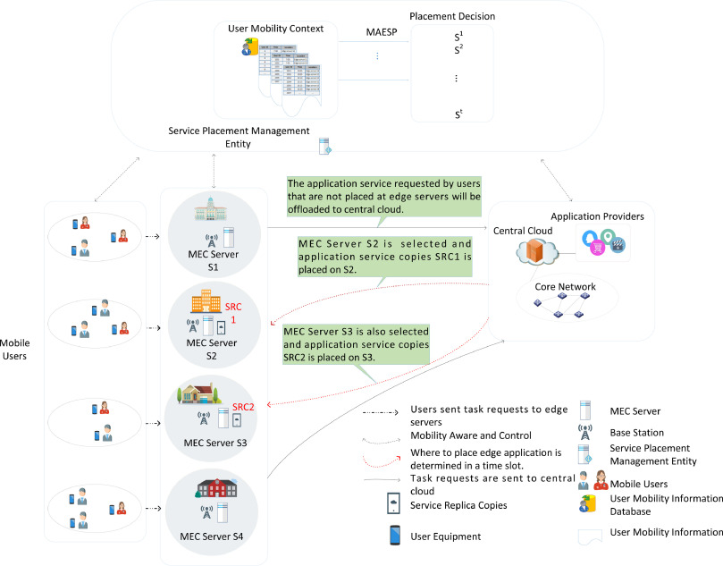

CHAPTER 4
TESTING AND IMPLEMENTATION

  - TESTING
Implementation is the stage of the project when the theoretical design is turned into a working system. This is the final and important phase in the system life cycle It is actually the process of converting the new system into a operational one.

4.1.1Unit Testing
Unit testing comprises the set of tests performed by an individual programmer prior to integration of the unit into a larger system. The module interface is tested to ensure that information properly flows into and out of the program unit. The local data structure is examined to ensure that data stored temporarily maintains its integrity during all steps in an algorithm’s execution. Boundary conditions are tested to ensure that the module operates properly at boundaries established to limit or restrict processing. All independent paths through the control structure are tested. All error-handling paths are tested.

4.1.2 Block Box Testing
Black-box testing is a method of software testing that examines the functionality of an application without peering into its internal structures or workings. This method of test can be applied virtually to every level of software testing: unit, integration, system and acceptance. It is sometimes referred to as specification-based testing.

4.2 SYSTEM IMPLEMENTATION
Implementation is the stage of the project when the theoretical design is turned into a working system. This is the final and important phase in the system life cycle It is actually the process of converting the new system into a operational one.

CHAPTER 5
CONCLUSION:
In this article, we presented a detailed survey of mobility aware MEC offloading techniques. The mobility of UE can lead to several challenges during the process of MEC offload such as intermittent connectivity, security, and reliability. As a result, machine learning, and nature inspired algorithms have been proposed to predict and manage user mobility for efficient MEC offloading frameworks. We presented the taxonomy of the state-ofthe-art MEC offloading frameworks in terms of objectives, constraints, mobility models, algorithms, and support networks. We listed a detailed literature review and comparison of fog, cloudlet, vehicular networks and MEC based mobility-aware offloading frameworks. At last, we listed research challenges in the form of security, reliability, and scalability for mobility aware MEC offloading frameworks.

CHAPTER-6
REFERENCE
- 1. Wang, Z., Zhao, Z., Min, G., Huang, X., Ni, Q., Wang, R.: User mobility aware task/assignment for mobile edge computing. Futur. Gener. Comput. Syst. 85, 1–8 (2018)
- 2. Sardar Khaliquz Zaman, Tahir Maqsood, Mazhar Ali, Kashif Bilal, Sajjad A. Madani, and A. U. R. Khan, A load balanced task scheduling heuristic for large-scale computing systems, Computer Systems Science and Engineering, vol. 34, pp. 1–12, 2019 .
- 3. Sheng, J., Hu, J., Teng, X., Wang, B., Pan, X.: Computation offloading strategy in mobile edge computing. Information 10, 191 (2019)
- 4. J. Shuja, A. Gani, M. H. ur Rehman, E. Ahmed, S. A. Madani, M. K. Khan, et al., Towards native code offloading based MCC frameworks for multimedia applications: a survey, Journal of Network and Computer Applications, vol. 75, pp. 335–354, 2016.
- 5. Yu, W., Liang, F., He, X., Hatcher, W.G., Lu, C., Lin, J., et al.: A survey on the edge computing for the Internet of Things. IEEE Access 6, 6900–6919 (2017)
- 6. Ziming, Z., Fang, L., Zhiping, C., Nong, X.: Edge computing: platforms, applications and challenges. Journal of Computer Research and Development 55, 327–337 (2018)
- 7. Sun, X., Ansari, N.: Latency aware workload offloading in the cloudlet network. IEEE Commun. Lett. 21, 1481–1484 (2017)
- 8. Yusong, S., Hui, S., Jie, C., Quan, Z., Wei, L.: Edge computing: a new computing model in the age of internet of things. Computer Research Development 54, 907–924 (2017)
- 9. Mach, P., Becvar, Z.: Mobile edge computing: a survey on architecture and computation offloading. IEEE Communications: Surveys Tutorials 19, 1628–1656 (2017)
- 10. Shuja, J., Gani, A., Naveed, A., Ahmed, E., Hsu, C.-H.: Case of ARM emulation optimization for offloading mechanisms in mobile cloud computing, Future Gener. Comput. Syst. 76, 407–417 (2017)

