Disease Prediction in Health Care System
ABSTRACT

To keep pace with the developments in medical informatics, health medical data is being collected continually. But, owing to the diversity of its categories and sources, medical data has become so complicated in many hospitals needs a clinical decision support (CDS) system for its management. To effectively utilize the accumulating health data, we propose a CDS framework that can integrate heterogeneous health data from different sources such as laboratory test results, basic information of patients, and health records into a consolidated representation of features of all patients. Using the electronic health medical data so created, multilevel classiﬁcation was employed to recommend a list of diseases and thus assist physicians in diagnosing or treating their patients’ health issues more efficiently. Once the physician diagnoses the disease of a patient, the next step is to consider the likely complications of that disease, which can lead to more diseases. Previous studies reveal that correlations do exist among some diseases. Considering these correlations, a k-nearest neighbors algorithm is improved for multilevel learning by using correlations among labels (CML-kNN). The CML-kNN algorithm ﬁrst exploits the dependence between every two labels to update the origin label matrix and then performs multilevel learning to estimate the probabilities of labels by using the integrated features. Finally, it recommends the top N diseases to the physicians. Experimental results on real health medical data establish the effectiveness and practicability of the proposed CDS framework.

INTRODUCTION

CHAPTER 1
INTRODUCTION
This is a potentially fatal disease caused mainly by environmental factors that mutate genes encoding critical cell-regulatory proteins. The resultant aberrant cell behavior leads to expansive masses of abnormal cells that destroy surrounding normal tissue and can spread to vital organs resulting in disseminated disease, commonly a harbinger of imminent patient death. More significantly, globalization of unhealthy lifestyles, particularly cigarette smoking and the adoption of many features of the modern Western diet (high fat, low fiber content) will increase rincidence. Data mining technique involves the use of sophisticated data analysis tools to discover previously unknown, valid patterns and relationships in large data set. These tools can include statistical models, mathematical algorithm and machine learning methods in early detectionr. In classification learning, the learning scheme is presented with a set of classified examples from which it is expected to learn a way of classifying unseen examples. In association learning, any association among features is sought, not just ones that predict a particular class value. In clustering, groups of examples that belong together are sought. In numeric prediction, the outcome to be predicted is not a discrete class but a numeric quantity. In this study, to classify the data and to mine frequent patterns in data set Decision Tree algorithm is used. Data Mining techniques are implemented together to create a novel method to diagnose the existence of for a particular patient. When beginning to work on a data mining problem, it is first necessary to bring all the data together into a set of instances. Integrating data from different sources usually presents many challenges. The data must be assembled, integrated, and cleaned up. Then only it can be used for processing through machine learning techniques. This developed system can be used by physicians and patients alike to easily know a person’s disease status and severity without screening them for testing. Also it is useful to record and save large volumes of sensitive information which can be used to gain knowledge about the disease and its treatment. One of the most encouraging and motivating areas of computer science that uses different statistical techniques is Data mining. The Data mining techniques are useful in finding patterns and relationships for the prediction of various diseases from the medical field [1]. There are plenty of cases where data mining techniques are being applied for the diagnosis of different diseases like heart disease [2], diabetes [2-3] Parkinson [2,4] [2,5], etc.According to WHO (World Health Organization) 8.2 million people die each year from disease and it is estimated that 13% of total death worldwide in caused due to 70% increase in new cases of is expected over the next two decades. Over all 100 types of exist each requiring unique treatment and diagnosis. The most commonly diagnosed worldwide is of the Lungs (1.8 million, 13% of total) Breast (1.7 million, 12% of total) Colorectal (1.4 million, 9.7 of total). The most common causes of death are of lungs (1.6 million, 19.1% of total) Liver (0.8 million, 9.1% of total) Stomach (0.7 million, 8.8 of total). It is estimated that by year 2025 increase to 19.3 million new cases per year can be noticed due to growth and aging of the population growth. is one of the most important reason of mortality in different countries of the world [6].The Figure 1 shows the estimated figure of total cases in India which shows the seriousness of the issue. This content of the paper proceeds with a brief introduction in Section I. Section II defines the statement of the problem that is targeted in this paper. Section III describes various types of and majorfactors that cause it. In Section IV a detailed survey of various researches about several data mining techniques and methodologies that have been applied in reference to diagnosis and prediction of disease is illustrated. Section V provides a comparative analysis of accuracies of different data mining techniques as reported by various researches in this domain. Section VI concludes the work and specifies the future work.
It is estimated that more than 70% of people in India are prone to general body diseases like viral, flu, cough, cold .etc, in every 2 months. Because many people don't realize that the general body diseases could be symptoms to something more harmful, 25 % of the population succumbs to death because of ignoring the early general body symptoms. This could be a dangerous situation for the population and can be are alarming. Hence identifying or predicting the disease at the earliest is very important to avoid any unwanted casualties. The currently available systems are the systems that are either dedicated to a particular disease or are in research phase for algorithms when it comes to generalized disease. The purpose of this system is to provide prediction for the general and more commonly occurring disease that when unchecked can turn into fatal disease. The system applies data mining techniques and ID3 decision tree algorithms. This system will predict the most possible disease based on the given symptoms and precautionary measures required to avoid the aggression of disease, it will also help the doctors analysethe pattern of presence of diseases in the society. In this project, the disease prediction system will carry out data mining in its preliminary stages, the system will be trained using machine learning and data mining.
The paper is divided into five sections. The first section gives a brief introduction of about the system. The second section is about data mining and the study of related existing systems. The third section details out the implementation of the system. The fourth section provides the results obtained using mining algorithms. Finally the conclusion gives the summary and future scope about the system.
1.1DESCRIPTION OF THE PROJECT
Plenty of work and researches have been done to find out different methods of diagnosis of various types. It is an attempt to predict and diagnose the disease based on symptoms that occurs at an early stage.

1.2Objectives of the project

- Providing best Service
- Monitoring quality in hospital
- Improving treatment processes
- Detection of disease earlier.

SYSTEM ANALYSIS

CHAPTER 2
2. SYSTEM ANALYSIS
2.1 EXISTING SYSTEM
The existing clinical decision support systems are poor in processing large volumes of multi-structured healthcare data and in providing accurate health recommendation, in practice
2.1.1 DRAWBACKS OF EXISTING SYSTEM ARE
Problem transformation method ﬁrst transforms one multilevel dataset into multiple single-label datasets, and then exploits existing single-label learning algorithm to process each single-label dataset
2.2. PROPOSED SYSTEM
Using Pattern Matching Algorithm the laboratory test data and basic information of patients, a set of experiments of different multi-label learning methods were performed to confirm the effectiveness and practicality of the proposed framework. The Disease Prediction in health care system is an information system that offers knowledge and personalized information to users in enhancing health and healthcare outcomes.
ADVANTAGES

- A novel framework is proposed for retrieving the most relevant information of patients from multiple data sources,.
- Such as laboratory test data, basic information of patients, symptoms of patients and electrocardiogram data, and for combining them to generate integrated features.

2.3 FEASIBILITY STUDY
The feasibility Analysis is an analytical program through project manager determines the project success ratio and through feasibility study project manager able to see either project . The key considerations involved in the feasibility analysis are:
• Economic Feasibility
• Technical Feasibility
• Operational Feasibility
• Environmental Feasibility
2.3.1 ECONOMICAL FEASIBILITY
Hence this project is economically feasible there is no need to involve any cost for this project.
2.3.2 TECHNICAL FEASIBILITY
Software Technologies used are vb6.0 and MS-Access. In the educational institutions, it is possible to update the system in future. No special hardware is required for the purpose of using this system. Hence it is declared that this project is technically feasible.
2.3.3 OPERATIONAL FEASIBILITY
As the admin work mainly to maintain the stock maintenance for the computer lab. Hence it is easy to operate with training. Therefore it is operationally feasible for implementation.
2.3.4 ENVIRONMENTAL FEASIBILITY
This project environment is correct as a admin has developed this system and no expenditure is involved under any head and this process is part of admin document management, this project environment is accessible.

2.4 SYSTEM REQUIREMENTS
2.4.1 HARDWARE REQUIREMENTS
- System : I3 Processer
- Hard Disk : 500 GB.
- Monitor : 15 VGA Color
- Mouse :
- Ram : 2 Gb

2.4.2 SOFTWARE REQUIREMENTS
- Operating system : Windows XP/7.
- Coding Language : PHP
- Database : MySql

2.5 MODULE DESCRIPTION
- Register and Login
- Health Care Data
- Pattern Matching Algorithm
- Recommend Diagnosis Analyze

2.5.1 Register and Login
Register as user by providing first name, last name, user name and password, etc..
Login Using User Name and Password.

2.5.2 Health Care Data
Patient health care data like height, weight, blood pressure, temperature, heart beat rate , Diseases Symptoms will be given as input.
2.5.3 Pattern Matching Algorithm
- Using Pattern Matching Algorithm data of each patient will be compared with symptoms of previous dataset and stored in database.
- Using the laboratory test data and basic information of patients, a set of experiments of different multi-label learning methods were performed to confirm the effectiveness and practicality of the proposed framework.
2.5.4 Recommend Diagnosis Analyze
- Using Pattern matching we have does string matching with disease dataset then the finalized analyzing disease status will be updated.
- Comparing the results of testing items with the reference ranges of those items to identify the abnormal items and quantify the levels of their abnormality.

SYSTEM DESIGN AND DEVELOPEMENT

CHAPTER 3

3. SYSTEM DESIGN
3.1 LOGICAL DESIGN
3.1.1 DATA FLOW DIAGRAM
The Data Flow Diagram is a way of expressing the system requirements in a graphical form. Based upon the System Flow and the Table Design the Data Flow Diagram is generated. Diagram shows how data is transformed as it moves from one system component to another. This diagram can be used as an aid in checking for duplication and discrepancies and as an index for more detailed documentation.
- It can help as in identifying the flow of data in a system without specifying the media or hardware involved.
- It uses a few simple symbols connected by arrow represents among data, flows, external entities source and destinations stores.
- It is simple to draw and easily depict the basic components and flow of the system
- It can be drawn in a increasing level of details starting with the summary high-level view and proceeding to more detailed lower level views.
- This supports a modular structured, top-down view of the system component and flows.
- It can also be used to represent physical viewpoints.

DATA FLOW DIAGRAM
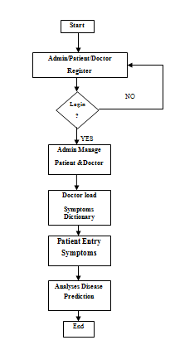

BLOCK DIAGRAM
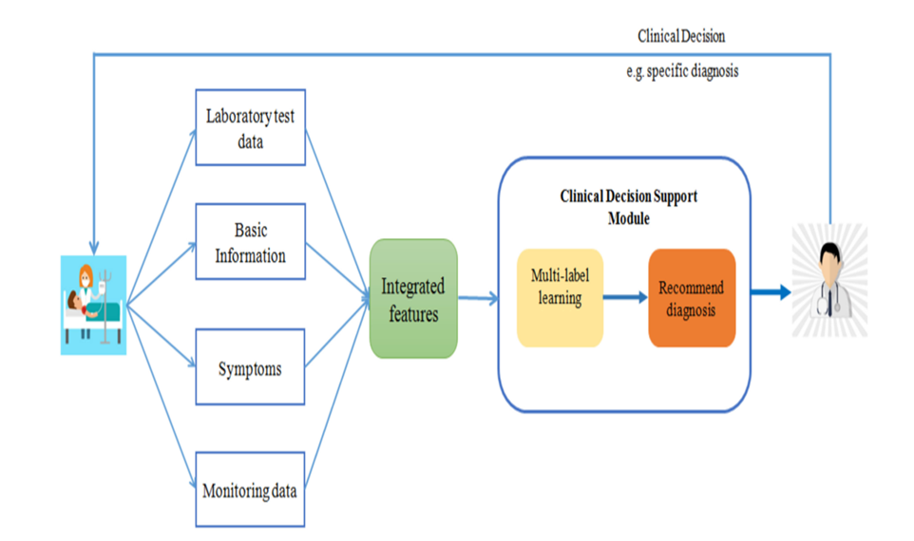
The general disease prediction system predicts chance of presence of a disease present in a patient on the basis of their symptoms. It will also recommend necessary precautionary measures required to treat the predicted disease. The system will initially be fed data from different sources i.e. patients, the data will then be pre-processed before further process is carried out, this is done so as to get clean data from the raw initial data, as the raw data would be noisy, or flawed. This data will be processed using Data mining algorithms, the system; will be trained so as to predict the disease based on the input data given by the user. The system is implemented into two parts, admin part and the user part. The duty of the admin is training the system for creation of the disease prediction model. The user uses the services provided by the model after logging in as the user, entering the symptoms into the model, which in turn returns the predicted results and necessary precautionary measures.

DATABASE DIAGRAM

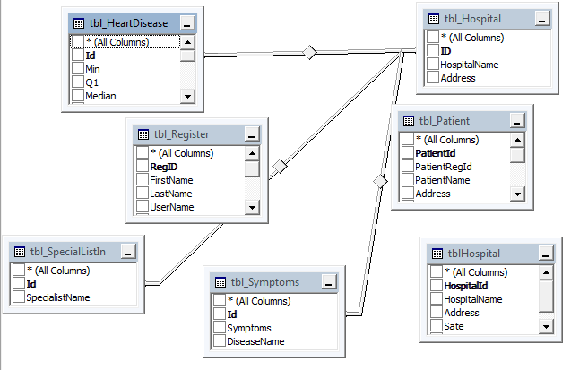

LOGIC DIAGRAM

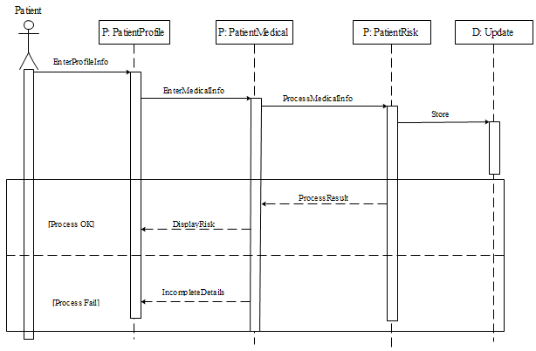

3.2.1 DATABASE DESIGN

