Resource Management and Pricing for Cloud Computing based Mobile Blockchain with Pooling

ABSTRACT
In a public blockchain system applying Proof of Work (PoW), the participants need to compete with their computing resources for reward, which is challenging for resource-limited devices. Mobile blockchain is proposed to facilitate the application of blockchain for mobile service, in which the lightweight devices can participate mining by renting resources from the Cloud Computing Service Provider (CCSP), but CCSP usually does not have the information about the demand preference of users. In this paper, a contract model is adopted to address the cloud computing resource allocation and pricing problem in the mobile blockchain. In particular, an adverse selection contract solution is proposed to overcome the information asymmetry problem, and resource pooling is introduced to improve the stability of users rewards. Simulation results show that the information asymmetry problem is well overcome by adverse selection contract so that CCSP can obtain more utility than linear pricing contracts. Furthermore, the resource pooling could effectively improve the users and CCSPs utilities. When the size of the mining pool is large enough, it can achieve an improvement effect of more than 10 times. The effect of pool size and user type distribution on CCSPs utility is also studied.

CHAPTER 2
2. SYSTEM ANALYSIS
  - EXISTING SYSTEM

- There is no existing work to provide a comprehensive survey on the combination of these important research areas, to our best knowledge.
- The existing blockchain networks still remain scalability bottlenecks in terms of the number of replicas and limited throughput.
- However, all existing paradigms still face the main problem related to centralized industrial network and third part-based authority.
- In a nutshell, centralized manufacturing architectures exist limitations with low flexibility, efficiency, and security.
- The adoption of machine learning provides more perspectives to evaluate, analyse and deal with existing issues in BCoT scenarios, enabling to boost QoS, security and performance of the whole network.
2.1.1 DRAWBACKS OF EXISTING SYSTEM :
- The impacts of different parameters from the proposed model on the performance, we consider a group of N miners, e.g., mobile users in the blockchain application involving PoW assisted by the CFP.
- we investigate the impacts of variable reward and fixed reward on miners and the CFP.
- To explore the impacts of discriminatory pricing on each specific miner, we investigate the optimal price and resulting individual computing service demand from miners.
- The profit maximization defined in is a convex optimization problem, and thus it can be solved by standard convex optimization algorithms, e.g., gradient assisted binary search.
2.2. PROPOSED SYSTEM
- An innovative blockchain instantiation named the data auditing blockchain (DAB) is proposed to investigate auditing requests between users and CSPs to verify data integrity.
- Moreover, proposed a cloud federation model which enable distributed resource provisions using an individual cloud under the management of blockchain network.
- The main purpose of blockchain in the proposed architecture is to provide secure network management.
- In, a secure cloud-assisted e-health system based on blockchain is proposed to protect the operation of outsourcing EHRs among medical users.

2.2.1. ADVANTAGES OF PROPOSED SYSTEM
- We conduct extensive numerical simulations to evaluate the performance of the proposed price-based resource management in blockchain networks.
- We conduct the extensive numerical simulations to evaluate the performance of our proposed price-based computing resource management to support blockchain application involving PoW.
- We have conducted the numerical simulations to evaluate the network performance, which help the cloud/fog provider to achieve optimal resource management and gain the highest profit.
- The high level of user activities may attract more users and in return further improve the robustness of the underlying blockchain network.
Literature Survey:
TITLE | AUTHORS | DESCRIPTION
Optimal pricing based edge computing resource management in mobile blockchain | Z. Xiong, S. Feng, D. Niyato, P. Wang and Z. Han, | In this paper, we, for the first time, consider the edge computing as the network enabler for mobile blockchain.
aBitcoin: A peer-to-peer electronic cash system | S. Nakamoto, | Digital signatures provide part of the solution, but the main benefits are lost if a trusted third party is still required to prevent double-spending.
A survey on consensus mechanisms and mining management in blockchain networks | W. Wang, D. T. Hoang, Z. Xiong, D. Niyato, P. Wang, P. Hu and Y. Wen, | The blockchain network was originated from the Internet financial sector as a decentralized, immutable ledger system for transactional data ordering.
Practical byzantine fault tolerance | M. Castro, B. Liskov et al., | Byzantine faults such as software bugs, operator mistakes, and malicious attacks are the major cause of service interruptions.

2.3 FEASIBILITY STUDY
The feasibility Analysis is an analytical program through project manager determines the project success ratio and through feasibility study project manager able to see either project. The key considerations involved in the feasibility analysis are:
- Economic Feasibility
- Technical Feasibility
- Operational Feasibility
- Environmental Feasibility
2.3.1 ECONOMICAL FEASIBILITY
Hence this project is economically feasible there is no need to involve any cost for this project.
2.3.2 TECHNICAL FEASIBILITY
Software Technologies used are PHP and MySql. In the educational institutions, it is possible to update the system in future. No special hardware is required for the purpose of using this system. Hence it is declared that this project is technically feasible.
2.3.3 OPERATIONAL FEASIBILITY
As the admin work mainly to maintain the Patient and Doctor .Doctor will predict patient cancer disease. Hence it is easy to operate with training. Therefore it is operationally feasible for implementation.
2.3.4 ENVIRONMENTAL FEASIBILITY
This project environment is correct as a admin has developed this system and no expenditure is involved under any head and this process is part of admin document management, this project environment is accessible.
2.4 SYSTEM REQUIREMENTS
- System : Pentium IV 2.4 GHz.
- Hard Disk : 40 GB.
- Monitor : 15 inch VGA Color.
- Mouse : Logitech Mouse.
- Ram : 512 MB
- Keyboard : Standard Keyboard
2.4.1 HARDWARE REQUIREMENTS
The Hardware of the computer consists of physical component such as Input Devices, Storage Devices, Processing & Control units and Output Devices. Computer includes external storage unit to store data in programs.
The Hardware Configuration involved in this project
- System : Pentium IV 2.4 GHz.
- Hard Disk : 40 GB.
- Monitor : 15 inch VGA Color.
- Mouse : Logitech Mouse.
- Ram : 512 MB
- Keyboard : Standard Keyboard
2.4.2 SOFTWARE REQUIREMENTS
Software is a group of programs that computers need to do a particular task. It is an essential requirement of Computer System. The Software used to develop the project is
- Operating System : Windows XP.
- Platform : DOT NET TECHNOLOGY
- Front End : ASP.Net 3.5
- Back End : SQL SERVER 2005

CHAPTER 3
SYSTEM DESIGN AND DEVELOPEMENT
SYSTEM ARCHICTURE

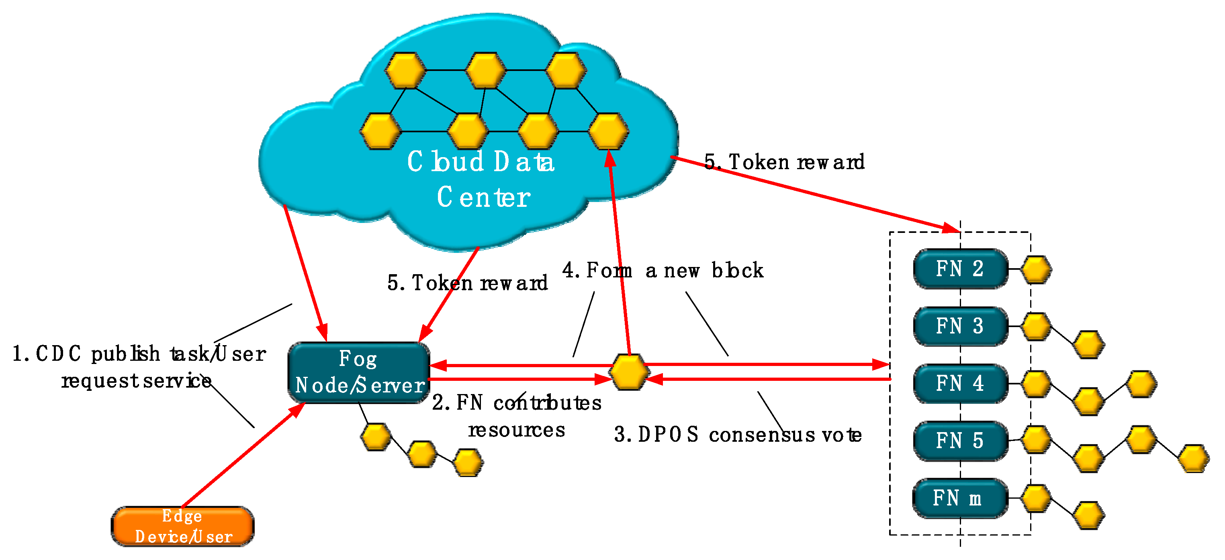

CHAPTER 4
TESTING AND IMPLEMENTATION

  - TESTING
Implementation is the stage of the project when the theoretical design is turned into a working system. This is the final and important phase in the system life cycle It is actually the process of converting the new system into a operational one.

4.1.1Unit Testing
Unit testing comprises the set of tests performed by an individual programmer prior to integration of the unit into a larger system. The module interface is tested to ensure that information properly flows into and out of the program unit. The local data structure is examined to ensure that data stored temporarily maintains its integrity during all steps in an algorithm’s execution. Boundary conditions are tested to ensure that the module operates properly at boundaries established to limit or restrict processing. All independent paths through the control structure are tested. All error-handling paths are tested.

4.1.2 Block Box Testing
Black-box testing is a method of software testing that examines the functionality of an application without peering into its internal structures or workings. This method of test can be applied virtually to every level of software testing: unit, integration, system and acceptance. It is sometimes referred to as specification-based testing.

4.2 SYSTEM IMPLEMENTATION
Implementation is the stage of the project when the theoretical design is turned into a working system. This is the final and important phase in the system life cycle It is actually the process of converting the new system into a operational one.

CHAPTER 5
CONCLUSION:
In this paper, we have investigated the price-based computing resource management, for supporting offloading mining tasks to cloud/fog provider in proof-of-work based public blockchain networks. In particular, we have adopted the two stage Stackelberg game model to jointly study the profit maximization of cloud/fog provider and the utility maximization of miners. Through backward induction, we have derived the unique Nash equilibrium point of the game among the miners. The optimal resource management schemes including the uniform and discriminatory pricing for the cloud/fog provider have been presented and examined. Further, the existence and uniqueness of the Stackelberg equilibrium have been proved analytically for both pricing schemes. We have performed the real experiment to validate the proposed analytical model. Additionally, we have conducted the numerical simulations to evaluate the network performance, which help the cloud/fog provider to achieve optimal resource management and gain the highest profit.

CHAPTER-6
REFERENCE
- [1] Z. Xiong, S. Feng, D. Niyato, P. Wang and Z. Han, “Optimal pricingbased edge computing resource management in mobile blockchain,” in Proceedings of IEEE ICC, Kansas City, MO, May 2018.
- [2] S. Nakamoto, “Bitcoin: A peer-to-peer electronic cash system,” Selfpublished Paper, May 2008.
- [3] W. Wang, D. T. Hoang, Z. Xiong, D. Niyato, P. Wang, P. Hu and Y. Wen, “A survey on consensus mechanisms and mining management in blockchain networks,” arXiv preprint arXiv:1805.02707, 2018.
- [4] M. Castro, B. Liskov et al., “Practical byzantine fault tolerance,” in Proceedings of the third symposium on Operating systems design and implementation, New Orleans, LA, Feb. 1999, vol. 99, pp. 173–186.
- [5] D. Ongaro and J. K. Ousterhout, “In search of an understandable consensus algorithm.,” in USENIX Annual Technical Conference, Philadelphia, PA, June 2014, pp. 305–319.
- [6] M. Vukolic, “The quest for scalable blockchain fabric: Proof-of-work vs. ´ bft replication,” in Open Problems in Network Security: IFIP WG 11.4 International Workshop, Zurich, Switzerland, Oct. 2015, pp. 112–125.
- [7] J. Garay, A. Kiayias and N. Leonardos, “The bitcoin backbone protocol: Analysis and applications,” in Advances in Cryptology - EUROCRYPT 2015: 34th Annual International Conference on the Theory and Applications of Cryptographic Techniques, Part II, Sofia, Bulgaria, Apr. 2015, pp. 281–310.
- [8] D. D. F. Maesa, P. Mori and L. Ricci, “Blockchain based access control,” in IFIP International Conference on Distributed Applications and Interoperable Systems, Neuchatel, Switzerland, June 2017.
- [9] W. Wang, D. Niyato, P. Wang and A. Leshem, “Decentralized caching for content delivery based on blockchain: A game theoretic perspective,” in Proceedings of IEEE ICC, Kansas City, MO, May 2018.
- [10] X. Chen, S. Chen, X. Zeng, X. Zheng, Y. Zhang and C. Rong, “Framework for context-aware computation offloading in mobile cloud computing,” Journal of Cloud Computing, vol. 6, no. 1, pp. 1, 2017.

