Design of Distributed Network Mass Data Processing System based on Cloud Computing Technology

ABSTRACT
In recent years, with the rapid development of cloud computing industry, big data processing technology is also constantly mature. At the same time, the scale of domestic mobile Internet market continues to expand, with more than 500 million users, bringing huge mobile Internet business data. In this context, the method of large-scale network data processing based on cloud computing big data processing technology is a very valuable research topic. From the perspective of the current situation of mobile Internet, on the one hand, mobile data services have risen sharply. And that puts a lot of pressure on the operator. Moreover, they need to invest more money in network construction and upgrading. Traditional voice and other SMS services are down. The operators then reached a point where they did not increase their earnings. Therefore, it is very important for communication operators to study the usage of large-scale mobile Internet data service resources obtained through service channels.

CHAPTER 2
2. SYSTEM ANALYSIS
  - EXISTING SYSTEM

- Cloud providers must use and adopt existing standards wherever appropriate. The IT industry has invested heavily in existing standards and standards organizations; there is no need to duplicate or reinvent them.
- When new standards (or adjustments to existing standards) are needed, we must be judicious and pragmatic to avoid creating too many standards.
- Though the above said challenges are existing in cloud computing, security is the major concern. Security in terms of data handling, maintaining, migrating or virtualization in clouds.
- Cloud providers must not use their market position to lock customers into their particular platforms and limiting their choice of providers.
2.1.1 DRAWBACKS OF EXISTING SYSTEM :
- Security is an important problem that limits the development and popularization of cloud computing technology.
- Researchers have done a lot of research on the problem, but after the introduction of large-scale network data processing project of mobile Internet, the existing Hadoop standard is still the security detection of data flow, which needs to be strengthened.
- The network security of this platform, the requirement of high speed and high precision of anomaly detection, the original network security technology with data encryption and security authentication, can not solve the security problem in this large-scale network data processing platform.
2.2. PROPOSED SYSTEM
- The purpose of this paper is to explore key concepts and ideas surrounding the security challenges of cloud computing, with particular reference to configuration having considerable impact on securing cloud services.
- The main purpose of our paper is to present a basic framework and determine benefits from Cloud Computing as an alternative to conventional IT infrastructure, such as privately owned and managed IT hardware.
- With this paper we have tried to find out the security issues and obstacles in the cloud and appropriate solutions for obstacles.
- Our purpose to this paper is to represent the Challenges and issues to be considered when switching to virtual cloud in IT industry.
2.2.1. ADVANTAGES OF PROPOSED SYSTEM
- The processing has the characteristics of high-speed transmission, huge data volume and half structure.
- HDFS technology realizes efficient and fast distributed storage of large amount of network data, and provides subsequent data processing services based on MapReduce technology.
- Based on the mobile Internet, people can access the Internet through mobile communication network in various mobile terminals such as mobile phones and tablets, and various network services such as language, video, social network and e-commerce can be used.
- In order to realize the communication and distribution of control information and original data, TCP connection is used.
Literature Survey:
TITLE | AUTHORS | DESCRIPTION
Optimization of Real-Time Traffic Network Assignment Based on IoT Data Using DBN and Clustering Model in Smart City | Jiachen Yanga, Yurong Hana, Yafang Wanga, | With the rapid development of the information age, smart city has gradually become the mainstream of urban construction.
Traffic services for vehicles: the process from receiving raw probe data to space-time diagrams and the resulting traffic service | Markus AUER. | Today, large quantities of vehicle data (FCD: floating car data) are widely used by traffic service providers to create and broadcast traffic states in road networks.
Real-time data processing scheme using big data analytics in internet of things based smart transportation environment | Muhammad Babar, Fahim Arif. | These smart objects are referred as “things” or physical devices that have the potential to sense the real-world physical objects, collect the data, and network with others.
Toward a M2M-based Internet of Vehicles Framework for Wireless Monitoring Applications | Fei Ding, Ruoyu Su, En Tong, | In the proposed framework, we design and implement a prototype of the mobile vehicle terminal.

2.3 FEASIBILITY STUDY
The feasibility Analysis is an analytical program through project manager determines the project success ratio and through feasibility study project manager able to see either project. The key considerations involved in the feasibility analysis are:
- Economic Feasibility
- Technical Feasibility
- Operational Feasibility
- Environmental Feasibility
2.3.1 ECONOMICAL FEASIBILITY
Hence this project is economically feasible there is no need to involve any cost for this project.

2.3.2 TECHNICAL FEASIBILITY
Software Technologies used are PHP and MySql. In the educational institutions, it is possible to update the system in future. No special hardware is required for the purpose of using this system. Hence it is declared that this project is technically feasible.
2.3.3 OPERATIONAL FEASIBILITY
As the admin work mainly to maintain the Patient and Doctor .Doctor will predict patient cancer disease. Hence it is easy to operate with training. Therefore it is operationally feasible for implementation.
2.3.4 ENVIRONMENTAL FEASIBILITY
This project environment is correct as a admin has developed this system and no expenditure is involved under any head and this process is part of admin document management, this project environment is accessible.
2.4 SYSTEM REQUIREMENTS
- System : Pentium IV 2.4 GHz.
- Hard Disk : 40 GB.
- Monitor : 15 inch VGA Color.
- Mouse : Logitech Mouse.
- Ram : 512 MB
- Keyboard : Standard Keyboard

2.4.1 HARDWARE REQUIREMENTS
The Hardware of the computer consists of physical component such as Input Devices, Storage Devices, Processing & Control units and Output Devices. Computer includes external storage unit to store data in programs.
The Hardware Configuration involved in this project
- System : Pentium IV 2.4 GHz.
- Hard Disk : 40 GB.
- Monitor : 15 inch VGA Color.
- Mouse : Logitech Mouse.
- Ram : 512 MB
- Keyboard : Standard Keyboard

2.4.2 SOFTWARE REQUIREMENTS
Software is a group of programs that computers need to do a particular task. It is an essential requirement of Computer System. The Software used to develop the project is
- Operating System : Windows XP.
- Platform : DOT NET TECHNOLOGY
- Front End : ASP.Net 3.5
- Back End : SQL SERVER 2005

CHAPTER 3
SYSTEM DESIGN AND DEVELOPEMENT
SYSTEM ARCHICTURE

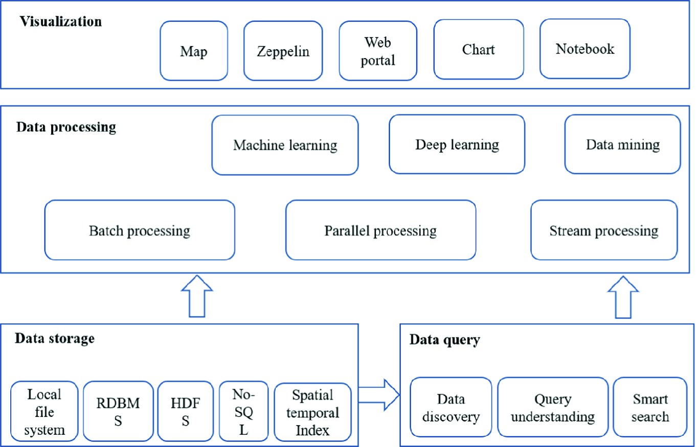

CHAPTER 4
TESTING AND IMPLEMENTATION

  - TESTING
Implementation is the stage of the project when the theoretical design is turned into a working system. This is the final and important phase in the system life cycle It is actually the process of converting the new system into a operational one.

4.1.1Unit Testing
Unit testing comprises the set of tests performed by an individual programmer prior to integration of the unit into a larger system. The module interface is tested to ensure that information properly flows into and out of the program unit. The local data structure is examined to ensure that data stored temporarily maintains its integrity during all steps in an algorithm’s execution. Boundary conditions are tested to ensure that the module operates properly at boundaries established to limit or restrict processing. All independent paths through the control structure are tested. All error-handling paths are tested.

4.1.2 Block Box Testing
Black-box testing is a method of software testing that examines the functionality of an application without peering into its internal structures or workings. This method of test can be applied virtually to every level of software testing: unit, integration, system and acceptance. It is sometimes referred to as specification-based testing.

4.2 SYSTEM IMPLEMENTATION
Implementation is the stage of the project when the theoretical design is turned into a working system. This is the final and important phase in the system life cycle It is actually the process of converting the new system into a operational one.

CHAPTER 5
CONCLUSION:
With the development of information technology, people 's demand for information will continue to increase. The contradiction between the technical requirements of rapid processing of massive data and the lag of current technical conditions will become more and more intense, which has become a hot issue in the world.

CHAPTER-6
REFERENCE
- [1] Jiachen Yanga, Yurong Hana, Yafang Wanga,. Optimization of Real-Time Traffic Network Assignment Based on IoT Data Using DBN and Clustering Model in Smart City. Future Generation Computer Systems, 2017.
- [2] Markus AUER. Traffic services for vehicles: the process from receiving raw probe data to space-time diagrams and the resulting traffic service. Frontiers of Engineering Management, vol. 4, no. 4, pp. 490-497, 2017.
- [3] Song Xueya, Desheng Li. Development of Wireless Mobile Video Surveillance on Windows Mobile Using DirectShow Technology. Journal of Computational & Theoretical Nanoscience, vol. 14, no. 7, pp. 3163-3169, 2017.
- [4] Jennifer K Carroll, Anne Moorhead, Raymond Bond,. Who Uses Mobile Phone Health Apps and Does Use Matter? A Secondary Data Analytics Approach. Journal of Medical Internet Research, vol. 19, no. 4, pp. e125, 2017.
- [5] Muhammad Babar, Fahim Arif. Real-time data processing scheme using big data analytics in internet of things based smart transportation environment. Journal of Ambient Intelligence & Humanized Computing, no. 1, 2018.
- [6] Tasneem S J Darwish, Kamalrulnizam Abu Bakar. Fog Based Intelligent Transportation Big Data Analytics in The Internet of Vehicles Environment: Motivations, Architecture, Challenges and Critical Issues. IEEE Access, no. 99, pp. 1-1, 2018.
- [7] Fei Ding, Ruoyu Su, En Tong,. Toward a M2M-based Internet of Vehicles Framework for Wireless Monitoring Applications. IEEE Access, vol. 6, pp. 67699-67708, 2018.
- [8] Sanhita Das, Anuj Budhkar, Akhilesh Kumar Maurya,. Multivariate Analysis on Dynamic CarFollowing Data of Non-lane-Based Traffic Environments. Transportation in Developing Economies, vol. 5, no. 2, 2019.
- [9] Syed Attique Shah, Dursun Zafer Seker, M. Mazhar Rathore,. Towards Disaster Resilient Smart Cities: Can Internet of Things and Big Data Analytics be the Game Changers?. IEEE Access, vol. 7, no. 1, pp. 91885-91903, 2019.
- [10] Joahannes B. D. da Costa, Allan Mariano de Souza, Denis Rosário,. Efficient Data Dissemination Protocol based on Complex Networks' Metrics for Urban Vehicular Networks. Journal of Internet Services and Applications, vol. 10, 2019.

