Integrating Resonant Recognition Model and Stockwell Transform for Localization of Hotspots in Tubulin

ABSTRACT
Tubulin is a promising target for designing anti-cancer drugs. Identification of hotspots in multifunctional Tubulin protein provides insights for new drug discovery. Although machine learning techniques have shown significant results in prediction, they fail to identify the hotspots corresponding to a particular biological function. This paper presents a signal processing technique combining resonant recognition model (RRM) and Stockwell Transform (ST) for the identification of hotspots corresponding to a particular functionality. The characteristic frequency (CF) representing a specific biological function is determined using the RRM. Then the spectrum of the protein sequence is computed using ST. The CF is filtered from the ST spectrum using a time-frequency mask. The energy peaks in the filtered sequence represent the hotspots. The hotspots predicted by the proposed method are compared with the experimentally detected binding residues of Tubulin stabilizing drug Taxol and destabilizing drug Colchicine present in the Tubulin protein. Out of the 53 experimentally identified hotspots, 60% are predicted by the proposed method whereas around 20% are predicted by existing machine learning based methods. Additionally, the proposed method predicts some new hot spots, which may be investigated.

CHAPTER 2
2. SYSTEM ANALYSIS
  - EXISTING SYSTEM

- Based on previous works and existing data, the authors proposed a model of reversible branch migration in mobile 3WJs with trinucleotide repeats, which may help the treatment of diseases.
- Almost all function implementations involve multiple coexisting and mutable conformations.
- Some existing hot spots remained and new ones formed which ultimately polarizes the signaling vector towards the left and elicits a change in the cell velocity.
- We speculated that a stronger correlation would exist when cell direction was compared to PI3K signaling vectors with magnitudes defined by Models, which factor in the level of PI3K activity.
2.1.1 DRAWBACKS OF EXISTING SYSTEM :
- The problem of locating genes and exons is sometimes generally referred to as the gene-finding problem.
- This problem can be avoided by subtracting the average of the numerical sequence from the values of its samples before computing its DFT.
- A variety of algorithms can be used for the optimization problem under consideration such as algorithms of the quasi-Newton family which are both very efficient as well as robust.
- This would be an interesting research problem to pursue that may eventually lead to significant advancements in our understanding of protein hot spots.
- It would be interesting to investigate the applicability of digital filters for this as well as other similar problems.
2.2. PROPOSED SYSTEM
- The purpose of clustering is to improve the arrangement of the data matrix by grouping data with ‘similar’ characteristics, in this case intensities and their proximities to one another.
- In an effort to recapitulate this process, we have adapted a published microfluidic design for generating tunable and stable PDGF gradients for the purpose of studying PI3K dynamics during directed fibroblast migration.
- Some of the bubbles come in contact with the fibroblasts attached in the channels and tear them from the surface, a phenomenon that is exploited in other microfluidic studies for the very purpose of detaching cells.
- The Whitesides group proposed a microfluidic design to overcome these limitations.

2.2.1. ADVANTAGES OF PROPOSED SYSTEM
- The development, implementation, and performance evaluation of new techniques for the location of hot spots in proteins and exons in DNA using digital filters are presented.
- The performance of the techniques is then evaluated using metrics such as sensitivity, specificity, accuracy, precision, and computational efficiency.
- Extensive performance analysis of the filter-based hot-spot and exon location techniques is carried out using a number of evaluation metrics and the so-called receiver operating characteristic (ROC) technique.
- We investigate the application of digital filters towards this goal, and make contributions in the development, testing, and performance analysis of such techniques.
Literature Survey:
TITLE | AUTHORS | DESCRIPTION
The emergence of biochemistry | J. S. Fruton, | Growth of a new science will be rather slow and sporadic until the pioneers realize that significant progress can only be achieved by collective action through some type of organized body.
Discovering Enzymes | D. Dressler and H. Potter, | Enzymes are biological catalysts (also known as biocatalysts) that speed up biochemical reactions in living organisms, and which can be extracted from cells and then used to catalyse a wide range of commercially important processes.
Nature’s Robots: A History of Proteins | C. Tanford and J. Reynolds, | Many predict that the study of the levels and interactions of all proteins (proteomics) represent a important research objective.
The Century of the Gene | E. F. Keller, | It is a compilation of practical exercises that form a strong foundation in both classical genetics and more recent molecular genetic techniques for students at degree level.

2.3 FEASIBILITY STUDY
The feasibility Analysis is an analytical program through project manager determines the project success ratio and through feasibility study project manager able to see either project. The key considerations involved in the feasibility analysis are:
- Economic Feasibility
- Technical Feasibility
- Operational Feasibility
- Environmental Feasibility
2.3.1 ECONOMICAL FEASIBILITY
Hence this project is economically feasible there is no need to involve any cost for this project.
2.3.2 TECHNICAL FEASIBILITY
Software Technologies used are PHP and MySql. In the educational institutions, it is possible to update the system in future. No special hardware is required for the purpose of using this system. Hence it is declared that this project is technically feasible.
2.3.3 OPERATIONAL FEASIBILITY
As the admin work mainly to maintain the Patient and Doctor .Doctor will predict patient cancer disease. Hence it is easy to operate with training. Therefore it is operationally feasible for implementation.
2.3.4 ENVIRONMENTAL FEASIBILITY
This project environment is correct as a admin has developed this system and no expenditure is involved under any head and this process is part of admin document management, this project environment is accessible.

2.4 SYSTEM REQUIREMENTS
- System : Pentium IV 2.4 GHz.
- Hard Disk : 40 GB.
- Monitor : 15 inch VGA Color.
- Mouse : Logitech Mouse.
- Ram : 512 MB
- Keyboard : Standard Keyboard

2.4.1 HARDWARE REQUIREMENTS
The Hardware of the computer consists of physical component such as Input Devices, Storage Devices, Processing & Control units and Output Devices. Computer includes external storage unit to store data in programs.
The Hardware Configuration involved in this project
- System : Pentium IV 2.4 GHz.
- Hard Disk : 40 GB.
- Monitor : 15 inch VGA Color.
- Mouse : Logitech Mouse.
- Ram : 512 MB
- Keyboard : Standard Keyboard

2.4.2 SOFTWARE REQUIREMENTS
Software is a group of programs that computers need to do a particular task. It is an essential requirement of Computer System. The Software used to develop the project is
- Operating System : Windows XP.
- Platform : DOT NET TECHNOLOGY
- Front End : ASP.Net 3.5
- Back End : SQL SERVER 2005

CHAPTER 3
SYSTEM DESIGN AND DEVELOPEMENT
SYSTEM ARCHICTURE

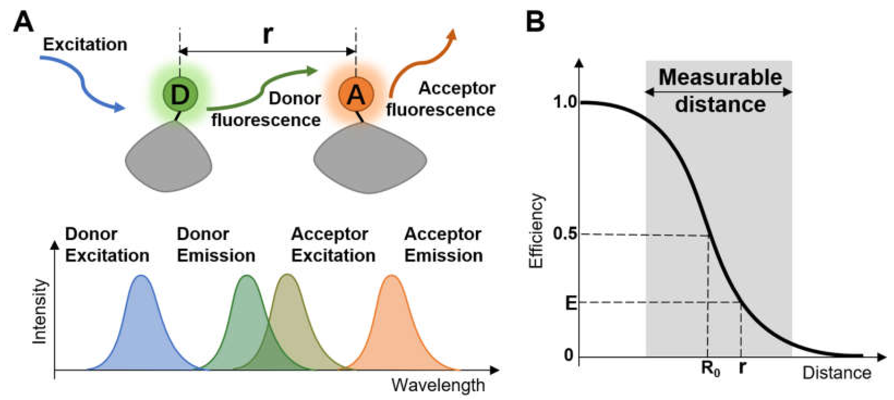

CHAPTER 4
TESTING AND IMPLEMENTATION

  - TESTING
Implementation is the stage of the project when the theoretical design is turned into a working system. This is the final and important phase in the system life cycle It is actually the process of converting the new system into a operational one.

4.1.1Unit Testing
Unit testing comprises the set of tests performed by an individual programmer prior to integration of the unit into a larger system. The module interface is tested to ensure that information properly flows into and out of the program unit. The local data structure is examined to ensure that data stored temporarily maintains its integrity during all steps in an algorithm’s execution. Boundary conditions are tested to ensure that the module operates properly at boundaries established to limit or restrict processing. All independent paths through the control structure are tested. All error-handling paths are tested.

4.1.2 Block Box Testing
Black-box testing is a method of software testing that examines the functionality of an application without peering into its internal structures or workings. This method of test can be applied virtually to every level of software testing: unit, integration, system and acceptance. It is sometimes referred to as specification-based testing.

4.2 SYSTEM IMPLEMENTATION
Implementation is the stage of the project when the theoretical design is turned into a working system. This is the final and important phase in the system life cycle It is actually the process of converting the new system into a operational one.

CHAPTER 5
CONCLUSION:
The training procedure was then employed to optimize the weights of the binary sequences. Although our initial objective was to obtain significantly improved ROC curves as a result of optimizing the weights, what we found out instead was a significant difference in the correlation of the individual binary sequences to exon locations. The optimized weights were used to determine the relative order of importance of the binary sequences. It turned out that exon locations are relatively insensitive to sequence T and, therefore, this sequence can be ignored without affecting the accuracy of the exon locations. Consequently, a computational saving of 25% can be achieved, which is substantial considering that DNA sequences encountered in practice are very long in nature. For the sake of completeness, simulations corresponding to all other possible combinations of binary sequences were carried out. Results showed that at least two sequences are required for reliable exon location, and among the six possible combinations of using two sequences, combinations A-G and G-C yield acceptable accuracy levels.

CHAPTER-6
REFERENCE
- [1] J. S. Fruton, “The emergence of biochemistry,” Science, vol. 192, no. 4237, pp. 327– 334, Apr. 1976.
- [2] D. Dressler and H. Potter, Discovering Enzymes. New York: Scientific American Library, 1991.
- [3] C. Tanford and J. Reynolds, Nature’s Robots: A History of Proteins. Oxford; New York: Oxford University Press, 2001.
- [4] Access Excellence - The Search for DNA. National Health Museum. [Online]. Available: http://www.accessexcellence.org/RC/AB/BC/Search for DNA.php
- [5] E. F. Keller, The Century of the Gene. Cambridge, Mass.: Harvard University Press, 2000.
- [6] Human Genome Project Information. U.S. DOE Human Genome Project. [Online]. Available: http://www.ornl.gov/hgmis/home.shtml
- [7] R. W. Old and S. B. Primrose, Principles of Gene Manipulation: An Introduction to Genetic Engineering, 4th ed. Oxford: Blackwell Scientific Publications, 1989.
- [8] J. A. Wells, “Systematic mutational analyses of protein-protein interfaces,” Methods in Enzymology, vol. 202, pp. 390–411, 1991.
- [9] L. Stein, “Genome annotation: From sequence to biology,” Nature Reviews Genetics, vol. 2, no. 7, pp. 493–503, Jul. 2001.
- [10] Access Excellence - Understanding Gene Testing. National Health Museum. [Online]. Available: http://www.accessexcellence.org/AE/AEPC/NIH/gene11.php

