A Data-Driven Modeling Method for Stochastic Nonlinear Degradation Process With Application to RUL Estimation

ABSTRACT
This article proposes a novel modeling method for the stochastic nonlinear degradation process by using the relevance vector machine (RVM), which can describe the nonlinearity of degradation process more flexibly and accurately. Compared with the existing methods, where degradation processes are modeled as the Wiener process with a nonlinear drift function formulized as the power law or exponential law, this kind of modeling method can characterize degradation processes with more nonlinear behavior. Instead of modeling the drift coefficient of the Wiener process directly, the weighted combination of basis functions is utilized to express the increment of the Wiener process and the parameters are calculated by a sparse Bayesian learning algorithm. Based on the proposed model, a numerical approximation formula for the probability density function (PDF) of the remaining useful life (RUL) is derived. Finally, comparison studies, including a numerical simulation and a practical case, are provided to demonstrate the effectiveness and the accuracy of the proposed methods for RUL estimation.

CHAPTER 2
2. SYSTEM ANALYSIS
  - EXISTING SYSTEM

- In most cases, the failure data from machines are not available, or only a few failure cases exist due to regular maintenance and the infrequent incidents.
- Most existing DL works will face substantial performance losses if the data distributions of training and test sets are not equal.
- Most existing machine learning algorithms result in a substantial performance loss because of the violation of the i.i.d. condition even with the same operating condition.
- We compare the performance of the proposed scheme to existing Bayesian approaches for predicting the RUL value of the experimental data of the PHM data challenge problem.
2.1.1 DRAWBACKS OF EXISTING SYSTEM :
- This type of degradation naturally brings two interesting problems, that is, how to model the degradations and how to predict their RULs.
- Some important and interesting problems to be further studied, along with future directions for FBM-based prediction.
- To solve this problem, the authors used a measure transformation to transform the original degradation process into an independent increment process.
- In general, this problem can be addressed by filtering methods based on the state-space equations of the degradations.
- In addition, for complex systems, how to integrate information collected from multiple sensors, identify the hidden degradation state, and predict the RUL are also challenging problems.
2.2. PROPOSED SYSTEM
- In the offline phase, the proposed method builds different health indicators representing degradation as a function of time using unsupervised variable selection, PCA, and trend extraction.
- The proposed CNN consists of multiple convolution and pooling layers to extract features and a logistic regression to convert the output features into a health indicator.
- The proposed prognostics integrate machine learning and mathematical degradation model of the time series data of the health indicator.
- The proposed feature importance ranking and PCA computes the health indicator based on the time series data in the online phase.
- However, our proposed scheme significantly reduces the computation complexity while guaranteeing the robustness against the possible uncertainty.
2.2.1. ADVANTAGES OF PROPOSED SYSTEM
- Assuming that the concerned product has p-dimensional performance characteristics and the degradation of each performance characteristic is governed by model, the RUL is defined as the FPT when at least one performance characteristic reaches its threshold.
- In fact, as stated in the current BM-based studies, the online update parameters can improve the accuracy of the model as the number of observations increases, thereby improving the predictive performance of the RUL.
- The model usually includes a drift term and a standard BM with a diffusion coefficient and is also a Markov process with independent increments.
- The basic linear model has a constant drift coefficient and a BM with a constant diffusion coefficient.
Literature Survey:
TITLE | AUTHORS | DESCRIPTION
Prognostics and Health Management of Electronics | Pecht M. | This paper presents the state-of-practice and the current state-of-research in the area of electronics prognostics and health management.
First Hitting Time Regression Models: Lifetime Data Analysis Based on Underlying Stochastic Processes | Caroni C. | The first hitting time regression models (or threshold regression) presented here represent observed events as the outcome of an underlying stochastic process.
Remaining useful life estimation—A review on the statistical data driven approaches | Si X S, Wang W, Hu C H, et al. | The research on how to best estimate the RUL has gained popularity recently due to the rapid advances in condition and health monitoring techniques.
Remaining useful life estimation: review | Ahmadzadeh F, Lundberg J. | The RUL estimation models are categorized into experimental, data driven, physics based and hybrid approaches.

2.3 FEASIBILITY STUDY
The feasibility Analysis is an analytical program through project manager determines the project success ratio and through feasibility study project manager able to see either project. The key considerations involved in the feasibility analysis are:
- Economic Feasibility
- Technical Feasibility
- Operational Feasibility
- Environmental Feasibility
2.3.1 ECONOMICAL FEASIBILITY
Hence this project is economically feasible there is no need to involve any cost for this project.
2.3.2 TECHNICAL FEASIBILITY
Software Technologies used are PHP and MySql. In the educational institutions, it is possible to update the system in future. No special hardware is required for the purpose of using this system. Hence it is declared that this project is technically feasible.
2.3.3 OPERATIONAL FEASIBILITY
As the admin work mainly to maintain the Patient and Doctor .Doctor will predict patient cancer disease. Hence it is easy to operate with training. Therefore it is operationally feasible for implementation.
2.3.4 ENVIRONMENTAL FEASIBILITY
This project environment is correct as a admin has developed this system and no expenditure is involved under any head and this process is part of admin document management, this project environment is accessible.
2.4 SYSTEM REQUIREMENTS
- System : Pentium IV 2.4 GHz.
- Hard Disk : 40 GB.
- Monitor : 15 inch VGA Color.
- Mouse : Logitech Mouse.
- Ram : 512 MB
- Keyboard : Standard Keyboard
2.4.1 HARDWARE REQUIREMENTS
The Hardware of the computer consists of physical component such as Input Devices, Storage Devices, Processing & Control units and Output Devices. Computer includes external storage unit to store data in programs.
The Hardware Configuration involved in this project
- System : Pentium IV 2.4 GHz.
- Hard Disk : 40 GB.
- Monitor : 15 inch VGA Color.
- Mouse : Logitech Mouse.
- Ram : 512 MB
- Keyboard : Standard Keyboard
2.4.2 SOFTWARE REQUIREMENTS
Software is a group of programs that computers need to do a particular task. It is an essential requirement of Computer System. The Software used to develop the project is
- Operating System : Windows XP.
- Platform : DOT NET TECHNOLOGY
- Front End : ASP.Net 3.5
- Back End : SQL SERVER 2005

CHAPTER 3
SYSTEM DESIGN AND DEVELOPEMENT
SYSTEM ARCHICTURE

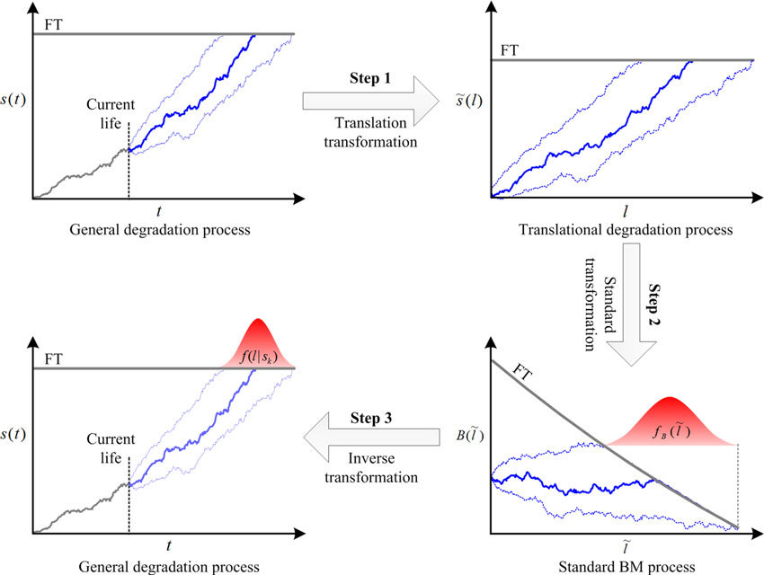

CHAPTER 4
TESTING AND IMPLEMENTATION

  - TESTING
Implementation is the stage of the project when the theoretical design is turned into a working system. This is the final and important phase in the system life cycle It is actually the process of converting the new system into a operational one.

4.1.1Unit Testing
Unit testing comprises the set of tests performed by an individual programmer prior to integration of the unit into a larger system. The module interface is tested to ensure that information properly flows into and out of the program unit. The local data structure is examined to ensure that data stored temporarily maintains its integrity during all steps in an algorithm’s execution. Boundary conditions are tested to ensure that the module operates properly at boundaries established to limit or restrict processing. All independent paths through the control structure are tested. All error-handling paths are tested.

4.1.2 Block Box Testing
Black-box testing is a method of software testing that examines the functionality of an application without peering into its internal structures or workings. This method of test can be applied virtually to every level of software testing: unit, integration, system and acceptance. It is sometimes referred to as specification-based testing.

4.2 SYSTEM IMPLEMENTATION
Implementation is the stage of the project when the theoretical design is turned into a working system. This is the final and important phase in the system life cycle It is actually the process of converting the new system into a operational one.

CHAPTER 5
CONCLUSION:
This paper reviewed the BM-based degradation models from the following two aspects.
• The models can be classified according to the degradation rate relative to the age, state, or covariates.
• The representative models are listed based on whether TV, IV, ME, and LRD are considered or not.
It is illustrated that the existing BM-based models completely ignore the LRD of the degradation processes. However, LRD exists in the degradation processes of some actual devices. Therefore, this study also summarizes recent studies on FBM-based degradation models, which can address the LRD in degradations. Two case studies show that FBM is more suitable for degradation modeling than BM. Furthermore, some important and interesting research perspectives are highlighted for future work.

CHAPTER-6
REFERENCE
- 1 Pecht M. Prognostics and Health Management of Electronics. Hoboken: Wiley Online Library, 2008.
- 2 Caroni C. First Hitting Time Regression Models: Lifetime Data Analysis Based on Underlying Stochastic Processes. Hoboken: John Wiley & Sons, 2017
- 3 Si X S, Wang W, Hu C H, et al. Remaining useful life estimation—A review on the statistical data driven approaches. Eur J Operational Res, 2011, 213: 1–14
- 4 Ahmadzadeh F, Lundberg J. Remaining useful life estimation: review. Int J Syst Assur Eng Manag, 2014, 5: 461–474
- 5 Ye Z S, Xie M. Stochastic modelling and analysis of degradation for highly reliable products. Appl Stochastic Model Bus Ind, 2015, 31: 16–32
- 6 Hu C, Zhou Z, Zhang J, et al. A survey on life prediction of equipment. Chin J Aeronaut, 2015, 28: 25–33
- 7 Tao L, Ma J, Cheng Y, et al. A review of stochastic battery models and health management. Renew Sustain Energy Rev, 2017, 80: 716–732
- 8 Alaswad S, Xiang Y. A review on condition-based maintenance optimization models for stochastically deteriorating system. Rel Eng Syst Saf, 2017, 157: 54–63
- 9 Shahraki A F. A review on degradation modelling and its engineering applications. Int J Perform Eng, 2017, 13: 299
- 10 Zhang Z, Si X, Hu C, et al. Degradation modeling-based remaining useful life estimation: a review on approaches for systems with heterogeneity. Proc Instit Mech Eng Part O-J Risk Reliab, 2015, 229: 343–355

