Automated Design of Multipass Heuristics for Resource-Constrained Job Scheduling With Self-Competitive Genetic Programming

ABSTRACT
Resource constraint job scheduling is an important combinatorial optimization problem with many practical applications. This problem aims at determining a schedule for executing jobs on machines satisfying several constraints (e.g., precedence and resource constraints) given a shared central resource while minimizing the tardiness of the jobs. Due to the complexity of the problem, several exact, heuristic, and hybrid methods have been attempted. Despite their success, scalability is still a major issue of the existing methods. In this study, we develop a new genetic programming algorithm for resource constraint job scheduling to overcome or alleviate the scalability issue. The goal of the proposed algorithm is to evolve effective and efficient multipass heuristics by a surrogate-assisted learning mechanism and self-competitive genetic operations. The experiments show that the evolved multipass heuristics are very effective when tested with a large dataset. Moreover, the algorithm scales very well as excellent solutions are found for even the largest problem instances, outperforming existing metaheuristic and hybrid methods.

CHAPTER 2
2. SYSTEM ANALYSIS
  - EXISTING SYSTEM

- These studies mainly examined the performance of simple combinations of different existing dispatching rules (DRs) and due-date assignment rules (DDARs).
- Comparing the evolved scheduling policies with existing scheduling policies from combinations of existing dispatching rules and due-date assignment rules.
- The function set used for DDARs is also applied here along with min, max and abs, which commonly appear in existing CDRs.
- The evolved non-dominated scheduling policies (SPs) are then compared with the existing SPs based on combinations of well-known dispatching rules with dynamic and regression-based due-date assignment rules.
2.1.1 DRAWBACKS OF EXISTING SYSTEM :
- Priority heuristics are usually the quickest way of obtaining “goodenough” solutions and have been useful for a range of different combinatorial optimization problems.
- It operates on a set of problem attributes and mathematical operators to evolve heuristics.
- While these algorithms have the benefit of producing good solutions, they often lack the generalization, flexibility and intuitiveness needed for real-world problems.
- This tightness makes the problem landscape significantly difficult to navigate for an algorithm and introduces the possibility of being stuck at the local optima.
2.2. PROPOSED SYSTEM
- A set of instances were used to train the rules and the performance of the rules evolved by the proposed methods are evaluated by a set of test instances.
- Some dynamic DDARs without the need of finding optimal coefficients have also been proposed, such as Dynamic Total Work Content (DTWK), Dynamic Processing Plus Waiting (DPPW) [37], and ADRES.
- The proposed GP method is used to create the priority rule for a single machine in both static and dynamic environments.
- They also proposed an interesting approach to provide some adaptive behaviours for the evolved rules by presenting a GP-3 system that evolves three components, a discriminant function and two dispatching rules.
2.2.1. ADVANTAGES OF PROPOSED SYSTEM
- A dynamic variant of the classical RCPSP is formulated and a multi-objective GPHH is proposed for discovering priority heuristics, with strong performance and low complexity, to deal with dynamic instances.
- The heuristics discovered in this study exhibit, either, on-par or superior performance in comparison to existing human designed approaches.
- The performance of any given algorithm or solution methodology is affected by a number of factors such as solution representation, schedule generation scheme, instance characteristics, etc.
- Some researchers have tried to combine priority rules with sampling methods as a way to further improve their performance.
- These lower-bounds are commonly used in RCPSP studies to measure the performance of algorithms.
Literature Survey:
TITLE | AUTHORS | DESCRIPTION
A neurogenetic approach for the resource constrained project scheduling problem | A. Agarwal, S. Colak, and S. Erenguc. | In this paper, we propose a Neurogenetic approach which is a hybrid of genetic algorithms (GA) and neural-network (NN) approaches.
A bi-objective model for robust resource constrained project scheduling | M. Al-Fawzan and M. Haouari. | In this paper, we address the issue of designing a project schedule which is not only short in time, but also less vulnerable to disruptions due to reworks and other undesirable conditions.
A robust genetic algorithm for resource allocation in project scheduling | J. Alcaraz and C. Maroto. | Genetic algorithms have been applied to many different optimization problems and they are one of the most promising metaheuristics.
Multiple regression genetic programming | I. Arnaldo, K. Krawiec, and U.-M. O’Reilly. | Our approach, called Multiple Regression Genetic Programming (MRGP) decouples and linearly combines a program's subexpressions via multiple regression on the target variable.

2.3 FEASIBILITY STUDY
The feasibility Analysis is an analytical program through project manager determines the project success ratio and through feasibility study project manager able to see either project. The key considerations involved in the feasibility analysis are:
- Economic Feasibility
- Technical Feasibility
- Operational Feasibility
- Environmental Feasibility
2.3.1 ECONOMICAL FEASIBILITY
Hence this project is economically feasible there is no need to involve any cost for this project.
2.3.2 TECHNICAL FEASIBILITY
Software Technologies used are PHP and MySql. In the educational institutions, it is possible to update the system in future. No special hardware is required for the purpose of using this system. Hence it is declared that this project is technically feasible.
2.3.3 OPERATIONAL FEASIBILITY
As the admin work mainly to maintain the Patient and Doctor .Doctor will predict patient cancer disease. Hence it is easy to operate with training. Therefore it is operationally feasible for implementation.
2.3.4 ENVIRONMENTAL FEASIBILITY
This project environment is correct as a admin has developed this system and no expenditure is involved under any head and this process is part of admin document management, this project environment is accessible.

2.4 SYSTEM REQUIREMENTS
- System : Pentium IV 2.4 GHz.
- Hard Disk : 40 GB.
- Monitor : 15 inch VGA Color.
- Mouse : Logitech Mouse.
- Ram : 512 MB
- Keyboard : Standard Keyboard

2.4.1 HARDWARE REQUIREMENTS
The Hardware of the computer consists of physical component such as Input Devices, Storage Devices, Processing & Control units and Output Devices. Computer includes external storage unit to store data in programs.
The Hardware Configuration involved in this project
- System : Pentium IV 2.4 GHz.
- Hard Disk : 40 GB.
- Monitor : 15 inch VGA Color.
- Mouse : Logitech Mouse.
- Ram : 512 MB
- Keyboard : Standard Keyboard

2.4.2 SOFTWARE REQUIREMENTS
Software is a group of programs that computers need to do a particular task. It is an essential requirement of Computer System. The Software used to develop the project is
- Operating System : Windows XP.
- Platform : DOT NET TECHNOLOGY
- Front End : ASP.Net 3.5
- Back End : SQL SERVER 2005

CHAPTER 3
SYSTEM DESIGN AND DEVELOPEMENT
SYSTEM ARCHICTURE

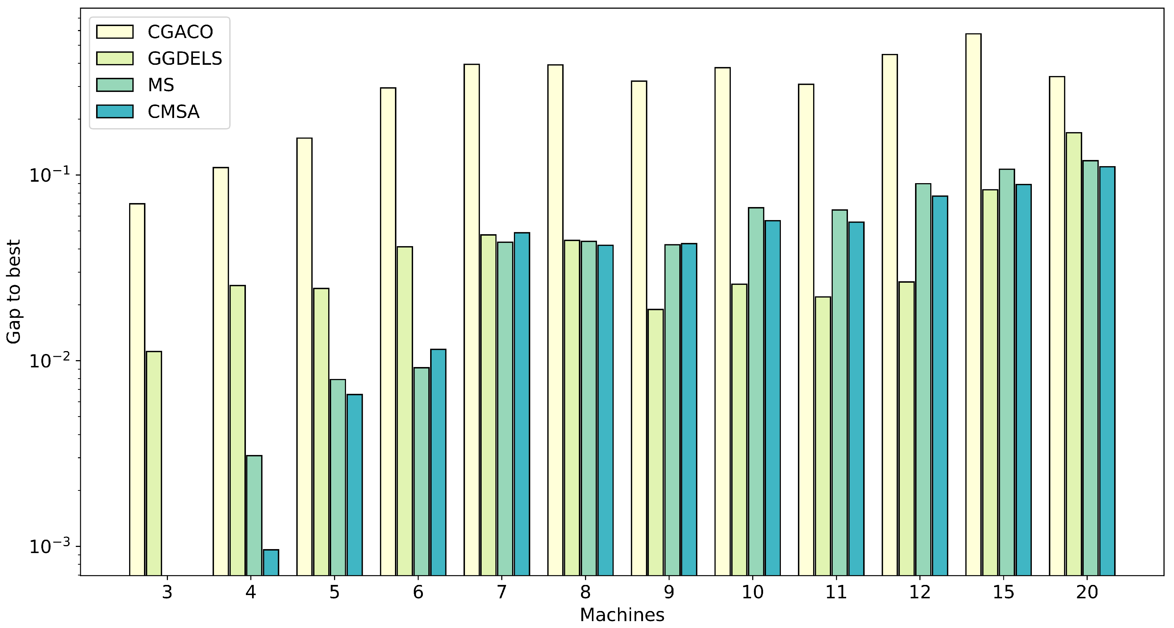

CHAPTER 4
TESTING AND IMPLEMENTATION

  - TESTING
Implementation is the stage of the project when the theoretical design is turned into a working system. This is the final and important phase in the system life cycle It is actually the process of converting the new system into a operational one.

4.1.1Unit Testing
Unit testing comprises the set of tests performed by an individual programmer prior to integration of the unit into a larger system. The module interface is tested to ensure that information properly flows into and out of the program unit. The local data structure is examined to ensure that data stored temporarily maintains its integrity during all steps in an algorithm’s execution. Boundary conditions are tested to ensure that the module operates properly at boundaries established to limit or restrict processing. All independent paths through the control structure are tested. All error-handling paths are tested.

4.1.2 Block Box Testing
Black-box testing is a method of software testing that examines the functionality of an application without peering into its internal structures or workings. This method of test can be applied virtually to every level of software testing: unit, integration, system and acceptance. It is sometimes referred to as specification-based testing.

4.2 SYSTEM IMPLEMENTATION
Implementation is the stage of the project when the theoretical design is turned into a working system. This is the final and important phase in the system life cycle It is actually the process of converting the new system into a operational one.

CHAPTER 5
CONCLUSION:
The thesis set out with an aim to explore the use of genetic programming based hyper-heuristics for the resource constrained project scheduling problem. Towards this end, a number of different approaches were proposed and investigated. The benefits of these approaches were demonstrated through comprehensive numerical experiments. The major highlights from this thesis include, but are not limited to: Development of a genetic programming based hyper-heuristic (GPHH) framework to evolve and discover new, reusable priority heuristics for the resource constrained project scheduling problem. The proposed framework operated on a superior feature set that utilized a diverse set of problem characteristics in order to automatically discover rules which for the first time were able to out-perform existing human designed rules. Decision tree based representation was also explored in order to discover rules which allowed for greater understandability and intuitiveness.

CHAPTER-6
REFERENCE
- [1] IBM ILOG CPLEX Optimization Studio. https://www.ibm.com/developerworks/ downloads/ws/ilogcplex/, 2016.
- [2] B. Abbasi, S. Shadrokh, and J. Arkat. Bi-objective resource-constrained project scheduling with robustness and makespan criteria. Applied Mathematics and Computation, 180(1):146 – 152, 2006.
- [3] A. Agarwal, S. Colak, and S. Erenguc. A neurogenetic approach for the resourceconstrained project scheduling problem. Computers & Operations Research, 38(1):44 – 50, 2011. Project Management and Scheduling.
- [4] M. Al-Fawzan and M. Haouari. A bi-objective model for robust resourceconstrained project scheduling. International Journal of Production Economics, 96(2):175 – 187, 2005.
- [5] J. Alcaraz and C. Maroto. A robust genetic algorithm for resource allocation in project scheduling. Annals of Operations Research, 102(1-4):83–109, 2001.
- [6] J. Alcaraz, C. Maroto, and R. Ruiz. Improving the performance of genetic algorithms for the rcps problem. In in: Proceedings of the Ninth International Workshop on Project Management and Scheduling, pages 40–43, 2004.
- [7] I. Arnaldo, K. Krawiec, and U.-M. O’Reilly. Multiple regression genetic programming. In Genetic and Evolutionary Computation Conference, pages 879–886, 2014.
- [8] I. Arnaldo, U.-M. O’Reilly, and K. Veeramachaneni. Building predictive models via feature synthesis. In Genetic and Evolutionary Computation Conference, pages 983–990, 2015.
- [9] C. Artigues, P. Michelon, and S. Reusser. Insertion techniques for static and dynamic resource-constrained project scheduling. European Journal of Operational Research, 149(2):249 – 267, 2003. Sequencing and Scheduling.
- [10] T. Baar, P. Brucker, and S. Knust. Tabu Search Algorithms and Lower Bounds for the Resource-Constrained Project Scheduling Problem, pages 1–18. Springer US, Boston, MA, 1999.

