Transfer Relation Network for Fault Diagnosis of Rotating Machinery With Small Data

ABSTRACT
Many deep-learning methods have been developed for fault diagnosis. However, due to the difficulty of collecting and labeling machine fault data, the datasets in some practical applications are relatively much smaller than the other big data benchmarks. In addition, the fault data come from different machines. Therefore, on some occasions, fault diagnosis is a multidomain problem with small data, where satisfactory transfer performance is difficult to obtain and has been rarely explored from the few-shot learning viewpoint. Different from the existing deep transfer learning solutions, a novel transfer relation network (TRN), combining a few-shot learning mechanism and transfer learning, is developed in this study. Specifically, the fault diagnosis problem has been treated as a similarity metric-learning problem instead of solely feature weighted classification. A feature net and a relation net have been, respectively, constructed for feature extraction and relation computation. The Siamese structure has been borrowed to extract the features of the source and the target domain samples with shared weights. Multikernel maximum mean discrepancy (MK-MMD) is employed on several higher layers with different tradeoff parameters to enable an efficient domain feature transfer considering different feature properties. To implement efficient diagnosis based on small data, an episode-based few-shot training strategy is adopted to train TRN. Average pooling has been adopted to suppress the noise influence from the vibration sequence which turns out to be important for the success of time sequence-based fault diagnosis. Transfer experiments on four datasets have verified the superior performance of TRN. A significant improvement of classification accuracy has been made compared with the state-of-the-art methods on the adopted datasets.

CHAPTER 2
2. SYSTEM ANALYSIS
  - EXISTING SYSTEM

- In this survey paper, we systematically summarize existing literature on bearing fault diagnostics with deep learning (DL) algorithms.
- Designed to tackle this practical and widely existing issue in numerous applications, transfer learning has aroused extensive attention in the machine learning community, and various transfer learning frameworks are proposed based on classical ML algorithms.
- Most of the existing DL algorithms can achieve an excellent classification accuracy of over 95% using the CWRU dataset, even with the classical CNN without any add-on architectures, which indicates that this dataset contains relatively simple features that can be easily extracted by a variety of DL methods.
- Most of the existing work employing DL techniques for bearing fault diagnosis relies on vibration data collected from accelerometers in a laboratory environment.

2.1.1 DRAWBACKS OF EXISTING SYSTEM :
- Adaptation methods are based on the adaptation of conventional classification methods to multi-label versions without problem transformation.
- However, practical engineering problems demanded the development of new automatic methods that are able to deal with multiple fault scenarios and noisy or uncertain fault features.
- The transfer of recent Machine Learning approaches to practical fault diagnosis problems of rotating electrical machines and drive systems may help to facilitate smart industrialization and intelligent modernization.
- Automated electrical signature analysis-based fault detection and diagnosis of electrical machines is still an especially important issue in modern industrial applications.
2.2. PROPOSED SYSTEM
- The study demonstrated that the proposed PCA technique is effective in classifying bearing faults with a higher accuracy and a lower number of input features when compared to using all of the original feature.
- This proposed ADCNN is also able to predict the fault size (defect width) with a satisfactory accuracy.
- The proposed method has a better diagnosis accuracy than deep belief networks, particularly with the added noises, where an average improvement of 7% is achieved.
- In, an ensemble deep auto-encoder consisting of a series of auto-encoders (AE) based on different activation functions is proposed for unsupervised feature learning from the measured vibration signal.
2.2.1. ADVANTAGES OF PROPOSED SYSTEM
- The proposed method also employs vibration and current signals and achieves nice performance; however, the method lacks the flexibility to easily fit with specific types of machines.
- In the presence of multiple faults, the single fault recognition techniques’ performance may be degraded.
- The performance of a classifier strongly depends on the effectiveness of the features representing the patterns of different fault events.
- It is worth noting that many attempts have been made with the purpose of improving performance through sophisticated feature extraction methods.
- We have also modified the maximum of tree depth in order to compare the performance using various maximum depths of the trees.

Literature Survey:
TITLE | AUTHORS | DESCRIPTION
Review of soft computing models in design and control of rotating electrical machines | Dineva, A.; Mosavi, A.; Ardabili, S.; Vajda, I.; Shamshirband, S.; Rabczuk, T.; Chau, K.W. | Rotating electrical machines are electromechanical energy converters with a fundamental impact on the production and conversion of energy.
The influence of combined strain and constructive solutions for stator insulation of rotating electrical machines on duration of their reliable exploitation | Jokanovi´c, B.; Bebi´c, M.; Kartalovi´c, N. | The parameters considered in this examination are the polarization index, the coefficient of proportionality and the lifetime exponent.
Elementary subdomain technique for magnetic field calculation in rotating electrical machines with local saturation effect | Roubache, L.; Boughrara, K.; Dubas, F.; Ibtiouen, R. | The magnetic field calculations have been performed for nonlinear B(H) curve and compared to nonlinear finite element method (FEM) predictions.
2-D exact analytical method for steady-state heat transfer prediction in rotating electrical machines | Boughrara, K.; Dubas, F.; Ibtiouen, R. | The analytical resolution of partial differential equations (PDEs) representing the temperature distribution in electrical machines doesn't exist.

2.3 FEASIBILITY STUDY
The feasibility Analysis is an analytical program through project manager determines the project success ratio and through feasibility study project manager able to see either project. The key considerations involved in the feasibility analysis are:
- Economic Feasibility
- Technical Feasibility
- Operational Feasibility
- Environmental Feasibility
2.3.1 ECONOMICAL FEASIBILITY
Hence this project is economically feasible there is no need to involve any cost for this project.
2.3.2 TECHNICAL FEASIBILITY
Software Technologies used are PHP and MySql. In the educational institutions, it is possible to update the system in future. No special hardware is required for the purpose of using this system. Hence it is declared that this project is technically feasible.
2.3.3 OPERATIONAL FEASIBILITY
As the admin work mainly to maintain the Patient and Doctor .Doctor will predict patient cancer disease. Hence it is easy to operate with training. Therefore it is operationally feasible for implementation.

2.3.4 ENVIRONMENTAL FEASIBILITY
This project environment is correct as a admin has developed this system and no expenditure is involved under any head and this process is part of admin document management, this project environment is accessible.
2.4 SYSTEM REQUIREMENTS
- System : Pentium IV 2.4 GHz.
- Hard Disk : 40 GB.
- Monitor : 15 inch VGA Color.
- Mouse : Logitech Mouse.
- Ram : 512 MB
- Keyboard : Standard Keyboard

2.4.1 HARDWARE REQUIREMENTS
The Hardware of the computer consists of physical component such as Input Devices, Storage Devices, Processing & Control units and Output Devices. Computer includes external storage unit to store data in programs.
The Hardware Configuration involved in this project
- System : Pentium IV 2.4 GHz.
- Hard Disk : 40 GB.
- Monitor : 15 inch VGA Color.
- Mouse : Logitech Mouse.
- Ram : 512 MB
- Keyboard : Standard Keyboard

2.4.2 SOFTWARE REQUIREMENTS
Software is a group of programs that computers need to do a particular task. It is an essential requirement of Computer System. The Software used to develop the project is
- Operating System : Windows XP.
- Platform : DOT NET TECHNOLOGY
- Front End : ASP.Net 3.5
- Back End : SQL SERVER 2005

CHAPTER 3
SYSTEM DESIGN AND DEVELOPEMENT
SYSTEM ARCHICTURE

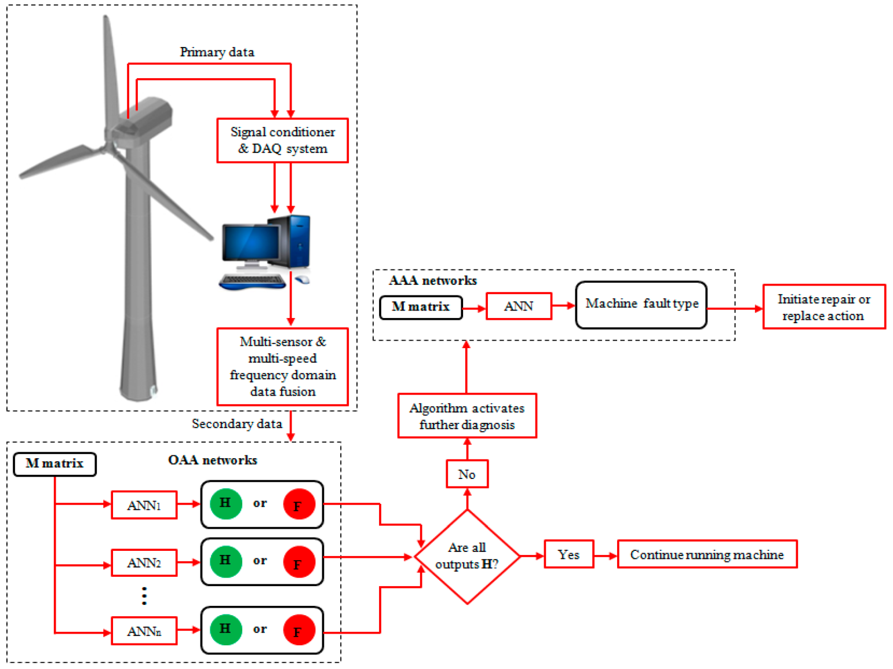

CHAPTER 4
TESTING AND IMPLEMENTATION

  - TESTING
Implementation is the stage of the project when the theoretical design is turned into a working system. This is the final and important phase in the system life cycle It is actually the process of converting the new system into a operational one.

4.1.1Unit Testing
Unit testing comprises the set of tests performed by an individual programmer prior to integration of the unit into a larger system. The module interface is tested to ensure that information properly flows into and out of the program unit. The local data structure is examined to ensure that data stored temporarily maintains its integrity during all steps in an algorithm’s execution. Boundary conditions are tested to ensure that the module operates properly at boundaries established to limit or restrict processing. All independent paths through the control structure are tested. All error-handling paths are tested.

4.1.2 Block Box Testing
Black-box testing is a method of software testing that examines the functionality of an application without peering into its internal structures or workings. This method of test can be applied virtually to every level of software testing: unit, integration, system and acceptance. It is sometimes referred to as specification-based testing.

4.2 SYSTEM IMPLEMENTATION
Implementation is the stage of the project when the theoretical design is turned into a working system. This is the final and important phase in the system life cycle It is actually the process of converting the new system into a operational one.

CHAPTER 5
CONCLUSION:
Automated electrical signature analysis-based fault detection and diagnosis of electrical machines is still an especially important issue in modern industrial applications. The recent data acquisition devices with high sample rate signal inputs have high levels of noise. The coupled machines may cause even heavy disturbances in the signal. A greater source of concern is the selection of the appropriate model and the unavailability of the dataset rich in fault signatures. With this in mind, this paper investigates the applicability of recent multi-label classification methods and suggests a new methodology for simultaneously diagnosing multiple faults and evaluating the fault severity under noisy conditions. Our study provides a new framework and strategy that has been tested on an experimental setup. According to the comparative investigations, we have found that the Classifier Chain strategy is the most suitable for issues of simultaneous noisy misalignment and unbalance fault. The fault signatures are composed of magnitudes of the fault and disturbing noise frequencies and some additional parameters. We have confirmed that relying on the knowledge of the physics of the fault event has twofold advantages. Obtaining the required training dataset is much shorter if we build a semi-synthetic database. A reliable model can be built by recording only a few measurements beforehand, which can be further refined during operation. On the other hand, the high dimension of attributes can be even simply reduced. Our investigations into this area are still ongoing and seem likely to confirm our hypothesis. To further our research, we intend to carry out more extensive investigations regarding the feature extraction techniques. For instance, extending recent findings of motor fault feature extraction, e.g., based on acoustic signals to electrical signature analysis, also taking into account sensor fusion, can be undertaken.

CHAPTER-6
REFERENCE
- 1. Dineva, A.; Mosavi, A.; Ardabili, S.; Vajda, I.; Shamshirband, S.; Rabczuk, T.; Chau, K.W. Review of soft computing models in design and control of rotating electrical machines. Energies 2019, 12, 1049. [CrossRef]
- 2. Jokanovi´c, B.; Bebi´c, M.; Kartalovi´c, N. The influence of combined strain and constructive solutions for stator insulation of rotating electrical machines on duration of their reliable exploitation. Int. J. Electr. Power Energy Syst. 2019, 110, 36–47. [CrossRef]
- 3. Roubache, L.; Boughrara, K.; Dubas, F.; Ibtiouen, R. Elementary subdomain technique for magnetic field calculation in rotating electrical machines with local saturation effect. COMPEL Int. J. Comput. Math. Electr. Electron. Eng. 2019, 38, 24–45. [CrossRef]
- 4. Boughrara, K.; Dubas, F.; Ibtiouen, R. 2-D exact analytical method for steady-state heat transfer prediction in rotating electrical machines. IEEE Trans. Magn. 2018, 54. [CrossRef]
- 5. Caruso, M.; Di Tommaso, A.O.; Miceli, R.; Rizzo, R. The use of slightly asymmetrical windings for rotating electrical machines. Int. Trans. Elecr. Energy Syst. 2018, 28. [CrossRef]
- 6. Kande, M.; Isaksson, A.J.; Thottappillil, R.; Taylor, N. Rotating electrical machine condition monitoring automation-A review. Machines 2017, 5, 24. [CrossRef]
- 7. Byerly, K.; Ohodnicki, P.R.; Moon, S.R.; Leary, A.M.; Keylin, V.; McHenry, M.E.; Simizu, S.; Beddingfield, R.; Yu, Y.; Feichter, G.; et al. Metal Amorphous Nanocomposite (MANC) Alloy Cores with Spatially Tuned Permeability for Advanced Power Magnetics Applications. JOM 2018, 70, 879–891. [CrossRef]
- 8. Fu, Y.; Huang, X.; Xu, Y.; Bai, C. Controllable inertial control strategy of rotating motor in DC distribution network. Dianli Zidonghua Shebei Electr. Power Autom. Equip. 2018, 38, 32–38. [CrossRef]
- 9. Guerroudj, C.; Saou, R.; Boulayoune, A.; El-hadi Zaïm, M.; Moreau, L. Performance analysis of Vernier slotted doubly salient permanent magnet generator for wind power. Int. J. Hydrogen Energy 2017, 42, 8744–8755. [CrossRef]
- 10. Song, Z.; Li, Y.; Zhang, C.; Liu, Y. Rotating core loss model for motor considering skin effect and dynamic hysteresis effect. Nongye Gongcheng Xuebao 2019, 35, 74–80. [CrossRef]

