Hyperspectral Image Classification via Discriminant Gabor Ensemble Filter

ABSTRACT
For a broad range of applications, hyperspectral image (HSI) classification is a hot topic in remote sensing, and convolutional neural network (CNN)-based methods are drawing increasing attention. However, to train millions of parameters in CNN requires a large number of labeled training samples, which are difficult to collect. A conventional Gabor filter can effectively extract spatial information with different scales and orientations without training, but it may be missing some important discriminative information. In this article, we propose the Gabor ensemble filter (GEF), a new convolutional filter to extract deep features for HSI with fewer trainable parameters. GEF filters each input channel by some fixed Gabor filters and learnable filters simultaneously, then reduces the dimensions by some learnable 1x 1 filters to generate the output channels. The fixed Gabor filters can extract common features with different scales and orientations, while the learnable filters can learn some complementary features that Gabor filters cannot extract. Based on GEF, we design a network architecture for HSI classification, which extracts deep features and can learn from limited training samples. In order to simultaneously learn more discriminative features and an end-to-end system, we propose to introduce the local discriminant structure for cross-entropy loss by combining the triplet hard loss. Results of experiments on three HSI datasets show that the proposed method has significantly higher classification accuracy than other state-of-the-art methods. Moreover, the proposed method is speedy for both training and testing.

CHAPTER 2
2. SYSTEM ANALYSIS
  - EXISTING SYSTEM

- Many existing methods used a series of manually extracted features, which involve massive parameter setting and experts’ experience.
- The existing literature presents the superior performance of ELM for the applications of HSI.
- It is a powerful tool for image applications, which can accurately localize the boundaries of the potential objects in different complicated scenarios.
- A typical graph based segmentation technique is the normalized cuts (NCuts), which needs to construct a large-scale connected graph and requires eigenvalue decomposition as solution.
- However, it is very time-consuming to perform eigenvalue decomposition for partitioning the segmentations.
2.1.1 DRAWBACKS OF EXISTING SYSTEM :
- In this letter, in order to make the most of deep CNN and Gabor filtering, a new strategy, which combines Gabor filters with convolutional filters, is proposed for hyperspectral image classification to mitigate the problem of overfitting.
- Due to the large number of learnable parameters in convolutional filters, lots of training samples are needed in deep CNNs to avoid the overfitting problem.
- Due to the high dimensionality of HSI and limited available training samples, overfitting is a serious problem one may face.
- On the contrary, Gabor filtering is an unsupervised technique for FE which is able to mitigate the overfitting problem in CNN-based HSI classification.
2.2. PROPOSED SYSTEM
- In the proposed method, spatial features are extracted based on linear prediction error analysis and local binary patterns; spatial features and spectral features are then stacked into high dimensional vectors.
- The proposed method obtains good classification performance in Arctic sea ice classification, and it may contribute to the Polar research communities.
- Most of the previously proposed spatial–spectral classification methods have focused on using handcrafted features, which are designed based on the experts’ prior knowledge, such as principle component analysis, Gabor wavelet filters, and morphological profiles.
- In this sense, the proposed SS-RMG can be considered as a kind of regularization.

2.2.1. ADVANTAGES OF PROPOSED SYSTEM
- The aforementioned applications, classification is a fundamental technique which has a greater influence on final performance.
- In, a deep CNN with five layers was employed to extract the spectral features of HSIs, leading to a promising classification performance.
- To boost the performance of the proposed method, advanced techniques including dropout, rectified linear unit (ReLU), and batch normalization (BN) are used and tested for HSI classification.
- To further enrich the performance of the networks, an advanced technique named BN is also adopted in this letter.
- In order to compare the performance of the Gabor-CNN with the original CNN architecture, different numbers of training samples were tested.
Literature Survey:
TITLE | AUTHORS | DESCRIPTION
Hyperspectral remote sensing data analysis and future challenges | J. M. Bioucas-Dias, A. Plaza, G. Camps-Valls, P. Scheunders, N. Nasrabadi, and J. Chanussot, | Current sensors onboard airborne and spaceborne platforms cover large areas of the Earth surface with unprecedented spectral, spatial, and temporal resolutions.
Multimodal classification of remote sensing images: A review and future directions | L. Gómez-Chova, D. Tuia, G. Moser, and G. Camps-Valls, | Earth observation through remote sensing images allows the accurate characterization and identification of materials on the surface from space and airborne platforms.
Advanced spectral classifiers for hyperspectral images: A review | P. Ghamisi, J. Plaza, Y. Chen, J. Li, and A. J. Plaza, | Hyperspectral image classification has been a vibrant area of research in recent years. Given a set of observations, i.e., pixel vectors in a hyperspectral image, classification approaches try to allocate a unique label to each pixel vector.
Spectral and spatial classification of hyperspectral data using SVMs and morphological profiles | M. Fauvel, J. A. Benediktsson, J. Chanussot, and J. R. Sveinsson, | The proposed method is based on the data fusion of the morphological information and the original hyperspectral data: the two vectors of attributes are concatenated.

2.3 FEASIBILITY STUDY
The feasibility Analysis is an analytical program through project manager determines the project success ratio and through feasibility study project manager able to see either project. The key considerations involved in the feasibility analysis are:
- Economic Feasibility
- Technical Feasibility
- Operational Feasibility
- Environmental Feasibility
2.3.1 ECONOMICAL FEASIBILITY
Hence this project is economically feasible there is no need to involve any cost for this project.
2.3.2 TECHNICAL FEASIBILITY
Software Technologies used are PHP and MySql. In the educational institutions, it is possible to update the system in future. No special hardware is required for the purpose of using this system. Hence it is declared that this project is technically feasible.
2.3.3 OPERATIONAL FEASIBILITY
As the admin work mainly to maintain the Patient and Doctor .Doctor will predict patient cancer disease. Hence it is easy to operate with training. Therefore it is operationally feasible for implementation.
2.3.4 ENVIRONMENTAL FEASIBILITY
This project environment is correct as a admin has developed this system and no expenditure is involved under any head and this process is part of admin document management, this project environment is accessible.

2.4 SYSTEM REQUIREMENTS
- System : Pentium IV 2.4 GHz.
- Hard Disk : 40 GB.
- Monitor : 15 inch VGA Color.
- Mouse : Logitech Mouse.
- Ram : 512 MB
- Keyboard : Standard Keyboard

2.4.1 HARDWARE REQUIREMENTS
The Hardware of the computer consists of physical component such as Input Devices, Storage Devices, Processing & Control units and Output Devices. Computer includes external storage unit to store data in programs.
The Hardware Configuration involved in this project
- System : Pentium IV 2.4 GHz.
- Hard Disk : 40 GB.
- Monitor : 15 inch VGA Color.
- Mouse : Logitech Mouse.
- Ram : 512 MB
- Keyboard : Standard Keyboard

2.4.2 SOFTWARE REQUIREMENTS
Software is a group of programs that computers need to do a particular task. It is an essential requirement of Computer System. The Software used to develop the project is
- Operating System : Windows XP.
- Platform : DOT NET TECHNOLOGY
- Front End : ASP.Net 3.5
- Back End : SQL SERVER 2005

CHAPTER 3
SYSTEM DESIGN AND DEVELOPEMENT
SYSTEM ARCHICTURE

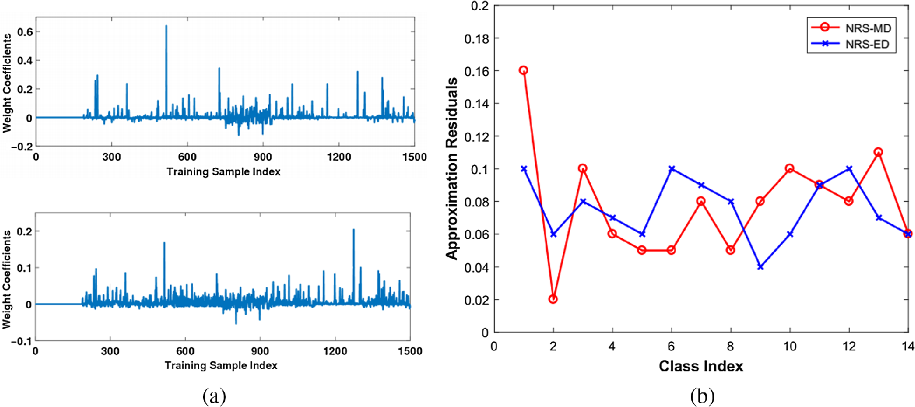

CHAPTER 4
TESTING AND IMPLEMENTATION

  - TESTING
Implementation is the stage of the project when the theoretical design is turned into a working system. This is the final and important phase in the system life cycle It is actually the process of converting the new system into a operational one.

4.1.1Unit Testing
Unit testing comprises the set of tests performed by an individual programmer prior to integration of the unit into a larger system. The module interface is tested to ensure that information properly flows into and out of the program unit. The local data structure is examined to ensure that data stored temporarily maintains its integrity during all steps in an algorithm’s execution. Boundary conditions are tested to ensure that the module operates properly at boundaries established to limit or restrict processing. All independent paths through the control structure are tested. All error-handling paths are tested.

4.1.2 Block Box Testing
Black-box testing is a method of software testing that examines the functionality of an application without peering into its internal structures or workings. This method of test can be applied virtually to every level of software testing: unit, integration, system and acceptance. It is sometimes referred to as specification-based testing.

4.2 SYSTEM IMPLEMENTATION
Implementation is the stage of the project when the theoretical design is turned into a working system. This is the final and important phase in the system life cycle It is actually the process of converting the new system into a operational one.

CHAPTER 5
CONCLUSION:
In this letter, a new strategy, which combines the Gabor filtering and the CNN, was proposed for HSI classification. CNN is a powerful FE method, but it suffers from the problem of overfitting when the number of training samples is insufficient. In order to alleviate the overfitting problem of CNN-based methods, Gabor filtering was used to effectively extract spatial information including edges and textures. The results obtained by the proposed method on Salinas, KSC, and Indian Pines data sets demonstrate that Gabor-CNN outperforms other studied methods when the number of training samples is limited. Thanks to the features extracted by the Gabor filters, CNNs can extract features and update weights effectively even if limited training samples are available.

CHAPTER-6
REFERENCE
- [1] J. M. Bioucas-Dias, A. Plaza, G. Camps-Valls, P. Scheunders, N. Nasrabadi, and J. Chanussot, “Hyperspectral remote sensing data analysis and future challenges,” IEEE Geosci. Remote Sens. Mag., vol. 1, no. 2, pp. 6–36, Jun. 2013.
- [2] L. Gómez-Chova, D. Tuia, G. Moser, and G. Camps-Valls, “Multimodal classification of remote sensing images: A review and future directions,” Proc. IEEE, vol. 103, no. 9, pp. 1560–1584, Sep. 2015.
- [3] P. Ghamisi, J. Plaza, Y. Chen, J. Li, and A. J. Plaza, “Advanced spectral classifiers for hyperspectral images: A review,” IEEE Geosci. Remote Sens. Mag., vol. 5, no. 1, pp. 8–32, Mar. 2017.
- [4] J. A. Benediktsson and P. Ghamisi, Spectral-Spatial Classification of Hyperspectral Remote Sensing Images. Boston, MA, USA: Artech House, 2015.
- [5] M. Fauvel, J. A. Benediktsson, J. Chanussot, and J. R. Sveinsson, “Spectral and spatial classification of hyperspectral data using SVMs and morphological profiles,” IEEE Trans. Geosci. Remote Sens., vol. 46, no. 11, pp. 3804–3814, Nov. 2008.
- [6] A. C. Bovik, M. Clark, and W. S. Geisler, “Multichannel texture analysis using localized spatial filters,” IEEE Trans. Pattern Anal. Mach. Intell., vol. 12, no. 1, pp. 55–73, Jan. 1990.
- [7] T. Randen and J. H. Husøy, “Filtering for texture classification: A comparative study,” IEEE Trans. Pattern Anal. Mach. Intell., vol. 21, no. 4, pp. 291–310, Apr. 1999.
- [8] G. Cheng, P. Zhou, and J. Han, “Learning rotation-invariant convolutional neural networks for object detection in VHR optical remote sensing images,” IEEE Trans. Geosci. Remote Sens., vol. 54, no. 12, pp. 7405–7415, Dec. 2016.
- [9] S. Chen, H. Wang, F. Xu, and Y.-Q. Jin, “Target classification using the deep convolutional networks for SAR images,” IEEE Trans. Geosci. Remote Sens., vol. 54, no. 8, pp. 4806–4817, Aug. 2016.
- [10] Y. Chen, H. Jiang, C. Li, X. Jia, and P. Ghamisi, “Deep feature extraction and classification of hyperspectral images based on convolutional neural networks,” IEEE Trans. Geosci. Remote Sens., vol. 54, no. 10, pp. 6232–6251, Oct. 2016.

