Small Low-Contrast Target Detection Data-Driven Spatiotemporal Feature Fusion and Implementation

ABSTRACT
Detecting small low-contrast targets in the airspace is an essential and challenging task. This article proposes a simple and effective data-driven support vector machine (SVM)-based spatiotemporal feature fusion detection method for small low-contrast targets. We design a novel pixel-level feature, called a spatiotemporal profile, to depict the discontinuity of each pixel in the spatial and temporal domains The spatiotemporal profile is a local patch of the spatiotemporal feature maps concatenated by the spatial feature maps and temporal feature maps in channelwise, which are generated by the morphological black-hat filter and a ghost-free dark-focusing frame difference methods, respectively. Instead of the handcrafted feature fusion mechanisms in previous works, we use the labeled spatiotemporal profiles to train an SVM classifier to learn the spatiotemporal feature fusion mechanism automatically. To speed up detection for high-resolution videos, the serial SVM classification process on central processing units (CPUs) is reformed as parallel convolution operations on graphics processing unit (GPUs), which exhibits over 1000+ times speedup in our real experiments. Finally, blob analysis is applied to generate final detection results. Elaborate experiments are conducted, and experimental results demonstrate that the proposed method performs better than 12 baseline methods for the small low-contrast target detection. The field tests manifest that the parallel implementation of the proposed method can realize real-time detection at 15.3 FPS for videos at a resolution of 2048x1536 and the maximum detection distance can reach 1 km for drones in sunny weather.

CHAPTER 2
2. SYSTEM ANALYSIS
  - EXISTING SYSTEM

- Existing open-source dataset in infrared small target detection is scarce, most traditional methods are evaluated on their in-house datasets.
- However, existing CNNbased methods cannot be directly applied for infrared small targets since pooling layers in their networks could lead to the loss of targets in deep layers.
- Compared to existing methods, our method is more robust to the variations of clutter background, target size, and target shape.
- Existing CNN-based methods can be divided into detection based methods and segmentation based methods.
- Existing CNNbased methods mainly use real infrared data with manual annotations.
2.1.1 DRAWBACKS OF EXISTING SYSTEM :
- Detecting infrared small targets is thus a form of blob detection, which is a problem with a long history in the image processing literature.
- However, in real-world scenarios, the problem is more complex: there are more distractors that also stand out as outliers in the background.
- Infrared small target detection can also be modeled as a supervised machine-learning problem, but it has long been stuck with insufficient training data due to the difficulty of collecting infrared small target images.
- We follow the convention of this field and model infrared small target detection as a segmentation problem.
2.2. PROPOSED SYSTEM
- This paper proposed a hybrid method by making a compromise for the spatial filter approach and temporal approach, known as the separate spatio-temporal filtering method based on an attribute-based plot association.
- In contrast, the proposed method (horizontal clutter rejection (L-DBRF) after M-MSF) showed an ideal ROC curve pattern.
- To detect infrared small targets, numerous traditional methods have been proposed, including filtering-based methods, local-contrast-based methods, and low-rank based methods.
- A dense nested interactive module and a channel-spatial attention module are proposed to achieve progressive feature fusion and adaptive feature enhancement.
2.2.1. ADVANTAGES OF PROPOSED SYSTEM
- We also compare the performance of our network against other model-driven methods and deep networks on the open SIRST dataset as well.
- It can be seen that, compared with FPN, the performance of the DLC-FPN is consistently and significantly better.
- It can be seen that by covering multiple dilation rates, the performance of MLCFPN is consistently better than DLC-FPN.
- The comparison among FPN, DLC-FPN, and MLC-FPN suggests that incorporating local contrast prior helps and a multi-scale measure in the same layer can further boost the performance.
- All convolutional networks perform better than the non-learning model-driven methods, which shows that learning from the data offers a promising way leading to better performance for infrared small detection.
Literature Survey:
TITLE | AUTHORS | DESCRIPTION
A thermal infrared video benchmark for visual analysis | Z. Wu, N. W. Fuller, D. H. Theriault, and M. Betke, | Our TIV benchmark enriches and diversifies video data sets available to the research community with thermal infrared footage, which poses new and challenging video analysis problems.
Algorithms for optical weak small targets detection and tracking: Review | Wei Zhang, Mingyu Cong, and Liping Wang, | This paper provides an extensive review of algorithms currently used for detection and tracking in optical weak small targets environments where conventional tracking techniques are inadequate.
Optical Moving Target Detection with 3-D Matched Filtering | I. S. Reed, R. M. Gagliardi, and L. B. Stotts, | Three-dimensional (3-D) matched filtering has been suggested as a powerful processing technique for detecting weak, moving optical targets immersed in a background noise field.
Infrared patch-image model for small target detection in a single image | C. Gao, D. Meng, Y. Yang, Y. Wang, X. Zhou, and A. G. Hauptmann, | The robust detection of small targets is one of the key techniques in infrared search and tracking applications.

2.3 FEASIBILITY STUDY
The feasibility Analysis is an analytical program through project manager determines the project success ratio and through feasibility study project manager able to see either project. The key considerations involved in the feasibility analysis are:
- Economic Feasibility
- Technical Feasibility
- Operational Feasibility
- Environmental Feasibility
2.3.1 ECONOMICAL FEASIBILITY
Hence this project is economically feasible there is no need to involve any cost for this project.
2.3.2 TECHNICAL FEASIBILITY
Software Technologies used are PHP and MySql. In the educational institutions, it is possible to update the system in future. No special hardware is required for the purpose of using this system. Hence it is declared that this project is technically feasible.
2.3.3 OPERATIONAL FEASIBILITY
As the admin work mainly to maintain the Patient and Doctor .Doctor will predict patient cancer disease. Hence it is easy to operate with training. Therefore it is operationally feasible for implementation.
2.3.4 ENVIRONMENTAL FEASIBILITY
This project environment is correct as a admin has developed this system and no expenditure is involved under any head and this process is part of admin document management, this project environment is accessible.

2.4 SYSTEM REQUIREMENTS
- System : Pentium IV 2.4 GHz.
- Hard Disk : 40 GB.
- Monitor : 15 inch VGA Color.
- Mouse : Logitech Mouse.
- Ram : 512 MB
- Keyboard : Standard Keyboard
2.4.1 HARDWARE REQUIREMENTS
The Hardware of the computer consists of physical component such as Input Devices, Storage Devices, Processing & Control units and Output Devices. Computer includes external storage unit to store data in programs.
The Hardware Configuration involved in this project
- System : Pentium IV 2.4 GHz.
- Hard Disk : 40 GB.
- Monitor : 15 inch VGA Color.
- Mouse : Logitech Mouse.
- Ram : 512 MB
- Keyboard : Standard Keyboard

2.4.2 SOFTWARE REQUIREMENTS
Software is a group of programs that computers need to do a particular task. It is an essential requirement of Computer System. The Software used to develop the project is
- Operating System : Windows XP.
- Platform : DOT NET TECHNOLOGY
- Front End : ASP.Net 3.5
- Back End : SQL SERVER 2005

CHAPTER 3
SYSTEM DESIGN AND DEVELOPEMENT
SYSTEM ARCHICTURE
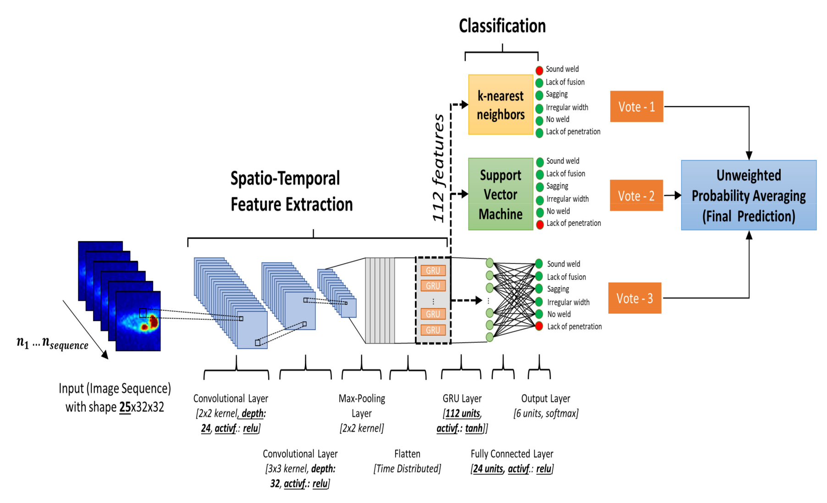

CHAPTER 4
TESTING AND IMPLEMENTATION

  - TESTING
Implementation is the stage of the project when the theoretical design is turned into a working system. This is the final and important phase in the system life cycle It is actually the process of converting the new system into a operational one.

4.1.1Unit Testing
Unit testing comprises the set of tests performed by an individual programmer prior to integration of the unit into a larger system. The module interface is tested to ensure that information properly flows into and out of the program unit. The local data structure is examined to ensure that data stored temporarily maintains its integrity during all steps in an algorithm’s execution. Boundary conditions are tested to ensure that the module operates properly at boundaries established to limit or restrict processing. All independent paths through the control structure are tested. All error-handling paths are tested.

4.1.2 Block Box Testing
Black-box testing is a method of software testing that examines the functionality of an application without peering into its internal structures or workings. This method of test can be applied virtually to every level of software testing: unit, integration, system and acceptance. It is sometimes referred to as specification-based testing.

4.2 SYSTEM IMPLEMENTATION
Implementation is the stage of the project when the theoretical design is turned into a working system. This is the final and important phase in the system life cycle It is actually the process of converting the new system into a operational one.

CHAPTER 5
CONCLUSION:
We have presented our ALCNet for infrared small target detection. In particular, we find that convolutional networks that integrate the local contrast prior, which is generally modeled in non-learning methods, are very promising and worthy of further research. By breaking the conventional non-overlapped patch constraint, we extract and fuse the local contrast feature maps in two stages, namely in the same layer and across layers, to better transplant the domain knowledge into networks. Besides, to highlight and preserve the small target in highlevel coarse features, we utilize a bottom-up local attentional modulation module that embeds subtle low-level details into high-level layers. We conduct extensive ablation studies and comparison with other state-of-the-art methods. The proposed ALCNet significantly outperforms the compared purely modeldriven methods and purely data-driven networks on the open SIRST dataset, which suggests that one should pay attention to combining deep networks with domain knowledge to detect small infrared targets and a target-preserving cross-layer fusion scheme holds the potential to yield better results.

CHAPTER-6
REFERENCE
- [1] Z. Wu, N. W. Fuller, D. H. Theriault, and M. Betke, “A thermal infrared video benchmark for visual analysis,” in 2014 IEEE Conference on Computer Vision and Pattern Recognition (CVPR) Workshops, Columbus, OH, USA, 2014, pp. 201–208.
- [2] Wei Zhang, Mingyu Cong, and Liping Wang, “Algorithms for optical weak small targets detection and tracking: Review,” in International Conference on Neural Networks and Signal Processing, Nanjing, China, vol. 1, 2003, pp. 643–647.
- [3] I. S. Reed, R. M. Gagliardi, and L. B. Stotts, “Optical Moving Target Detection with 3-D Matched Filtering,” IEEE Transactions on Aerospace and Electronic Systems, vol. 24, no. 4, pp. 327–336, Jul 1988.
- [4] C. Gao, D. Meng, Y. Yang, Y. Wang, X. Zhou, and A. G. Hauptmann, “Infrared patch-image model for small target detection in a single image,” IEEE Transactions on Image Processing, vol. 22, no. 12, pp. 4996–5009, 2013.
- [5] G. Arce and M. McLoughlin, “Theoretical analysis of the max/median filter,” IEEE Transactions on Acoustics, Speech, and Signal Processing, vol. 35, no. 1, pp. 60–69, 1987.
- [6] K. Mikolajczyk and C. Schmid, “Scale & affine invariant interest point detectors,” International Journal of Computer Vision, vol. 60, no. 1, pp. 63–86, 2004.
- [7] D. Liu, L. Cao, Z. Li, T. Liu, and P. Che, “Infrared small target detection based on flux density and direction diversity in gradient vector field,” IEEE Journal of Selected Topics in Applied Earth Observations and Remote Sensing, vol. 11, no. 7, pp. 2528–2554, 2018.
- [8] C. L. P. Chen, H. Li, Y. Wei, T. Xia, and Y. Y. Tang, “A local contrast method for small infrared target detection,” IEEE Transactions on Geoscience and Remote Sensing, vol. 52, no. 1, pp. 574–581, 2014.
- [9] H. Deng, X. Sun, M. Liu, C. Ye, and X. Zhou, “Small infrared target detection based on weighted local difference measure,” IEEE Transactions on Geoscience and Remote Sensing, vol. 54, no. 7, pp. 4204–4214, 2016.
- [10] Y. Dai, Y. Wu, Y. Song, and J. Guo, “Non-negative infrared patch-image model: Robust target-background separation via partial sum minimization of singular values,” Infrared Physics & Technology, vol. 81, pp. 182–194,2017.

